Задание 1:

docker compose version

> Docker Compose version v2.24.7<

nano docker-compose.yml

>

version: '3.9'

services:

db:

image: mariadb:10.10.2

restart: always

environment:

MYSQL_ROOT_PASSWORD: 12345

adminer:

image: adminer:4.8.1

restart: always

ports:

- 6080:8080

<

docker-compose up –d

docker ps



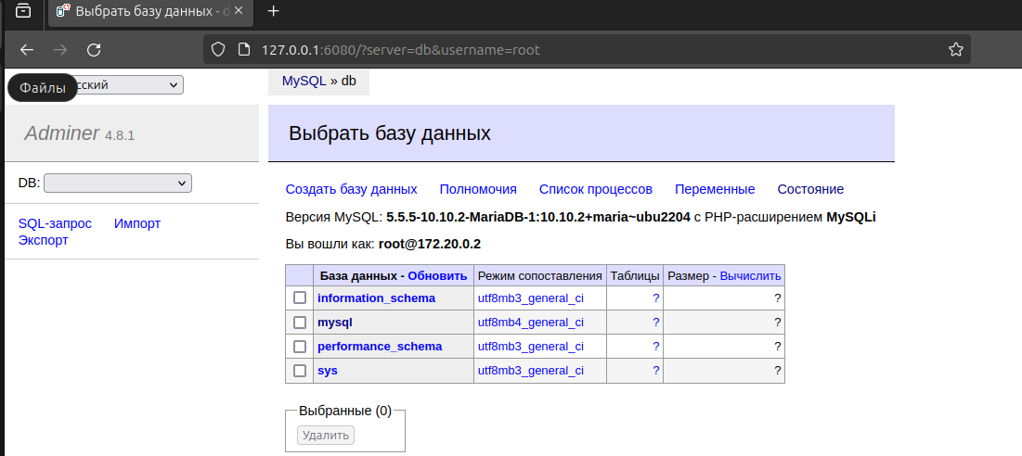

docker swarm init

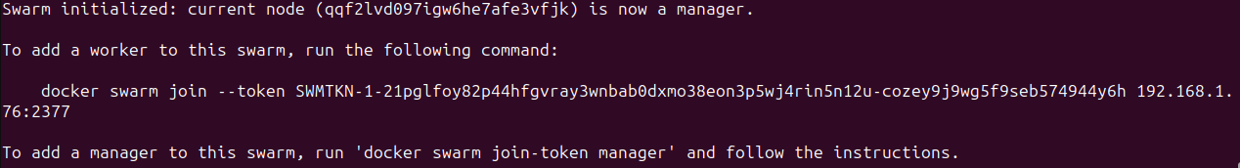

docker network create --driver overlay testnw --attachable

docker service create --name mariadb --replicas 4 -e MYSQL_ROOT_PASSWORD=12345 -p 3306:3306 --network testnw mariadb:10.10.2

docker ps

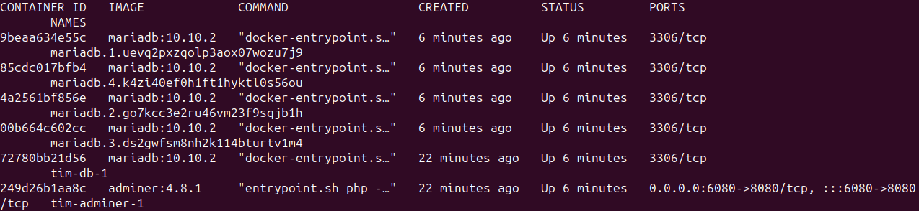

docker node update --label-add env=prod qqf2lvd097igw6he7afe3vfjk

docker inspect qqf2lvd097igw6he7afe3vfjk

