**CP363 Assignment 1**Mason Cooper

140328200

Due: Feb. 27, 2017

Suppliers:

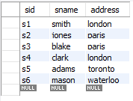

Parts:

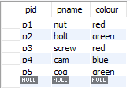

Catalog:

