**CP363 Assignment 2**Mason Cooper

140328200

Due: March 6, 2017

Question 1

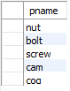

Question 2

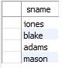

Question 3

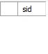 (Empty)

Question 4

C:\Users\exacte\AppData\Local\Microsoft\Windows\INetCache\Content.Word\q4.png

Question 5

C:\Users\exacte\AppData\Local\Microsoft\Windows\INetCache\Content.Word\q5.png

Question 6

C:\Users\exacte\AppData\Local\Microsoft\Windows\INetCache\Content.Word\q6.png

Question 7

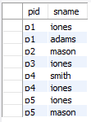

Question 8

