**CP363 Assignment 2**Mason Cooper

140328200

Due: Mar. 13, 2017

Albums:

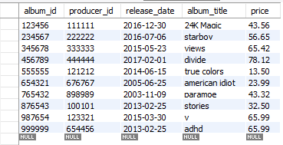

Musicians:

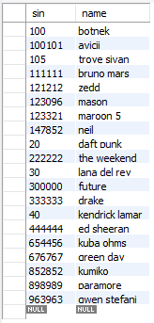

Perform:

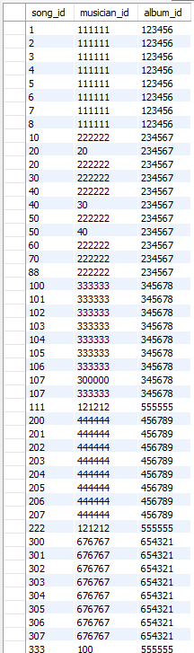

Perform – cont’d:

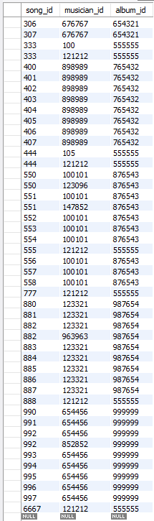

Songs:

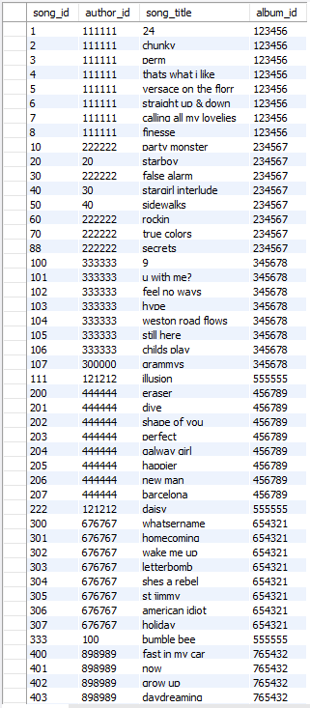

Songs – cont’d:

