**CP363 Assignment 3**Mason Cooper

140328200

Due: Mar. 20, 2017

Customers:

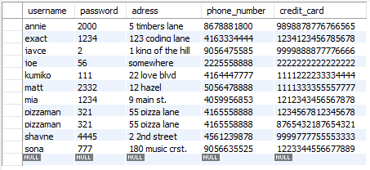

Purchases:

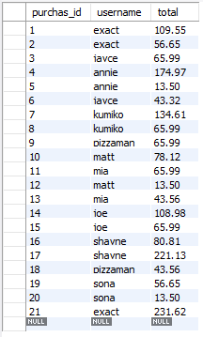

Orders:



Albums:

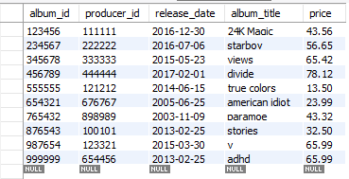

Musicians:

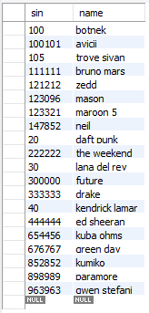

Perform:

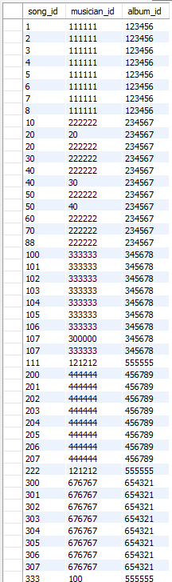

Perform – cont’d:

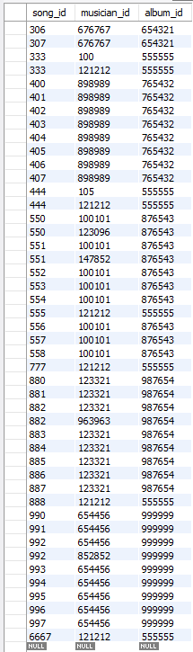

Songs:

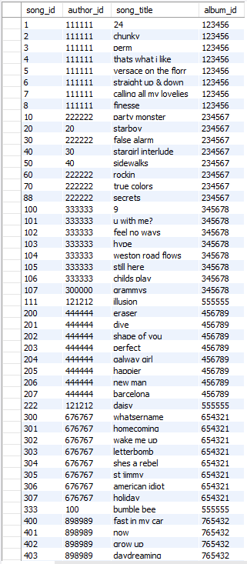

Songs – cont’d:

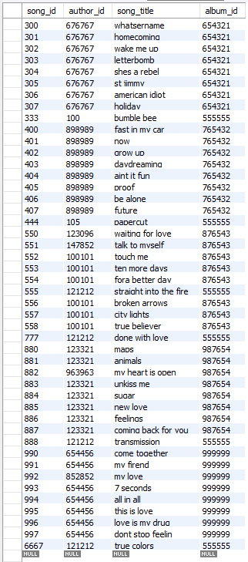

Code

*'''*

*Created on Mar 18, 2017*

**@author:** *Mason Cooper, 140328200*

*'''*

import mysql.connector

# Main Function, This functions handle all calls towards other function in the program. Also runs the main loop and updates the database

def **Main**():

chk = True

db = *""*

cart = []

while chk:

ask = input(*'What would you like to do\n Login(L)\n Register(R)\n Quit(Q)\n-> '*)

if ask.lower() == *'l'*:

db = logIn() #Calls Login function, and returns database if successful

cursor = db.cursor() #Sets database cursor

chk = False

elif ask.lower() == *'r'*:

register()

elif ask.lower() == *'q'*:

chk = False

else:

print(*'Invalid Input\n'*)

if db != *""*:

print(*'Welcome Back!'*)

ask = input(*'What would you like to do\n Add Album(A)\n Add Song(S)\n Search(R)\n View Cart(V)\n Checkout(C)\n Quit(Q)\n-> '*) #Prompt user for answer, if they want to add album, add song, or quit

while ask.lower() != *'q'*: #Main Loop, continuously prompts user to add songs or albums until they decide to quit

if ask.lower() == *'a'*: #This if-elif-else statement checks if they want to add an album, a song, or if they entered invalid input

addAlbum(cursor) #Calls the function to add an album

elif ask.lower() == *'s'*:

song_id = addSong(cursor) #Calls function to add a song

if song_id != *""*:

addPerformer(cursor, song_id) #Calls function to insert into perform

elif ask.lower() == *'r'*:

album, price = search(cursor)

if album != *""*:

cart = addCart(cart, album, price)

elif ask.lower() == *'v'*:

viewCart(cart)

elif ask.lower() == *'c'*:

if cart != []:

stmt = *'SELECT USER()'*

cursor.execute(stmt)

hold = cursor.fetchone()[0]

hold = hold.split(*"@"*)

user = hold[0]

checkout(cart, user)

else:

print(*'\nCart is Empty!\n'*)

else:

print(*'Invalid Input\n'*)

ask = input(*'What would you like to do\n Add Album(A)\n Add Song(S)\n Search(R)\n View Cart(V)\n Checkout(C)\n Quit(Q)\n-> '*)

db.commit() #Updates database

cursor.close() #Closes the cursor

db.close() #Closes the database

print(*'Finished!'*)

return

def **register**():

db = mysql.connector.connect(user = *'root'*,

password = *'1234'*,

host = *'localhost'*,

database = *'notown'*)

cursor = db.cursor()

print(*'User Information\n'*)

username = input(*'Username: '*)

password = input(*'Password: '*)

adress = input(*'Adress: '*)

phone_number = input(*'Phone Number: '*)

numb_cc = int(input(*'How many credit cards would you like to add(1-5)? '*))

try:

stmt = *"CREATE USER '%s'@'localhost' IDENTIFIED BY '%s'"* % (username, password)

cursor.execute(stmt)

stmt = *"GRANT SELECT ON notown.albums TO '%s'@'localhost'"* % (username)

cursor.execute(stmt)

stmt = *"GRANT SELECT ON notown.songs TO '%s'@'localhost'"* % (username)

cursor.execute(stmt)

stmt = *"GRANT SELECT ON notown.musicians TO '%s'@'localhost'"* % (username)

cursor.execute(stmt)

stmt = *"GRANT INSERT ON notown.* TO '%s'@'localhost'"* % (username)

cursor.execute(stmt)

for i in range(0,numb_cc):

credit_card = input(*'Credit Card Number: '*)

stmt = *"INSERT INTO customers (username, password, adress, phone_number, credit_card) VALUES ('%s', '%s', '%s', %s, %s)"* % (username, password, adress, phone_number, credit_card)

cursor.execute(stmt)

print(*'\nRegistration Successful!\n'*)

except:

print(*'\nUser already exists in our database!\n'*)

db.commit() #Updates database

cursor.close() #Closes the cursor

db.close() #Closes the database

return

#This Function prompts the user for their user name and passwords. Then validates the user name and password. If incorrect information entered the user may continue to attempt until they decide to quit

def **logIn**():

cont = True

askchk = True

chk = *''*

while cont: #Loops until the user successfully logins in or decides to quit

print(*'Login'*)

username = input(*'Username: '*) #Prompt user for user name

passW = input(*'Password: '*) #Prompt user for password

try: #Attempts to log user in with given credentials

db = mysql.connector.connect(user = username,

password = passW,

host = *'localhost'*,

database = *'notown'*)

cont = False

except: #Handles failure of login

askchk = True

print(*'Username or Password is Incorrect'*)

while askchk:

chk = input(*'Would you like to continue(Y/N): '*) #Prompts user if the wish to try again

if chk.lower() == *'n'*: #This if-elif-else statement checks if they want to try again, quit, or if they entered invalid input

db = *''*

cont = False

askchk = False

elif chk.lower() == *'y'*:

askchk = False

else:

print(*'Invalid Input'*)

return db #returns database. db is empty string, if login was unsuccessful

#This function handles, obtaining the information of albums and entering albums into the album table

def **addAlbum**(cursor):

print(*'Album Information\n'*)

album_id = input(*'Album ID: '*) #Prompts user for album id

producer_id = input(*'Producer ID: '*) #Prompts user for producer id

producer_Name = input(*'Producer Name: '*) #Prompts user for producer name

release_date = input(*'Release Date(yyyy-mm-dd): '*) #Prompts user for release date

album_title = input(*'Album Title: '*) #Prompts user for album title

price = input(*'Price: '*) #Prompts user for price

try: #Adds producer to musician table, will be successful if producer does not already exist in the musician table and will go to exception otherwise

stmt = *"INSERT INTO musicians (sin, name) VALUES (%s, '%s')"* % (producer_id, producer_Name)

cursor.execute(stmt)

except: #This exception just passes, because producer is already contained within musician and their is no issue

pass

try: #Attempts to add new album based on given information, if album already exists will go to exception

stmt = *"INSERT INTO albums (album_id, producer_id, release_date, album_title, price) VALUES (%s, %s, '%s', '%s', '%s')"* % (album_id, producer_id, release_date, album_title, price)

cursor.execute(stmt)

except: #Lets user know album already exists

print(*'Album already exists'*)

return

#This function handles, obtaining the information of songs and entering songs into the songs table

def **addSong**(cursor):

album_id = input(*'Please enter the id of the album you would like to add to:\n-> '*) #Prompts user for album id

try:

stmt = *'SELECT album_title from albums WHERE album_id = %s'* % (album_id) #The following block obtains album_id from albums table using album_title

cursor.execute(stmt)

album_title = cursor.fetchone()[0]

except:

chk = True

while chk:

ans = input(*'Album does not exist, would you like to create a new album(Y/N)?\n-> '*)

if ans.lower() == *'y'*: #This if-elif-else statement checks if they want to add the album as a new album or not if they entered invalid input

addAlbum(cursor)

chk = False

elif ans.lower() == *'n'*:

return *""*

else:

print(*'Invalid Input'*)

chk = True

while chk:

try:

numbofsongs = int(input(*'How many songs would you like to add(1-20)?\n-> '*))

if numbofsongs < 21 and numbofsongs > 0:

chk = False

else:

print(*'Invalid Input: Input was outside accepted range'*)

except:

print(*'Invalid Input: Input was not a number'*)

print(*'Song Information\n'*)

for i in range(1,numbofsongs+1):

print(*'Song %s'* % (i))

song_id = input(*'Song ID: '*) #Prompts user for song id

author_id = input(*'Author ID: '*) #Prompts user for author id

author_name = input(*'Author Name: '*) #Prompts user for author name

song_title = input(*'Song Title: '*) #Prompts user for song title

try: #Adds author to musician table, will be successful if author does not already exist in the musician table and will go to exception otherwise

stmt = *"INSERT INTO musicians (sin, name) VALUES (%s, '%s')"* % (author_id, author_name)

cursor.execute(stmt)

except: #This exception just passes, because author is already contained within musician and their is no issue

pass

try: #Attempts to add new song based on given information

stmt = *"INSERT INTO songs (song_id, author_id, song_title, album_id) VALUES (%s, %s, '%s', %s)"* % (song_id, author_id, song_title, album_id)

cursor.execute(stmt)

except Exception as e: #Lets user know of any errors that may occur if the attempt to add song fails

print(str(e))

print(*'Songs added!\n'*)

return song_id

#This function adding songs into the perform table

def **addPerformer**(cursor, song_id):

stmt = *'SELECT album_id from songs WHERE song_id = %s'* % (song_id) #The following block obtains album_id from songs table using song_id

cursor.execute(stmt)

album_id = cursor.fetchone()[0]

stmt = *'SELECT author_id from songs WHERE song_id = %s'* % (song_id) #The following block obtains author_id from songs table using song_id

cursor.execute(stmt)

song_musician_id = cursor.fetchone()[0]

stmt = *'SELECT producer_id from albums WHERE album_id = %s'* % (album_id) #The following block obtains producer_id from songs table using album_id

cursor.execute(stmt)

album_musician_id = cursor.fetchone()[0]

if song_musician_id == album_musician_id: #This if statement adds one record into perform table if author id and producer id are the same

stmt = *'INSERT INTO perform (song_id, musician_id, album_id) VALUES (%s, %s, %s)'* % (song_id, song_musician_id, album_id)

cursor.execute(stmt)

else: #This else statement adds two record into perform table if author id and producer id are not the same, one entry for each author and producer

stmt = *'INSERT INTO perform (song_id, musician_id, album_id) VALUES (%s, %s, %s)'* % (song_id, song_musician_id, album_id)

cursor.execute(stmt)

stmt = *'INSERT INTO perform (song_id, musician_id, album_id) VALUES (%s, %s, %s)'* % (song_id, album_musician_id, album_id)

cursor.execute(stmt)

return

def **search**(cursor):

chk = True

album = *""*

print(*'Search:'*)

while chk:

ask = input(*'How would like to search?\n By Album Title(A)\n By Name of Album Producer(P)\n By Name of Song(S)\n By Name of Musician(M)\n Quit(Q)\n-> '*)

if ask.lower() == *'a'*:

try:

album_title = input(*'Enter Album Title: '*)

stmt = *"SELECT album_title from albums where album_title='%s'"* % (album_title)

cursor.execute(stmt)

album = cursor.fetchone()[0]

print(*"\nFound Album, '%s'"* % (album))

add = input(*'Would you like to Add this Album(Y/N)? '*)

if add.lower() == *'y'*:

stmt = *"SELECT price from albums where album_title='%s'"* % (album_title)

cursor.execute(stmt)

price = float(cursor.fetchone()[0])

return album, price

except:

print(*'\nNo Album Exists with that Title!\n'*)

elif ask.lower() == *'p'*:

try:

name = input(*'Enter Name of Album Producer: '*)

stmt = *"SELECT sin from musicians where name='%s'"* % (name)

cursor.execute(stmt)

sin = cursor.fetchone()[0]

stmt = *"SELECT album_title from albums where producer_id='%s'"* % (sin)

cursor.execute(stmt)

album = cursor.fetchone()[0]

print(*"\nFound Album, '%s'"* % (album))

add = input(*'Would you like to Add this Album(Y/N)? '*)

if add.lower() == *'y'*:

stmt = *"SELECT price from albums where producer_id='%s'"* % (sin)

cursor.execute(stmt)

price = float(cursor.fetchone()[0])

return album, price

except:

print(*'\nNo Producer Exists with that Name!\n'*)

elif ask.lower() == *'s'*:

try:

song_title = input(*'Enter Name of Song: '*)

stmt = *"SELECT album_id from songs where song_title='%s'"* % (song_title)

cursor.execute(stmt)

album_id = cursor.fetchone()[0]

stmt = *"SELECT album_title from albums where album_id='%s'"* % (album_id)

cursor.execute(stmt)

album = cursor.fetchone()[0]

print(*"\nFound Album, '%s'"* % (album))

add = input(*'Would you like to Add this Album(Y/N)? '*)

if add.lower() == *'y'*:

stmt = *"SELECT price from albums where album_id='%s'"* % (album_id)

cursor.execute(stmt)

price = float(cursor.fetchone()[0])

return album, price

except:

print(*'\nNo Song Exists with that Title!\n'*)

elif ask.lower() == *'m'*:

try:

name = input(*'Enter Name of Musician: '*)

stmt = *"SELECT sin from musicians where name='%s'"* % (name)

cursor.execute(stmt)

author_id = cursor.fetchone()[0]

stmt = *"SELECT album_id from songs where author_id='%s'"* % (author_id)

cursor.execute(stmt)

album_id = cursor.fetchone()[0]

stmt = *"SELECT album_title from albums where album_id='%s'"* % (album_id)

cursor.execute(stmt)

album = cursor.fetchone()[0]

print(*"\nFound Album, '%s'"* % (album))

add = input(*'Would you like to Add this Album(Y/N)? '*)

if add.lower() == *'y'*:

stmt = *"SELECT price from albums where album_id='%s'"* % (album_id)

cursor.execute(stmt)

price = float(cursor.fetchone()[0])

return album, price

except:

print(*'\nNo Musician Exists with that Name!\n'*)

elif ask.lower() == *'q'*:

chk = False

else:

print(*'Invalid Input\n'*)

return album

def **addCart**(cart, album, price):

for i in range(0, len(cart)):

if album == cart[i][0]:

print(*'\nAlbum already in your cart!\n'*)

return cart

cart.append([album, price])

print(*'\nSuccessfully Added!\n'*)

return cart

def **viewCart**(cart):

total = 0

print(*'\nCart'*)

for i in range(0, len(cart)):

print(*'{0:s}: ${1:.2f}'*.format(cart[i][0], cart[i][1]))

total += cart[i][1]

print(*'Total: ${0:.2f}\n'*.format(total))

return

def **checkout**(cart, username):

db = mysql.connector.connect(user = *'root'*,

password = *'1234'*,

host = *'localhost'*,

database = *'notown'*)

cursor = db.cursor()

total = 0

purchas_id = 0

for i in range(0, len(cart)):

total += cart[i][1]

stmt = *"SELECT MAX(purchas_id) FROM purchases"*

cursor.execute(stmt)

max_id = cursor.fetchone()[0]

if max_id != None:

purchas_id = max_id + 1

else:

purchas_id = 1

for i in range(0, len(cart)):

stmt = *"SELECT album_id from albums where album_title='%s'"* % (cart[i][0])

cursor.execute(stmt)

album_id = cursor.fetchone()[0]

stmt = *'INSERT INTO orders (order_id, album_id, price) VALUES (%s, %s, %s)'* % (purchas_id, album_id, cart[i][1])

cursor.execute(stmt)

stmt = *"INSERT INTO purchases (purchas_id, username, total) VALUES (%s, '%s', %s)"* % (purchas_id, username, total)

print(*'\nCheckout Successful!\n'*)

cursor.execute(stmt)

db.commit() #Updates database

cursor.close() #Closes the cursor

db.close() #Closes the database

return

Main() #Runs Main Function

Sample Run

What would you like to do

Login(L)

Register(R)

Quit(Q)

-> r

User Information

Username: exact

Password: 1234

Adress: 123 coding lane

Phone Number: 4163334444

How many credit cards would you like to add(1-5)? 1

Credit Card Number: 1234123456785678

Registration Successful!

What would you like to do

Login(L)

Register(R)

Quit(Q)

-> l

Login

Username: exact

Password: 1234

Welcome Back!

What would you like to do

Add Album(A)

Add Song(S)

Search(R)

View Cart(V)

Checkout(C)

Quit(Q)

-> r

Search:

How would like to search?

By Album Title(A)

By Name of Album Producer(P)

By Name of Song(S)

By Name of Musician(M)

Quit(Q)

-> a

Enter Album Title: views

Found Album, 'views'

Would you like to Add this Album(Y/N)? y

Successfully Added!

What would you like to do

Add Album(A)

Add Song(S)

Search(R)

View Cart(V)

Checkout(C)

Quit(Q)

-> r

Search:

How would like to search?

By Album Title(A)

By Name of Album Producer(P)

By Name of Song(S)

By Name of Musician(M)

Quit(Q)

-> p

Enter Name of Album Producer: bruno mars

Found Album, '24K Magic'

Would you like to Add this Album(Y/N)? y

Successfully Added!

What would you like to do

Add Album(A)

Add Song(S)

Search(R)

View Cart(V)

Checkout(C)

Quit(Q)

-> r

Search:

How would like to search?

By Album Title(A)

By Name of Album Producer(P)

By Name of Song(S)

By Name of Musician(M)

Quit(Q)

-> s

Enter Name of Song: sugar

Found Album, 'v'

Would you like to Add this Album(Y/N)? y

Successfully Added!

What would you like to do

Add Album(A)

Add Song(S)

Search(R)

View Cart(V)

Checkout(C)

Quit(Q)

-> r

Search:

How would like to search?

By Album Title(A)

By Name of Album Producer(P)

By Name of Song(S)

By Name of Musician(M)

Quit(Q)

-> m

Enter Name of Musician: daft punk

Found Album, 'starboy'

Would you like to Add this Album(Y/N)? y

Successfully Added!

What would you like to do

Add Album(A)

Add Song(S)

Search(R)

View Cart(V)

Checkout(C)

Quit(Q)

-> v

Cart

views: $65.42

24K Magic: $43.56

v: $65.99

starboy: $56.65

Total: $231.62

What would you like to do

Add Album(A)

Add Song(S)

Search(R)

View Cart(V)

Checkout(C)

Quit(Q)

-> c

Checkout Successful!

What would you like to do

Add Album(A)

Add Song(S)

Search(R)

View Cart(V)

Checkout(C)

Quit(Q)

-> q

Finished!