Machine Learning Roadmap
LinkedIn Post

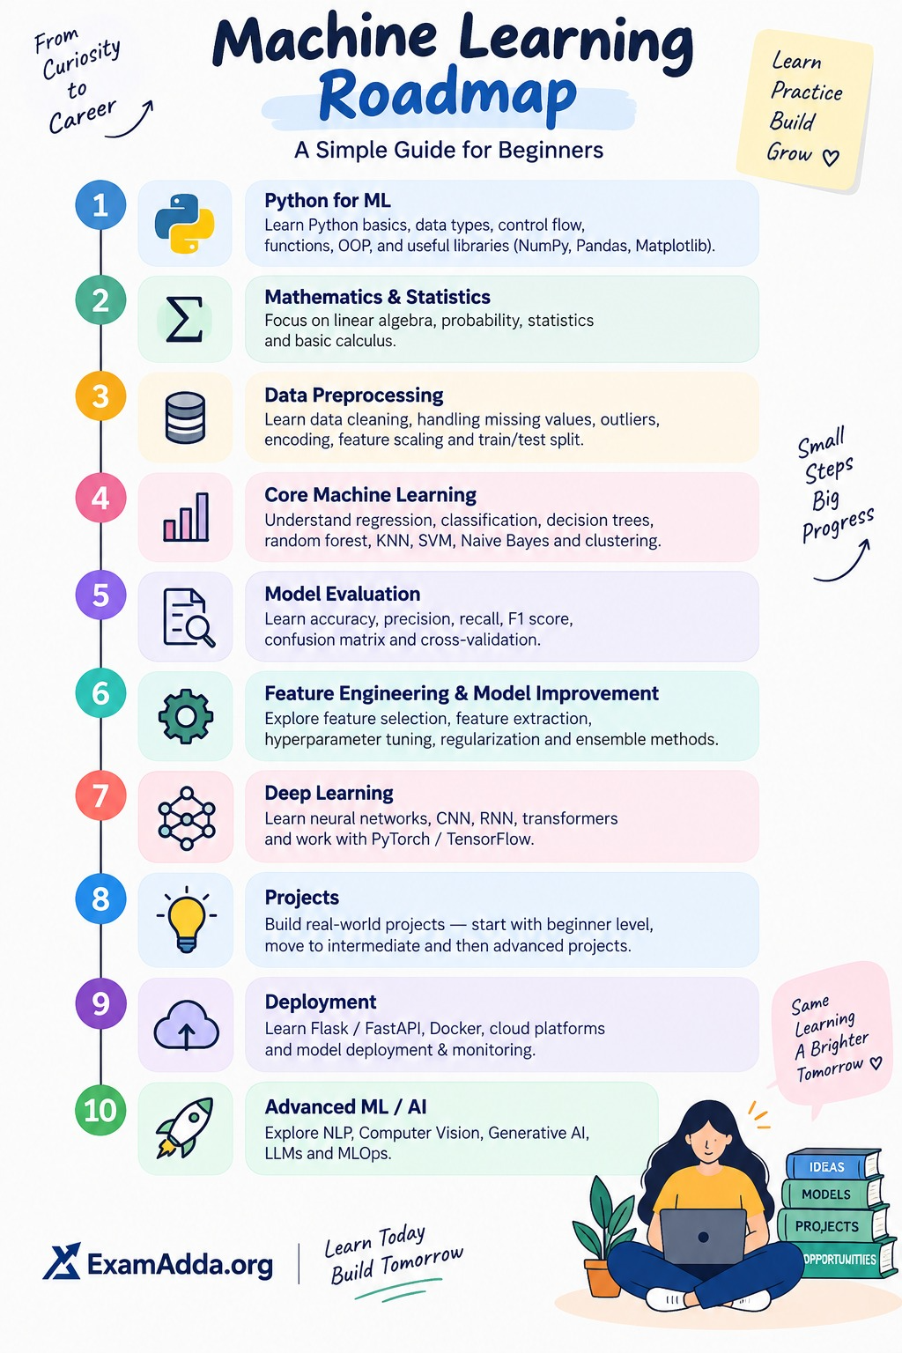

🚀 Planning to learn Machine Learning but not sure where to start?
Machine Learning can seem overwhelming when you don’t know what to learn first and what comes next.
A structured roadmap can make the journey much easier — from Python and Mathematics to ML Algorithms, Deep Learning, Projects, Deployment, and Advanced AI.
📌 Machine Learning Roadmap
Explore the complete roadmap and follow your learning journey step by step:
https://tech.examadda.org/roadmaps/machine-learning
Remember:
Learn → Practice → Build → Improve.
You don’t have to master everything at once. Start with the basics, stay consistent, and keep building. 💡
📍 Save this roadmap for your ML learning journey.
#MachineLearning #ArtificialIntelligence #DataScience #Python #DeepLearning #MLRoadmap #ExamAdda #TechExamAdda

