LinkedIn Post — DSA Roadmap
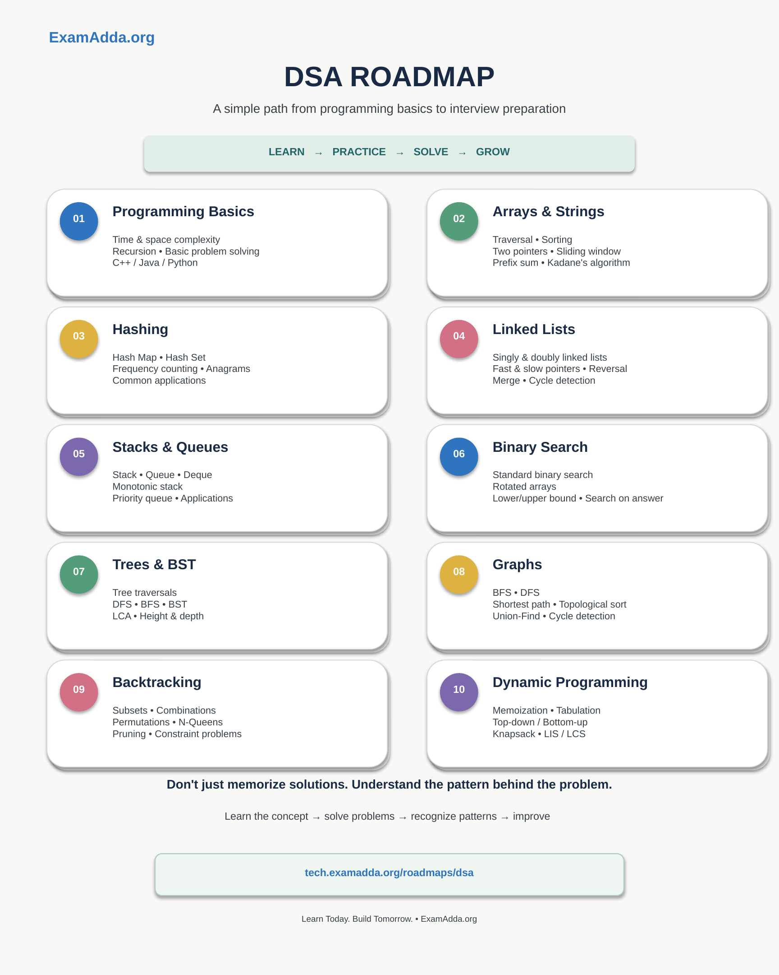
Suggested LinkedIn caption
🚀 DSA Roadmap for Beginners
Starting Data Structures & Algorithms can feel overwhelming when you don’t know what to learn first.
Here’s a simple roadmap to help you move step by step — from programming basics to interview preparation:
1️⃣ Programming Basics — complexity, recursion & problem solving
2️⃣ Arrays & Strings — sorting, two pointers, sliding window & prefix sum
3️⃣ Hashing — maps, sets, frequency counting & anagrams
4️⃣ Linked Lists — pointers, reversal, merging & cycle detection
5️⃣ Stacks & Queues — deque, monotonic stack & priority queue
6️⃣ Binary Search — rotated arrays, bounds & search on answer
7️⃣ Trees & BST — traversals, DFS/BFS & LCA
8️⃣ Graphs — BFS/DFS, shortest path, topological sort & Union-Find
9️⃣ Backtracking — subsets, combinations, permutations & N-Queens
🔟 Dynamic Programming — memoization, tabulation, Knapsack & LIS/LCS
The goal is not to memorize solutions. Understand the pattern, solve problems, and gradually build your problem-solving skills. 💡
🔗 Explore the roadmap:
https://tech.examadda.org/roadmaps/dsa
Learn Today. Build Tomorrow. 🚀
#DSA #DataStructures #Algorithms #Coding #Programming #LeetCode #InterviewPreparation #SoftwareEngineering #CodingRoadmap
Roadmap content based on the uploaded DSA roadmap presentation.

