Machine Learning Roadmap for Beginners

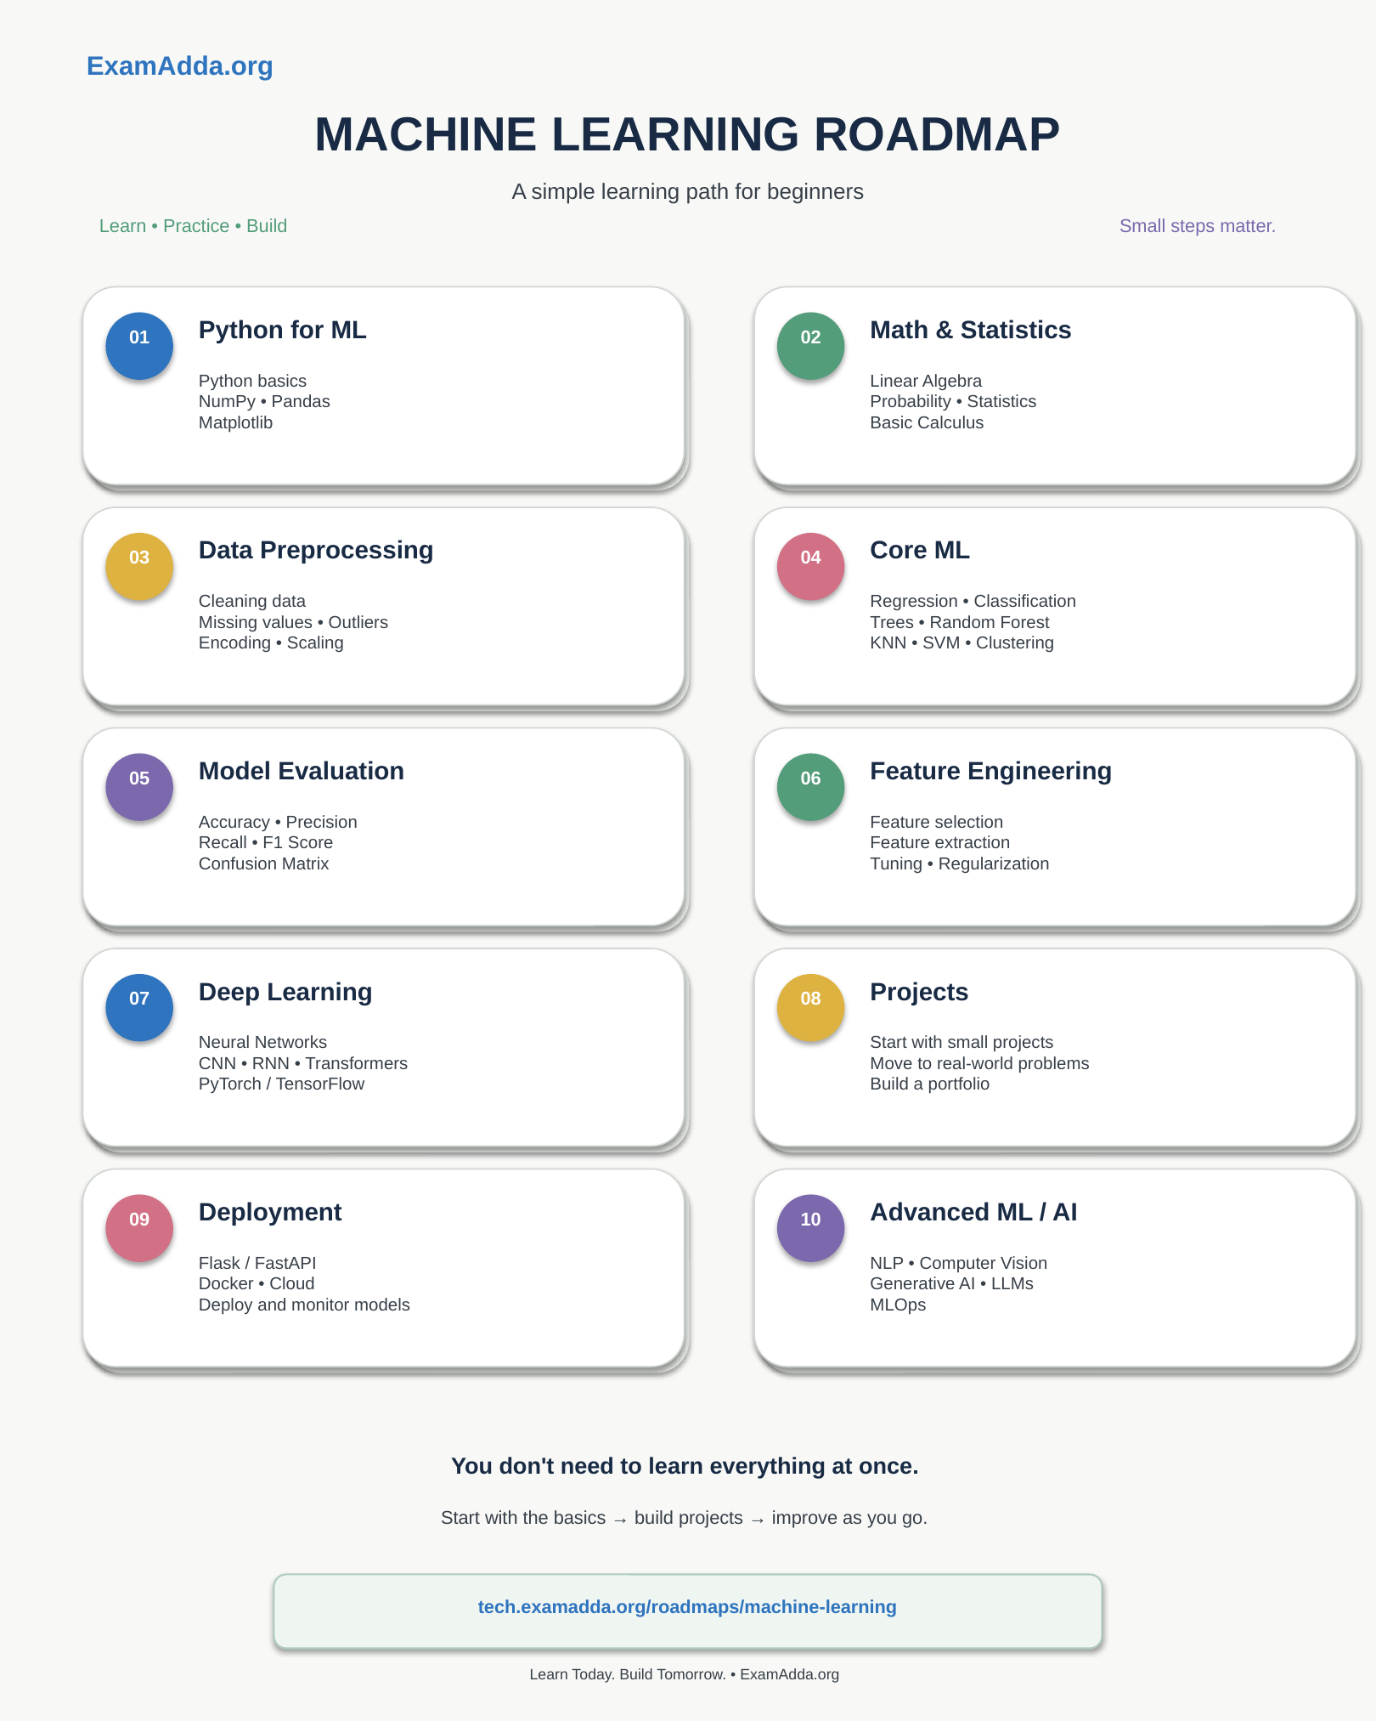

LinkedIn Post Description
🚀 Machine Learning Roadmap for Beginners
Want to start your Machine Learning journey but don't know where to begin?
Here’s a simple step-by-step roadmap to help you learn, practice, and build with confidence.
🔹 01. Python for ML
• Python basics
• NumPy & Pandas
• Matplotlib
🔹 02. Math & Statistics
• Linear Algebra
• Probability & Statistics
• Basic Calculus
🔹 03. Data Preprocessing
• Cleaning data
• Missing values & outliers
• Encoding & scaling
🔹 04. Core Machine Learning
• Regression & Classification
• Trees & Random Forest
• KNN, SVM & Clustering
🔹 05. Model Evaluation
• Accuracy & Precision
• Recall & F1 Score
• Confusion Matrix
🔹 06. Feature Engineering
• Feature selection
• Feature extraction
• Tuning & Regularization
🔹 07. Deep Learning
• Neural Networks
• CNN, RNN & Transformers
• PyTorch / TensorFlow
🔹 08. Projects
• Start with small projects
• Move to real-world problems
• Build a portfolio
🔹 09. Deployment
• Flask / FastAPI
• Docker & Cloud
• Deploy and monitor models
🔹 10. Advanced ML / AI
• NLP & Computer Vision
• Generative AI & LLMs
• MLOps
💡 You don’t need to learn everything at once.
Start with the basics → build projects → improve as you go.
🔗 Explore the Machine Learning Roadmap:
https://tech.examadda.org/roadmaps/machine-learning
Learn Today. Build Tomorrow. 🚀
#MachineLearning #ML #AI #Python #DataScience #DeepLearning #MLOps #LearningRoadmap #TechSkills #ExamAdda

