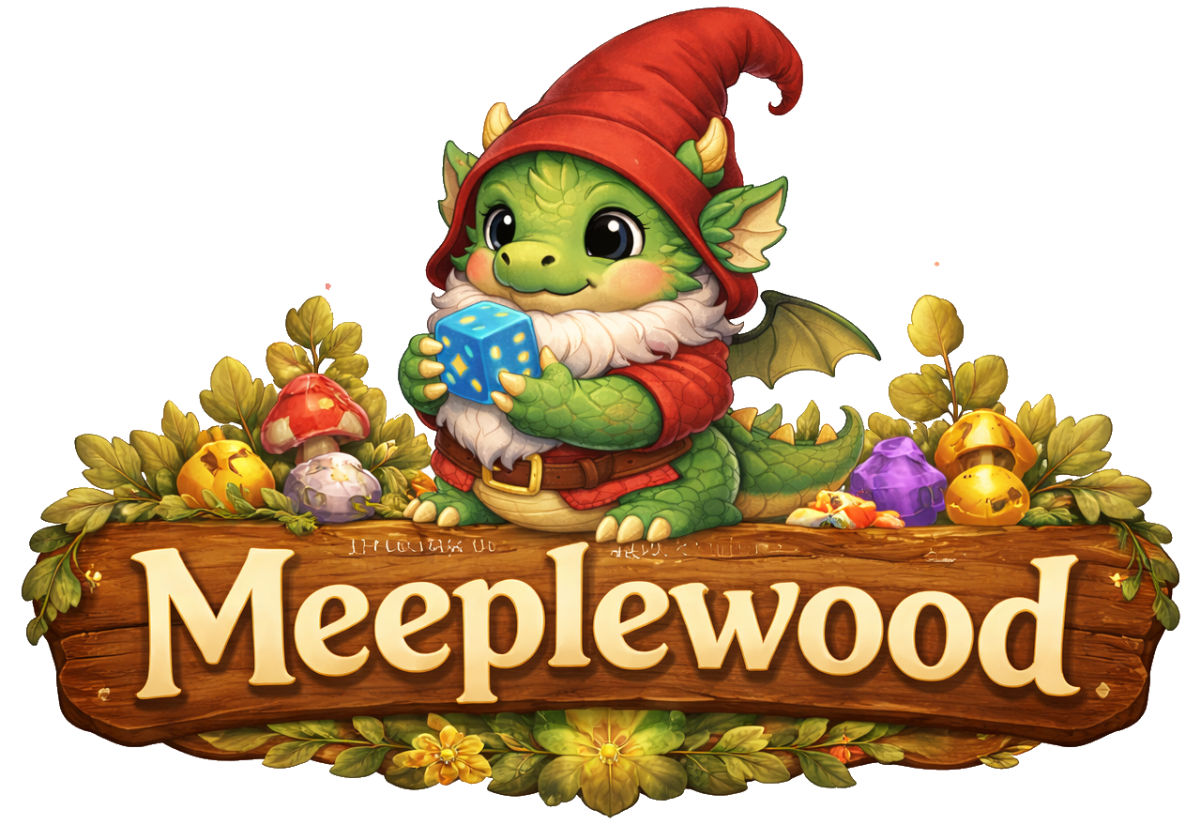
Design

Rianne Boumans
Inhoud
Introduction and overview 2
System architecture 2
Data design 2
Interface design 2
Component design 2
User interface design 3
Assumptions and dependencies 3
Glossary of terms 3

Introduction

Project Overview & Motivation

Intended Audience

Design Approach Overview

Empathize & Define

Domain Situation

User Analysis

Task analysis
- Task Abstraction
- User Stories

Data abstraction
- Data Sources
- Data Structure

Ideate & Prototype

Design Ideas
- Theme
- Overall look -and-feel

Usecase model
- UC-Diagram and overall description

UC.x
Use Case​ | <Unieke code>: <Unieke, beschrijvende naam voor de use-case>​
Beschrijving​ | <Korte beschrijving (max 5 zinnen) die uitlegt wat de UC doet>​
Actor(en)​ | <Welke Actor/Actoren voeren deze use-case uit?>​
Trigger(s)​ | <Situatie(s) waaronder de use-case wordt gestart, meestal gelijk de 1e stap>​
Pre-conditions​ | <Optioneel; Alle voorwaarden, die noodzakelijk waar zijn voordat de use-case wordt gestart>​
Post-conditions​ | <Wat is het resultaat van een succesvol verloop van de use case>​
Steps​ | <stappen die uitgevoerd (kunnen) worden tijdens de use-case. ​  Links = acties vanuit de actor; rechts = acties vanuit het systeem>​
 | 1. ​  3.​  4.​  …​ | 2.​  5. ​
Main Succes Scenario​ | <volgorde van stappen voor het belangrijkste (meest voorkomende) succesvolle scenario>​
Alternative Scenario’s​ | <volgorde van stappen voor alle overige scenario's ; geef telkens een naam voor het scenario en of deze wel of niet succesvol is>​

Lo-Fi Prototype

Technical Solution and Implementation

Used Frameworks

System Architecture Overview

Component Diagram

Classdiagram

Data Design

Introduction
Meeplewood is a personal “because I can” project: a playful software experiment built to explore programming concepts and try out fun ideas. The application combines a magical, cute forest theme with board game data management and analysis.
Meeplewood is designed around several board game data sources, mainly based on logged plays from BGStats and collection / wishlist exports from BoardGameGeek. The goal is to bring these data sources together in one place and turn them into useful insights and playful decision support for board game enthusiasts.
The application focuses on four main areas. First, it helps organize a board game collection by showing which games are owned, which are wanted, and which games may already be covered by other people’s collections. Second, it supports combining Spiel preview lists over multiple years. Third, it offers several ways to analyze logged plays, such as identifying the most played games, play patterns with specific people, and winners by game category or genre. Finally, it helps answer the question “What to play?” by suggesting games based on different criteria.

Intended Audience
Meeplewood is a personal project built for myself: a programmer and board game enthusiast who wants to explore ideas, experiment with software design, and create a playful tool for managing and analysing board game data. The first version is therefore intended mainly for my own use and development.
In the future, the application may evolve into a broader tool for other board game players who want to upload and analyse their own data in a playful way. It may also become useful for local board game stores that want to work with collected data, preview lists or related board game information.

Design Approach
Explain that the document combines multiple methods and why:
- Nested Design Model for understanding the domain, abstracting data/tasks, and shaping the visual encoding.
- Design Thinking for exploring user needs and generating ideas.
- Agile for incremental development through user stories.
- Traditional Software Engineering for formal analysis, data modelling, and diagrams.

Empathize
what the users need and how they currently handle it

Domain Analysis
Domain situation.
Stakeholders and context of use.
Key concepts in the board game domain.
Problems and opportunities in the current workflow.

User Analysis
- Primary user.
- Secondary users, future users, and possible store users.
- User goals and pain points.
- Usage scenarios.

Data Design
This is where formal data modelling fits well.
- Input sources.
- Data cleaning and normalization.
- Core entities.
- Relationships between entities.
- Data storage and import/export strategy.
- Normalisation

Task Abstraction
From the Nested Design Model:
- What tasks users perform.
- Which tasks are core vs. supporting.
- Task decomposition.
- Task-to-feature mapping.

User interface design

- Wireframes or mockups of key screens
- Description of user workflows and interactions
- Accessibility considerations

Data design
- Database structure and table layouts
- Data flow diagrams
- Data validation and integrity rules
- How data will be stored and retrieved

System architecture
- A high-level diagram of the architecture
- Description of major components and what they do
- Explanation of design patterns and architectural styles used
- Discussion of important design decisions and trade-offs

Interface design
- API specifications and protocols
- Message formats and data structures
- How errors and exceptions will be handled
- Security and authentication methods

Component design
- Purpose and responsibilities
- Input and output specifications
- Algorithms and processing logic
- Dependencies on other components or external systems

Assumptions and dependencies
- Technical assumptions about the development environment
- Dependencies on external libraries or services
- Constraints related to hardware, software, or infrastructure
- Any regulatory or compliance requirements

Glossary of terms
1.5 Definitions and Acronyms

