Министерство образования и науки РФ

Федеральное государственное автономное

образовательное учреждение высшего образования

«Санкт-Петербургский национальный исследовательский университет

информационных технологий, механики и оптики»

**факультет программной инженерии и компьютерной техники**

**ЛАБОРАТОРНАЯ РАБОТА № 2**

по дисциплине

‘Методы и средства программной инженерии’

Вариант № 320412

*Выполнили:*

Студенты

Р32111 Павлов Александр Сергеевич

N32471 Бахарев Никита Алексеевич

*Преподаватель:*

Бострикова Дарья Константиновна



Санкт-Петербург, 2023

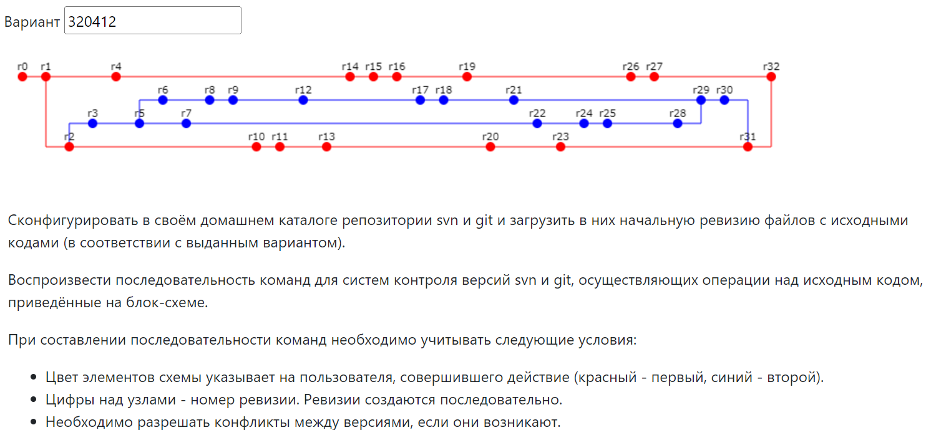

Список команд

Git

git init

git config --local user.name red

git config --local user.email red@mail.ru

cp ../commits/commit0/* .

git add .

git commit -m "r0"

cp ../commits/commit1/* .

git add .

git commit -m "r1"

git checkout -b branch1

cp ../commits/commit2/* .

git add .

git commit -m "r2"

git config --local user.name blue

git config --local user.email blue@mail.ru

git checkout -b branch2

cp ../commits/commit3/* .

git add .

git commit -m "r3"

git config --local user.name red

git config --local user.email red@mail.ru

git checkout master

cp ../commits/commit4/* .

git add .

git commit -m "r4"

git config --local user.name blue

git config --local user.email blue@mail.ru

git checkout branch2

cp ../commits/commit5/* .

git add .

git commit -m "r5"

git checkout -b branch3

cp ../commits/commit6/* .

git add .

git commit -m "r6"

git checkout branch2

cp ../commits/commit7/* .

git add .

git commit -m "r7"

git checkout branch3

cp ../commits/commit8/* .

git add .

git commit -m "r8"

cp ../commits/commit9/* .

git add .

git commit -m "r9"

git config --local user.name red

git config --local user.email red@mail.ru

git checkout branch1

cp ../commits/commit10/* .

git add .

git commit -m "r10"

cp ../commits/commit11/* .

git add .

git commit -m "r11"

git config --local user.name blue

git config --local user.email blue@mail.ru

git checkout branch3

cp ../commits/commit12/* .

git add .

git commit -m "r12"

git config --local user.name red

git config --local user.email red@mail.ru

git checkout branch1

cp ../commits/commit13/* .

git add .

git commit -m "r13"

git checkout master

cp ../commits/commit14/* .

git add .

git commit -m "r14"

cp ../commits/commit15/* .

git add .

git commit -m "r15"

cp ../commits/commit16/* .

git add .

git commit -m "r16"

git config --local user.name blue

git config --local user.email blue@mail.ru

git checkout branch3

cp ../commits/commit17/* .

git add .

git commit -m "r17"

cp ../commits/commit18/* .

git add .

git commit -m "r18"

git config --local user.name red

git config --local user.email red@mail.ru

git checkout master

cp ../commits/commit19/* .

git add .

git commit -m "r19"

git checkout branch1

cp ../commits/commit20/* .

git add .

git commit -m "r20"

git config --local user.name blue

git config --local user.email blue@mail.ru

git checkout branch3

cp ../commits/commit21/* .

git add .

git commit -m "r21"

git checkout branch2

cp ../commits/commit22/* .

git add .

git commit -m "r22"

git config --local user.name red

git config --local user.email red@mail.ru

git checkout branch1

cp ../commits/commit23/* .

git add .

git commit -m "r23"

git config --local user.name blue

git config --local user.email blue@mail.ru

git checkout branch2

cp ../commits/commit24/* .

git add .

git commit -m "r24"

cp ../commits/commit25/* .

git add .

git commit -m "r25"

git config --local user.name red

git config --local user.email red@mail.ru

git checkout master

cp ../commits/commit26/* .

git add .

git commit -m "r26"

cp ../commits/commit27/* .

git add .

git commit -m "r27"

git config --local user.name blue

git config --local user.email blue@mail.ru

git checkout branch2

cp ../commits/commit28/* .

git add .

git commit -m "r28"

#merge success

git checkout branch3

git merge --no-commit branch2

cp ../commits/commit29/* .

git add .

git commit -m "r29"

cp ../commits/commit30/* .

git add .

git commit -m "r30"

git config --local user.name red

git config --local user.email red@mail.ru

git checkout branch1

git merge --no-commit branch3

# Обнаружены конфликты в A.java, B.java, H.java

# git merge-base branch3 branch1

# git diff -U0 hash branch3 A.java

# git diff -U0 hash branch1 A.java

# Так проверяем для B.java и H.java и убеждаемся в том, что в branch3 методов больше, чем в branch1 => в слияние попадут файлы из branch3

git checkout --theirs A.java

git checkout --theirs B.java

git checkout --theirs H.java

cp ../commits/commit31/* .

git add .

git commit -m "r31"

git checkout master

git merge --no-commit branch1

# Обнаружены конфликты в A.java, B.java, H.java

# git merge-base master branch1

# git diff -U0 hash master A.java

# git diff -U0 hash branch1 A.java

# Так проверяем для B.java и H.java и убеждаемся в том, что в branch1 методов больше, чем в branch1 => в слияние попадут файлы из branch3

git checkout --theirs A.java

git checkout --theirs B.java

git checkout --theirs H.java

cp ../commits/commit32/* .

git add .

git commit -m "r32"

# Для проверки правильности выполнения команд

git log --oneline --all --graph

Svn

export SVN_EDITOR=vim

mkdir ./.svnrepos/

cd .svnrepos/

svnadmin create workSvn

svn mkdir -m "Create directory structure." file:///home/studs/s335989/mispi/lab2/.svnrepos/workSvn/trunk file:///home/studs/s335989/mispi/lab2/.svnrepos/workSvn/branches file:///home/studs/s335989/mispi/lab2/.svnrepos/workSvn/tags

cd ..

mkdir workSvn

cd workSvn

svn checkout file:///home/studs/s335989/mispi/lab2/.svnrepos/workSvn/trunk ./

cp ../commits/commit0/* .

svn add * --force

svn commit -m "r0" --username=red

cp ../commits/commit1/* .

svn add * --force

svn commit -m "r1" --username=red

svn copy file:///home/studs/s335989/mispi/lab2/.svnrepos/workSvn/trunk file:///home/studs/s335989/mispi/lab2/.svnrepos/workSvn/branches/branch1 -m "Add branch1" --username=red

svn sw file:///home/studs/s335989/mispi/lab2/.svnrepos/workSvn/branches/branch1

cp ../commits/commit2/* .

svn add * --force

svn commit -m "r2" --username=red

svn copy file:///home/studs/s335989/mispi/lab2/.svnrepos/workSvn/branches/branch1 file:///home/studs/s335989/mispi/lab2/.svnrepos/workSvn/branches/branch2 -m "Add branch2" --username=blue

svn sw file:///home/studs/s335989/mispi/lab2/.svnrepos/workSvn/branches/branch2

cp ../commits/commit3/* .

svn add * --force

svn commit -m "r3" --username=blue

svn sw file:///home/studs/s335989/mispi/lab2/.svnrepos/workSvn/trunk

cp ../commits/commit4/* .

svn add * --force

svn commit -m "r4" --username=red

svn sw file:///home/studs/s335989/mispi/lab2/.svnrepos/workSvn/branches/branch2

cp ../commits/commit5/* .

svn add * --force

svn commit -m "r5" --username=blue

svn copy file:///home/studs/s335989/mispi/lab2/.svnrepos/workSvn/branches/branch2 file:///home/studs/s335989/mispi/lab2/.svnrepos/workSvn/branches/branch3 -m "Add branch3" --username=blue

svn sw file:///home/studs/s335989/mispi/lab2/.svnrepos/workSvn/branches/branch3

cp ../commits/commit6/* .

svn add * --force

svn commit -m "r6" --username=blue

svn sw file:///home/studs/s335989/mispi/lab2/.svnrepos/workSvn/branches/branch2

cp ../commits/commit7/* .

svn add * --force

svn commit -m "r7" --username=blue

svn sw file:///home/studs/s335989/mispi/lab2/.svnrepos/workSvn/branches/branch3

cp ../commits/commit8/* .

svn add * --force

svn commit -m "r8" --username=blue

cp ../commits/commit9/* .

svn add * --force

svn commit -m "r9" --username=blue

svn sw file:///home/studs/s335989/mispi/lab2/.svnrepos/workSvn/branches/branch1

cp ../commits/commit10/* .

svn add * --force

svn commit -m "r10" --username=red

cp ../commits/commit11/* .

svn add * --force

svn commit -m "r11" --username=red

svn sw file:///home/studs/s335989/mispi/lab2/.svnrepos/workSvn/branches/branch3

cp ../commits/commit12/* .

svn add * --force

svn commit -m "r12" --username=blue

svn sw file:///home/studs/s335989/mispi/lab2/.svnrepos/workSvn/branches/branch1

cp ../commits/commit13/* .

svn add * --force

svn commit -m "r13" --username=red

svn sw file:///home/studs/s335989/mispi/lab2/.svnrepos/workSvn/trunk

cp ../commits/commit14/* .

svn add * --force

svn commit -m "r14" --username=red

cp ../commits/commit15/* .

svn add * --force

svn commit -m "r15" --username=red

cp ../commits/commit16/* .

svn add * --force

svn commit -m "r16" --username=red

svn sw file:///home/studs/s335989/mispi/lab2/.svnrepos/workSvn/branches/branch3

cp ../commits/commit17/* .

svn add * --force

svn commit -m "r17" --username=blue

cp ../commits/commit18/* .

svn add * --force

svn commit -m "r18" --username=blue

svn sw file:///home/studs/s335989/mispi/lab2/.svnrepos/workSvn/trunk

cp ../commits/commit19/* .

svn add * --force

svn commit -m "r19" --username=red

svn sw file:///home/studs/s335989/mispi/lab2/.svnrepos/workSvn/branches/branch1

cp ../commits/commit20/* .

svn add * --force

svn commit -m "r20" --username=red

svn sw file:///home/studs/s335989/mispi/lab2/.svnrepos/workSvn/branches/branch3

cp ../commits/commit21/* .

svn add * --force

svn commit -m "r21" --username=blue

svn sw file:///home/studs/s335989/mispi/lab2/.svnrepos/workSvn/branches/branch2

cp ../commits/commit22/* .

svn add * --force

svn commit -m "r22" --username=blue

svn sw file:///home/studs/s335989/mispi/lab2/.svnrepos/workSvn/branches/branch1

cp ../commits/commit23/* .

svn add * --force

svn commit -m "r23" --username=red

svn sw file:///home/studs/s335989/mispi/lab2/.svnrepos/workSvn/branches/branch2

cp ../commits/commit24/* .

svn add * --force

svn commit -m "r24" --username=blue

cp ../commits/commit25/* .

svn add * --force

svn commit -m "r25" --username=blue

svn sw file:///home/studs/s335989/mispi/lab2/.svnrepos/workSvn/trunk

cp ../commits/commit26/* .

svn add * --force

svn commit -m "r26" --username=red

cp ../commits/commit27/* .

svn add * --force

svn commit -m "r27" --username=red

svn sw file:///home/studs/s335989/mispi/lab2/.svnrepos/workSvn/branches/branch2

cp ../commits/commit28/* .

svn add * --force

svn commit -m "r28" --username=blue

svn sw file:///home/studs/s335989/mispi/lab2/.svnrepos/workSvn/branches/branch3

svn merge --force file:///home/studs/s335989/mispi/lab2/.svnrepos/workSvn/branches/branch2

cp ../commits/commit29/* .

svn add * --force

svn commit -m "r29" --username=blue

cp ../commits/commit30/* .

svn add * --force

svn commit -m "r30" --username=blue

svn sw file:///home/studs/s335989/mispi/lab2/.svnrepos/workSvn/branches/branch1

svn merge --force file:///home/studs/s335989/mispi/lab2/.svnrepos/workSvn/branches/branch3

cp ../commits/commit31/* .

svn add * --force

svn commit -m "r31" --username=red

svn sw file:///home/studs/s335989/mispi/lab2/.svnrepos/workSvn/trunk

svn merge --force file:///home/studs/s335989/mispi/lab2/.svnrepos/workSvn/branches/branch1

cp ../commits/commit32/* .

svn add * --force

svn commit -m "r32" --username=red

Выводы

Во время выполнения лабораторной работы мы изучили основные принципы взаимодействия с системами контроля версий Git и SVN, создали свой собственный репозиторий и научились работать со всеми необходимыми для выполнения лабораторной работы командами. Научились создавать новые ветки, менять пользователя.