**Figure 1**

Flow of task builder

**Figure 2**

**Figure 3**

**Figure 4**

**Figure 5**

**Figure 6**

**Figure 7**

**Figure 8**

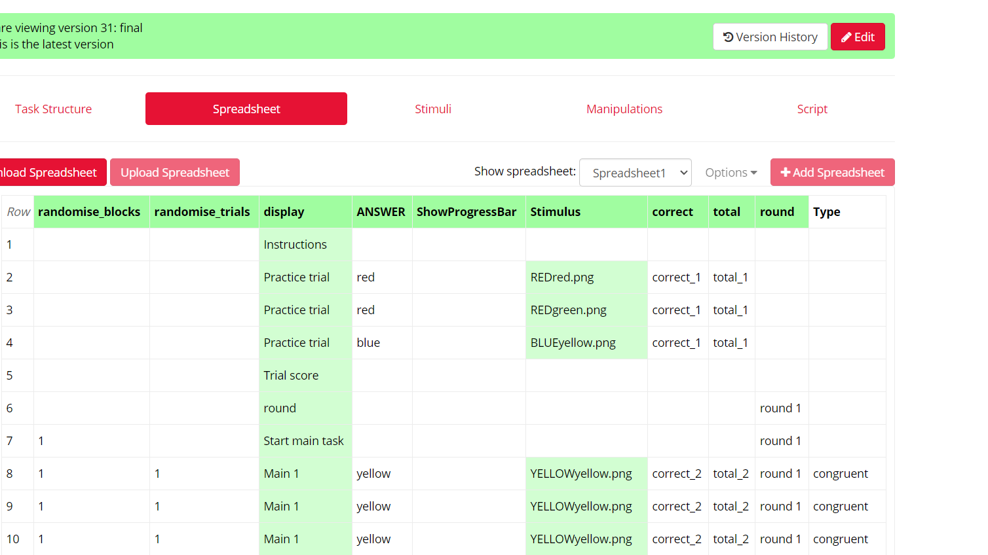

**Figure 9**

**Figure 10**

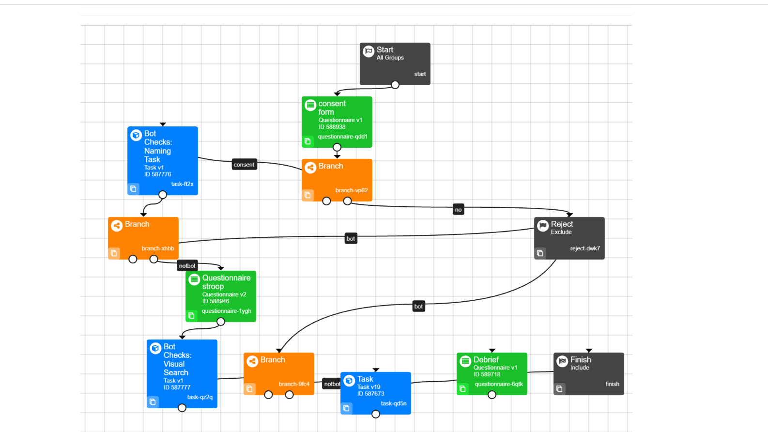

**Figure 11**

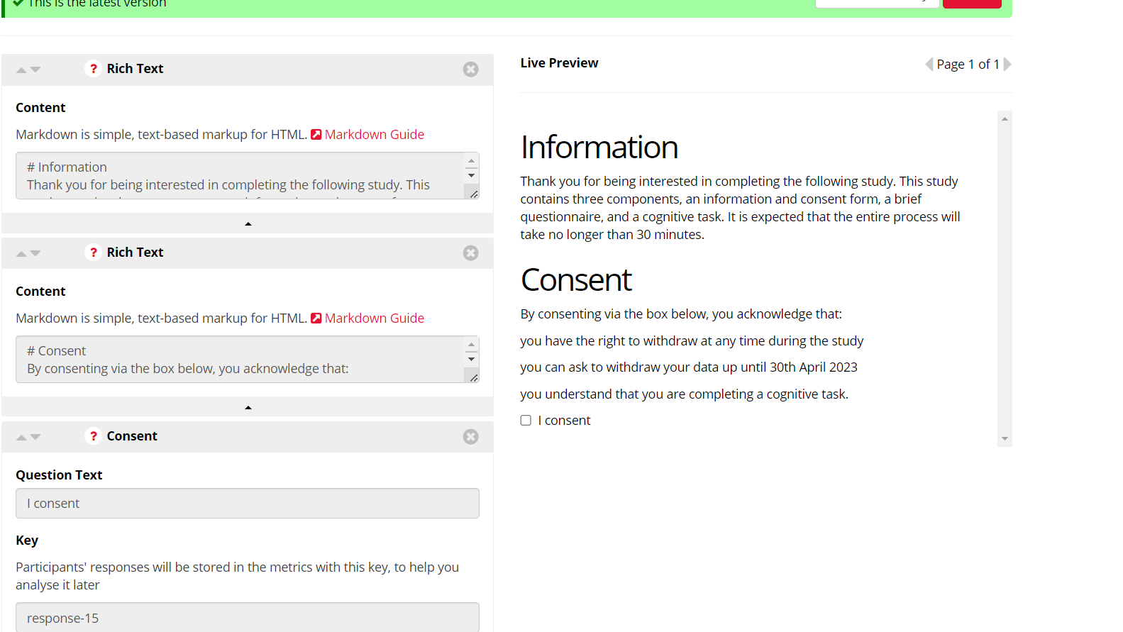

**Figure 12**

**Figure 13**

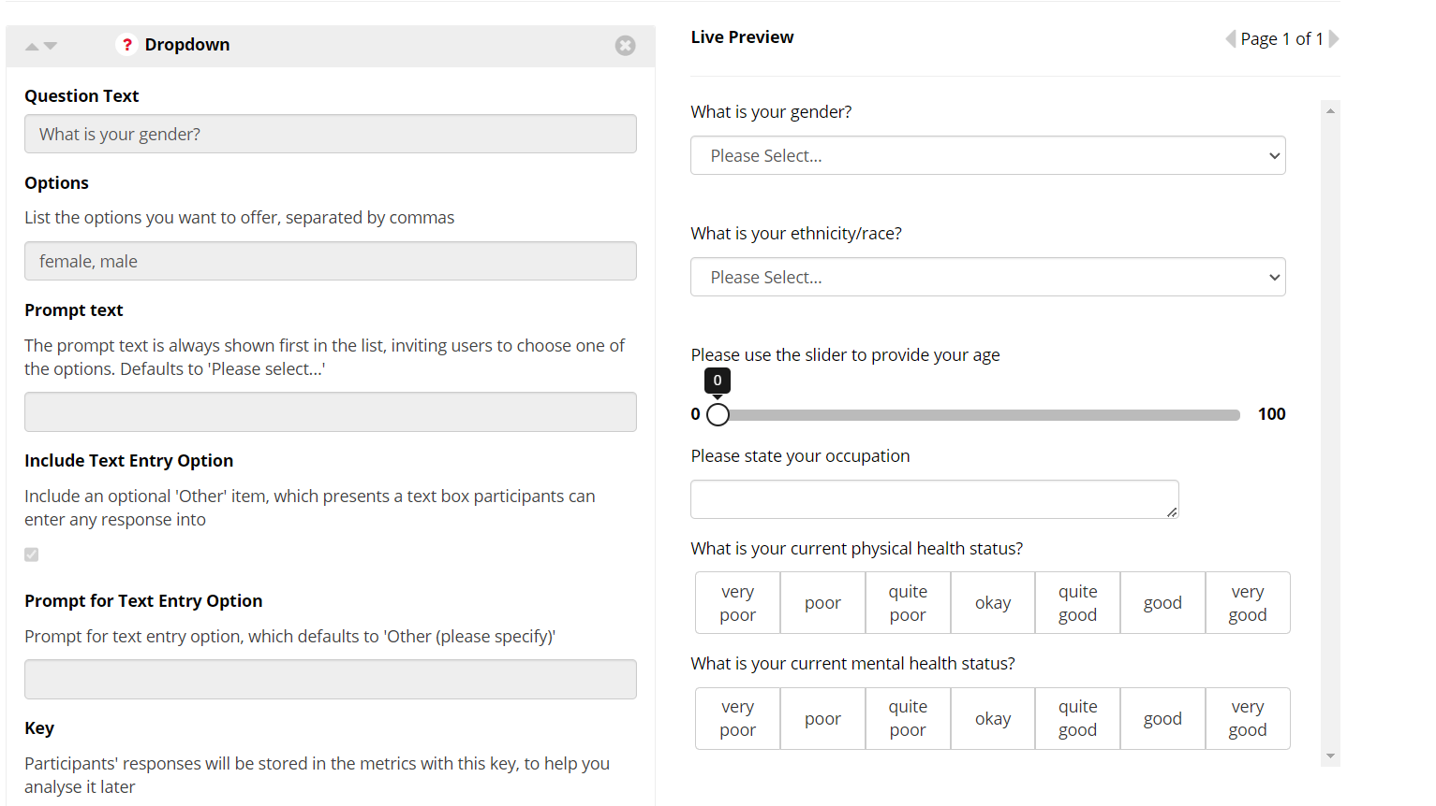

**Figure 14**

**Figure 15**

**Figure 16**

**

**Figure 18**

