Go to Project Homepage on GitLab:
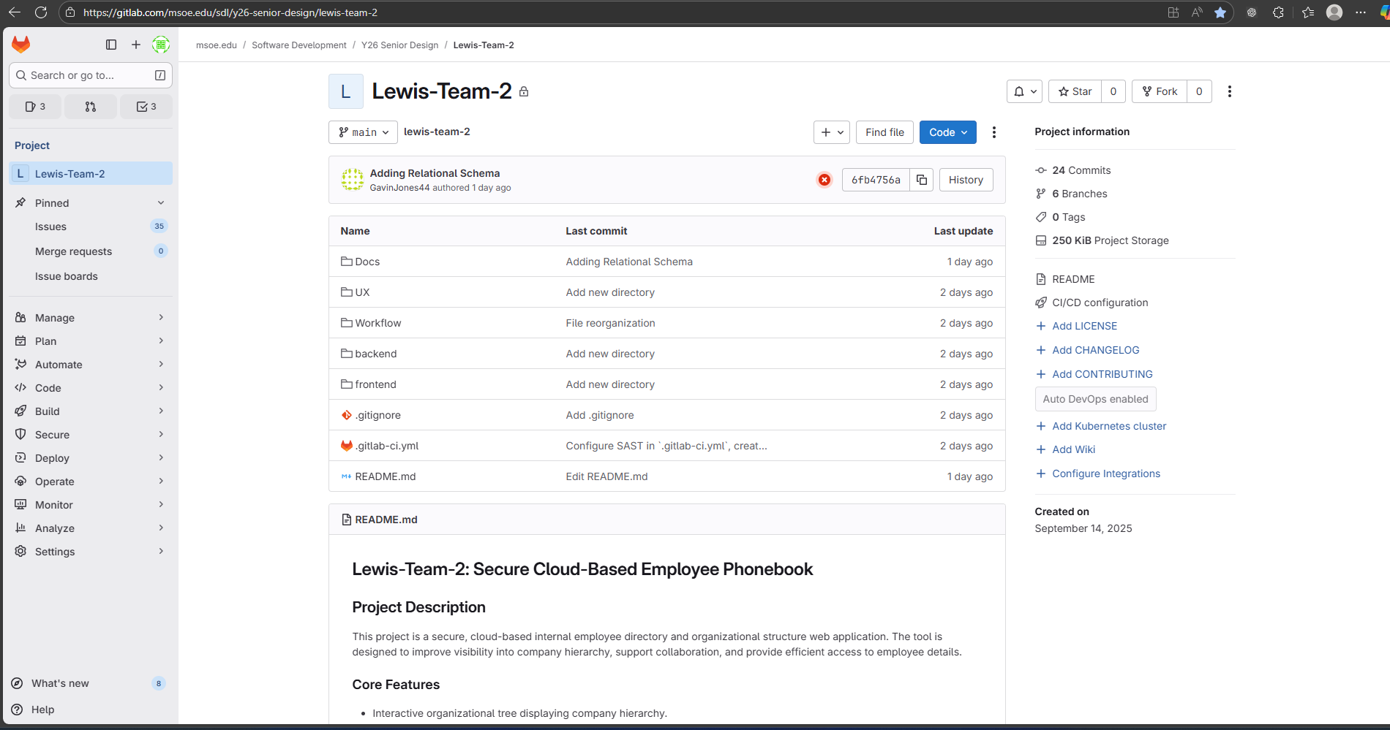

Select Settings -> Access Tokens in the Left-Hand Menu:
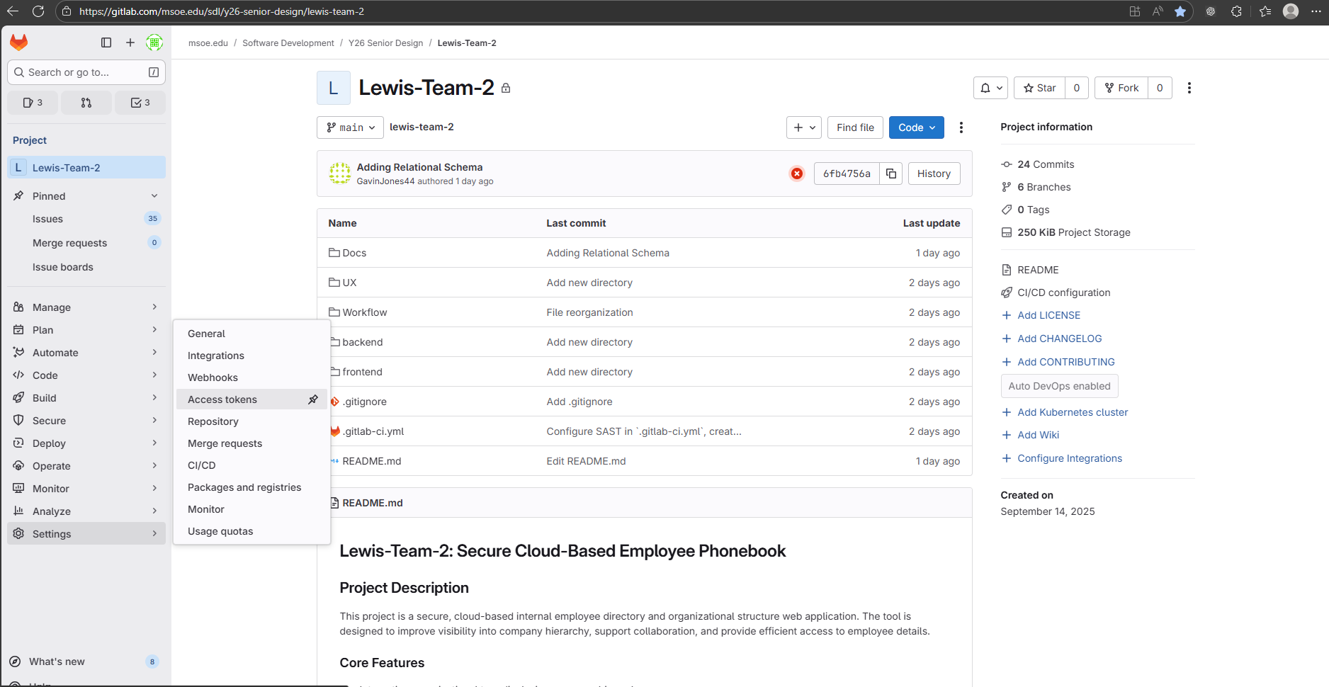

Access Tokens Page should look like:
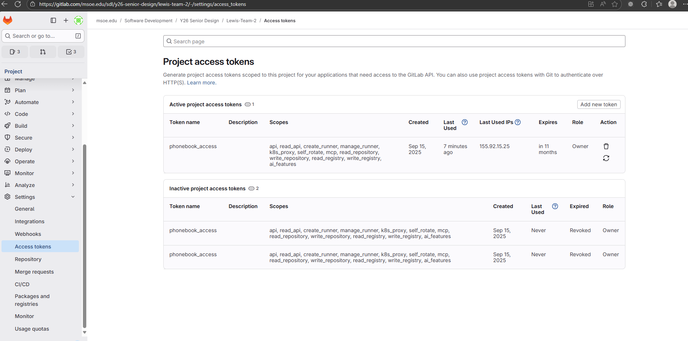

Click Add new token:
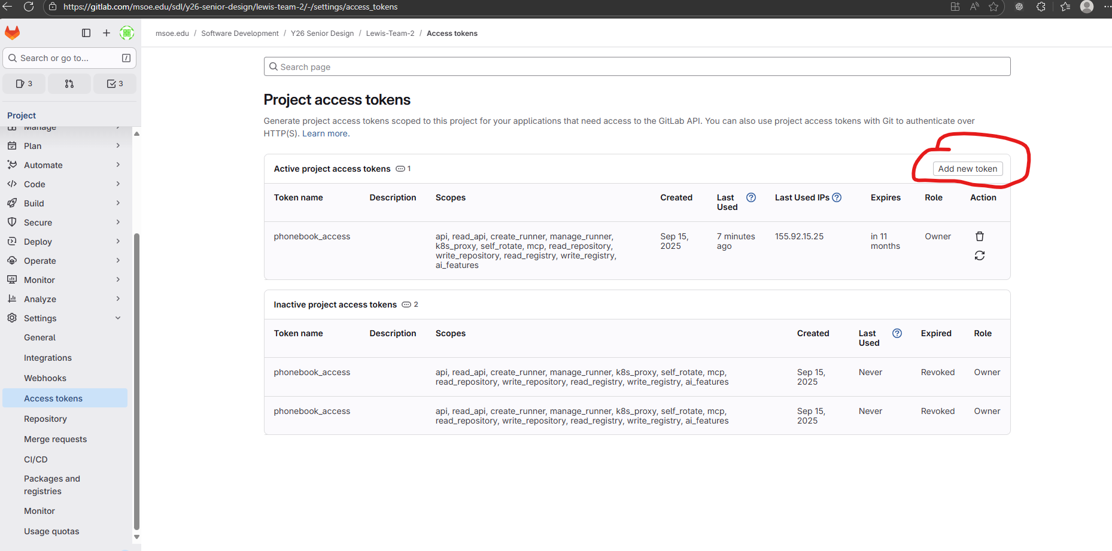

Create your access token with the following settings :
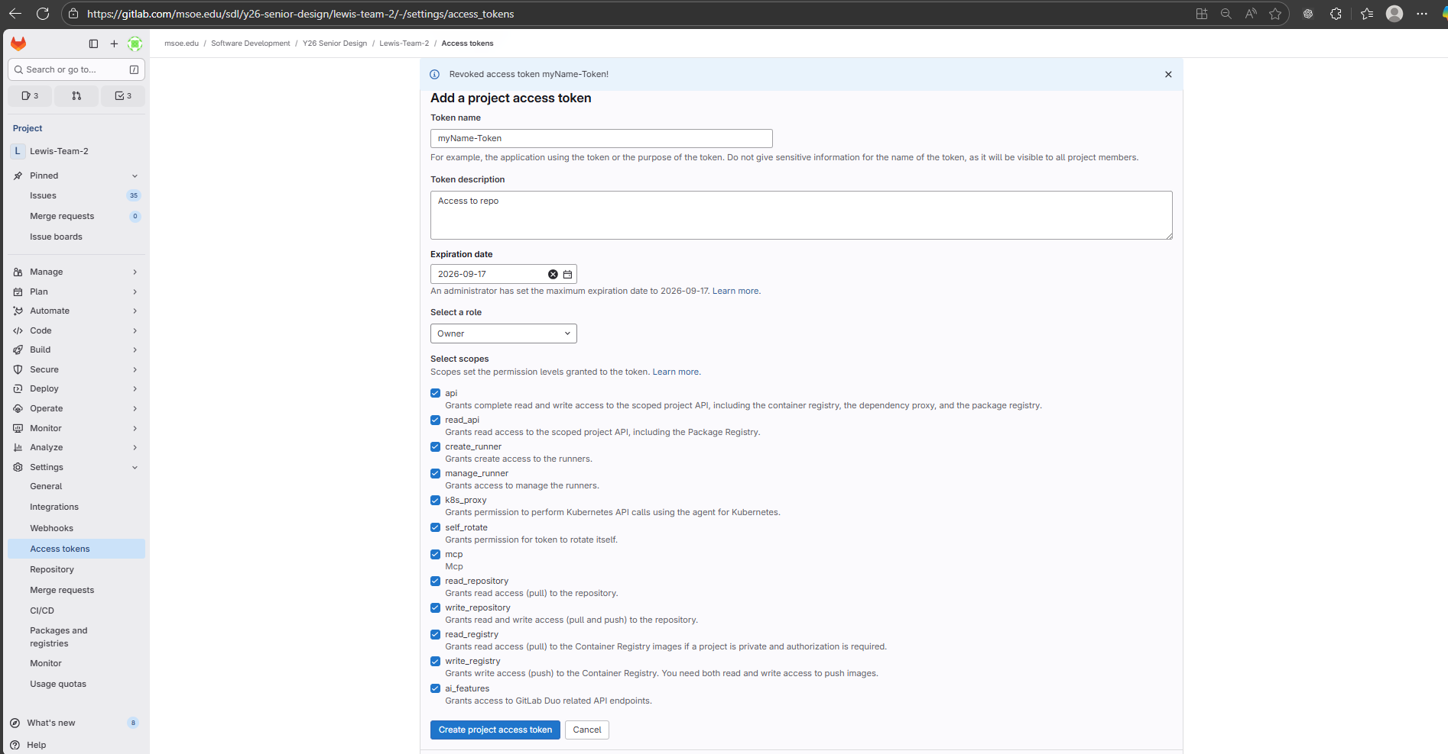
Press ‘Create Project Access Token’. Copy down the token now (reveal it using the eyeball). It is only displayed once:
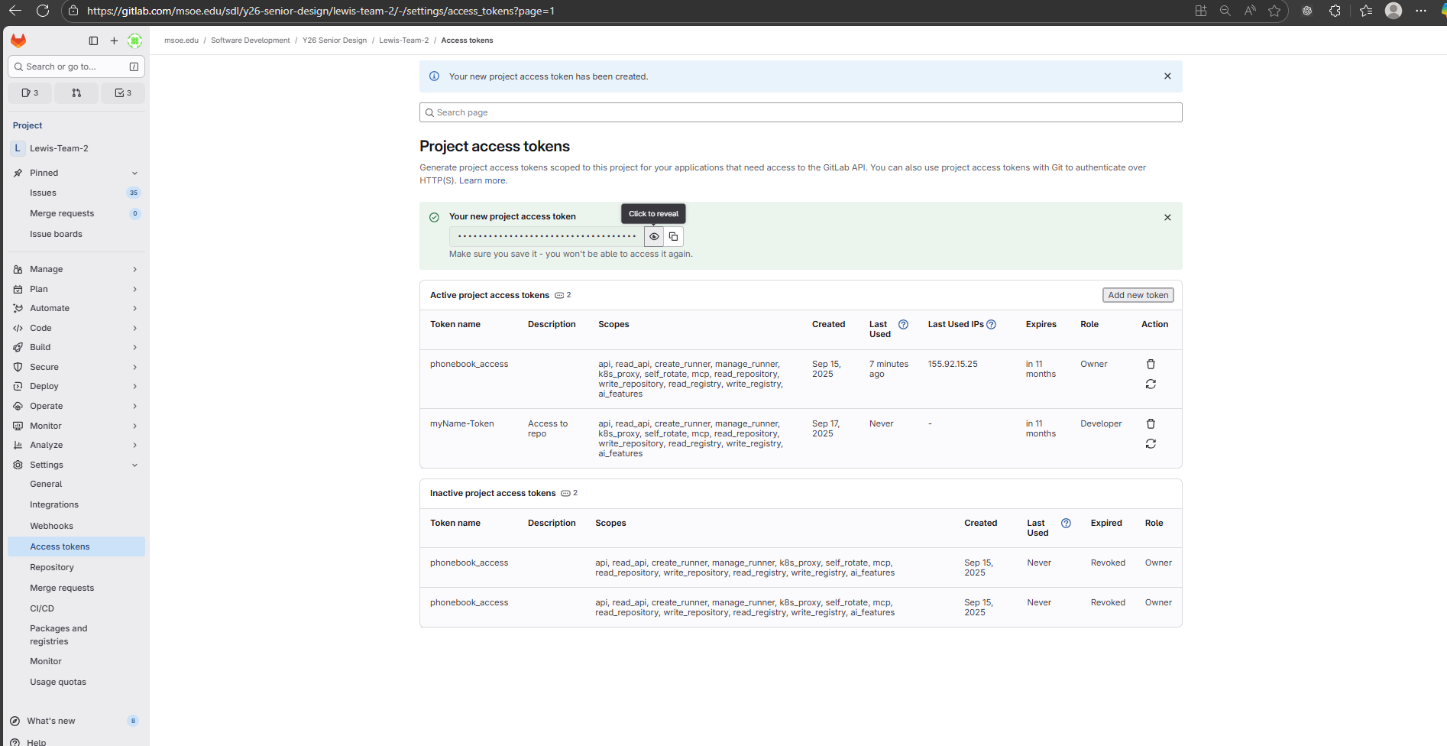

Take that Access token to a JetBrains IDE of your choice. Go to File -> Project from Version Control. Go to the ‘GitLab’ tab. (In this one I am showing a GitHub tab but the logins are identical).
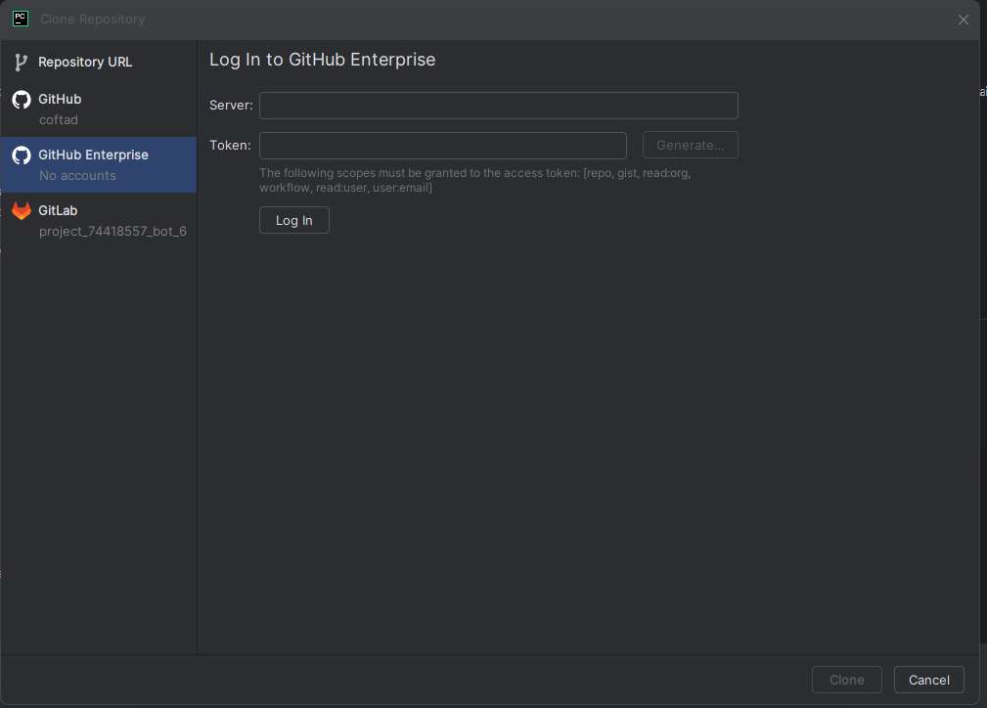

Insert the https link to the repo (ssh won’t work here). Insert your token into the Token text box. Press login, it should start the cloning process.
