**Image for the blog background (choose one that fit well):**

* <https://pixabay.com/photos/chain-stainless-steel-metal-iron-4049725/>
* <https://pixabay.com/photos/keys-open-locks-security-unlock-525732/>
* <https://pixabay.com/photos/padlock-lock-chain-key-security-597495/>

**Title:**

How to test an OAuth2/OpenID Connect based system?

**Abstract:**

Delegation of the authorization/authentication via the leveraging of OAuth2/OpenID Connect (OIDC) is more and more common in modern systems but how ensure that no weaknesses were left during the implementation and the configuration or such systems? Let's we show you some key points to verify…

**GitHub repository associated that will be moved to public when blog post will be released:**

<https://github.com/ExcelliumSA/OAuth2OIDC-Study>

**SEO rules indicated by Mathilde:**

* Paragraphs with fewer than 300 words.
* Keyword used as much as possible: *oauth, oidc, security*
* Presence of sections.

**Author(s):** Dominique Righetto

**Note:** In the content below, all figure captions refer to the image file that Mathilde must be when she creates the blog post. So it's normal if the caption do not describe the figure.

# Introduction

This post present a collection of security oriented validation points that should be verified on a system using OAuth/OpenID Connect (OpenID Connect will be called **OIDC** in the rest of the post). Therefore, it assumes you are familiar with all the concepts related to OAuth/OIDC. All references to OAuth refer to OAuth 2.0.

If it is not the case then you can refer to this free online course named "*Introduction to OAuth 2.0 and OpenID Connect*" [1] kindly created and provided by Dr. Philippe De Ryck [2] or the several tutorials from ConnectId [3].

Note that this post is mainly a security-oriented feedback following a complete focused training that I recently taken on the OAuth/OIDC topic.

# Context

OAuth and OIDC address respectively the Authorization and Authentication aspects of a system. Therefore, any issues in these areas can have critical consequences from a security point of view like authentication or authorization bypass for example.

One of the challenges is that there are several actors involved as well as well as different communications exchanges.

Below is a **simplified example** of OAuth authorization code flow:

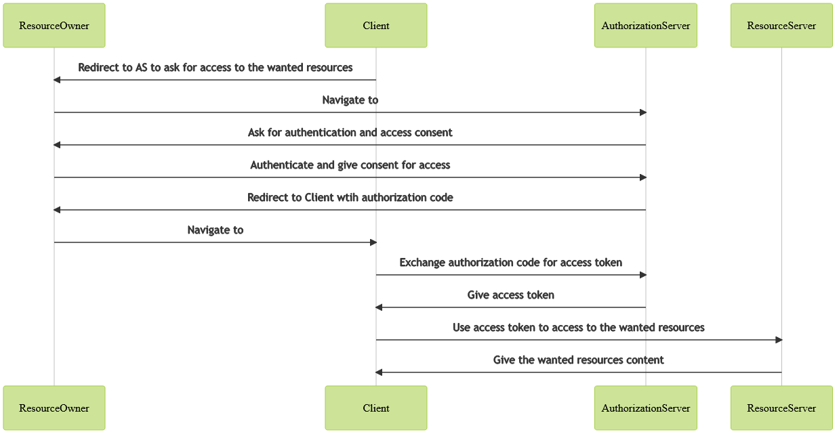

Figure 1: File Figure00.png

This makes the attack surface quite large. To make matters worse, leveraging OAuth/ODIC require to configure an **OpenID Provider** (OIDC) and/or an **Authorization Server** (OAuth). Note that depending on the context, sometimes, you must also provision the entire OpenID Provider/Authorization Server instance. One time again, it's easy to introduce a weakness via insecure settings.

# Find my way in the fog

As I was totally new to the OAuth and OIDC world, I decided to take the course named "*Mastering OAuth 2.0 and OpenID Connect*" [4]. Following the lessons, I decided to create a list of all pitfalls discovered during the training. The courses are oriented for developers but I simply converted the "attention points" into "security test" as well as performing a "mental" on-the-fly penetration test on feature/flow presented by the instructor to identify potential attack vector/scenario. It is obvious that the list is not exhaustive but it's a good foundation and it will evolve over the time with the growing of my experience in this field.

The list of validation points [5] was organized by actors in order to allow focusing on one actor if the scopes of an assessment (code review, configuration review, penetration test, etc.) target only a specific actor. Each validation point has a unique identifier in order to allow referencing it in document, script, report and so on.

A table [6] is provided to indicate if a validation point is manual or can be automated. The automation status is based on the technical capabilities to create code that perform the target test without human interaction and give a reliable result with the same level of trust that is was performed manually. Once again this "automation status" can be not accurate for you in you know how to automate it ☺

# Overview of the validation points

xxx

# How to apply control?

xxx

# Conclusion

Xxx

# References

1. <https://courses.pragmaticwebsecurity.com/courses/introduction-to-oauth-2-0-and-openid-connect>
2. <https://pragmaticwebsecurity.com/about.html>
3. <https://connect2id.com/learn>
4. <https://courses.pragmaticwebsecurity.com/bundles/mastering-oauth-oidc>
5. <https://github.com/ExcelliumSA/OAuth2OIDC-Study/blob/main/OAauth2_OIDC_Security_Validations.md>
6. <https://github.com/ExcelliumSA/OAuth2OIDC-Study/blob/main/OAauth2_OIDC_Security_Validations.md#validation-automation-status>