

IT342-G03
SYSTEMS INTEGRATION AND ARCHITECTURE 1

FUNCTIONAL REQUIREMENTS SPECIFICATION (FRS)

Project Title: Unsaid Cebu Prepared By: April John A. Sultan Date of Submission:
Version:

Table of Contents
1. Introduction 3
1.1. Purpose 3
1.2. Scope 3
1.3. Definitions, Acronyms, and Abbreviations 3
2. Overall Description 3
2.1. System Perspective 3
2.2. User Classes and Characteristics 3
2.3. Operating Environment 4
2.4. Assumptions and Dependencies 4
3. System Features and Functional Requirements 4
3.1. Feature 1: 4
3.2. Feature 2: 4
4. Non-Functional Requirements 4
5. System Models (Diagrams) 4
5.1. ERD 4
5.2. Use Case Diagram 5
5.3. Activity Diagram 5
5.4. Class Diagram 6
5.5. Sequence Diagram 7
6. Appendices 7

Introduction

Purpose
This document describes the requirements and overall design of a locationbased anonymous messaging application focused on expressing the “unsaid feelings of Cebu.” The intended audience includes developers, designers, project stakeholders, and instructors who need a clear understanding of how the system works and what it aims to achieve.

Scope

The system allows users within Cebu to post anonymous messages tied to their current location. Other nearby users can view these messages and reply anonymously. The application focuses only on anonymous, location-based message sharing and does not include identity tracking, personal messaging, or social networking features.

Definitions, Acronyms, and Abbreviations

Anonymous Message – A message posted without revealing the sender’s identity.
Location-Based – Messages are visible based on the user’s geographic location.
Reply – An anonymous response to a posted message.
GPS – Global Positioning System used to detect user location.
User – Any person using the application to post or read messages.

Overall Description

System Perspective
The application is a standalone mobile system that uses GPS services to determine user location and a backend server to store and retrieve anonymous messages. It relies on internet connectivity and device location services to function properly.

User Classes and Characteristics
General Users. Individuals within Cebu want to express their thoughts or feelings anonymously. Can post messages, view nearby messages, and reply anonymously. No technical expertise required; designed for simple and intuitive use.

Operating Environment
The application operates on Android smartphones with GPS capability. It requires the Android operating system, the mobile application, a backend server, and a database. The system relies on GPS/location services, an internet connection, an API server, and a database management system to function properly..

Assumptions and Dependencies
The system assumes that users have an Android device with location services enabled and a stable internet connection. It depends on GPS accuracy to determine message visibility and requires the backend server and database to be continuously available. The application also assumes that users are physically located within Cebu to access relevant messages.

System Features and Functional Requirements
Describe each major feature of the system and its functional requirements.

Feature 1:
Description:
Functional Requirements:
-
-
-

Feature 2:
Description:
Functional Requirements:
-
-
-

Non-Functional Requirements
Specify system quality attributes such as performance, security, usability, reliability, etc.

System Models (Diagrams)
Insert the necessary diagrams for the system:

ERD
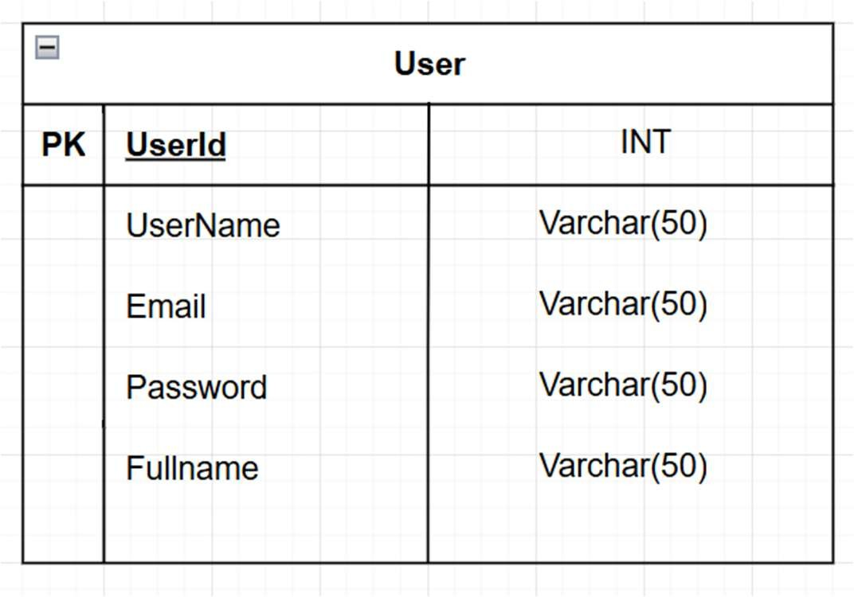
Insert ERD here

Use Case Diagram
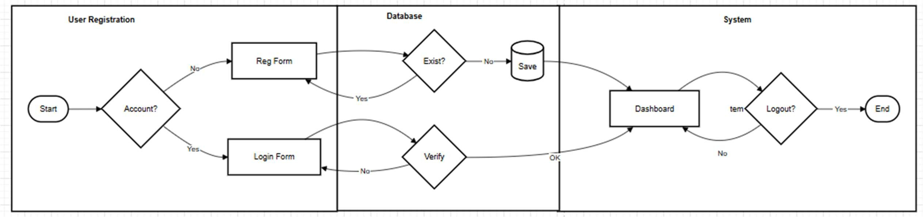
Insert ERD here
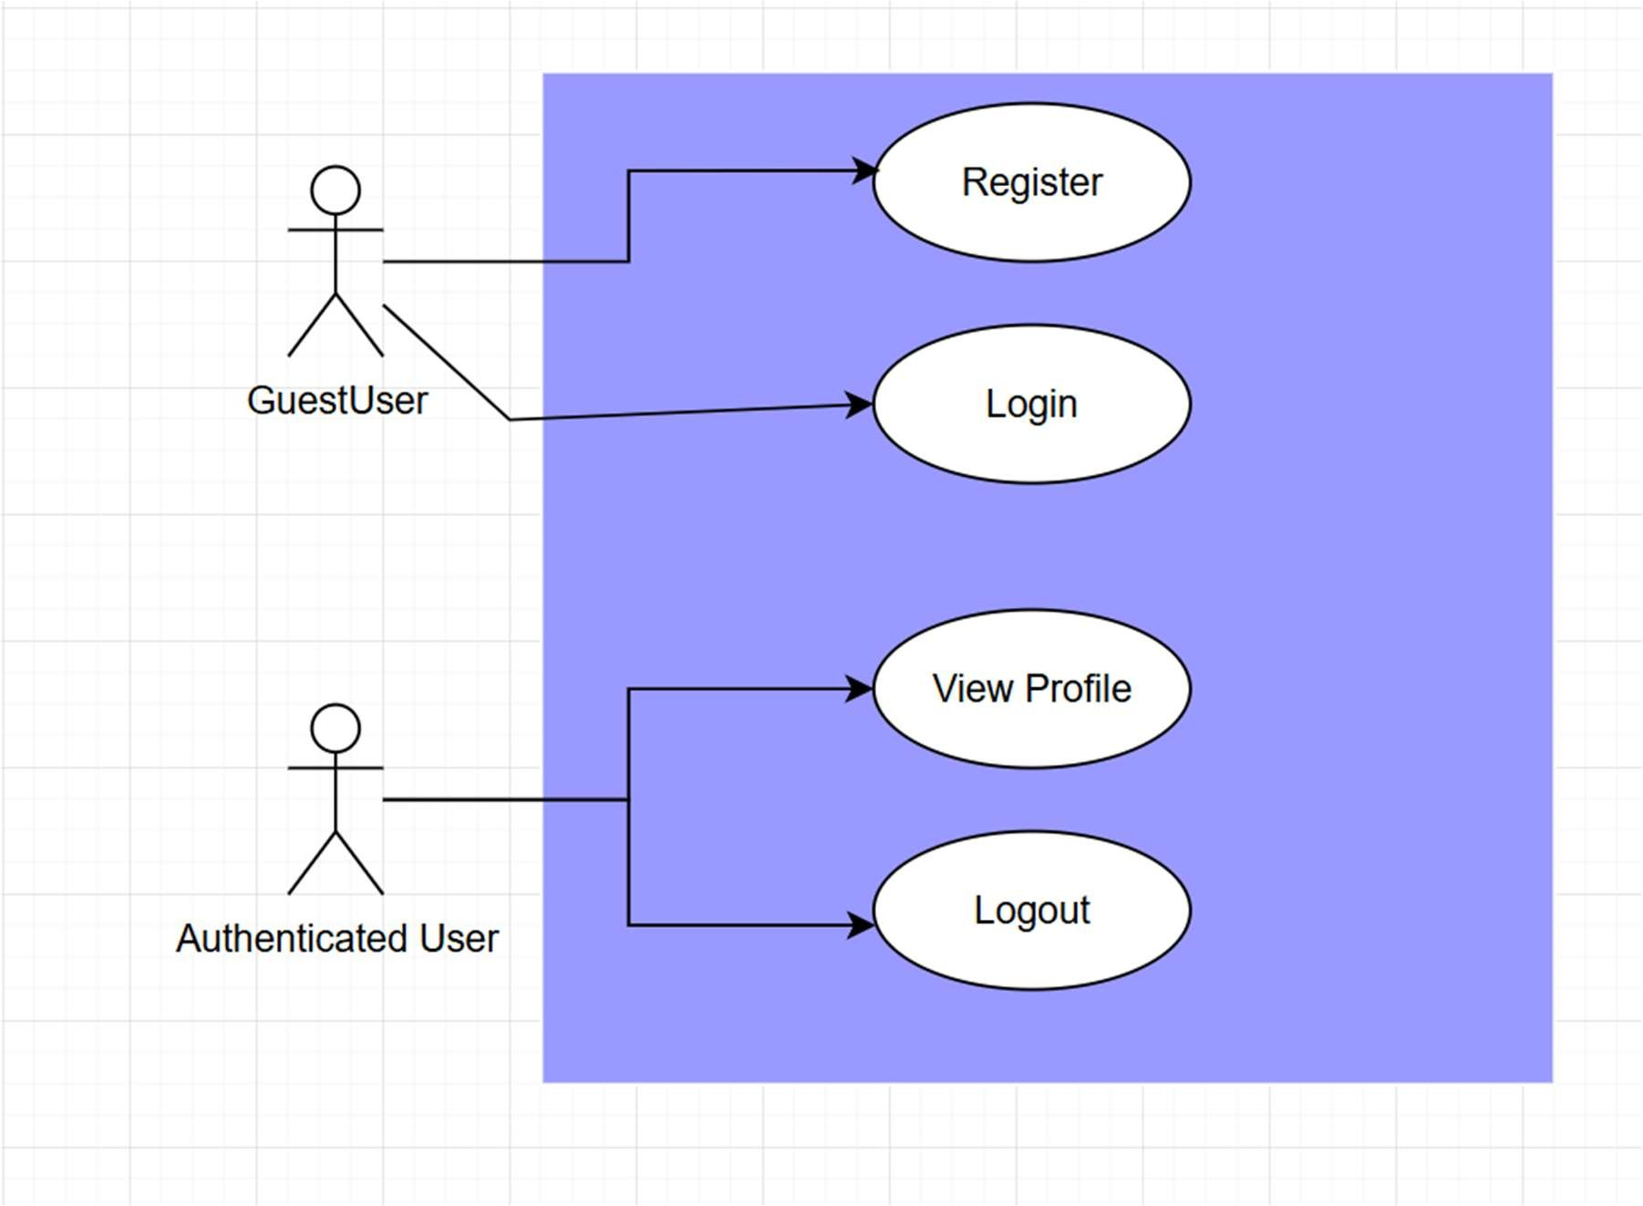

Activity Diagram
Insert ERD here

Class Diagram
Insert ERD here

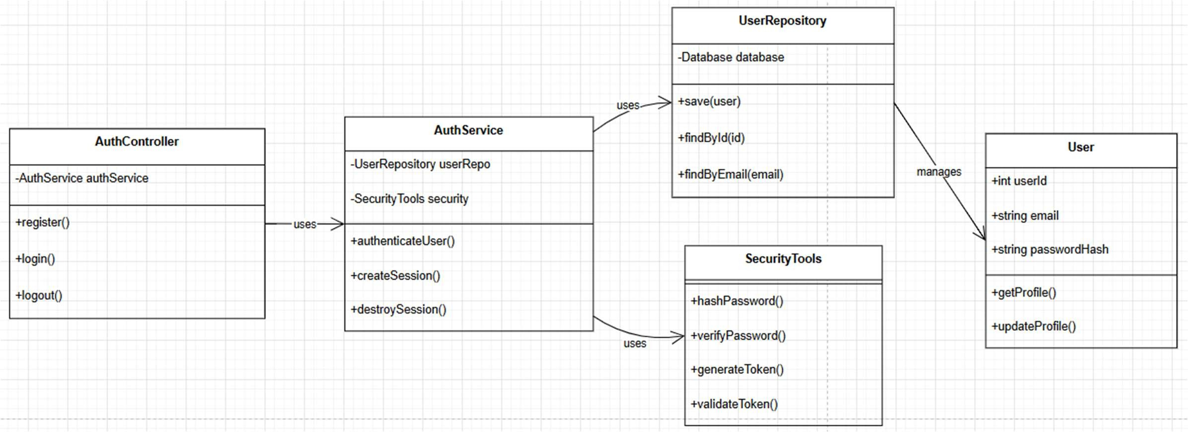

Sequence Diagram

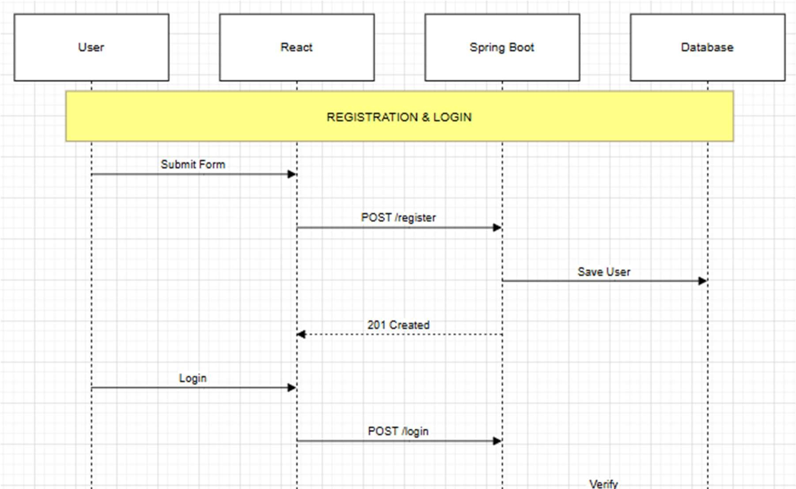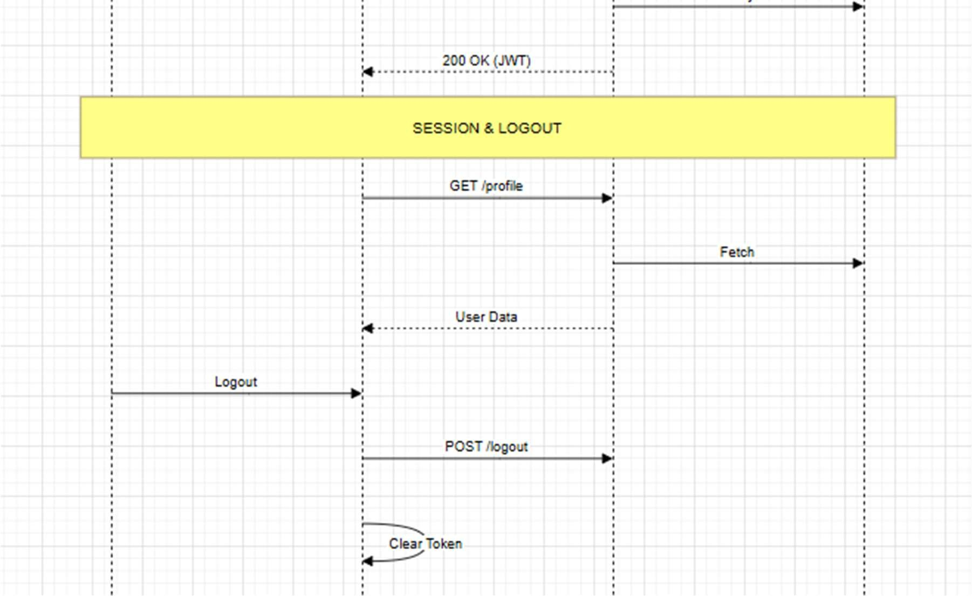

Appendices
Include any additional information, references, or support materials.

