Step 1:

Download and install TortoiseSVN
http://tortoisesvn.net/downloads.html
Step 2:
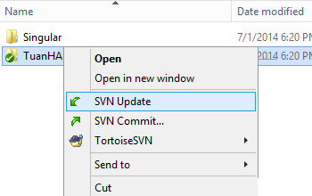
- Right-Click Folder TuanHADruidWoD
- Select SVN Update
Step 3: (If you don’t have SVN Update option but SVN Upgrade working copy option)
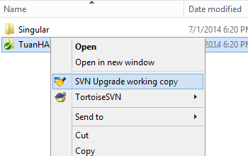
- Right-Click Folder TuanHADruidWoD
- Select SVN Update working Copy
- Go back to Step 2
Step 4: (Conflic Issue)
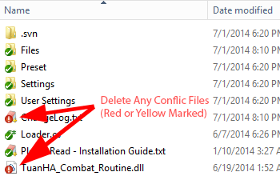
- Delete any Conflic Files or Folder (Red or Yellow Marked)
- Go back to Step 2

