**GUI**

1. To start with, feel free to download the code from <https://github.com/andydeangelis/Windows-Hot-Fix-Report>. Download the repository as a ZIP file and extract to whatever directory you wish. The script (like so many of my others) uses a text file with a list of server names.
2. There are two ways to run the tool; either via command line or the GUI.
   1. To run from the GUI, double click the included .exe file.
   2. On the Step 1 tab:
      1. Select the text file that lists the server names. You will know this is successful because the server names will be populated in the lower window.
      2. Select the path where you would like the resultant spreadsheet to be saved.
      3. Click the Next button to move to Step 2.

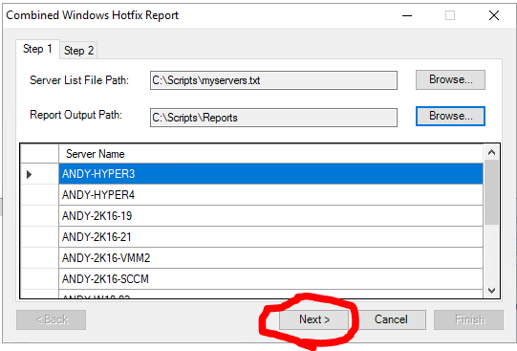

1. On the Step 2 tab, click the Set Domain Account button and enter your domain admin credentials. When finished, click the Execute Data Collection to run the report.

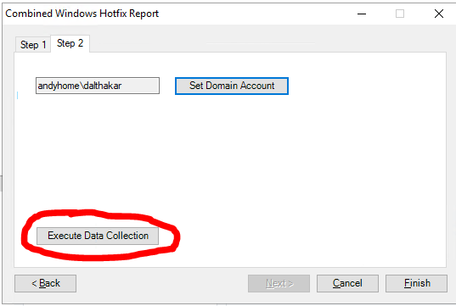

**Command Line**

1. The script does not need to be run via the GUI. It can be run via command line, and even scheduled!
2. Let’s start with the parameters available:
   1. ServerFileName – The txt file containing the list of servers.
   2. ReportPath – Target directory to save reports.
   3. DomainCredXMLFile – Path to the encrypted XML file that stores credentials. This is needed if you are trying to schedule this to run as a job.
   4. SaveCreds – By default, the script will delete the aforementioned CredXML file after the script runs. Specifying this parameter stores the cred file for later use.
   5. RunSilent – Prevents any dialog boxes from being prompted.
   6. DomainCredentials – The actual credential object returned from the Get-Credential cmdlet.
3. Some notes:
   1. The ServerFileName and ReportPath parameters are mandatory.
   2. If neither the DomainCredXMLFile nor the DomainCredentials parameter is specified, you will be prompted with a Get-Credential dialog box.
4. **Example command line for running once.** This script will specify the server text file and the report path, prompting the end user for domain credentials before continuing. Note: If you select no in the pop up to specify a log on credential, the script will use the session credentials.

PS> .\HotFixReport.ps1 -ServerFileName “C:\Scripts\myservers.txt” -ReportPath “C:\Reports”

1. **Saving credentials for future use**. In order to run the script as a scheduled task, we need to save the credentials as an exported XML file. Do not save this to the credential file to the script’s root directory. Let’s start by creating our XML file:

PS> Get-Credential | Export-Clixml -Path domainCred.xml

1. Ensure that the files have been created. You can open these XML files in your favorite editor to view the contents. Note that the password is stored as an encrypted string. This string is encrypted using Microsoft's DPAPI method.(You can read more about DPAPI [here](https://msdn.microsoft.com/en-us/library/ms995355.aspx).)
   1. Note that the credential files created are tied to the user account creating them. For example, if you create the credential files as Domain\UserA, you will not be able to run the script as Domain\UserB while passing the previously created credential files.

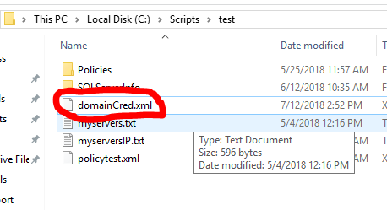

1. Now that we have our credentials, we need to modify the **ScheduledTask.ps1** script file. To start, navigate to your script root's **CombineSQLReportTools** directory. Open the **ScheduledTask.ps1** file in an editor of your choosing (Notepad, PowerShell ISE, etc.). **Note:** Do not move this file from this location.

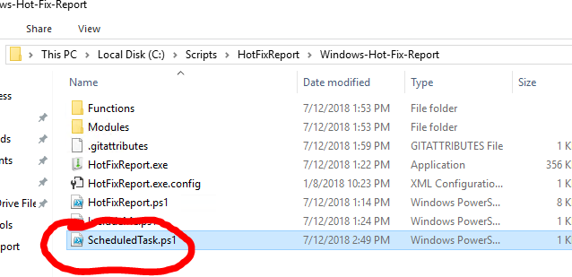

1. Modify the first 3 lines with the appropriate values for your environment, then save and close the file.

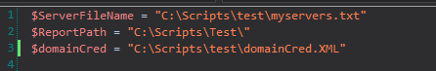

1. Now that we have our scheduled task script, we can set up our scheduled task. Let's start by opening Task Scheduler and selecting **Create Basic Task**.

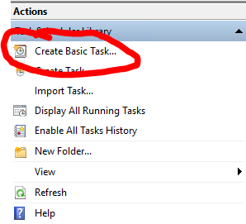

1. Give your task a name and, optionally, a description, then click **Next**.

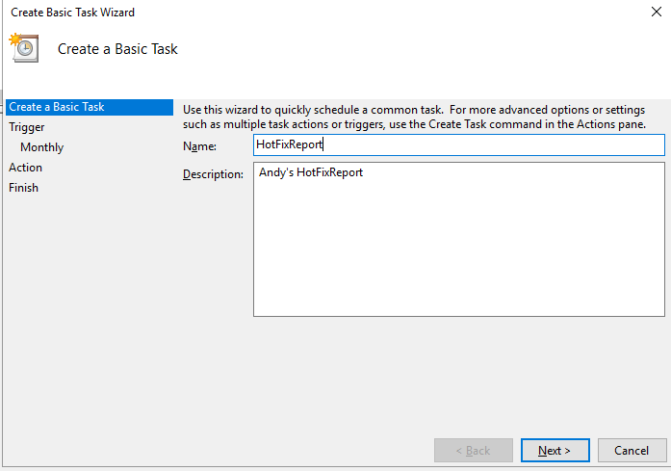

1. Configure your trigger parameters.

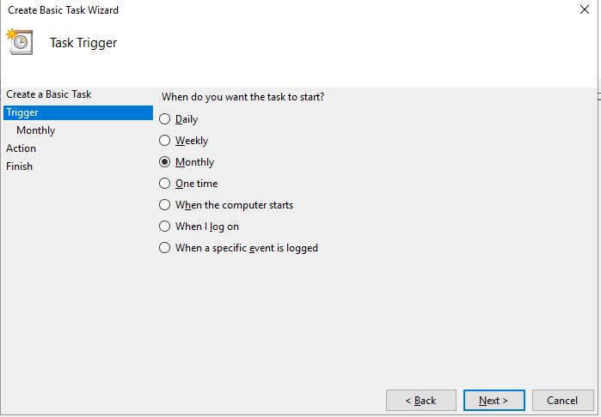

1. For Action, select **Start a program**.

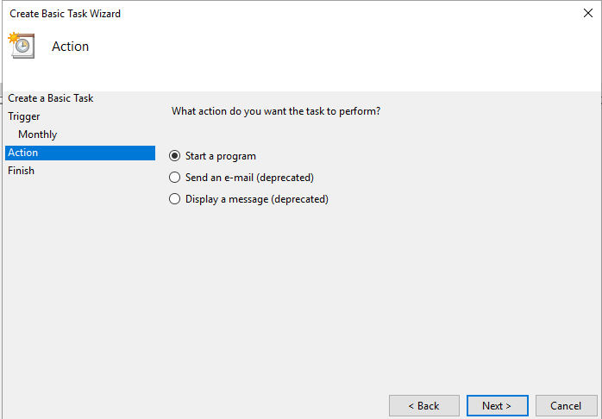

1. On the **Start a Program** screen, enter the following information. Note that your **Start in** path may change depending on where you placed the script directory. This path is the location of the **ScheduledTask.ps1** file.
   1. Program/Script: **powershell.exe**
   2. Add Arguments (optional): **-file "ScheduledTask.ps1"**
   3. Start in (optional): **C:\Scripts\HotFixReport\Windows-Hot-Fix-Report**

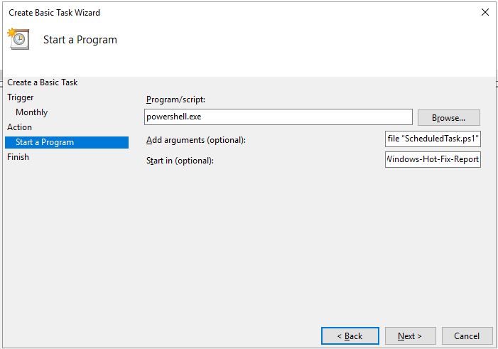

1. On the **Summary** page, review the configured settings for the task. Check the box to open the **Properties** dialog, then click Finish.

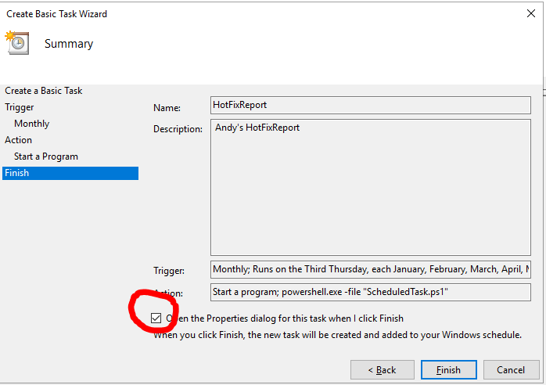

1. On the **Properties** dialog, ensure the User account specified is the same user account that created the **domainCred.xml** files. If it isn't, click the **Change User or Group** button to specify the correct account.

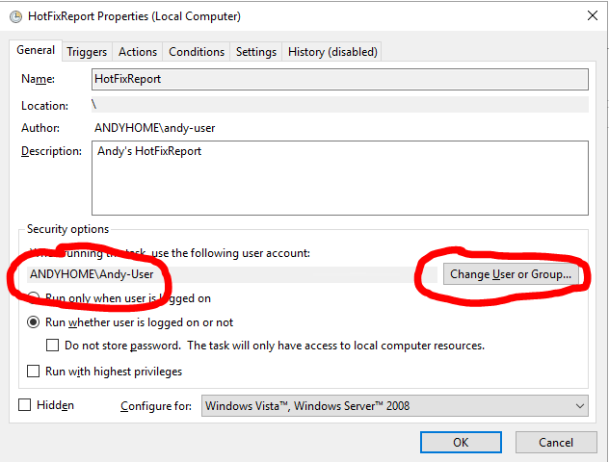

1. Select the **Run whether user is logged on or not** radio button.

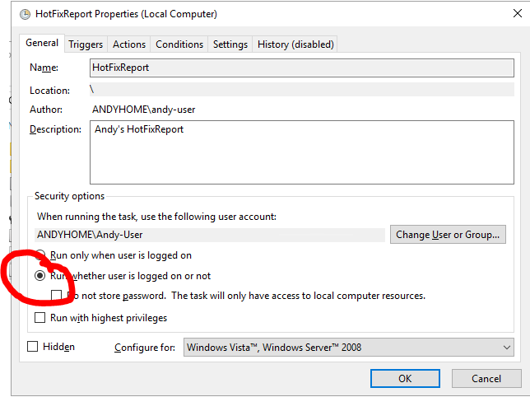

1. Click the **OK** button and enter the password for the specified user account.

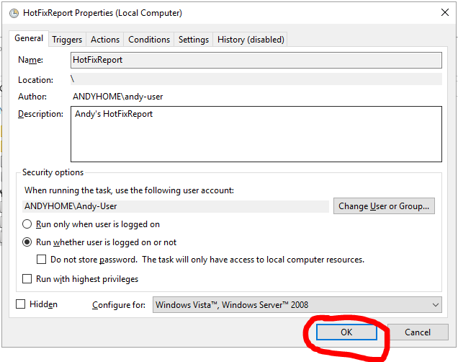 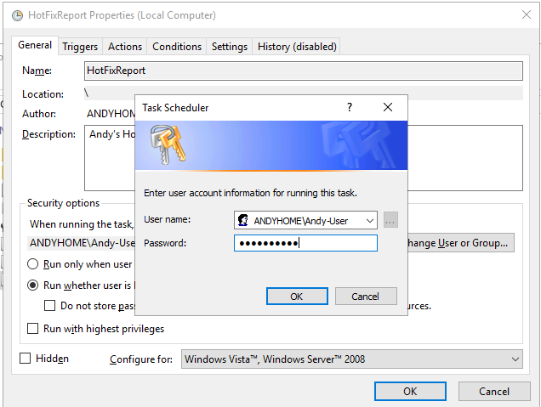

1. Ensure that the new task has been created.

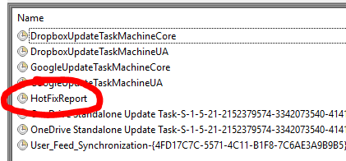

1. Test the task by right clicking the task and click **Run**.

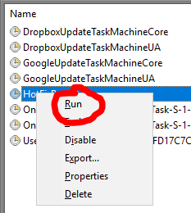

1. The task will launch. You should see the script have a status of **Running**.

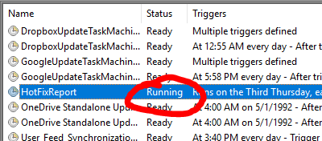

1. Once the task has completed, the Last Run Result should display "The operation completed successfully. (0x0)". **Note**: Depending on the number of servers you are scanning, you may need to wait a few minutes. Hit the Refresh button in Task Scheduler every so often to ensure the job has completed.

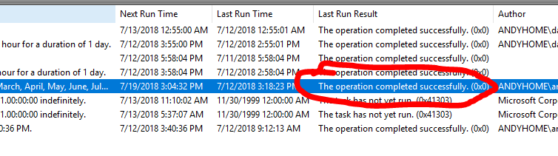

1. Verify your results in your target Report Path directory.

