Graphs (Calculations Further Down)
piezoelectric testing
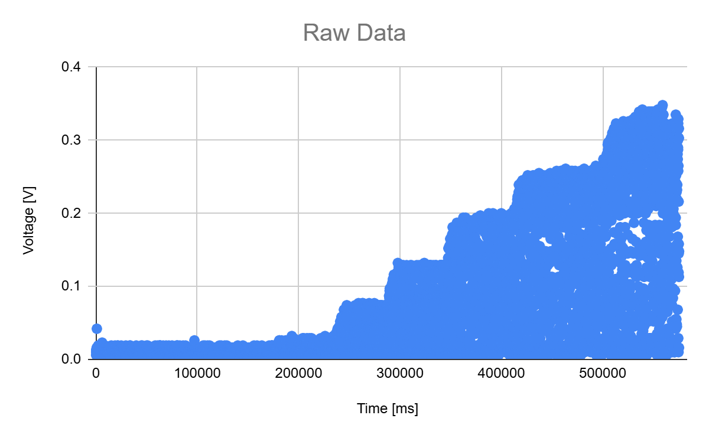
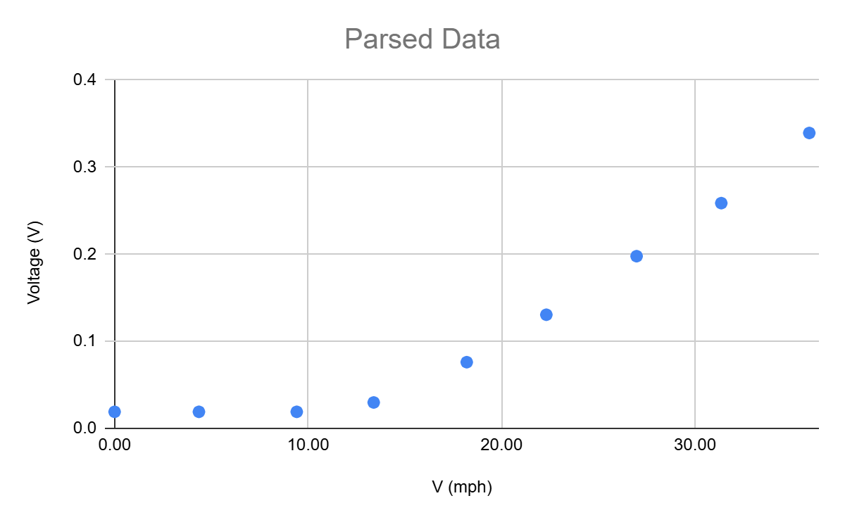
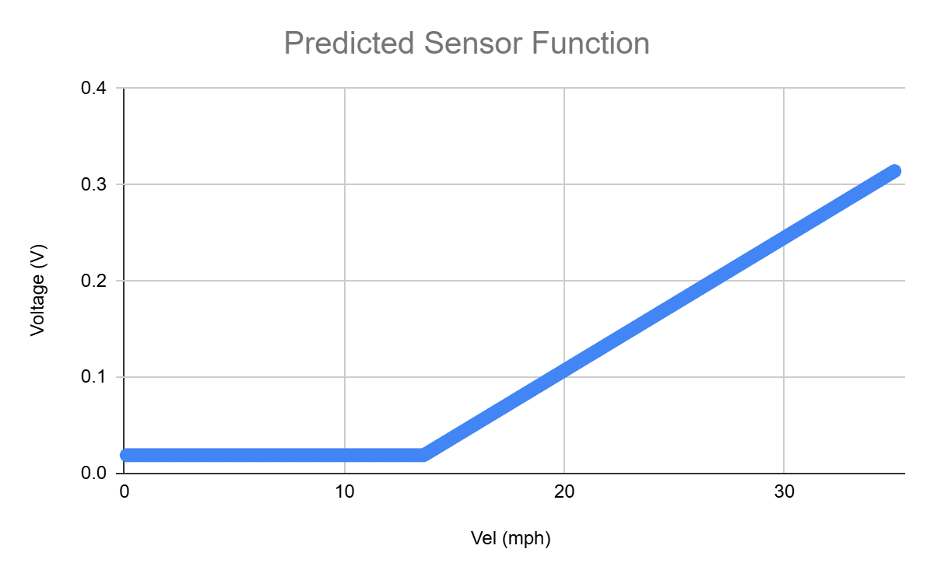
Equation Logic for Predicted Sensor Function:
IF (Expected Voltage < 0.019 [ sensor minimum ] )
Expected Voltage = 0.019
ELSE
Expected Voltage = (SLOPE * MPH) + (Y-INTERCEPT)
[ y = mx + b ]
Testing Conditions
Raw Testing Conditions
q (in H2O ideal) | q (in H2O DAQ) |  | q (in H2O) | q (Pa) | Fan Spin | V (m/s)
-0.008 | -0.008 |  | 0 | 0 | not spinning | 0
0.001 | 0.001 |  | 0.009 | 2.2392 | not spinning | 1.948
0.030 | 0.034 |  | 0.042 | 10.4496 | not spinning | 4.208
0.077 | 0.077 |  | 0.085 | 21.148 | spinning | 5.987
0.144 | 0.149 |  | 0.157 | 39.0616 |  | 8.137
0.229 | 0.228 |  | 0.236 | 58.7168 |  | 9.976
0.333 | 0.337 |  | 0.345 | 85.836 |  | 12.062
0.457 | 0.458 |  | 0.466 | 115.9408 |  | 14.018
0.599 | 0.603 |  | 0.611 | 152.0168 |  | 16.052

Sensor Best Fit Calculations
Voltage Parsed | Average Voltage | Veloctity Test Phase
0.042 | 0.019 | 1
0.019 | 0.019 | 1
0.019 | 0.019 | 1
0.019 | 0.019 | 1
0.019 | 0.019 | 1
0.019 | 0.019 | 2
0.019 | 0.019 | 2
0.026 | 0.019 | 2
0.019 | 0.019 | 2
0.019 | 0.019 | 2

Line of best fit calculations |  | y-intercept | -0.1687017263
 |  | slope | 0.0138
mph_filtered | V_filtered | mph_line | V_line
 |  | 0.00 | 0.019
 |  | 4.36 | 0.019
 |  | 9.41 | 0.019
13.39 | 0.02975 | 13.39 | 0.01607773286
18.20 | 0.076 | 18.20 | 0.08242564748
22.32 | 0.1305 | 22.32 | 0.1391915679
26.98 | 0.19775 | 26.98 | 0.2035646195
31.36 | 0.2586666667 | 31.36 | 0.2639487509
35.91 | 0.33925 | 35.91 | 0.326708348

Excel formula used to populate Predicted Sensor Function Graph:
=IF((($AC$22 * AH2)+($AC$21))<0.019,0.019,($AC$22 * AH2)+($AC$21))
Pseudo Code Version:
IF (Expected Voltage < 0.019 [ sensor minimum ] )
Expected Voltage = 0.019
ELSE
Expected Voltage = (SLOPE * MPH) + (Y-INTERCEPT)
[ y = mx + b ]
An alteration of this formula can be used to know what MPH air is moving at based on Voltage

