FiltSure HVAC Monitor

IoT Mesh-Based HVAC Filtration Health Monitor  
  
Industrial and DIY Installation & Operation Guide  
  
Version: v1.0 Full Draft  
Date: June 11, 2025  
  
Prepared for:  
Industrial HVAC Technicians & DIY Installers  
  
Prepared by:  
[ Your Company Name / Placeholder]

Table of Contents

1. Project Overview 3

1.1 Key Features 3

2. System Architecture 3

2.1 Typical System Layout 4

3. Hardware Bill of Materials (BOM) 5

3.1 Sensor Node (per unit) 5

3.2 Gateway Node 5

3.3 Optional / Tools 5

4. Software & Firmware Structure 5

4.1 Sensor Node Firmware 5

4.2 Gateway Node Firmware 6

4.3 Cloud Logging (Google Apps Script) 6

5. Communication Protocol 7

5.1 LoRa Packet Structure 7

5.2 Diagnostic PING Flow 7

5.3 OTA Update Flow 7

6. Installation & Configuration Instructions 7

6.1 Industrial Technician Installation 7

Pre-Installation Checklist 7

Sensor Node Mounting 7

Gateway Node Setup 8

Initial System Test 8

6.2 DIY User Installation 8

6.3 Safety Notes 9

7. Operating Instructions 10

7.1 Normal Operation 10

7.2 RFID Tag Replacement Flow 10

7.3 Diagnostic LED Behavior 10

7.4 Estimated Battery Life 10

7.5 Battery Replacement Best Practices 10

8. Troubleshooting Guide 11

Common Issues & Solutions 11

Forcing Diagnostic Mode 12

LED Diagnostic Code Quick Reference 12

9. Development Log / Timeline 13

10. Full Source Code Appendix / Links 13

11. References / Related Documents 13

# 1. Project Overview

The FiltSure HVAC Monitor is a wireless IoT system designed to monitor HVAC air filtration systems and airflow performance in real time. It provides both industrial service technicians and DIY users with actionable insights into filter condition, airflow efficiency, and overall system health.  
  
FiltSure combines a distributed network of sensor nodes and a central gateway to create an intelligent, mesh-capable HVAC monitoring solution. Data is wirelessly transmitted to the cloud for logging, diagnostics, and long-term performance tracking.

## 1.1 Key Features

- Wireless mesh network using LoRa for long-range, resilient communication  
- ESP32-based Sensor Nodes with multi-sensor data collection  
- Cloud logging to Google Sheets via WiFi-connected Gateway Node  
- OTA (Over-The-Air) firmware updates for easy device maintenance  
- Visual diagnostic LED feedback on each Sensor Node  
- Compatible with both commercial HVAC units and home systems  
- Simple installation for both professionals and DIY users

# 2. System Architecture

Overall Flow:  
[ Sensor Node(s) ] --LoRa--> [ Gateway Node ] --WiFi--> [ Google Sheets / Cloud Log ]  
  
Components:  
- Sensor Node (ESP32-based):  
 - BME280 — Temperature, Humidity, Pressure  
 - MFRC522 — RFID for Filter Identification  
 - Wind Sensor — Airflow speed (via brushless fan)  
 - Battery Monitor — 14-bit ADC-based battery level sensing  
 - RGB LED — Multi-color diagnostic feedback  
- Gateway Node (ESP32-based with LoRa and WiFi):  
 - LoRa → WiFi bridge  
 - Handles OTA update delivery  
 - Initiates diagnostic PINGs  
 - Forwards data to Google Sheets via Google Apps Script  
- Cloud Logging:  
 - Google Sheets stores historical data for each Sensor Node  
 - Sheet tabs automatically created per Device ID  
 - Data includes timestamp, sensor readings, filter RFID tags, diagnostic status

2.1 Typical System Layout  
The FiltSure HVAC Monitor system typically consists of one or more Sensor Nodes installed inside HVAC units, communicating wirelessly with a centrally located Gateway Node. The Gateway connects to the building's WiFi and forwards data to a Google Sheets-based cloud log.  
  
2.2 LoRa Range Expectations  
- Indoors: typical LoRa range is 50–100 feet indoors, depending on HVAC cabinet construction and building materials.  
- HVAC cabinets may attenuate signal; Gateway should be located within one floor level and with partial line-of-sight to the Sensor Node when possible.  
- Sensor placement tip: avoid mounting Sensor Node inside fully sealed metal compartments unless external antenna used.  
  
2.3 Component Roles  
Sensor Node: Collects sensor data, transmits via LoRa, responds to diagnostic PINGs, supports OTA.  
Gateway Node: Receives LoRa packets, forwards to Google Sheets, handles OTA distribution, issues PINGs.  
Google Sheets Cloud Log: Stores time-stamped data records from each Sensor Node.  
  
2.4 Multi-Node Support  
The system supports multiple Sensor Nodes communicating with a single Gateway Node.  
Each Sensor Node must be assigned a unique Device ID (currently manually assigned in firmware).  
Google Sheets will automatically create a separate tab for each node (UNIT_<DeviceID>).

# 3. Hardware Bill of Materials (BOM)

3.1 Sensor Node (per unit)  
- ESP32-C6 or ESP32-C3 Dev Board  
- BME280 Environmental Sensor  
- MFRC522 RFID Module  
- Wind Speed Sensor  
- 2x D Cell Batteries  
- Battery Monitor  
- RGB LED  
- Misc passive components  
- Mounting hardware

3.2 Gateway Node  
- ESP32-C3 or ESP32-S3 Dev Board  
- LoRa Module (RFM95 / SX127x)  
- WiFi Antenna (optional)  
- Power Supply

3.3 Optional / Tools  
- USB-Serial Adapter  
- JTAG/SWD Debug Adapter

# 4. Software & Firmware Structure

4.1 Sensor Node Firmware  
- Initialize Sensors  
- Periodic Data Read Cycle  
- LoRa Packet Composition & Send  
- RGB LED Diagnostic Pulse Routine  
- Deep Sleep between cycles  
- OTA Update Handler  
- Diagnostic Mode triggers

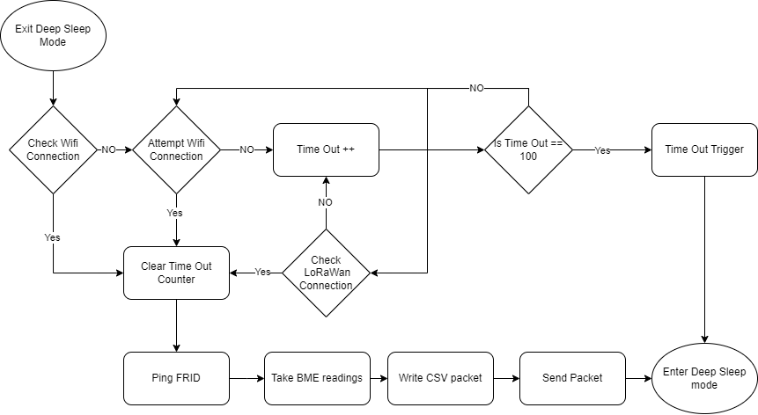

4.2 Gateway Node Firmware  
- Listen for LoRa Packets  
- Forward data to Google Sheets  
- Accept OTA Update Commands  
- Issue LoRa PINGs  
- Serve optional Web Config Interface  
- USB Serial & Telnet Command Interface

4.3 Cloud Logging (Google Apps Script)  
- Accept HTTP POST from Gateway  
- Parse Sensor Node Data  
- Auto-create Sheet Tab per Device ID  
- Append timestamped row of data  
- Web GUI view

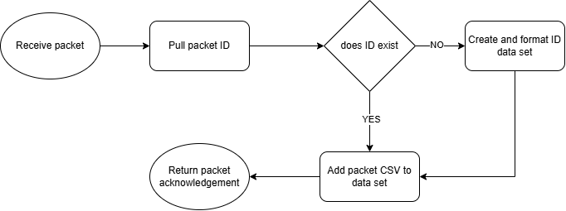

# 5. Communication Protocol

5.1 LoRa Packet Structure  
- Device ID  
- Boot Count  
- Battery Voltage (%)  
- Sensor Status  
- Temperature (C)  
- Humidity (Rh)  
- Pressure (Pa)  
- Wind Speed (m/s)  
- RFID Tag

Ex:

5.2 Diagnostic PING Flow  
- Gateway → Sensor Node: PING  
- Sensor Node → Gateway: PONG + Status Packet

5.3 OTA Update Flow  
- Operator sends OTA binary to Gateway  
- Gateway → Sensor Node(s)  
- Sensor Node validates, writes new firmware, reboots

# 6. Installation & Configuration Instructions

## 6.1 Industrial Technician Installation

### Pre-Installation Checklist

* Verify HVAC system is powered down.
* Confirm LoRa Gateway Node is already online and configured (WiFi connected, LoRa tested).
* Charge and verify Sensor Node batteries (2x D Cells recommended).
* Confirm RFID tags for filters are pre-provisioned and available.

### Sensor Node Mounting

* Select appropriate mounting location:
  + Preferably near filter intake side for optimal airflow monitoring.
  + Allow visibility for RFID reader (tag scan range: ~3-5 cm).
  + Avoid placing next to high EMI sources (large motors, variable frequency drives).
* Mount using:
  + Adhesive pads (industrial-grade recommended)
  + Zip ties (for temporary test install)
  + Screws / standoffs (for permanent install — predrill required)

### Gateway Node Setup

* Place Gateway centrally within building zone of interest.
* Elevate Gateway antenna if possible — improves LoRa range.
* Connect to **5V regulated USB power**, wall adapter, or computer tower for active use.
* Configure Gateway WiFi:
  + Use Web Config Interface: http://192.168.4.1/config when in AP mode.
  + Or connect via Serial Console and set via commands.
* Perform initial test PING to confirm LoRa link with Sensor Node(s).

### Initial System Test

* After powering nodes, trigger manual PING from Gateway.
* Expect **PONG** response from Sensor Node.
* Observe first full data log appearing in Google Sheet.
* Manually test RFID read:
  + Insert RFID-tagged filter.
  + Confirm UID appears in next data report.

## 6.2 DIY User Installation

#### Assembly Notes (for Kit)

* Verify all components included in kit:
  + Sensor Node pre-flashed
  + Gateway Node pre-flashed
  + Sensors connected per wiring diagram
* Insert **2x D Cells** into Sensor Node.
* Power up Gateway → configure WiFi.
* Use included adhesive pads to mount Sensor Node inside HVAC unit.
* Place RFID tag on filter (use provided adhesive).
* Ensure airflow fan is aligned and unobstructed.

#### Testing

* Use "PING" button on Gateway Web UI to verify node connectivity.
* Check Sensor Node LED diagnostic sequence at startup.
* Confirm Google Sheet is receiving data.
* Replace filter → verify new RFID UID logged.
* Watch battery status in logs — replace when below 40% reported.

## 6.3 Safety Notes

Installation Safety Precautions  
  
- Always power down HVAC system.  
- Do not install Sensor Node near high-voltage wiring.  
- Mount securely; avoid obstructing airflow.  
- Route cables properly; no loose wires.  
- Do not install near HVAC logic boards unless shielded.  
- Only qualified technicians should open commercial HVAC units.

# 7. Operating Instructions

7.1 Normal Operation  
- Sensor Node sleeps between cycles  
- Default reading interval: every 5 minutes (configurable)  
- Data sent via LoRa → Gateway → Google Sheets  
- Battery level monitored  
- RFID read each cycle

7.2 RFID Tag Replacement Flow  
  
- Replace HVAC filter and RFID tag.  
- Sensor Node reads RFID at next cycle.  
- New UID appears in Google Sheet automatically.  
- No reboot required.

7.3 Diagnostic LED Behavior  
Sensor Status: Green / Yellow / Blue / Red  
Battery Level: Green / Yellow / Red  
Communication Mode: Green / Blue / Red

7.4 Estimated Battery Life (with 2x D Cells)  
Every 5 min: ~2–3 months  
Every 10 min: ~5 months  
Every 30 min: ~11 months  
Every 1 hour: ~16 months  
4 times per day: ~1.88 years

7.5 Battery Replacement Best Practices  
  
- Monitor Battery Level column in Google Sheet.  
- Replace batteries below 40% (Yellow LED pulse).  
- Preventive replacement: 1 year for D Cells.  
- Use fresh matched D Cell pair.  
  
Note: See Appendix for full power budget reference.

# 8. Troubleshooting Guide

### Common Issues & Solutions

| **Symptom** | **Possible Cause** | **Resolution** |
| --- | --- | --- |
| No data in Google Sheet | Gateway WiFi not connected | Reconnect Gateway WiFi, verify Internet access |
| No LoRa link (PING fails) | Sensor Node out of range / battery dead | Move Gateway, replace Sensor Node batteries |
| Sensor Node not powering on | Dead batteries / loose connection | Check battery terminals, replace batteries |
| RFID Tag not reading | Tag out of range / misaligned | Move tag closer, verify correct orientation |
| RFID Tag UID not changing when new filter installed | Filter tag not updated; old data cached | Force Sensor Node reboot to trigger re-read |
| Sensor data missing / incorrect | Faulty sensor / wiring issue | Recheck wiring, test sensor individually |
| OTA update fails | LoRa congestion / weak signal | Move Gateway closer, retry OTA process |
| Diagnostic LED shows persistent Red | Hardware fault / critical error | Power cycle node, check all sensor connections, re-flash firmware if needed |
| Battery level stuck at 100% / 0% | ADC calibration issue | Verify voltage divider resistors, check ADC reference settings |
| Wind speed reading 0 consistently | Fan sensor misaligned / stuck / wiring | Inspect fan mounting, clean debris, verify wiring continuity |

### Forcing Diagnostic Mode

* Connect USB cable → Sensor Node enters **diagnostic mode**.
* Alternatively: Short GPIO2 to GND → forces diagnostic mode manually.
* Gateway can also trigger via LoRa **PING** → expect **PONG + Status**.

During Diagnostic Mode, a set of six flashes will occur; three white flashes will signal the beginning of the protocol followed by three more flashes in the following order with the colored meanings below

### LED Diagnostic Code Quick Reference

| **Stage** | **Color** | **Meaning** |
| --- | --- | --- |
| Sensor Status | Green | All sensors OK |
|  | Yellow | Only BME280 present |
|  | Blue | Only RFID present |
|  | Red | No sensors detected |
| Battery Level | Green | >75% |
|  | Yellow | 40–75% |
|  | Red | <40% |
| Communication Status | Green | WiFi + LoRa working |
|  | Blue | LoRa only |
|  | Red | No communication |

# 9. Development Log / Timeline

- November 2024: Initial RF + LoRa hardware testing

- January 2025: Sensor Node firmware stabilization

- March 2025: Sensor Node deep sleep optimized  
- May 2025: Diagnostic LED codes implemented  
- May 2025: First successful LoRa → Gateway → Google Sheets data flow  
- May 2025: OTA update system tested  
- May 2025: Gateway Node PING → Sensor Node PONG implemented  
- June 2025: Documentation first draft created  
- Ongoing: Continued improvements

Known Limitations / Roadmap  
- Mesh auto-routing not implemented.  
- OTA size limited to ~32 KB.  
- LoRa MAC ACK/Retry not fully implemented.  
- Multi-hop LoRa repeater nodes under investigation.  
- Remote configuration planned.  
- Gateway to support MQTT / cloud services.

# 10. Full Source Code Appendix / Links

GitHub / Repository (TBD)  
- Sensor Node Firmware  
- Gateway Node Firmware  
- Google Apps Script  
- Additional Resources  
FiltSure Power Budget Spreadsheet

# 11. References / Related Documents

- Bosch BME280 Datasheet  
- MFRC522 Datasheet  
- SX127x / RFM95 Datasheet  
- ESP32 Hardware Reference  
- Google Apps Script API Documentation  
- FiltSure Power Budget Spreadsheet