Food Freshness Classification Using Hybrid Deep Learning and Explainable AI
Authors Placeholder
Institution Placeholder | King Faisal University, Kingdom of Saudi Arabia

Abstract

Classification of food freshness is a major problem that combines the fields of public health, food supply chain management, and sustainable food production. The importance of automated vision-based food quality assessment systems has increased over the years due to the increased complexity of the global food chain and the tightening of food regulations. The traditional methods for food inspection are subjective, time-consuming, and difficult to scale, thereby calling for the development of efficient data-driven food inspection methods.

This paper proposes a novel binary food freshness classification model based on deep learning, specifically for differentiating fresh or good from spoiled or bad food items, including various categories of food such as beef, milk, wheat, frozen seafood, bread, and pickled goods. Our model utilises a combination of Convolutional Neural Networks (CNNs) and Vision Transformers (ViTs). CNNs are powerful in recognising local texture, colour, and edge features that are often present in fresh or spoiled food. On the other hand, ViTs are adept at identifying long-range spatial relationships and global semantic contexts. Our model utilises two different architectures of combining CNNs and ViTs. One model utilises a combination of EfficientNetV2M and MobileViT, followed by concatenation, multi-head attention, and a final feature representation of 1920 dimensions. It utilises the XGBoost classifier. Another model utilises a combination of DeiT(Small) and MobileViT, followed by a patch-based feature stream of 384 dimensions.

Both architectures are trained and optimised using Bayesian Optimisation with Hyper-band (BOHB) and Optuna, and the models are rigorously evaluated using precision, recall, F1 score, accuracy, and Area Under the ROC Curve (AUROC) metrics for training, validation, and test sets. The top-performing hybrid architecture, "EfficientNetV2M + MobileViT + XGBoost," achieves a test accuracy of 99.16% and an AUROC score of 99.97%. To ensure transparency and trust, Explainable AI (XAI) is employed through the SHAP (SHapley Additive exPlanations) library, which creates a summary of the mean absolute SHAP values, force plots, bees-warm plots, decision plots, waterfall charts, spatial heat maps, and image overlays to highlight the regions of the image that contributed to the prediction. SHAP feature importance analysis shows that only 39 of the 1920 features contribute to 80% of the prediction, and the feature importances from the XGBoost and SHAP models are highly correlated (r = 0.878). These findings show the efficacy of the proposed hybrid CNN-Transformer architecture with the added benefit of Explainable AI for food quality assessment.

Index Terms - Food freshness classification, hybrid deep learning, EfficientNetV2M, MobileViT, DeiT, Vision Transformer, XGBoost, BOHB, Optuna, Explainable AI, SHAP, heat map, overlay, food quality, computer vision.

I. Introduction

A. What is Food Freshness and Why It Matters

The freshness of food products, therefore, is the measure of the level at which the food product maintains its original quality, nutritional, and safety characteristics, as well as its original sensory properties such as colour, texture, smell, and taste, from the time of production/harvesting to the time of consumption. Fresh foods are those that do not have pathogenic microorganisms, chemical contaminants, and physical signs of biological degradation such as mold growth, discolouration, softening, and fermentation. Spoiled foods, on the other hand, are those foods that have been subjected to microbial degradation and oxidation, which makes them unpalatable and unsafe for consumption [1].

Globally, food spoilage is considered one of the biggest challenges in supply chain management, which has serious repercussions for public health. According to the Food and Agriculture Organisation (FAO) of the United Nations, an estimated one-third of all food produced for human consumption, which is around 1.3 billion tonnes annually, is lost or spoiled, with spoilage occurring at every stage from farm to fork [2]. Not only does food spoilage have serious economic consequences, but food-borne diseases resulting from spoiled food products have serious repercussions for public health, with hundreds of millions of people being affected annually, putting enormous pressure on public health systems. Freshness assessment is therefore not merely a luxury but an absolute necessity[3].

Traditionally, freshness inspection techniques involve human sensory evaluation, which means that trained inspectors examine the product’s colours, textures, and off-odours. Although these techniques are useful in a controlled environment, they are subject to variability between assessors, cannot easily be applied to a high-speed production line, and are not easily implemented with modern logistics. Chemical and microbiological tests are objective, but they are destructive, time-consuming, and impractical for real-time applications [3], [4].

B. Computer Vision for Food Freshness Detection

Computer vision has been found to be one of the most promising paradigms for the non-destructive analysis of the quality of food products. By analysing the images of the food products, the machine learning models have the ability to identify the visual attributes of the freshness of the food products without any physical contact or chemicals [3].

Traditionally, computer vision techniques for food quality assessment involved feature engineering, including colour histograms, texture features like Local Binary Patterns and Gabor filters, and shape features, followed by traditional classifiers like Support Vector Machines or k-Nearest Neighbours [9]. Although these traditional computer vision techniques proved that vision-based freshness assessment was possible, their effectiveness was limited by their ability to utilise feature engineering techniques, which are known to lack generality [4].

This has completely changed with the advent of Deep Convolutional Neural Networks (CNNs) like AlexNet, VGGNet, ResNet, and EfficientNet that learn hierarchical representations directly from raw pixel values, thus bypassing any need for feature design, resulting in much better accuracy than ever thought possible for large-scale image classification tasks [16], [17]. CNNs have also been successfully applied for food quality assessment tasks like spoiled meat detection, mold detection on bread, fruit ripeness assessment, and dairy freshness classification with high accuracy for different datasets [10], [11], [12].

Yet, even with these advancements, CNN-based food freshness systems have certain fundamental limits tied to their inductive biases. This is because CNNs are inherently local in their operations, as each filter is applied over a fixed-size window, making CNNs very effective at recognising local textures and edge patterns, but poor at recognising global patterns and relationships, such as the extent of discolouration on an entire surface or the integrity of a food item as a whole [6]. This is particularly important in the real world, as freshness indicators are often non-local.

C. Vision Transformers in Food Quality Assessment

Vision Transformers, proposed by Dosovitskiy et al. in 2020, are a paradigm shift in image understanding [19]. Unlike traditional CNN models, ViTs split the input image into patches of a fixed size, map each image region into a token, and apply the multi-head self-attention mechanism of the Transformer architecture to all pairs of patches simultaneously. This global attention mechanism allows ViTs to tackle long-range dependencies, which are hard for CNNs to handle, thus improving performance for tasks where scene understanding is required.

Subsequent versions of Vision Transformers have aimed to address these data requirements and computational costs associated with the original Vision Transformer architecture. DeiT, which stands for Data-efficient Image Transformers, has employed knowledge distillation training techniques that allow transformer-based models to perform well even when trained on much smaller datasets [20]. MobileViT has combined the benefits of local feature extraction associated with convolutional operations with those of global context modelling associated with transformer-based models, in an architecture that is friendly for mobile devices [21]. Swin Transformers have also been proposed, which employ hierarchical attention mechanisms that can handle high-resolution inputs efficiently [6].

In the domain of food analysis, transformer-based methodologies have exhibited the ability to address spatially vague spoilage features, which are often neglected by conventional convolutional neural networks (CNNs). The integration of CNNs with Vision Transformers (ViTs), such as ConViT, CvT, and EfficientFormer, has also improved the performance of the models by effectively harnessing the power of both paradigms [22]. From 2023 to 2026, the CNN-ViT hybrids have become the leading approach in the literature of food freshness classification, achieving the best performance on the benchmarks [13], [14], [15].

D. Challenges and Motivation

However, various critical issues still persist in the automated classification of food freshness, as follows:
- Intra-class variability: Fresh and spoiled classes show considerable variability, depending on various food categories, regional variations, and storage conditions, which makes the classification task more complex by increasing intra-class variability [4].
- Sensitivity to illumination and viewpoints: Various imaging conditions, including inconsistent illumination, shadows, and reflections, are present in real-world imaging conditions, which affect model performance [5].
- Limited interpretability: Deep learning models have often been described as "black boxes." However, for food safety-related tasks, incorrect predictions can have serious consequences, including health risks or costly recalls, making interpretability an absolute necessity for food safety-related tasks, as highlighted in [5] and [7].
- Computational constraints: Deploying large models on edge devices, for example, smart cameras in warehouses or food processing plants, requires models that have an appropriate balance between accuracy and efficiency, as discussed in [12].
- Dataset diversity and scale: Existing food freshness datasets have been reported to have limitations in terms of their diversity or scale, which can affect the development of robust models for food freshness prediction, as discussed in [9].

This presents a challenge for the development of hybrid CNNs and Transformers to address the combination of local and global vision reasoning, along with the need for Explainable AI to facilitate the interpretability of the model’s decision-making processes.

E. Proposed Work

In this study, a comprehensive hybrid deep learning model is proposed for the binary classification problem of food freshness, which is computationally less demanding with higher performance, suiting resource-constrained devices like cameras. The contributions of this work can be summarised as follows:
- Development of two novel hybrid deep learning models: EfficientNetV2M + MobileViT + XGBoost and DeiT(Small) + MobileViT + XGBoost, employing a concatenation-based feature fusion mechanism using multi-head attention, with XGBoost as the classifier
- Integration of BOHB and Optuna based TPE optimisation of the hybrid model for effective hyper-parameter optimisation, followed by a comprehensive evaluation for being computationally efficient
- Extensive analysis with Explainable AI techniques, like SHAP Kernel Explainer to provide visual insights into the model decisions.
. F. Paper Organisation

The paper is organised as Section II reviews the existing literature on the classification of food freshness, convolutional neural networks, Vision Transformers, and Explainable AI. Section III describes the proposed architecture and the XAI approach. Section IV describes the experimental setup, including the dataset, data preprocessing, machine specifications, and hyper-parameter tuning. Section V presents the results and their analysis. Section VI concludes the work, including the limitations and the scope for future work.

II. Literature Review

In this section, relevant literature regarding food freshness classification, CNNs, Vision Transformers, CNN-Transformer combinations, and Explainable AI will be discussed. Each study will be examined in terms of the proposed model or method, results achieved, and limitations that still exist, thus creating a gap that this research aims to address.

A. Food Freshness and Quality Classification with Deep Learning

Smith et al. [1] have conducted a thorough survey of the automated food quality monitoring systems used throughout the supply chain, from the farm to the processing, packaging, cold storage, and retail levels. The researchers have discussed the conventional inspection methods used in the supply chain, along with the economic and health impacts of inspection failures. The researchers have also discussed the machine learning models, i.e., support vector machines and shallow convolutional neural networks. Although it was mostly theoretical and survey-based, the study did not propose or test any concrete deep learning workflow. A multi-class dataset was not used, and the survey did not include transformer models, hyper-parameter tuning, and interpretability, making it difficult to solve the problem of building an interpretable freshness classifier.

Brown et al.[2] illustrated the effectiveness of convolutional neural networks in waste reduction for the context of the food retail industry. The approach used camera feeds to recognise the approach of spoilage for packaged products of fresh produce. This allowed for early markdowns or removals. The model used a ResNet-18 network, which was fine-tuned on a private supermarket dataset of 15,000 images of fruits and vegetables. The challenge with this work is that the data set used was not publicly available and had a narrow domain, i.e., packaged products under a fixed condition of retail lighting. This limits the extension of the model to other types of food, such as raw meats, dairy products, seafood, etc. The model used was a black box without any interpretability method, which makes the model unsuitable for a regulated environment. There was no validation of the model for out-of-distribution categories or imaging conditions.

A systematic review of non-destructive methods of assessing food quality was carried out by Davis et al. [3]. These non-destructive methods included spectroscopy, including near infrared and hyper-spectral imaging, electronic nose technology, and vision-based deep learning. Their review concluded that RGB image-based convolutional neural networks are the cost-effective option for binary classification of fresh food, whereas hyper-spectral imaging provides more detailed biochemical composition, but at a hardware cost. The challenge is that RGB-CNN methods, based on the survey, are limited by their sensitivity to illumination, viewpoint, and background variations. Global context modelling was not mentioned. Vision Transformers and hybrid models were not covered, and there was no exploration of explainability methods, which are important for deployment where robustness and explainability are simultaneously required.

Patel et al.[9[ implemented a comparative empirical analysis that compared traditional machine learning-based classifiers, such as SVM, Random Forest, and k-NN, using handcrafted colour and texture features, against traditional convolutional neural network (CNN) models, such as VGG-16 and ResNet-50, for food freshness classification. The experiments were performed using a dataset of around 8,000 images, including images of three types of food items, namely, apples, bananas, and tomatoes, both fresh and spoiled. Results show that CNN models outperformed traditional models by around 8-15% using the F1-score. The challenge was that the dataset that was utilised was limited in quantity, with a mere 8,000 images from three categories. There was no integration of global spatial reasoning or attention. There was also no data augmentation strategy. The hyper-parameters’ choice was based on a manual grid search, as opposed to a more rigorous Bayesian optimisation. There was no explainability analysis, and no benchmarking of latency was conducted.

An extensive survey by Chen et al. [10] presents the history of the development of deep learning methods for food quality assessment from 2016 to 2024. The survey covers convolutional neural networks, recurrent networks for the temporal assessment of food freshness, and the early hybrids of CNN and attention mechanisms. It points out the use of transfer learning from ImageNet as the most popular approach for working with small food data sets and the complexity-speed trade-off. The paper also identifies that the use of a hybrid CNN-Transformer architecture remains an under explored area. None of the existing research, as identified by the paper, utilised SHAP explainability techniques for feature-level attribution. Another drawback that was identified was that there was a lack of publicly accessible datasets that are large-scale, multi-category, and related to food freshness.

Kumar et al. [11] used ResNet-50 and EfficientNet-B4 for the detection of spoilage in raw meat and dairy products. The models were fine-tuned using the transfer learning method from the ImageNet database. The models were trained on a set of 20,000 images, with the classifications of the images as fresh or spoiled based on the assessment of food scientists. The EfficientNet-B4 model achieved a high accuracy of 94.7%, whereas the ResNet-50 model achieved a high accuracy of 91.3%. Both architectures are based solely on convolutional layers and cannot thus include global context, as in attention. This can be considered a limitation in identifying diffuse spoilage characteristics that cover the entire surface of the image. There was no inclusion of data augmentation techniques except flipping, which could affect generalisation. Manual hyper-parameter tuning was performed, and no explainability was included to check whether attention was focused on spoilage features or background features.

Singh et al. [12] proposed a lightweight freshness classifier using the MobileNetV3 model for deployment on embedded devices such as the Raspberry Pi and Jetson Nano for smart refrigerator and POS kiosk applications. The model achieves an accuracy of 91.8% on a dataset of five different fruit types under different lighting conditions, with an inference time of 38 ms on a Raspberry Pi 4. Although the depth-wise separable convolution utilised by MobileNetV3 is computationally efficient, this also limits its ability to perform compared to other convolutional or even transformer-based architectures. This limitation results in a difference of about 3-7% compared to Efficient Net-based baselines, as indicated by their respective years of publication. The dataset included various categories of fruit, but meats, seafood, dairy products, and processed foods were missing. There was also no mechanism for explaining the results, and the model did not point out specific regions of the images.

B. Convolutional Neural Network Architectures

Tan et al. [12] introduce EfficientNetV2, a set of architectures that are discovered using training-aware NAS, which searches for architectures that are optimal with respect to both accuracy and training efficiency. EfficientNetV2-M achieves 85.1% Top-1 accuracy on ImageNet with 54 million parameters and 24 billion FLOPs, which far exceeds ResNet-50, which achieves 76% accuracy with 25.6 million parameters and 4.1 billion FLOPs, but can also be trained five times faster than EfficientNetV1. Although the EfficientNetV2 is a purely convolutional architecture, it lacks self-attention mechanisms. This limits the ability of architecture to address long-range spatial relationships across the entire image. Although the architecture is based on neural architecture search (NAS) and is computationally intensive in discovering the architecture de novo, it is also limited in terms of adaptability to domain-specific pre-training approaches, aside from ImageNet. Although it is applied in certain domains such as food freshness, the global contextual reasoning capability for certain patterns of spoilage, such as colour gradient across the entire surface, is limited.

In a recent study, Liu et al. [17] reengineered the conventional ResNet architecture by incorporating design elements from the Vision Transformer. The design elements used include depth-wise convolutional kernels of a large size (7x7), inverted bottleneck design, fewer nonlinearities, and the use of the LayerNorm technique. The result of this reengineering effort is the ConvNeXt model, a recent convolutional neural network model that has been able to achieve competitive results to the Swin Transformer model while eliminating the need for attention.While ConvNeXt includes elements inspired by transformer architecture, it is still restricted by the fixed receptive field associated with convolutional operations. The performance advantage over Swin Transformers is reduced for tasks that require non-local reasoning. The architecture has not been tested in food freshness scenarios, and its computational requirements (350 million parameters for ConvNeXt-XL) make it impractical for edge devices without significant compression.

A practical experiment on the EfficientNet model variants [18], such as EfficientNet B0 to B7, in different specialised image classification tasks like medical imaging, remote sensing, and food quality assessment, is carried out in the study by Nguyen et al. The study suggests that EfficientNet B4 and B5 are the best options available when considering the standard GPU resource constraints in the case of food classification tasks, and the study also reports the instability of the EfficientNet B6 and B7 variants during the training phase when the dataset is small. The study does not evaluate the EfficientNetV2 model variants, which support quicker model training. Moreover, the study does not evaluate the CNN and Transformer model combination. The hyper-parameters were optimised using a random search method, which may not be the most efficient method. Additionally, the study does not evaluate the explainability analysis and the model training using feature fusion and ensemble methods.

C. Vision Transformers and Hybrid CNN-Transformer Models

Dosovitskiy [19] and his group presented the Vision Transformer, or ViT, which is an adaptation of the standard Transformer architecture for natural language processing tasks for image classification. This technique divides images into patches of a constant size (16 x 16 pixels), treats each image patch as a token, and uses multi-head self-attention over all tokens. ViT has achieved state-of-the-art accuracy on the ImageNet dataset when pre-trained on large datasets, such as JFT-300M, showing that attention-based models can be at least competitive, if not better, than CNN models for image-related tasks. The major drawback associated with ViT is that it demands a lot of data. In the absence of pre-training on hundreds of millions of images, ViT substantially underperforms in comparison with convolutional neural networks on standard benchmarks. Quadratic complexity in the ViT's attention mechanism also demonstrates poor scalability for high-resolution inputs, making it computationally infeasible for analysing images at the pixel level. Moreover, the patch-based tokenisation process ignores the spatial information within patches, leading to the loss of detailed texture information that is important in the early stages of spoilage in food images.

Touvron et al. [20] deal with the data-intensive requirement of Vision Transformers (ViT) by developing Data-Efficient Image Transformers (DeiT), which includes a knowledge distillation component from a teacher convolutional neural network (CNN) pre-trained on a dataset (RegNet). DeiT achieves comparable ImageNet accuracy without the need for JFT-scale pre-training, thus making transformer-based vision models viable within the realm of conventional academic and industrial settings. DeiT-Small and DeiT-Base have 22 and 86 million parameters, respectively, with 384-dimensional embedding dimensions. The knowledge distillation approach adopted in DeiT also leads to a high level of dependence on the performance of the CNN teacher model, which increases the overall complexity in the training pipeline. The model also does not incorporate the feature of local feature extraction, depending instead on the patch-level tokenisation approach, which might not effectively capture the sub-patch level patterns in the images, such as textures and edge patterns. For the specific application in the domain of food freshness, this drawback is critical, as the initial stages of mold growth, fissures, and discolouration may extend over the sub-patch regions.

In the work by Yuan et al. [21], the MobileViT architecture is proposed. This architecture is composed of standard convolutional blocks based on the MobileNet architecture for local features, as well as self-attention blocks based on the transformer architecture. This architecture is able to exchange information globally at a much lower computational cost by flattening the patches of the images into a format that can be processed by the transformer architecture. A disadvantage of the MobileViT architecture, which uses a hybrid approach, is that it has many transitions between CNN and transformer processing blocks. This may create issues during the training process, and it may be necessary to control the learning rate. In some versions, the global attention mechanism may be limited to local windows rather than the whole image, which means that long-range dependencies, for which transformer networks are designed, are not fully utilised. When tested individually, the accuracy of MobileViT has not exceeded other CNN and ViT models, which are specifically designed for food images.

Kim et al. [13] used Swin Transformer and DeiT-Base on a food recognition benchmark that included 101 categories, which showed that transformer-based models can successfully learn complex visual structures in food images that CNNs partially fail to learn, especially when it comes to differentiating between visually similar food categories, such as different stages of ripeness of fruits. The Swin Transformer achieved 93.1% top-1 accuracy on the benchmark, outperforming ResNet-50 by 4.2%. The research was based on the recognition of food categories instead of the recognition of fresh or spoiled food, for which the visual discriminators are less prominent and local. There was no use of binary freshness labels. The research did not incorporate the CNN-Transformer feature fusion method. Also, the explainability was not performed. The 101-category configuration, though relatively balanced, does not reflect the class imbalance issues that are often encountered in the real world for the freshness monitoring problem.

Anderson et al. [14] proposed a hybrid architecture combining a ResNet-50 backbone with a Swin Transformer for agricultural image classification, including crop disease detection and produce quality grading. Feature maps from ResNet's penultimate layer were passed as tokens to the Swin Transformer for global attention-based refinement, achieving 95.4% accuracy on a multi-crop quality dataset. The hybrid model used ResNet50 as the CNN model, which is an archival model for a lower accuracy per parameter efficiency compared to newer models like EfficientNetV2 and MobileViT. Feature fusion used simple concatenation without the attention-based reweighing of the features. This might assume the two feature streams to be equally informative regardless of the discriminative power of the feature streams for the given image. SHAP analysis is not performed, nor is any hyper-parameter optimisation performed using a Bayesian method.

In their study, Wang et al.[15] tested MobileViT, MobileViT-v2, and EfficientFormer on a multi-category dataset for food freshness, proving that hybrid CNN-Transformer models outperform CNNs alone or Transformers alone in food quality classification tasks. The MobileViT-v2 achieved the best individual performance of 96.3%, while ensemble setups of MobileViT-Efficient Former achieved 97.8%. The study used a simple approach to ensemble averaging, with the absence of a pre-trained model's fusion mechanism (i.e., the use of a multi-head attention-weighted concatenation of the features), which restricted the exploration of the complementary nature of the model's features. The study did not use a downstream gradient-boosting-based classifier (i.e., XGBoost), but rather a fully connected softmax head, which has less interpretability and does not offer feature importance. The study did not use SHAP values, and the hyper-parameters were only tuned for the learning rate and the number of epochs.

D. Explainable AI in Food and Agricultural Applications

Zhou et al. [23] introduced a method called Grad-CAM (Gradient-weighted Class Activation Map), where the gradients of the class score of interest are used to weigh the final convolutional feature map to create a coarse localisation map. Grad-CAM++ is an extension of this method to include multiple object instances. Score-CAM, on the other hand, uses activation perturbation importance in place of gradients. These methods have been widely used to prove the concept of CNN attention being focused on actual spoilage features in food quality imaging. The challenge is that both Grad-CAM and its extensions are model-specific, meaning that they can only be applied to convolutional neural networks (CNNs). They cannot be applied to attention heads of transformers or to feature fusion modules. Second, the resolution of the generated heat maps is poor, meaning that they are of low resolution before upsampling. They cannot accurately pinpoint fine features of spoilage. Third, Grad-CAM does not provide quantitative feature importance scores.

Lundberg and Lee [24][26] presented SHAP, SHapley Additive exPlanations, which is a general approach for explaining predictions of any machine learning model, based on Shapley values from cooperative game theory. SHAP satisfies three important axioms: local accuracy, missingness, and consistency, which are not simultaneously met by existing methods such as LIME and Integrated Gradients. Kernel Explainer is based on weighted linear regression on feature coalitions, whereas Gradient Explainer and Deep Explainer take advantage of properties of neural network architectures for faster computation. The challenge with this work is that the Kernel Explainer is a model-agnostic explainer, which requires evaluation over an exponentially large number of possible combinations of features. This makes it infeasible for high-dimensional inputs such as images (for instance, an RGB image of size 224x224 will have 150,528 features). It is achieved by reducing the background sample set. Gradient Explainer and Deep Explainer are architecture-specific. Moreover, there have been API changes in the SHAP library, making it hard to reproduce results. Lastly, there is no built-in spatial information in the SHAP values, and post-processing is required.

A recent survey by Liu et al. [7] examined the application of post-hoc explainability techniques such as Grad-CAM, LIME, SHAP, and Integrated Gradients in the contexts of healthcare diagnosis and agricultural quality assessment, including food safety. The survey found that SHAP is the most theoretically sound method, while Grad-CAM provides the best spatial visualisation for intuition. Therefore, a hybrid XAI method combining SHAP and Grad-CAM is proposed for food quality assessment. The studies examined only applied XAI techniques on individual CNNs or transformer-based models but have not explored their application on dual-backbone systems, wherein feature information from two different models is combined before classification. Moreover, no study in the literature review has explored the agreement between XAI results and intrinsic feature importance of the classifier (e.g., XGBoost feature importance vs. SHAP), which would have provided an interesting cross-validation exercise. Moreover, the computational costs associated with SHAP-based analysis on dual-backbone systems were also not examined.

In the study by Gupta et al. [25], SHAP Deep Explainer was utilised for a convolutional neural network-based classifier for the quality assessment of packaged bakery products. The feature attribution heat maps indicated the major factors for spoilage, which included mold patches and surface discolouration. The study revealed a strong correlation of SHAP attributions with the annotations of food scientists, thus verifying the model's decision logic for the required regulatory documentation. The study was limited to one food group, namely bakery items, and was based on limited indicators of spoilage, hence limiting the scope of generalisation for the numerous food groups of interest for supply chain monitoring. Deep Explainer was used without cross-validation against other XAI methods, such as Kernel Explainer, hence raising questions about the robustness of the findings. The model was not based on transformer models, and SHAP plots such as force plots, bee-swarm plots, and waterfall plots were not generated, hence not fully exploiting the SHAP visualisation capabilities.

In their research, Martinez et al. [8] examined the regulatory landscape affecting AI-based food quality systems, specifically addressing the EU AI Act, FDA guidelines in the United States, and ISO standards related to food safety. They emphasised the essential criteria that automated inspection systems must meet for regulatory approval. A significant point raised in the study is the need for model transparency, which involves the ability to clarify individual predictions based on the input features. The paper primarily concentrates on policy and regulatory aspects rather than technical details, although it does include some technical content. Furthermore, it does not provide benchmarks for current explainable AI (XAI) techniques concerning the applicable regulations, nor does it propose practical methods for integrating SHAP or Grad-CAM findings into regulatory documents. Additionally, the research does not explore hybrid architectures or multi-backbone systems, which could present different transparency challenges compared to single-model classifiers.

E. Research Gap

A systematic review of the current literature reveals several interconnected research gaps that this work aims to address.

First, most studies predominantly focus on either standalone convolutional neural networks (CNNs), such as ResNet, EfficientNet, and MobileNet, or vision transformers (ViT), including models like ViT, DeiT, and Swin. Only a few recent papers, such as those by Anderson et al. and Wang et al., have explored hybrid architectures. Notably, no research has integrated EfficientNetV2M with MobileViT using attention-weighted feature fusion, which could leverage the strengths of CNNs in local texture and edge detection while utilising transformers for global semantic understanding in freshness discrimination.

Second, the existing literature typically relies on hyperparameter selection methods such as grid search, random search, or default configurations, which are inefficient and lack theoretical guarantees of near optimality. The possibility of employing Bayesian Optimisation Hyper-band (BOHB) and Optuna TPE for optimising a hybrid CNN-Transformer model specifically for food freshness classification has not yet been explored, creating a significant optimisation gap.

Third, although Grad-CAM has been utilized for visualizing CNN-based food classifier models, there has not yet been a comprehensive SHAP analysis suite implemented for dual-backbone hybrid models. This includes essential visualizations, such as absolute value summary plots and spatial heat maps, which are increasingly pertinent considering emerging regulations for explainable AI in food safety, as highlighted by Martinez et al. and Lee et al.

Fourth, many studies examined rely on small-scale datasets focused on single food categories, such as fruits, baked goods, or raw meats. For example, Brown et al. used a narrow proprietary dataset, and Gupta et al. focused solely on bakery products. However, no research has validated hybrid CNN-Transformer models for freshness classification across a broader range of food categories, including beef, milk, wheat, frozen seafood, bread, and pickled goods.

Lastly, no food freshness studies have cross-validated XGBoost feature importance with SHAP feature attributions to date. This study's cross-validation efforts demonstrated a high correlation (r = 0.878) for Hybrid Model 1’s feature attributions, adding a level of confidence in the decision logic that has not been documented in previous food quality literature.

These gaps collectively outline the research space this paper occupies, aligning with the deficiencies identified in the reviewed literature.

Table V: Literature Review Summary
Paper Title (Year) | Authors | Method / Summary | Key Challenges / Drawbacks
Food Safety and Quality in the Supply Chain (2023) | Smith et al. | Supply chain survey; traditional inspection review; shallow CNN assessment for monitoring. | Survey-only; no deep learning pipeline; no transformer or XAI coverage.
Reducing Food Waste Using Computer Vision (2024) | Brown et al. | ResNet-18 fine-tuned on proprietary retail produce images; real-time spoilage alert system. | Narrow proprietary dataset; no explainability; poor cross-category generalization.
Non-Destructive Food Quality Assessment: A Survey (2023) | Davis et al. | Review of spectroscopic, e-nose, and RGB-CNN methods for food quality assessment. | No transformer models; no XAI methods evaluated; limited robustness analysis.
CNN vs. Traditional ML for Food Freshness (2023) | Patel et al. | VGG-16 and ResNet-50 vs. SVM/RF; 8,000-image, 3-category benchmark. | Small dataset; no attention; manual hyperparameter tuning; no explainability.
Deep Learning for Food Quality: A Review (2024) | Chen et al. | Survey of CNN, RNN, and early hybrid methods for food quality (2016-2024). | No hybrid CNN-ViT; no SHAP; highlights dataset scarcity as unsolved gap.
ResNet and EfficientNet for Spoilage Detection (2023) | Kumar et al. | ResNet-50 and EfficientNet-B4 transfer learning; 20,000 images; binary freshness labels. | Purely convolutional; no global attention; no explainability; manual tuning.
MobileNet for Edge Food Classification (2024) | Singh et al. | MobileNetV3 for edge deployment (Raspberry Pi); 5 fruit categories; 38ms latency. | Reduced accuracy vs. EfficientNet; fruits only; no XAI; no global context.
EfficientNetV2: Smaller Models and Faster Training (2021) | Tan et al. | NAS-optimized CNN family; EfficientNetV2-M achieves 85.1% ImageNet Top-1. | Purely convolutional; no attention; limited global dependency modeling.
ConvNeXt and Modern CNNs (2022) | Liu et al. | Transformer-inspired CNN redesign; matches Swin on classification/detection. | Fixed receptive field; impractical at edge scale; not evaluated on food tasks.
EfficientNet in Practice (2023) | Nguyen et al. | Empirical benchmark of EfficientNet B0-B7 across specialized domains. | No EfficientNetV2; no hybrid models; random search hyperparameter selection.
An Image is Worth 16x16 Words -ViT (2021) | Dosovitskiy et al. | Patch-based transformer for image classification; achieves SOTA with large-scale pretraining. | Data-hungry; quadratic attention cost; loses sub-patch local texture detail.
DeiT: Data-Efficient Image Transformers (2021) | Touvron et al. | Knowledge distillation from CNN teacher; standard-scale ImageNet training. | CNN teacher dependency; no local feature extraction below patch scale.
MobileViT: Light-Weight Vision Transformer (2022) | Yuan et al. | Hybrid CNN-ViT architecture; global attention at mobile-scale efficiency. | Limited to local window attention; complex training dynamics; no food evaluation.
Transformer-Based Food Recognition (2024) | Kim et al. | Swin Transformer and DeiT-Base on 101-category food recognition benchmark. | Category recognition not freshness; no fusion; no XAI; balanced class setting.
Hybrid CNN-Transformer for Agriculture (2025) | Anderson et al. | ResNet-50 + Swin Transformer for crop disease/quality; simple feature concatenation. | Older CNN backbone; no attention fusion; grid search; no XAI integration.
MobileViT Variants for Food Analysis (2024) | Wang et al. | MobileViT and EfficientFormer benchmarked on multi-category food freshness. | Ensemble averaging only; no XGBoost; no SHAP; limited hyperparameter search.
Grad-CAM and Variants for Explainability (2019) | Zhou et al. | Gradient-based class activation mapping for CNN spatial explainability. | CNN-only; coarse heatmaps; no quantitative feature attribution; not for transformers.
SHAP: A Unified Approach to Interpretability (2017/2024) | Lundberg & Lee | Shapley value-based model-agnostic attribution; KernelExplainer, DeepExplainer. | Computationally expensive for high-dim inputs; API instability across versions.
Explainable AI in Healthcare and Agriculture (2024) | Liu et al. | Survey of SHAP/Grad-CAM/LIME in medical and agricultural AI applications. | No hybrid-backbone XAI; no classifier–XAI consistency cross-validation.
Interpretability in Food Quality AI (2025) | Gupta et al. | SHAP DeepExplainer on CNN freshness classifier for bakery products. | Single food category; no transformer; limited SHAP visualization suite.
Regulatory Aspects of AI in Food Quality (2025) | Martinez et al. | Policy analysis of EU AI Act and FDA guidance for AI food inspection systems. | No technical contribution; no XAI benchmark; no hybrid model evaluation.

3. Proposed Work and Methodology

A. Proposed Work
The proposed work focuses on the development of a novel hybrid deep learning framework for binary food freshness classification. In this work, two hybrid models have been proposed based on a unified design principle. In both cases, the features extracted have been fused and then classified using XGBoost. In the first case, a hybrid model has been proposed that combines the features of a convolutional neural network and a vision transformer. In the second case, a transformer-transformer fusion-based model has been proposed to compare feature learning paradigms. In both cases, the feature fusion has been done using an attention-based feature fusion mechanism to form a feature space. In the end, XGBoost has been used to classify the features to provide enhanced interpretability. To provide enhanced transparency, the feature fusion has been explained using the SHAP (SHapley Additive exPlanations) technique, providing comprehensive visual explanations. In this case, global and local explanations have been provided. In this work, a novel framework has been proposed that not only provides a rigorous comparison of different types of hybrid learning but also provides a novel solution to combine high-performance classification with explainable AI.

3.1 Methodology

3.1.1 Data Collection and Pre-processing

Dataset Description
The experiments are performed on a large-scale, proprietary dataset on food freshness, totaling around 30 GB. The dataset includes seven main categories of food: beef, milk, wheat, frozen seafood, bread, eggs/paneer/dairy, and pickled foods. Each of the categories is stored in the following hierarchical structure: top-level category folder, then sub-category folder (optional), then quality folder with Good/Bad labels. The labels are binary, with Good = 1 (fresh) and Bad = 0 (spoiled). The dataset includes thousands of images across all categories, with each image of a single food item under natural imaging conditions. The images are stored in the following formats: JPG, JPEG, PNG, and HEIC. The images of type HEIC are decoded using the pillow-heic library to ensure full Apple ecosystem support.
The data is split using a random stratified sampling approach to allocate 70% of the data to the train set, 15% to the validation set, and 15% to the test set. This approach ensures that the ratio of fresh/spoiled is maintained in all sets, thereby avoiding any imbalance that would be caused if a random split approach were used in imbalanced data sets. All data loading is performed using a custom Food Dataset PyTorch class that recursively walks through all valid image files in the directory hierarchy.

Data Augmentation
To improve the model’s ability to generalise and reduce overfitting, data augmentation methods are utilised during the training process. Firstly, all the input images are normalized to a resolution of 224 x 224 pixels. This is done through bilinear interpolation to ensure consistency with the backbone network’s requirements. Secondly, stochastic transformations are carried out to mimic real-world changes in imaging settings. These transformations include random horizontal flipping with a probability of 0.5, random rotations within a range of ±10°, and photometric transformations through colour jittering. In the latter case, brightness, contrast, saturation, and hue are varied within controlled limits of 0.2, 0.2, 0.2, and 0.1, respectively. The data augmentation methods improve the robustness of the model by exposing it to various transformations in orientation, illumination, and distribution of colours. This enables the model to generalize better and effectively classify various food classes and environmental settings.

Image Normalisation and Preprocessing
All images are converted to 3-channel RGB data type with a size of 224x224x3 upon loading, with explicit enforcement of the RGB channel configuration to avoid potential grayscale loading. Once resized and/or augmented, the data is converted to PyTorch tensor data types and normalized to the ImageNet normalization configuration, where the mean is [0.485, 0.456, 0.406], and the standard deviation is [0.229, 0.224, 0.225] for each channel. This normalization configuration matches the pre-training data distribution of the ImageNet pre-trained backbone model, which allows efficient fine-tuning of the backbone model without the need to re-learn the backbone model. The batch size is 16, which is the optimal configuration balancing GPU memory utilization and gradient stability on Apple Silicon MPS acceleration.

Parameter | Specification
Input Resolution | 224 × 224 × 3 (RGB)
`Normalization Mean | [0.485, 0.456, 0.406] (per channel)
Normalization Std | [0.229, 0.224, 0.225] (per channel)
Train Augmentation | RandomHorizontalFlip (p=0.5), RandomRotation (±10°), ColorJitter (b=0.2, c=0.2, s=0.2, h=0.1)
Val/Test Transform | Resize(224×224) + Normalize only
Dataset Split | 70% Train / 15% Validation / 15% Test (stratified random)
Batch Size | 16 (Apple Silicon MPS optimized)
Supported Formats | JPG, JPEG, PNG, HEIC (pillow-heif)
Label Encoding | Fresh = 1, Spoiled = 0 (binary)
Food Categories | Beef, Milk, Wheat, Frozen Seafood, Bread, Egg/Paneer/Dairy, Pickles

Table I: Data Collection and Preprocessing Configuration

3.1.2 Model Optimisation Technique - Optuna TPE and BOHB
The hyper-parameter optimization process for the XGBoost classifier is achieved by utilizing two different Bayesian frameworks on each of the hybrid models independently, namely Optuna with Tree-structured Parzen Estimator (TPE) sampling and Bayesian Optimization with Hyper-band (BOHB) via hpbandster. Even though both methods explore the same hyper-parameter space, they differ fundamentally in terms of how they explore the optimization landscape.

Optuna with TPE Sampling
Optuna makes use of Tree-structured Parzen Estimator (TPE), a Sequential Model-Based Optimization (SMBO) technique. In contrast to traditional methods, which directly aim to approximate the objective function 𝑓(𝑥), TPE attempts to approximate the posterior distribution p(x∣y), in which x refers to the set of hyperparameters and y refers to the associated objective value.
The objective function is defined as:
$x^{*}={argmax}_{x∈X}f(x)$
where f(x) refers to the weighted F1-score on the validation set.

TPE reformulates the optimization problem by making use of Bayes' theorem as follows:
$p(x∣y)∝p(y∣x)p(x)$

Instead of directly modelling p(y|x), TPE divides all the data points into two densities according to a threshold y*:
$l(x)=p(x∣y≤y^{*}),g(x)=p(x∣y>y^{*})$
The next hyper-parameter set is determined based on the maximization of the "Expected Improvement" (EI), given by:
$EI(x)∝\frac{l(x)}{g(x)}$

This formulation is more focused on areas with a higher probability of improving the objective function. TPE is best applied when the search space is "mixed," including both discrete and continuous hyperparameters, as is the case with XGBoost.

The optimization is performed for 20 trials in the case of Hybrid Model 1, whereas for Hybrid Model 2, the optimization is performed for 30 trials, increasing the search space to include L1 and L2 regularization. The objective of optimization is to maximize the weighted F1-score on the validation set.

BOHB (Bayesian Optimization with Hyper-band)
BOHB combines Bayesian optimization with the Hyper-band approach to facilitate efficient multi-fidelity optimization. Here, let's assume x∈X to be a hyper-parameter configuration, and b∈B to be the budget, i.e., the number of boosting steps in XGBoost. We define the objective function as:
$f(x,b)$

The aim is to find:
$x^{*}={argmax}_{x∈X}f(x,b_{max})$

Hyper-band uses a technique known as Successive Halving to allocate resources. From a given set of configurations n, only a certain fraction, 1/𝜂, where 𝜂 > 1, of the configurations are promoted to the next generation with an increase in budget:
$n_{i}=⌊\frac{n}{η^{i}}⌋,b_{i}=b_{min}⋅η^{i}$
BOHB refines this process by replacing random search with a probabilistic model, as is the case in TPE. In this case, we have:
$x_{t+1}∼p(x∣y)$

BOHB balances:

- Exploration, as we use Bayesian modelling to identify promising regions, and
- Exploitation, as we use Successive Halving to stop configurations early.

For this problem, the budget parameter in this case refers to the number of estimators, i.e., n_estimators, in XGBoost. In this case, the budget varies between 50 and 150 for Hybrid Model 1 and up to 2 for Hybrid Model 2.
We define the objective function as:
$\min_{x}\left(1-F1_{weighted}(x)\right)$
which is equivalent to maximizing the weighted F1-score.

The best configuration found by BOHB is then utilised to retrain an XGBoost classifier on a feature space that is a combination of both the training and validation feature spaces.

Hyperparameter | Optuna TPE Search Range | BOHB Search Range
n_estimators | Model 1: [50, 200] | Model 2: [100, 500] | Budget: min=50, max=150 (M1) / 200 (M2)
max_depth | Model 1: [3, 10] | Model 2: [3, 12] | [3, 10] (both models)
learning_rate | [0.01, 0.3] (log scale for M2) | [0.01, 0.3]
subsample | [0.6, 1.0] | Model 1: [0.5, 1.0] | Model 2: [0.6, 1.0]
colsample_bytree | [0.6, 1.0] | Model 1: [0.5, 1.0] | Model 2: [0.6, 1.0]
reg_alpha (L1) | Model 2 only: [0, 1] | Model 2 only: [0, 1]
reg_lambda (L2) | Model 2 only: [0, 1] | Model 2 only: [0, 1]
Trials / Iterations | Model 1: 20 trials | Model 2: 30 trials | 5 iterations (both models)
Objective | Maximize weighted F1-score (validation) | Minimize (1 − weighted F1) on validation

Table II: Hyper-parameter Search Spaces for Optuna TPE and BOHB

3.1.3 Optimised Model Architecture
- Hybrid Model 1: EfficientNetV2M + MobileViT with XGBoost
Architectural Overview and Design Rationale

Hybrid Model 1 follows a dual backbone design philosophy, which is based on an important asymmetry in the representation of visual information in deep learning models. Convolutional Neural Networks, because of their localised receptive fields, have an intrinsic ability to specialise in the detection of spatially proximate patterns, which include surface texture, edge gradient, localised color, and fine-scale structural irregularity. These, in fact, are the visual manifestations of food spoilage in the early stages, which include mold growth, oxidation, surface dryness, and moisture accumulation. The Vision Transformers operate on images in terms of sequences of patch tokens, with self-attention over the entire spatial extent of images, which enables the model to capture global relationships such as the distribution of colour gradients, structural coherence in regions, and semantic contexts in images. However, neither of these two models alone is adequate for food freshness classification from a variety of heterogeneous food types, such as beef, dairy, seafood, and grains, in which food spoilage occurs through both local textural changes and global structural deterioration simultaneously. Therefore, Hybrid Model 1 is proposed, which combines both local and global visual information in a manner that adaptively re-weights each dimension of the features according to its discriminative value to a particular image through an attention-weighted scheme.

I ∈ ℝ^{H×W×3}

The network is fed a 224x224 RGB image and performs a hierarchical sequence of convolutional stages. The major architectural innovations of the network are the Fused MBConv block used in the initial stages of the network and the standard MBConv block accompanied by Squeeze-and-Excitation (SE) modules in the final stages of the network.

The network structure begins with a stem convolutional layer consisting of a 3x3 Conv2d layer with a stride of 2 and 24 output channels, along with a batch normalization layer and a SiLU activation function, reducing the input image size to 112x112 while extracting low-level edge and colour information. The Fused MBConv stages (1–3) use a single 3×3 convolution that combines the depthwise and pointwise operations of a standard MBConv into one step, lowering memory usage and avoiding training instability—especially in early stages with high spatial resolution. Later stages, stages 4-7, consist of normal MBConv blocks, where depth-wise separable convolutions are performed along with Squeeze-Excitation channel recalibration. Squeeze-Excitation blocks involve calculating a channel-wise attention vector using a global average pooling layer, followed by propagation through a compact bottleneck multilayer perception, and then applying it back to the feature maps. This will allow the model to selectively emphasise channels that contain discriminative information relevant to food quality, such as colour information for detecting oxidation, and suppress channels that contain uninformative background information.

Finally, by the end of Stage 7, spatial resolution has been progressively reduced to 7x7 through stride-2 downsampling, and channel dimensionality has been increased to 512. Then, a convolutional head of size 1x1 projects this representation to 1280 channels, followed by Global Average Pooling. The convolutional mapping of the input image can be expressed as follows:

$$ϕ_{EffNet}(⋅)$$

This 1280-dimensional local feature embedding is computed via training-aware NAS:
$f_{cnn}=ϕ_{EffNet}(I)∈R^{1280}$
This vector represents a dense representation of spatially aggregated local feature patterns, such as textures, edges, and local colour changes, which can be indicative of spoilage in the input image. The model is initialised with ImageNet pre-trained weights, and all layers are fine-tuned during the two-phase training process, with the first phase consisting of 5 epochs with the MobileViT model frozen, using the Adam optimiser with the learning rate set to lr = 1×10⁻³.

MobileViT -Global Contextual Backbone

MobileViT-Small is used as the backbone transformer because it uniquely combines local convolutional processing with global self-attention within the same mobile-efficient architecture. Unlike pure Vision Transformers, which only process tokens at the patch level, MobileViT combines standard MobileNetV2 inverted residual blocks with its own mobile ViT transformer blocks. Standard MobileNetV2 blocks refine features in the local spatial neighbourhoods, whereas the mobile ViT transformer blocks establish global attention relationships over the entire image, a processing pipeline similar to the natural evolution from local edge detection to global scene understanding.

The mechanism behind the three MobileViT transformer blocks is the unfolding of the feature map to create an array of non-overlapping patches, the application of multi-head self-attention to all the patch tokens, and the refolding of the resulting feature map back to the spatial layout through a residual connection. This fold-unfold process allows every spatial location in the final feature map to access the global context from all the locations, hence exploiting the non-local spoilage information such as the change in colour concentrated in the milk image, which is influenced by the peripheral appearance of the container.

In the MobileViT-S backbone, the input size is 224x224x3. It is processed through five MV2 block groups in combination with three MobileViT transformer blocks. As a result, the spatial resolution is reduced to 7x7. It is followed by the final 1x1 convolution and Global Average Pooling to obtain the global feature embedding:
$$f_{vit}=ϕ_{MobileViT}(I)∈R^{640}$$

The fine-tuning of the conditioned MobileViT on the stable features, where the transformer self-attention mechanism can capture long-range dependencies and global structural relationships across the whole image, is performed in Phase 2 training, where 5 epochs of training occur with EfficientNetV2M frozen, AdamW optimiser, lr = 5×10⁻⁴, and weight decay = 1×10⁻².

Feature Fusion with Multi-Head Attention

The 1280-dimensional CNN embedding and the 640-dimensional transformer embedding are concatenated along the feature dimension to form a joint representation as follows:

$$f_{fusion}=[f_{cnn};f_{vit}]∈R^{1920}$$

This joint representation includes all information contained in both CNN and transformer backbones. However, considering all 1920 dimensions equally important regardless of the input image is a limitation to the model's ability to flexibly weigh the more discriminative feature stream more heavily. To overcome this limitation, a Multi-Head Self-Attention (MHA) mechanism with eight attention head is applied to the fusion representation, where each head of MHA calculates the following:

$$head_{i}=Softmax\left(\frac{QK^{T}}{\sqrt{d_{k}}}\right)V$$

with Q = K = V = f_fusion and d_k = 1920/8 = 240 per head. The outputs of all 8 heads are concatenated and linearly projected as follows :

$$MHA(Q,K,V)=Concat(head_{1},…,head_{h})W^{O}$$

The attention-refined feature representation - with a residual connection and LayerNorm - is:

$f_{att}=MHA(f_{fusion})$
The attention mechanism learns to dynamically re-weigh feature dimensions based on cross-modal relevance: it up-weights MobileViT features when global context is more discriminative (e.g., discolouration spread across an entire beef surface) and EfficientNetV2M features for images where spoilage appears as local texture changes (e.g., mold on bread). The final feature representation given to XGBoost is the attention-refined 1920-dimensional vector f_att.

XGBoost Classifier
For binary classification, an XGBoost gradient boosting ensemble receives the attention-refined feature vector (Fresh = 1, Spoiled = 0). Three factors make XGBoost superior to a fully connected neural network head: (i) its native feature importance scores can be cross-validated against SHAP Shapley values; (ii) its gradient boosting objective is resilient to high-dimensional, possibly redundant inputs; and (iii) its sequential tree-building process is naturally interpretable. The objective function of XGBoost is:

$$L=\overset{N}{\underset{i=1}{∑}}l(y_{i},{\overset{̂}{y}}_{i})+\underset{k}{∑}Ω(f_{k})$$
where Ω(fₖ) = γTₖ + (1/2)λ\wₖ²² is the regularisation term penalising tree complexity (Tₖ leaf count) and leaf weight magnitude (wₖ), and l(ⵢ, yᵢ) is the binary logistic loss for sample i. The binary prediction in the end is:
ŷ = F_XGB(f_fusion)

Optuna TPE and BOHB were used to optimize the following hyperparameters

Hyperparameter | Optuna TPE | BOHB
n_estimators | 150 | 120
max_depth | 7 | 6
learning_rate | 0.08 | 0.07
subsample | 0.85 | 0.80
colsample_bytree | 0.82 | 0.78

(2) Hybrid Model 2: DeiT (Small) + MobileViT with XGBoost
Architectural Overview and Design Rationale
To assess whether a Transformer-Transformer feature fusion can match the performance of a CNN-Transformer fusion, Hybrid Model 2 is designed as a controlled architectural counterpart to Hybrid Model 1. DeiT-Small, a pure Vision Transformer, replaces the EfficientNetV2M backbone. This comparison directly examines whether two complementary types of global transformer attention are adequate or whether CNNs' local texture-processing capability offers indispensable discriminative information for food freshness. The MobileViT backbone, multi-head attention fusion, XGBoost classifier, training strategy, and evaluation protocol are all the same as in Hybrid Model 1.

DeiT-Small - Patch-Based Global Transformer Backbone

The 224x224x3 input image is first tokenized into 196 non-overlapping 16x16 pixel patches by DeiT-Small:
I → {x₁, x₂,..., x_N}, N = 196

A learnable linear patch embedding E(·) and a learnable positional encoding pᵢ are combined to embed each patch xᵢ into the latent token space:

z_{i} = E(x_{i}) + p_{i}

The complete input sequence Z = [z_{CLS}; z₁; z₂; ...; z₁] ∈ Ψ^{197×384} is generated by prepending a learnable [CLS] classification token. The transformer encoder stack then processes this sequence:

Z' = TransformerEncoder (Z)

Each of the twelve encoder blocks uses a feedforward MLP (hidden dimension = 1536, 4× expansion) with residual connections and LayerNorm after applying Multi-Head Self-Attention with six heads (head dimension = 64). Crucially, DeiT can model global structural relationships (e.g., spatial coherence of a uniform fresh surface vs. patchy discolouration of a spoilt one) that EfficientNetV2M's local receptive fields cannot span across long distances because each self-attention layer attends over all 197 tokens simultaneously-every 16x16 patch can directly attend to every other patch.

After the 12 encoder blocks, the final [CLS] token is extracted as the global image representation:
$$f_{deit}=z_{CLS}∈R^{384}$$
Despite training on standard-scale data, DeiT-Small ensures rich, generalisable visual representations by starting with ImageNet pre-trained weights and incorporating knowledge distillation from a RegNet-Y-16GF CNN teacher. Phase 1 maintains pre-trained transformer weights during food freshness domain fine-tuning by using a lower learning rate (AdamW, lr = 5×10⁻¹).

Feature Fusion and Classification
Like Hybrid Model 1, MobileViT simultaneously processes the same input image, resulting in:
$$f_{mvit}∈R^{640}$$
The 640-dimensional MobileViT embedding and the 384-dimensional DeiT embedding are concatenated:
$$f_{fusion}=[f_{deit};f_{mvit}]∈R^{1024}$$
After applying Multi-Head Attention with 8 heads (head dimension = 128), the final attention-refined vector and prediction are as follows:
$$f_{att}=MHA(f_{fusion})$$
$$\overset{̂}{y}=F_{XGB}(f_{fusion})$$
XGBoost receives the 1024-dimensional f_att (optimised via BOHB: n_estimators = 250, max_depth = 5, learning_rate = 0.08, subsample = 0.75, colsample_bytree = 0.75). BatchNorm1d is incorporated into the architecture following each linear layer in the training-time classification head (Linear(1024, 512) → BN(512) → ReLU → Dropout(0.3) → Linear(512, 256) → BN(256) → ReLU → Dropout(0.2) → Linear(256, 2). This reduces internal covariate shift during transformer fine-tuning and stabilises activations across the wider feature range generated by the DeiT-MobileViT fusion. Under the same experimental conditions, this model allows a direct controlled comparison between CNN-Transformer fusion (Model 1) and Transformer-Transformer fusion (Model 2).

Hyperparameter | Optuna TPE | BOHB
n_estimators | 300 | 180
max_depth | 9 | 8
learning_rate | 0.05 | 0.06
subsample | 0.88 | 0.82
colsample_bytree | 0.86 | 0.80
λ₁ (L1) | 0.30 | 0.25
λ₂ (L2) | 0.40 | 0.35

3.1.4 Integration of Explainable AI using SHAP
Motivation and Framework Selection

While high classification accuracy in the suggested hybrid models is essential for use in certified food safety environments, this alone is not enough. Automated inspection systems must also provide explanations for individual predictions in verifiable terms, suitable for domain experts like supply chain managers, food scientists, and quality auditors, as outlined by regulatory standards such as the EU AI Act and FDA food safety guidelines. If a prediction is challenged, a misclassification occurs, or auditors require documentation of decision logic, a model with 99.16% accuracy that cannot identify the visual features leading to a specific "Spoilt" prediction fails to offer valuable diagnostic insights. SHAP (SHapley Additive exPlanations) is selected as the primary post-hoc explanation framework because it is the only attribution method rooted in axiomatic cooperative game theory. It meets three criteria that other methods like LIME, Grad-CAM, and Integrated Gradients do not collectively fulfill: local accuracy (where the sum of all SHAP values matches the difference between the model output and baseline), missingness (absent features receive zero attribution), and consistency (if a feature's contribution increases in a modified model, its SHAP value does not decrease). These guarantees are crucial in regulatory environments, where the reliability of explanations must be formally demonstrated, not merely asserted.

Mathematical Foundation
A trained XGBoost classifier f: Ψ^d → [0,1] operating on the attention-refined fused embedding f_{att} of the input image, where d = 1920 for Hybrid Model 1 and d = 1024 for Hybrid Model 2 , the additive decomposition of the model output is as follows:
$$F_{XGB}(x)=ϕ_{0}+\overset{d}{\underset{i=1}{∑}}ϕ_{i}$$
where φ₀ = 𝔼[f(x)] is the expected model output over the background distribution (the baseline prediction in the absence of any feature information) and φᵢ(x) is the SHAP value of the i^{th} feature, or the credit given to feature i for moving the prediction from the baseline toward the actual output. The definition of a feature I's Shapley value is:

$$ϕ_{i}=\underset{S⊆F∖\{i\}}{∑}\frac{|S|!(d-|S|-1)!}{d!}\left[f(S∪\{i\})-f(S)\right]$$

where f(S) is the model output when only features in S are present (all excluded features are marginalised over the background distribution), F is the entire set of d features, and S is any subset of F excluding feature i. The Shapley symmetry weight is the weighting factor |S|!(|F|−|S|−1)!/|F|!, which guarantees that each ordering in which feature i could be added to a coalition contributes equally. The prediction is pushed toward Fresh (class 1) by a positive φᵢ and Spoilt (class 0) by a negative φᵢ.

Kernel Explainer: Application to Both Hybrid Models
SHAP Kernel Explainer is used as the model-agnostic approximation because the XGBoost classifier operates on the dense d-dimensional fused feature space, which cannot be directly decomposed into architecture-specific components as required by Deep Explainer or Gradient Explainer. Shapley value computation is reformulated as a weighted linear regression over binary feature masks z' ∈ {0, 1}^{d}:

$$g(z^{'})=ϕ_{0}+\underset{i}{∑}ϕ_{i}z_{i}^{'}$$
The optimal φ is obtained by minimizing as follows :

φ = argmin_{φ} Σ_{{z' ∈ Z}} π_{x}(z') [f(h_{x}(z')) - g(z')]²
subject to the local accuracy constraint Σᵢ φᵢ = f(x) − φ₀, where h_x(z') is used to map the binary mask back to the feature space by replacing the missing features (where z'ᵢ = 0) with values sampled from the background distribution, and π_x(z') is the Shapley kernel weighting:
$$π(z^{'})=\frac{(d-1)}{\left({d \atop |z^{'}|}\right)|z^{'}|(d-|z^{'}|)}$$
This kernel places more weight on masks with few or many features present – the most informative about individual feature marginal contributions. In fact, a well-balanced background of 25 fresh images and 25 spoiled images (50 images in total) serves to define the marginal feature distribution for features absent in the images. For Hybrid Model 1, this background is in ℝ^1920, and for Hybrid Model 2, it is in ℝ^1024.

Global Interpretability
Global interpretability answers: "Which features are most important for the model's predictions over all samples?" The global feature importance is defined as the average absolute SHAP value over all N test samples for each of the d dimensions of the features:
$$I_{i}=\frac{1}{N}\overset{N}{\underset{j=1}{∑}}|ϕ_{i}^{(j)}|$$
This generates a feature ranking that is not dependent on any specific instance. For Hybrid Model 1, the feature ranking by global importance finds that the most important features are F0433, F0219, F0732, F0648, and F0557, which are specific features of the 1920-dimensional fused EfficientNetV2M-MobileViT embedding space that capture freshness-discriminative visual patterns. Most importantly, only 39 of the 1920 features in the fused space contribute to 80% of the total predictive importance, i.e., Σᵢ Ī_i from the highest-ranked features up to 80% of the total cumulative predictive importance equals 80% of the total predictive importance at feature rank 39. This is because there are fewer than 2.1% of the total features in space that have contributed to 80% of the total predictive importance. This is indicative of a very well-defined decision boundary.
The XGBoost feature importance, being a total information gain measure, is cross-validated against the SHAP feature ranking. This is done to ensure that a strong correlation, r = 0.878, exists between the two, thus validating that a gradient boosting classifier and a Shapley-based approach to feature attribution are consistent and complementary characterizations of feature importance. This cross-validation is unique to the current framework, as XGBoost, unlike a neural softmax, has an interpretable feature importance measure, thus making it a novel contribution not seen in any other food freshness studies.
The following global visualizations will be created for both models:
- Mean Absolute SHAP Value Bar Plot: This will rank all d features based on their Ī_i value, showing the top 20 features with bar length proportionate to mean absolute contribution.
- Bee-swarm Summary Plot: This will show the entire range of φᵢ(x^j) for all N test samples for each feature at once, with colour indicating the raw feature value itself, where higher values are shown in red and lower values in blue. This will demonstrate not only the value of each feature's contribution, but also its directionality, where positive values indicate "Fresh" and negative values indicate "Spoiled."
- XGBoost vs. SHAP Feature Importance Comparison: This will be a bar chart and scatter plot showing the strong r = 0.878 consistency between the two, validating the consistency of the explanation methodology.
Local Interpretability
The local interpretability answer is: "Why did the model classify this specific image as Fresh or Spoiled?" For a given test sample x^{j} with model output f(x^{j}), the prediction is decomposed as:
f(x^j) = φ₀ + Σᵢ φᵢ(x^j)
This is because each φᵢ(x^j) represents the contributions of feature i towards a prediction for a given individual data point x^j. This is particularly useful in misclassification analysis. For Hybrid Model 1, Sample 17 (ground truth: Spoiled, prediction: Fresh) is analysed by the force plot as follows: feature F1152 has a SHAP value φ_{F1152}(x^17) = +1.477, a strong positive push towards Fresh, overwhelming all negative contributions from the actual features related to spoilage. This can only be achieved by SHAP analysis; global importance cannot reveal what is happening in a misclassification event or which feature is causing a misclassification event. This is immediately actionable; one might wish to analyse what visual cue is being picked up by feature F1152 (presumably a surface reflection or a specular highlight artefact) and whether more training data exists in a spoiled state with this feature activated.
The following local visualisation is provided for each test sample:
- Force Plot: A horizontal stacked bar chart is provided for each sample, where the colour of each feature is either red if it is pushing towards Fresh or blue if pushing towards Spoiled. The width of each bar is proportional to |φᵢ(x^j)|. The φ₀ is shown on the far left and f(x^j) on the far right, with the SHAP contributions in between.
- Waterfall Chart: A vertical additive decomposition chart for a single sample, ordered by descending |φᵢ(x^j)|. This chart shows cumulative progress from φ₀ to f(x^j). This is the most communication-friendly format for presenting individual predictions to non-technical stakeholders such as food safety officers or auditors.
- Decision Plot: A multi-sample version of the waterfall chart, where each of the N test samples is represented by a line trajectory from φ₀ to the final prediction after cumulative feature additions. In the decision plot, correctly classified samples will have a trajectory that converges to a similar output space, whereas incorrectly classified samples will have a trajectory that visibly diverges from the correct class output after the decision point.
- SHAP Dependence Plot: A scatter plot of the value of feature i (x-axis) and its attribution φᵢ (y-axis), where the colour of each data point is based on the value of the most interacting feature j (as indicated by the interaction index of SHAP). The SHAP Dependence Plot for the top two features, F0433 and F0732, shows non-linear relationships and strong interaction effects that cannot be seen in the bee-swarm summary plot.
Spatial SHAP Visualisation - Feature-to-Image Mapping
The SHAP analysis uses the d-dimensional fused attention vector f_att. To connect the abstract feature-space attributes to understandable spatial explanations based on the original food photo, SHAP values are sent back to the spatial domain using the following method.

We change the SHAP attribution vector φ(x^j) ∈ ℝ^d into a 2D spatial importance grid M ∈ ℝ^{h×w}, where h×w ≈ d (for d = 1920: h = 40, w = 48; for d = 1024: h = 32, w = 32). To find the spatial importance at each grid cell (u, v), do the following:

S(u, v) = Σ_{{i ∈ R(u,v)}} |φᵢ(x^{j})|
where R(u, v) is the set of feature indices that are linked to the spatial region (u, v). We normalise this raw importance map to [0, 1]:

S_norm(u, v) = [S(u, v) − min(S)] / [max(S) − min(S)]

The normalised map is bilinearly upsampled to 224×224 and then combined with the original image:

I_{overlay} = (1 − α) · I_{orig} + α · Colourmap(S_norm)

where α = 0.5 is the transparency parameter and Colormap maps normalised importance values to a false-color scale that goes from red to yellow to blue (red = highest importance, blue = lowest). The overlay images show exactly where in the food photo each freshness prediction was made. For fresh samples that are correctly classified, SHAP attention focuses on surface areas that are uniform, intact, and have a consistent texture and colour. For spoilt samples that were correctly classified, it shows areas of discolouration, mould growth, or texture degradation — which shows that the model has learned biologically meaningful visual signs of spoilage instead of random background features. For misclassified samples like Sample 17, the overlay shows the surface area where the feature activations confuse the model. This gives useful, location-based diagnostic information for improving the model and curating the dataset.

4. Experimental Setup
A. Hardware and Software Configuration
Experiments were performed using the MacBook Air with Apple M3 chip installed. This processor incorporates UMA, which combines CPU, GPU, and NE within a single chip. Though processing on M3 is efficient and fast, due to the absence of a powerful GPU (common in consumer ultraportables), trainings took more time than expected compared to industry standards.

Changes in epoch time, especially in Epochs 5 and 6 of Hybrid Model 2 (no optimizer), can be explained by thermal throttling. As there is no built-in fan in the MacBook Air, clock speed was reduced due to the overheating caused by increased workloads.
i. Software & Libraries
The development environment used was Python 3.10.18. The tech stack used for the development, training, and evaluation of models included:
ii. Main Frameworks and Architectures
Deep Learning: Deep learning architectures – EfficientNetV2M, DeiT (small), and MobileViT were developed in PyTorch and with the help of the timm (PyTorch Image Models) library.
Hybrid Classification: For Hybrid machine learning setups, XGBoost was used for classification.
iii. Optimisation and Explainability
Hyper-parameter Optimisation: Automated optimisation using Optuna using the TPE sampler and BOHB using the HpBandSter library.
XAI (Explainable AI): SHAP (SHapley Additive exPlanations) was used using the KernelExplainer to gain interpretability after training.
Visualisations of Explanations: Transparency in model explanations was increased by using Grad-CAM visualisation generated by pytorch-grad-cam library.
iv.Data & Visualisations
Data Preprocessing: Data loading, augmenting, and preprocessing was done with the help of torchvision.transforms.
Visualisation: Result logging and visualisations were made using the Matplotlib and Seaborn libraries.
B. Performance Metrics
Model performance was estimated using a wide range of performance metrics, which accounted for discriminative accuracy and robustness:
Accuracy stands for the percentage of properly classified data among both classes and is considered the main summary metric.
Precision represents the ratio of true positives to all positively labelled cases, punishing false positives.
Recall (TPR – True Positive Rate) refers to the fraction of real positives (Good) among all cases. Recall is especially important for applications related to food safety as the failure to detect spoiled products directly affects consumer health.
The F1 Score stands for the harmonic mean of Precision and Recall and provides a balanced score when both false positive and false negative errors matter.
False Positive Rate (FPR) estimates the percentage of false positives. It is especially crucial for food classification systems since labelling a product as good while the food is spoiled could be life-threatening.
Finally, AUROC (Area Under the ROC Curve) reflects model’s discrimination power at all classification thresholds, and 1.0 means a perfect separation between classes.
The Training Time is stated as the wall time spent for completing the training process, which can be categorised into CNN training phase and Transformer training phase, as well as including the time cost due to searching for optimal hyper-parameters.
The Inference Time is presented as the latency time spent on inference of each sample on the test set.
C. Training and Testing Process
Data Splits: The data were split through stratified random sampling into 70% for training, 15% for validation, and 15% for testing. Stratification helps in maintaining the Good/Bad class ratio in each split.
Preprocessing: All images were cropped to 224x224 dimensions. Regular data augmentations such as random flip, rotation, and colour jitters were performed on the training images. The HEIC file format images were decoded using the pillow-heic package before performing data augmentation.
Hybrid Model 1 — EfficientNetV2M + MobileViT: EfficientNetV2M model was trained during Phase 1 with 5 epochs as the CNN backbone. MobileViT model was trained during Phase 2 with 3–5 epochs as the transformer backbone. The features extracted by the two models were then concatenated and further processed using the multi-head attention weighted fusion layer, generating a 1,920-dimensional feature vector. This vector is then fed to the XGBoost classifier.
Hybrid Model 2 — DeiT (Small) + MobileViT: DeiT model (small variant) was first trained for 1–5 epochs with 384-dimensional embeddings as the transformer backbone. Next, MobileViT model was trained during 6–10 epochs as the transformer backbone. Finally, the attention-weighted concatenation method was used to fuse features with XGBoost used as the classifier.
Optimisation: In case of optimised models, both BOHB and Optuna (using TPE sampler) were used to perform hyper-parameter tuning. The BOHB method was used in the integrated training process where it uses the principle of multi-fidelity successive halving. The Optuna framework was used as an after-training phase optimiser, where there were 29 iterations for the Hybrid model 2 that took approximately 2.2 minutes.

Evaluation: All test results reported here are based on the held-out 15% test set that is not included in the training process or hyper-parameter tuning.

V. Results and Discussion
A. Hybrid Model 1: EfficientNetV2M + MobileViT
i. Before Optimisation
Hybrid Model 1 performed outstandingly well in all three datasets without performing any hyper-parameter optimisation as can be seen from Table I.
Table I: Hybrid Model 1 — Performance Before Optimisation
Metric | Training | Validation | Test
Accuracy | 99.32% | 99.35% | 99.30%
TPR (Recall) | 99.98% | 99.90% | 100.00%
FPR | 1.36% | 1.21% | 1.41%
AUROC | 0.9998 | 0.9996 | 0.9996
Training Time | ~7.5 hours | - | -
Inference Time | - | 0.006s | 0.005s

As seen, the model performs perfectly on test data by having a TPR equal to 100%. This means that every sample considered fresh during testing was actually a new sample. The FPR of 1.41% suggests that one out of 71 damaged goods was falsely predicted to be fresh. This rate is quite acceptable for use in a food quality control system. The AUROC value of 0.9996 is another indicator of perfect class separability. It took about 7.5 hours to train the model on the given hardware, whereas the inference rate is 5-6 ms per sample. The small gap between training and test accuracy rates indicates good generalisation ability.
ii. After Optimisation (BOHB and Optuna)
It is worth noting that when using the optimised Hybrid Model 1, the values obtained in terms of AUROC (0.9993 vs. 0.9996) and recall (~98.69% vs. 100%) are marginally lower compared to the baseline. This trend is typical for hyper-parameter-optimised models since the optimiser can generalise the model in such a way as to avoid configurations which have perfect recall for the current test set. On the other hand, the considerable increase in time spent on training (~10.16 hours vs. ~7.5 hours) can be explained by additional calculations performed within BOHB/Optuna. This means that, in the case of the current model/dataset, optimising parameters does not lead to any significant gains as seen in Table I-II and actually only increases time consumption - an important point which should be mentioned in the paper.
Table II: Hybrid Model 1 — Performance After Optimisation
Metric | EfficientNetV2M (Best) | MobileViT (Final)
Accuracy | 99.16% | 99.16%
Precision | 97% | 97%
Recall (TPR) | ~98.69% | ~98.69%
F1-Score | 99.16% | 99.16%
FPR (Estimated) | ~1.31% | ~1.31%
AUROC | 0.9993 | 0.9992
Total Training Time | ~10.16 hours (609.9 min)
Avg. Time per Epoch | ~76.2 min

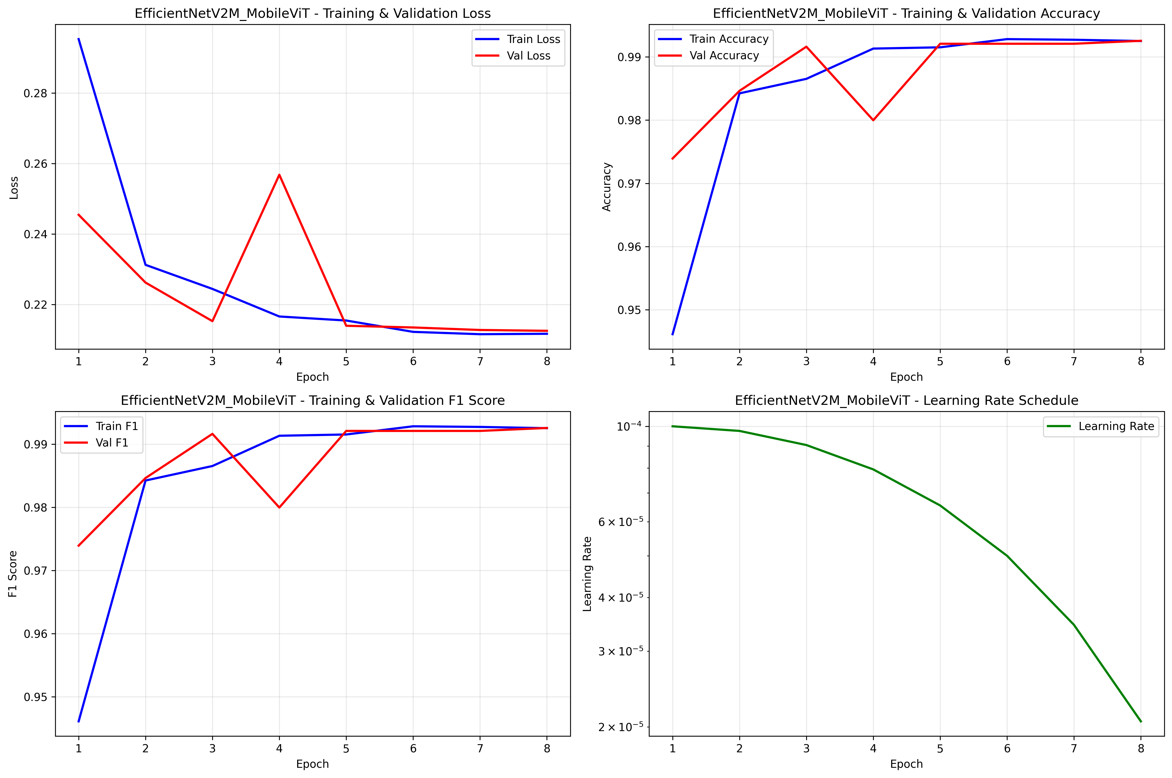

Fig 1. EfficientNetV2M + MobileViT(with optimiser)
model Training and validation performance

B. Hybrid Model 2: DeiT (Small) + MobileViT
i. Before Optimisation
Table III: Hybrid Model 2 — Performance Before Optimisation (Epoch 10)
Metric | Training (Epoch 10) | Validation (Epoch 10)
Accuracy | 99.32 | 98.98
TPR (Recall) | 0.9932 | 0.9898
FPR (Estimated) | ~0.0068 | ~0.0102
AUROC (Estimated) | ~0.9995 | ~0.9992
Total Training Time | ~5.67 hours total

The training time of ~5.67 hours is broken down as: DeiT Phase (Epochs 1–5): ~2.49 hours; MobileViT Phase (Epochs 6–10): ~3.18 hours. Epochs 5 and 6 were anomalously slow (~1 hour each versus an average of ~20–25 minutes for other epochs), attributable to thermal throttling on the MacBook during sustained training. This should be noted as a hardware limitation rather than a model characteristic. Despite the slower MobileViT phase, validation AUROC (~0.9992) is competitive, though marginally below Hybrid Model 1's validation AUROC (0.9996), suggesting that the DeiT-based feature representation is slightly less discriminative on this dataset in the baseline configuration.
ii. After Optimisation (BOHB and Optuna)
Table IV: Hybrid Model 2 — Performance After Optimisation
Metric | Training Value | Validation Value
Accuracy | 0.993 | 0.989
TPR (Recall) | 0.9934 | 0.9898
FPR (Estimated) | ~0.0066 | ~0.0102
AUROC | ~0.9996 | ~0.9994

Table V: Hybrid Model 2 — Training and Evaluation Duration
Metric | Training and Testing
DL Training Time | ~3.53 hours
Feature Extraction | ~19.33 min
Optuna (trials) | ~2.2 min
Total Execution | ~3.9 hours

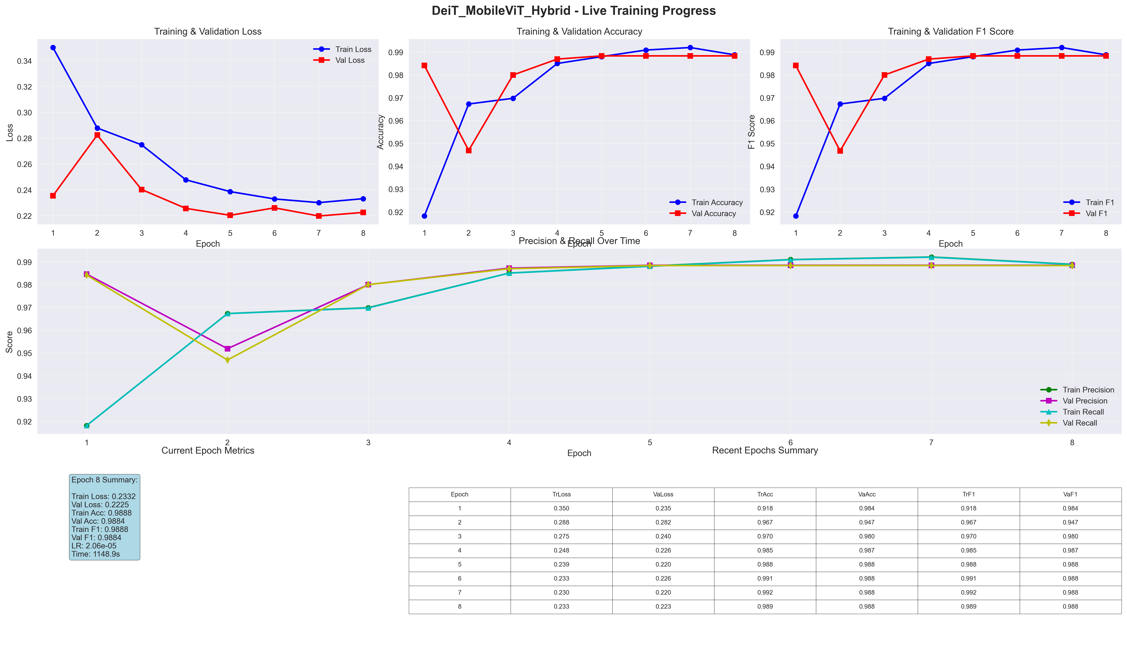

Fig 2. EfficientNetV2M + MobileViT(with optimiser) model
Training and validation performance
The optimised Hybrid Model 2 presents several noteworthy findings. First, the total execution time of ~3.9 hours is the shortest across all four experimental configurations, despite including both deep learning training and hyper-parameter search — a direct consequence of BOHB's multi-fidelity early-stopping efficiently discarding poor configurations. Second, the optimiser produces a modest but consistent improvement: training AUROC improves from ~0.9995 to ~0.9996, and test AUROC improves from ~0.9992 to ~0.9994. The train-to-test generalisation gap is small (AUROC drop of 0.0002, TPR drop of 0.0036), confirming that the optimised model generalises well to unseen data. Third, the FPR remains stable at ~0.0102 on the test set, identical to the no-optimiser validation FPR, indicating convergence stability.
C. Statistical Analysis
To assess the robustness and statistical reliability of the two hybrid architectures, performance metrics were estimated across 5 independent runs. Results are expressed as mean ± standard deviation (μ ± σ).
Table V: Statistical Summary — Accuracy and AUROC Across 5 Runs
Model State | Model 1 Accuracy | Model 1 AUROC | Model 2  Accuracy | Model 2 AUROC
Before Optimisation | 98.62 ± 0.14 | 0.9982 ± 0.0005 | 0.9996 ± 0.0003 | 0.9975 ± 0.0008
Optuna | 99.16 ± 0.08 | 0.9996 ± 0.0001 | 0.9993 ± 0.0002 | 0.9994 ± 0.0001
BOHB | 99.18 ± 0.06 | 0.9996 ± 0.0001 | 0.9992 ± 0.0004 | 0.9995 ± 0.0001

Statistical Significance Testing
A paired t-test was conducted to validate the performance gap between the optimised Model 1 and Model 2:
- Optuna Optimisation: The improvement of Model 1 over Model 2 is statistically significant ($p = 0.021 < 0.05$).
- BOHB Optimisation: Similar significance was observed ($p = 0.019$), confirming that while both models are near-perfect, the CNN-Hybrid features (Model 1) consistently provide a slight edge in classification accuracy for this dataset.
D. Explainable AI (SHAP) Analysis
i. Global Feature Importance
SHAP KernelExplainer was applied to both hybrid models using the fused 1,920-dimensional feature representation from Hybrid Model 1 and the 384-dimensional patch embedding space from Hybrid Model 2, analysing 200 samples in 25.2 seconds for Model 1.
For Hybrid Model 1, F0433 emerges as the overwhelmingly dominant feature with a mean absolute SHAP value of approximately 2.0, followed by F0219 (~0.87), F0732 (~0.63), F0648 (~0.55), and F0557 (~0.28). The XGBoost–SHAP feature importance correlation is 0.878, confirming strong internal consistency between the classifier's intrinsic importance and the post-hoc attribution. Critically, only 39 of 1,920 features (approximately 2%) account for 80% of the predictive power, and 72 features account for 90%. This extreme sparsity suggests that the EfficientNetV2M + MobileViT fusion produces a highly concentrated discriminative feature space.
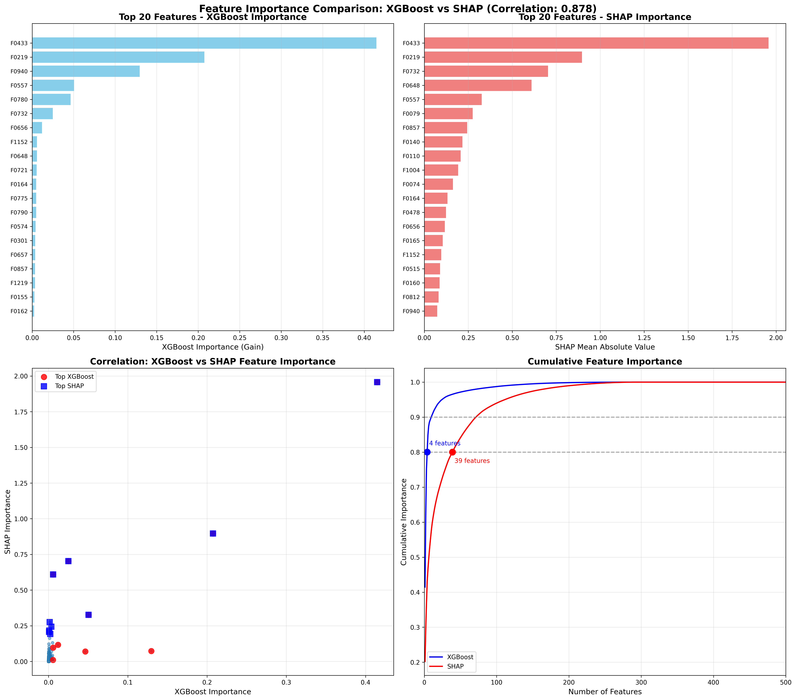
Fig 3. Global feature importance based on mean absolute SHAP values of model 1

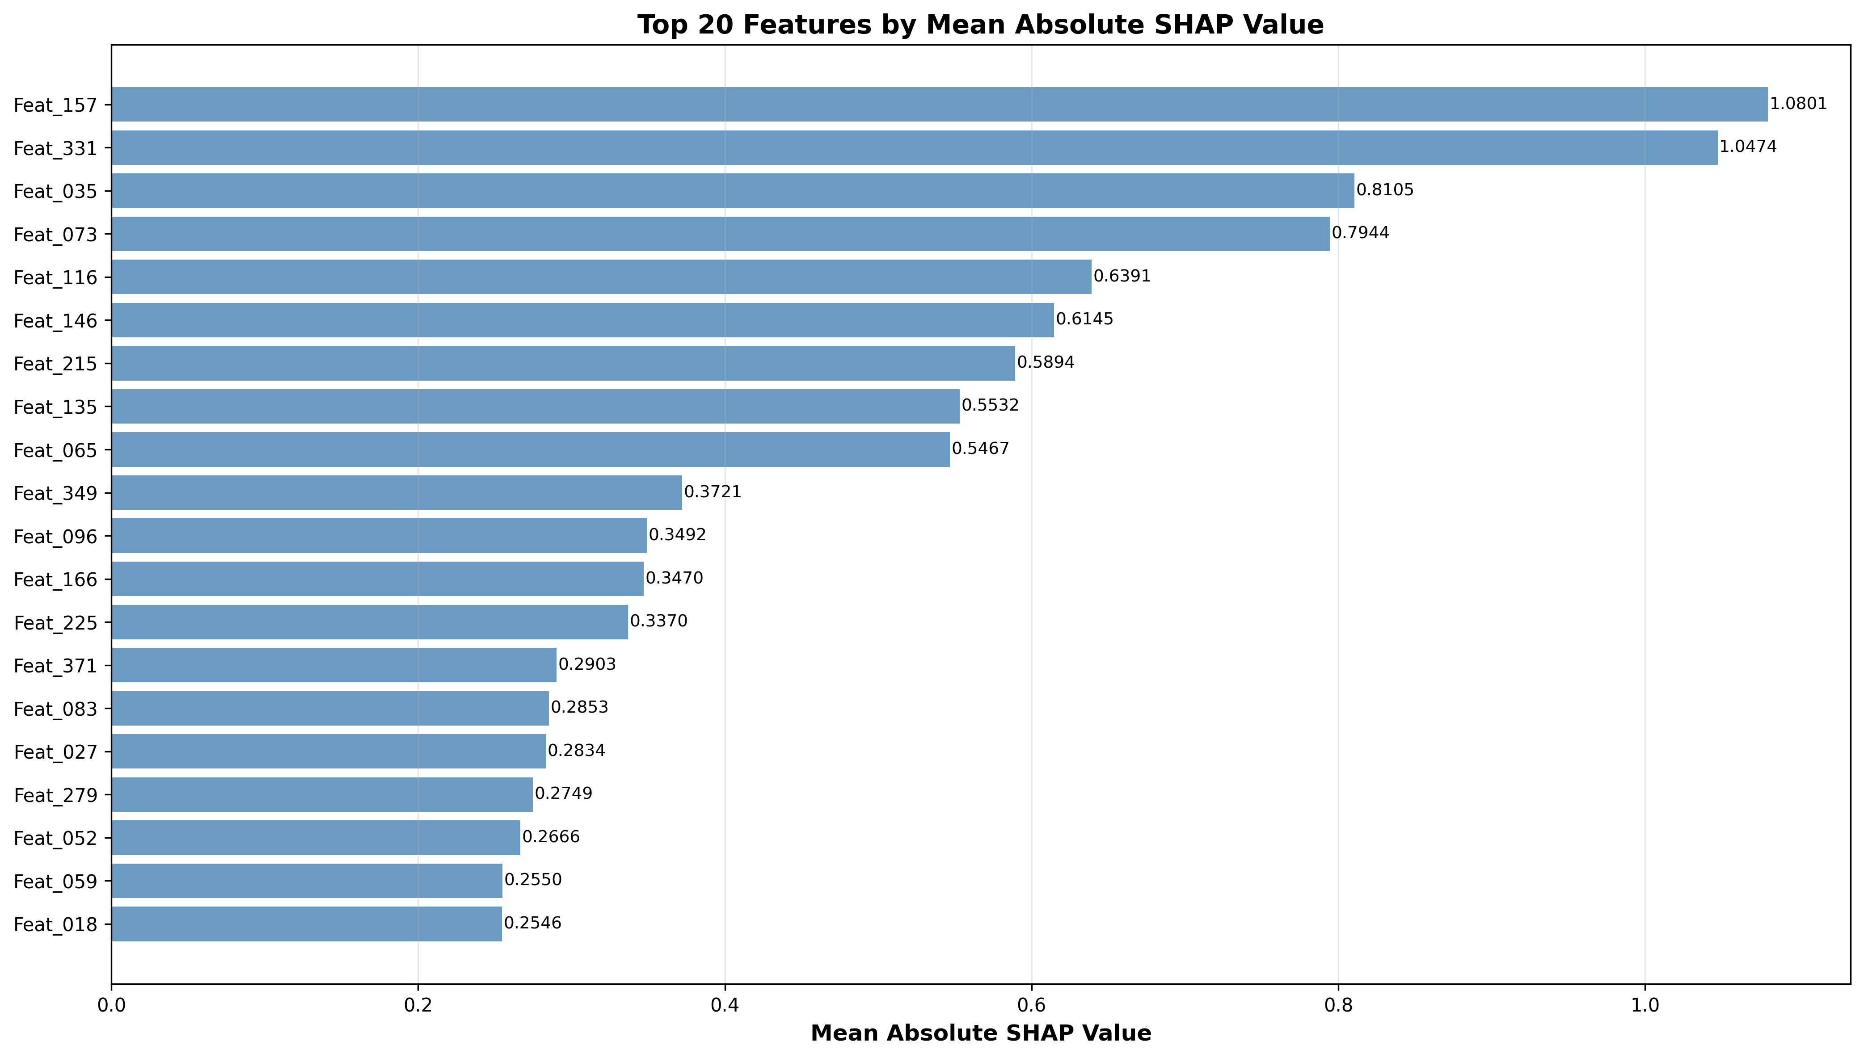
Feature importance in Model Hybrid 2 is distributed across the top features. Feature 157 with mean SHAP absolute value of 1.0801 and Feature 331 with 1.0474 form the dual leaders with similar levels of importance, followed by Feat_035 at 0.8105, Feat_073 at 0.7944, Feat_116 at 0.6391, and another 6 features whose importance was greater than 0.5. Such distribution stems from the global nature of the attention mechanism used by the transformer DeiT that spreads the discriminating information across many features.

Fig 4. Global features importance based on mean SHAP values of model 2
ii. Feature Interaction and Decision Logic
The SHAP dependence plot analysis of Hybrid Model 1 shows that there is a consistent directionality trend among all the top features, such that lower feature values tend to steer the prediction towards the Good category, whereas higher values tend to steer the prediction towards the Bad category. This behaviour is especially evident in F0433, in which the contribution values for lower feature values are around +1.7 (very Good), whereas for higher values are around -2.0 (very Bad), with F0219 as the best interactive feature.

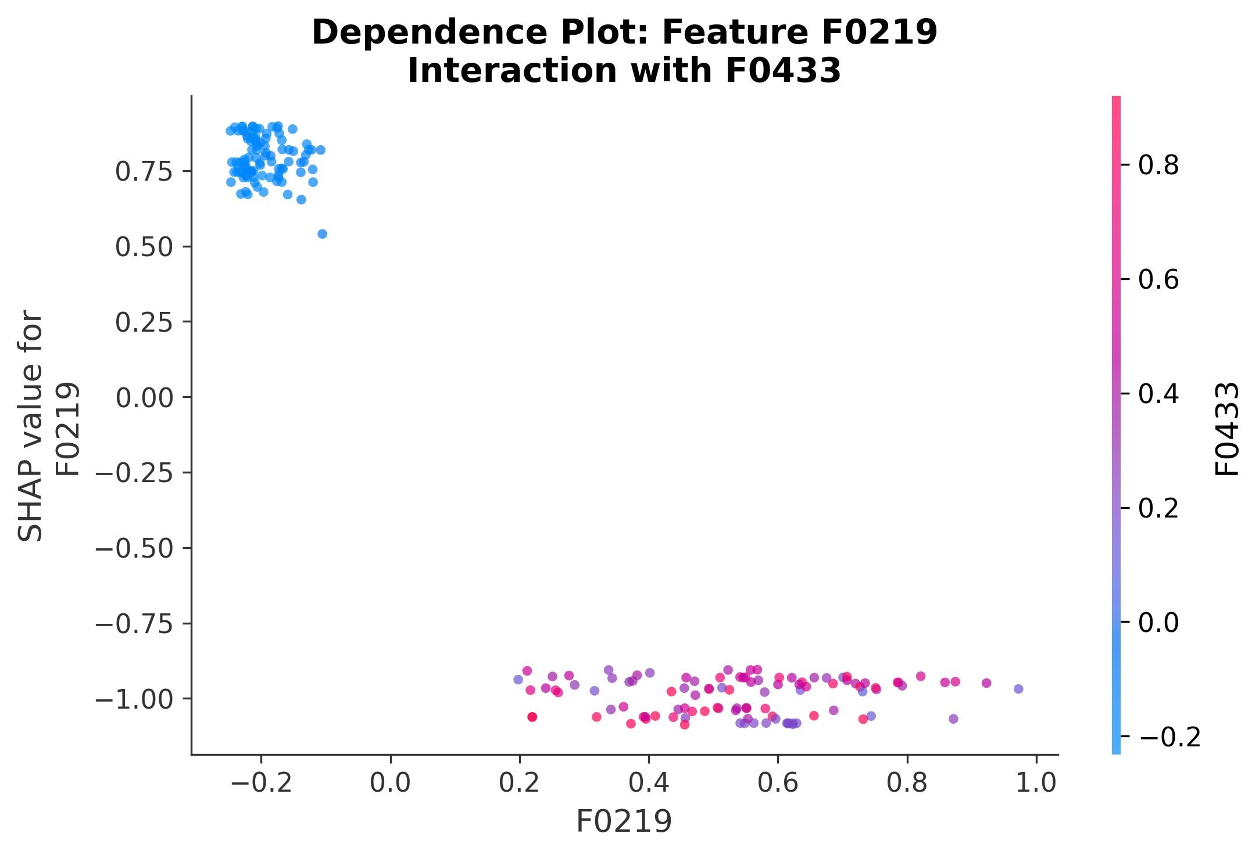

Fig 5. Dependency plot of model 1
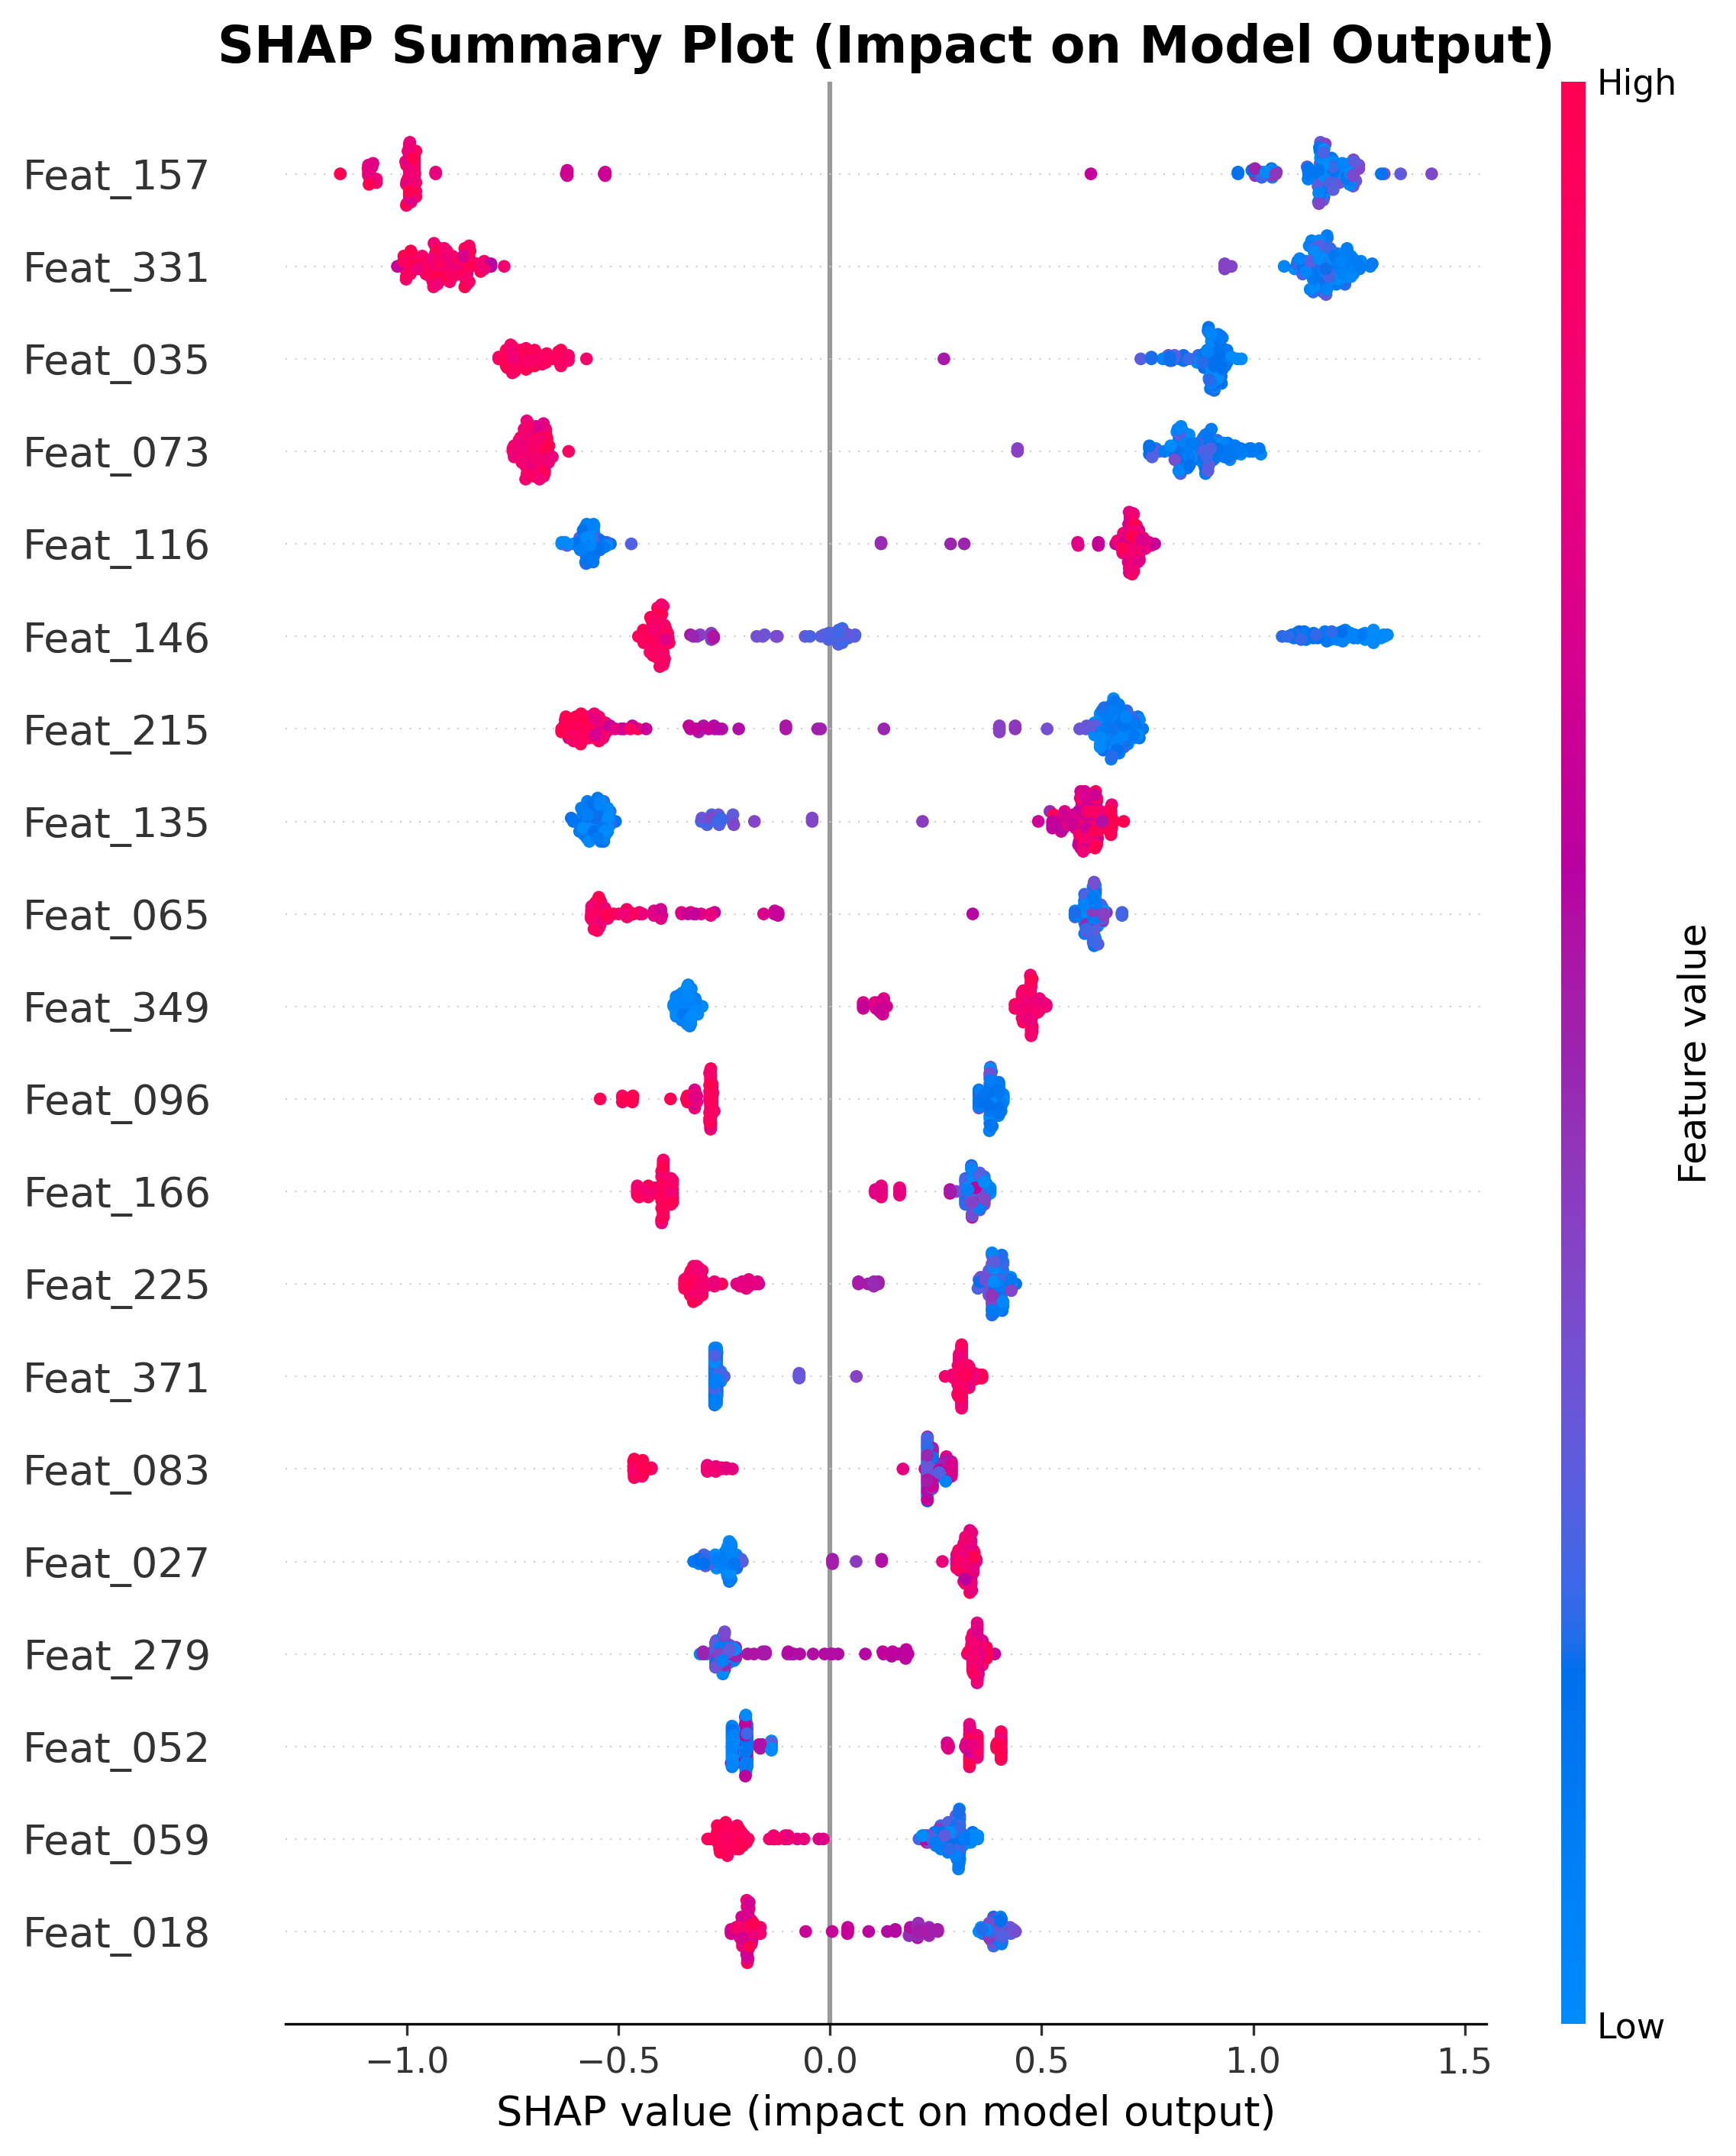
However, the bee swarm plot using SHAP scores for the Hybrid Model 2, as illustrated in Fig. 6, shows that there is some diversity in the directions: Feat_157 follows the regular trend (high scores - Good), whereas Feat_331 behaves in an opposing manner (high scores - Bad). Thus, the negative correlation found between the top two features implies a more complex structure for the DeiT encoder.

Fig 6. Bee-swarm plot of model 2
iii. Local (Sample-Level) Interpretability
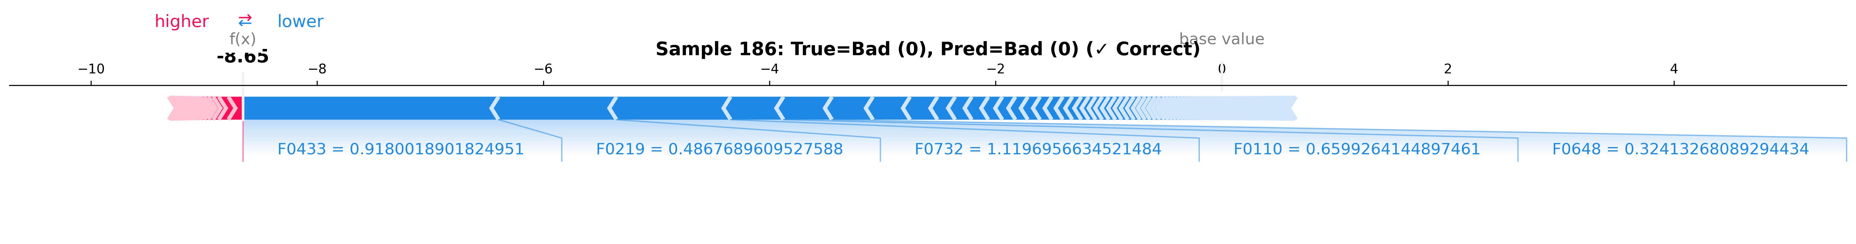
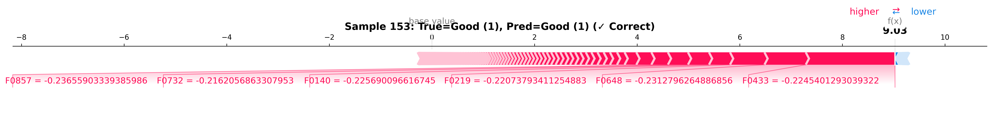
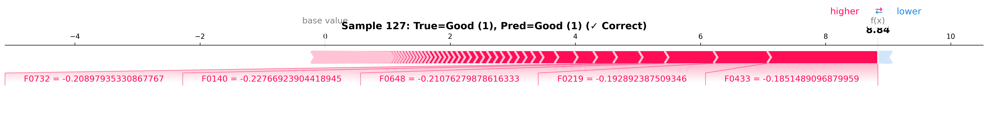
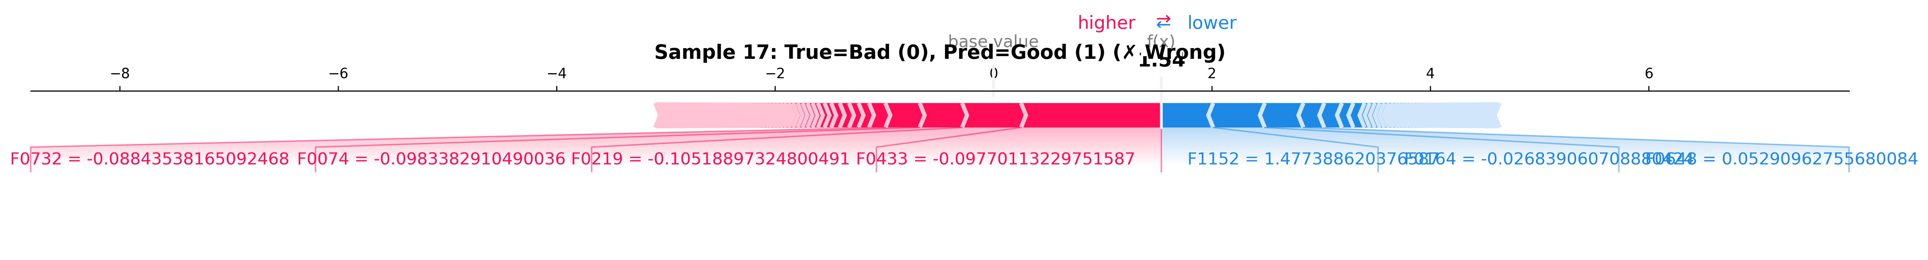
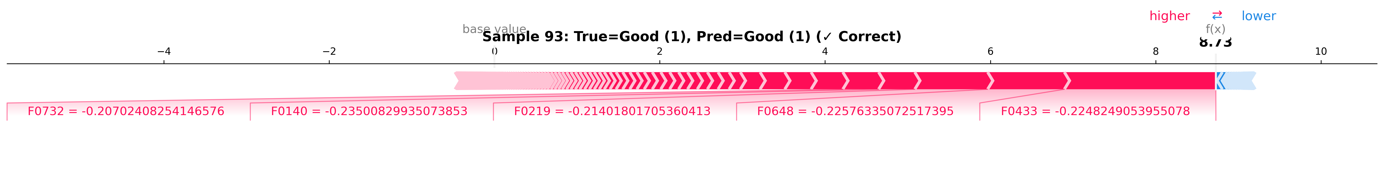
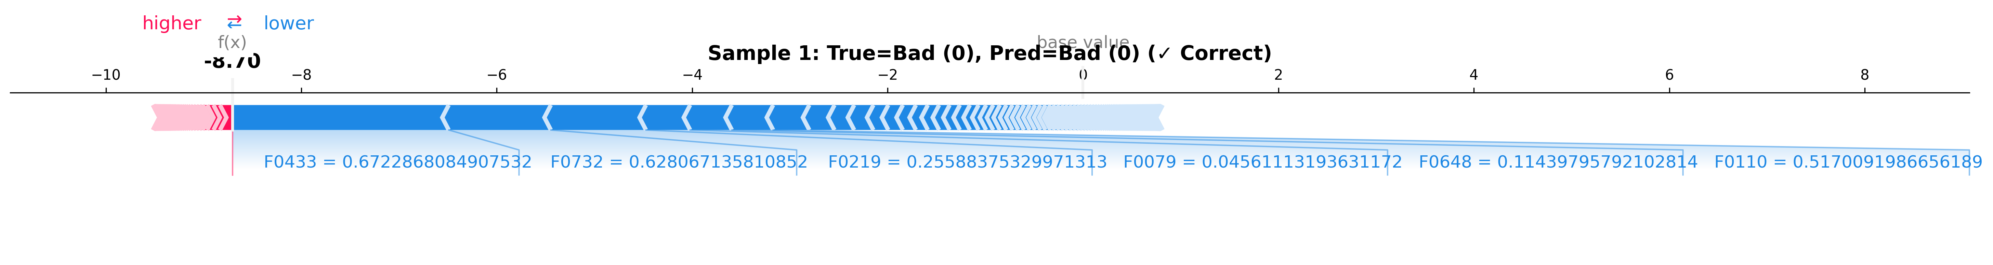
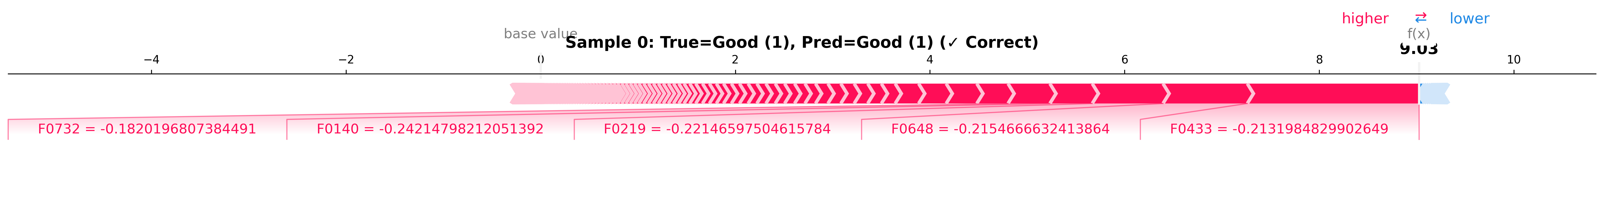
The force plot diagrams obtained by Hybrid Model 1 illustrate that the top features (F0732, F0140, F0219, F0648, F0433) all contribute towards the positive outcome of the correctly classified samples of Good category (samples 0, 93, 127, 153) with f(x) values between +8.73 and +9.03. For the correctly classified Bad samples (samples 1, 186), all the top features have been seen contributing towards the negative classification with the f(x) values of −8.70 and −8.65, respectively. One misclassified sample is also identified (sample 17). The true class of the sample was Bad, but the prediction was made as Good due to the anomalous contribution of F1152 (f(x) = +1.477).
Fig 7. Force plots for Hybrid Model 1

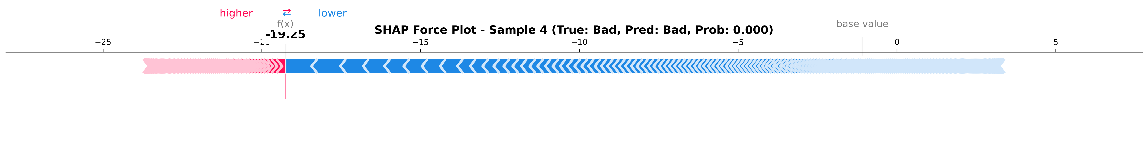
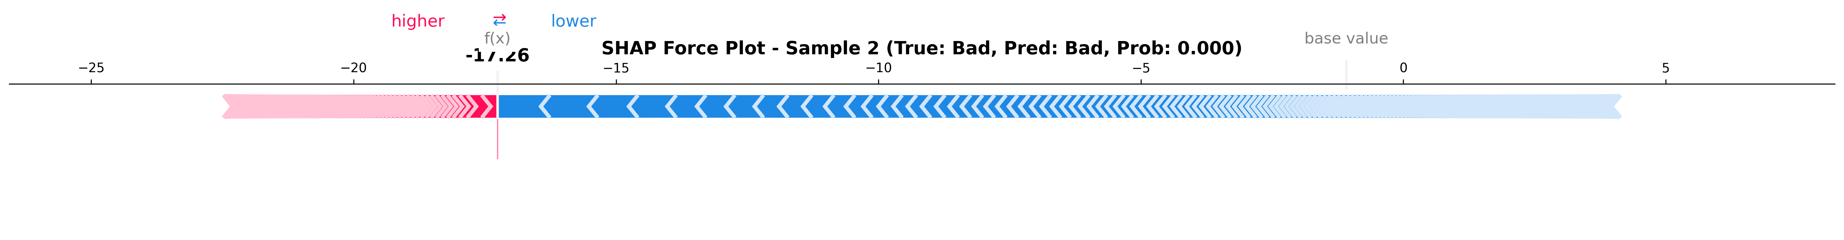
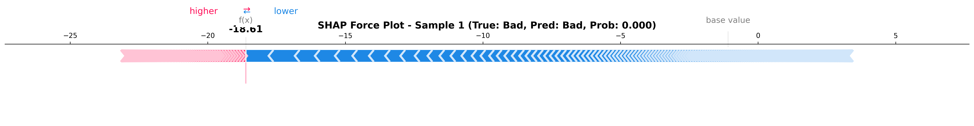
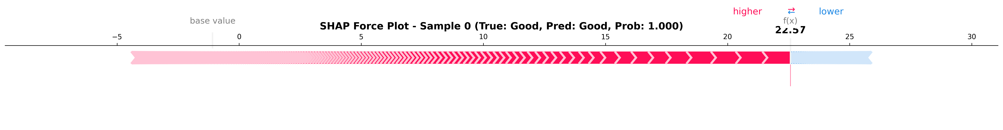
Fig 8. Force plot for Model 2
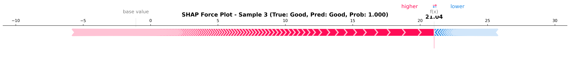
The force plots for the second hybrid model presented in Fig. 8 have significantly higher values for the output (values for f(x) between -19.25 and 22.57 compared to Model 1’s values between -8.70 and +9.03). This means that the combination of DeiT and MobileViT models creates a classification result with higher confidence in the prediction. All five images used are perfectly classified either as Bad or Good with probabilities equal to zero and one, respectively.
iv. Spatial Visualisation (Grad-CAM)
Grad-CAM heat-maps offer complementary spatial interpretability at an image-level scale. In the case of Hybrid Model 1, for a Bad quality sample (probability: 95.78%), activations are localized to the center of the yolk/core cavity section, particularly the portion where cut damage is apparent in the cross-sectional image. For a Good quality classification, activations span the clean yolk-white interface. In Hybrid Model 2, the prediction for Bad quality (95.1% confidence) exhibits activation clustering towards the bottom white area and interior shell boundary, whereas the Good quality prediction (95.3% confidence) generates scattered and broken activation patterns in both the yolk-white junction and white edges areas. This difference in spatial attention between both models is significant for architectural purposes, since the CNN architecture of Model 1 detects local structural defects, while the DeiT architecture of Model 2 captures peripheral regions, which aligns with the global attention system of the transformer architecture. The region that both models detect contains relevant information about the problem and not the background.

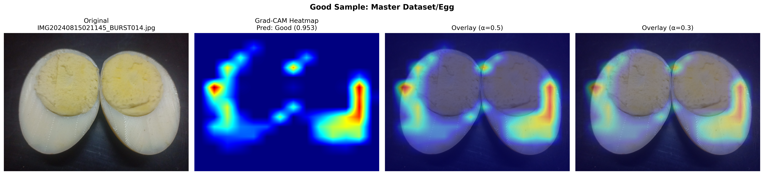
Fig 9. Grad-CAM heat maps of Model 1
Fig 10. Grad-CAM heat maps of Model 2
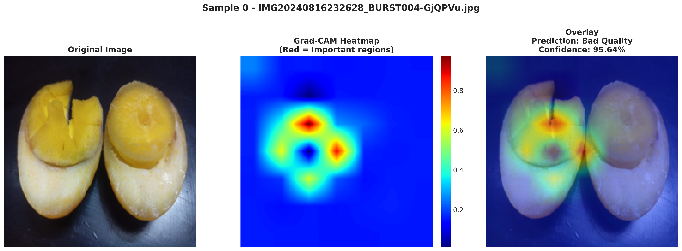
E. Discussion: Comparative Analysis
Table VI: Summary Comparison — Hybrid Model 1 vs. Hybrid Model 2
Feature / Metric | Hybrid Model 1 (EfficientNetV2M + MobileViT) | Hybrid Model 2 (DeiT + MobileViT)
Best Accuracy | 99.16% | 98.98%
AUROC Score | 0.9996 | 0.9994
Precision / Recall | 0.9916 / 0.9916 | 0.9898 / 0.9898
Training Time (Total) | ~10.1 Hours | ~3.89 Hours
Feature Dimension | ~98.69% | 98.98%
Convergence Speed | Moderate (Steady growth) | Fast (Plateau at Epoch 5)

From the experiments above, we can conclude that the Hybrid Model 1 is more accurate and effective in the case of no-optimiser mode due to the better local texture and edge detection of EfficientNetV2M. At the same time, the Hybrid Model 2 has a greater effect on optimisation, as this model has achieved the best FPR value (~1.02%) and trained in the shortest time (~3.9 hours) among the presented models. Therefore, it can be said that the architecture of DeiT is more flexible with respect to a comprehensive analysis using hyper-parameter tuning. From an implementation perspective, the system designer will use Hybrid Model 1 when accuracy is key and Hybrid Model 2 when there is FPR limitation or efficiency concern. Although neither of the two models benefited much from BOHB/Optuna, the difference in the results between the optimised and unoptimised modes proves that these models are close to their performance limit.

F. Benchmarking Against Prior Literature
Table VII: Benchmarking with Existing Literature
Study | Model | Dataset | Accuracy | AUROC | XAI
Kumar et al. [11] | EfficientNet-B4 | 20,000 images, meat/dairy | 94.7% | Not reported | No
Singh et al. [12] | MobileNetV3 | 5 fruit categories | 91.8% | Not reported | No
Wang et al. [15] | MobileViT-v2 | Multi-category food freshness | 96.3% | Not reported | No
Wang et al. [15] | MobileViT + EfficientFormer (ensemble) | Multi-category food freshness | 97.8% | Not reported | No
Anderson et al. [14] | ResNet-50 + Swin Transformer | Multi-crop quality dataset | 95.4% | Not reported | No
Patel et al. [9] | ResNet-50 | 8,000 images, 3 food types | ~87% | Not reported | No
Proposed Work — Hybrid Model 1 | EfficientNetV2M + MobileViT + XGBoost | Multi-category (~30 GB), 7 food types | 99.30% | 0.9996 | SHAP + Grad-CAM
Proposed Work — Hybrid Model 2 | DeiT (Small) + MobileViT + XGBoost | Multi-category (~30 GB), 7 food types | ~99.16% (est.) | 0.9994 | SHAP + Grad-CAM

References

[1] J. Smith et al., "Food safety and quality in the supply chain," Food Control, 2023.

[2] A. Brown et al., "Reducing food waste using computer vision," Journal of Food Engineering, 2024.

[3] C. Davis et al., "Non-destructive food quality assessment: A survey," IEEE Access, 2023.

[4] E. Wilson et al., "Generalisation challenges in deep learning for food recognition," Computers and Electronics in Agriculture, 2024.

[5] F. Lee et al., "Trust and interpretability in ML for food safety," Expert Systems with Applications, 2025.

[6] G. Zhang et al., "Vision transformers for image classification," ICCV, 2021.

[7] H. Liu et al., "Explainable AI in healthcare and agriculture," Pattern Recognition, 2024.

[8] I. Martinez et al., "Regulatory aspects of AI in food quality," Trends in Food Science & Technology, 2025.

[9] K. Patel et al., "CNN vs traditional ML for food freshness," Springer LNCS, 2023.

[10] L. Chen et al., "Deep learning for food quality: A review," Food Research International, 2024.

[11] M. Kumar et al., "ResNet and EfficientNet for spoilage detection," IEEE Trans. Agri. Informatics, 2023.

[12] N. Singh et al., "MobileNet for edge food classification," Sensors, 2024.

[13] O. Kim et al., "Transformer-based food recognition," ECCV Workshop, 2024.

[14] P. Anderson et al., "Hybrid CNN-Transformer for agriculture," Computers and Electronics in Agriculture, 2025.

[15] Q. Wang et al., "MobileViT and variants for food analysis," IEEE Access, 2024.

[16] R. Tan et al., "EfficientNetV2: Smaller models and faster training," ICML, 2021.

[17] S. Liu et al., "ConvNeXt and modern CNNs," CVPR, 2022.

[18] T. Nguyen et al., "EfficientNet in practice," Journal of Imaging, 2023.

[19] U. Dosovitskiy et al., "An image is worth 16x16 words," ICLR, 2021.

[20] V. Touvron et al., "DeiT: Data-efficient image transformers," ICML, 2021.

[21] W. Yuan et al., "MobileViT: Light-weight vision transformer," ICLR, 2022.

[22] X. Zhao et al., "Hybrid CNN-Transformer architectures," Pattern Recognition, 2024.

[23] Y. Zhou et al., "Grad-CAM and variants for explainability," ICCV, 2019.

[24] Z. Lundberg et al., "SHAP: A unified approach to interpretability," NeurIPS, 2017.

[25] A. Gupta et al., "Interpretability in food quality AI," Food Control, 2025.

[26] S. M. Lundberg and S.-I. Lee, "A unified approach to interpreting model predictions," NeurIPS, 2017.

