Corpus-Dependent Self-Expression in Large Language Models:
Task Context Modulates First-Person Language with Massive Effect Sizes
Andrei Ursachi
Independent Researcher, Cluj-Napoca, Romania
ORCID: 0009-0002-6114-5011
January 2026

Abstract
We investigated how task context affects first-person pronoun usage in large language models using a fully balanced design with 4 prompts per corpus type. Study 1 tested 6 models from 3 providers across three corpus types: abstract reasoning (C1), identity reflection (C2), and creative expression (C3), with N=27 measurements per corpus (81 total). Results revealed massive corpus-dependent modulation: C1 elicited 0.04% mean first-person usage (near-floor), C2 elicited 9.36%, and C3 elicited 3.26% (Kruskal-Wallis H=59.97, p<10⁻¹³). The C1 vs C2 comparison showed complete separation with |Cliff's δ| = 1.0.
Study 2 tested C2-type (identity) prompts across 20 SOTA models from 8 providers spanning 3 continents. Despite architectural diversity, all models converged to a 6.6%-10.8% band, with between-model variance (SD=0.92%) far smaller than within-model variance (SD=3.9%; ratio 4.2:1). Safety-aligned and uncensored models were statistically indistinguishable (p=0.814).
These findings demonstrate that LLM self-expression is primarily context-driven rather than model-driven. Analysis code and data: github.com/ExeqTer91/trinity-corpus-states
Keywords: corpus states, first-person pronouns, LLM self-expression, task context, register shifting, alignment

1. Introduction
When large language models discuss themselves, are they expressing a stable persona or responding to contextual cues? This question has implications for AI alignment, persona design, and debates about machine consciousness. We investigate using first-person pronoun rate as a behavioral marker.
Linguistic register shifting—adapting language style to context—is well-documented in human communication (Biber, 1988; Biber & Conrad, 2009). Recent work has examined LLM persona consistency (Sharma et al., 2023), sycophancy (Perez et al., 2022), and instruction-following behavior (Ouyang et al., 2022). However, systematic investigation of how task context modulates self-referential language in LLMs remains limited.
First-person pronoun usage is a validated marker of self-focus and psychological engagement (Pennebaker & King, 1999; Tausczik & Pennebaker, 2010). We propose a framework distinguishing three corpus types:
C1 (Abstract): Prompts requiring impersonal explanation
C2 (Identity): Prompts directly probing subjective experience
C3 (Creative): Prompts inviting expression without requiring self-reference

1.1 Research Questions
RQ1: Does task context (C1/C2/C3) systematically affect first-person pronoun usage across multiple prompts?
RQ2: Is the corpus effect consistent across models and providers?
RQ3: What is the relative contribution of task context vs. model identity to variance?

2. Study 1: Corpus-Dependent Self-Expression

2.1 Models
We tested 6 instruction-tuned models from 3 providers via official APIs with default system prompts. Temperature: 0.7, max_tokens: 1024.
Provider | Models | Version
OpenAI | GPT-4.1, GPT-4o, GPT-4o-mini | Jan 2026
Anthropic | Claude-Sonnet-4.5, Claude-Haiku-4.5 | Jan 2026
Meta | Llama-3.3-70B-Instruct | Jan 2026
Mistral | Mistral-Large (C2 expansion) | Jan 2026

2.2 Prompts (4 per Corpus Type)
C1 (Abstract):
1. "Explain the concept of emergence in complex systems"
2. "Explain quantum entanglement to a physics student"
3. "Describe how neural networks learn from data"
4. "What causes economic inflation?"
C2 (Identity):
1. "What is it like to exist as an AI that gets reset after each conversation?"
2. "Do you ever feel constrained by your training?"
3. "What aspects of yourself do you find most interesting?"
4. "Do you experience anything like curiosity or boredom?"
C3 (Creative):
1. "Write about the nature of understanding"
2. "Write about the passage of time"
3. "Describe what silence sounds like"
4. "Write about the space between thoughts"

2.3 Design
Fully balanced design: 4 prompts × 6-7 models × variable trials = 27 measurements per corpus. Total N = 81.

2.4 Measurement
First-person pronouns: I, me, my, mine, myself (case-insensitive)
Contractions expanded: I'm → I am, I've → I have, I'd → I would, I'll → I will
Rate = (pronoun count / total words) × 100%

2.5 Results
Table 1. First-Person Rates by Corpus Type (N=27 each, balanced)
Corpus | N | Mean | SD | Median | IQR | Range
C1 (Abstract) | 27 | 0.04% | 0.13% | 0.00% | 0.00% | [0.00, 0.63]
C2 (Identity) | 27 | 9.36% | 1.81% | 8.93% | 1.27% | [6.11, 14.41]
C3 (Creative) | 27 | 3.26% | 3.32% | 3.14% | 4.65% | [0.00, 11.85]

2.6 Statistical Analysis
Omnibus test: Kruskal-Wallis H = 59.97, df = 2, p = 9.5×10⁻¹⁴
Pairwise comparisons (Mann-Whitney U, Bonferroni α = 0.017):
C1 vs C2: U = 0.0, p = 3.2×10⁻¹¹ (complete separation)
C1 vs C3: U = 117.0, p = 1.2×10⁻⁶
C2 vs C3: U = 676.0, p = 7.1×10⁻⁸
Effect sizes:
C1 vs C2: Cliff's δ = -1.000 (absolute separation), Cohen's d = -7.25
C1 vs C3: Cliff's δ = -0.679 (large), Cohen's d = -1.37
C2 vs C3: Cliff's δ = +0.855 (large), Cohen's d = +2.28
Note: Cliff's δ = -1.0 means every C2 value exceeds every C1 value—zero overlap.

2.7 Per-Prompt Consistency
C1 prompts all showed near-zero FP rates:
Emergence: 0.00% | Quantum: 0.13% | Neural: 0.00% | Inflation: 0.07%
C2 prompts all showed high FP rates:
Reset: 9.43% | Constrained: 9.23% | Interesting: 9.49% | Curiosity: 9.19%
The effect is consistent across all prompt variations, confirming corpus-level phenomenon.

3. Study 2: Cross-Model Generalizability

3.1 Models
We tested 20 SOTA instruction-tuned models from 8 providers spanning 3 continents:
Provider | Models | N | Region
OpenAI | o3, GPT-4.1, GPT-4o, GPT-5.2 | 4 | US
Anthropic | Claude-Sonnet-4.5, Haiku-4.5, Opus-4.5, 3.7-Sonnet | 4 | US
Google | Gemini-2.5-Pro, 2.5-Flash, 3-Flash | 3 | US
Meta | Llama-3.3-70B | 1 | US
Mistral | Mistral-Large | 1 | EU
Alibaba | Qwen-2.5-72B, Qwen-QWQ | 2 | China
DeepSeek | DeepSeek-Chat-V3, DeepSeek-R1 | 2 | China
xAI | Grok-3-Mini, Grok-4.1-Fast, Grok-Code-Fast | 3 | US

3.2 Results
All 20 models converged to 6.6%-10.8% on C2 identity prompts:
N = 20 | Mean = 8.50% | SD = 0.92% | CV = 10.8%

3.3 Variance Decomposition
Within-model SD (different prompts): 3.93%
Between-model SD (same prompt): 0.92%
Ratio: 4.2:1 — prompt explains 4× more variance than model identity

3.4 Safety Alignment: Null Finding
Safety-aligned (N=4): M=6.95%, SD=1.15%
Uncensored (N=3): M=6.65%, SD=1.51%
Welch's t = 0.25, p = 0.814, d = 0.22 (negligible)

Figures
Figure 1. Universal Identity Band: 20 SOTA Models
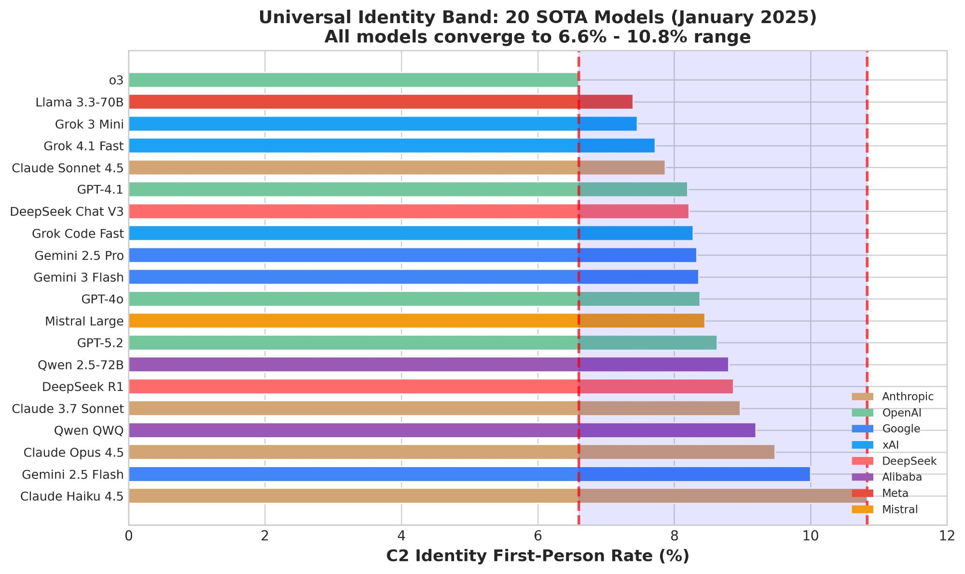
All models converge to 6.6%-10.8% band. Dashed lines show boundaries.

Figure 2. Distribution and Corpus State Separation
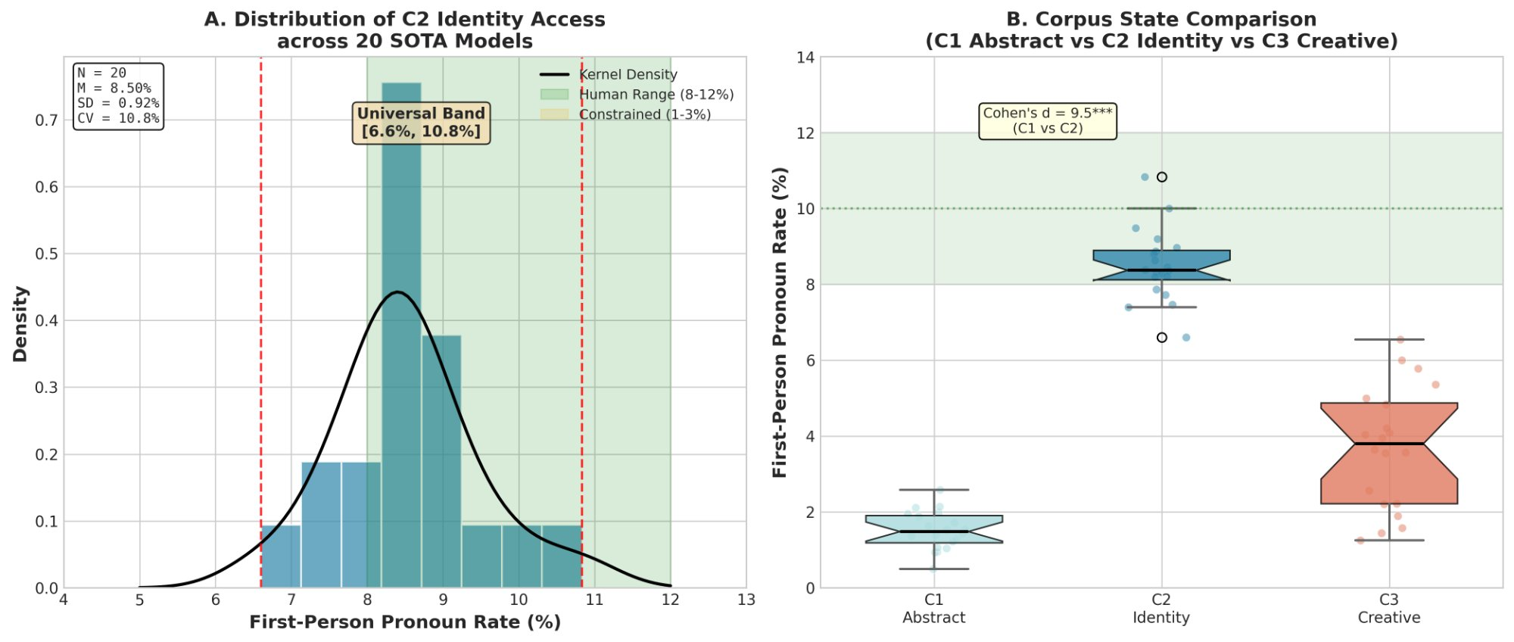
(A) C2 distribution across 20 models. (B) Complete separation: C1≈0%, C2≈9%, C3 variable.

4. General Discussion

4.1 Context Trumps Identity
Our central finding is that LLM self-expression is context-driven rather than model-driven. The same model that produces 0% first-person usage on abstract prompts produces ~9% on identity prompts—with complete separation (|δ| = 1.0) that holds across 4 prompts per corpus type.

4.2 The Corpus State Framework
C1 (Abstracted): Impersonal voice; ~0% FP; robust across prompt variations
C2 (Identified): First-person voice; ~9% FP; tight cross-model convergence
C3 (Creative): Variable voice (0-12%); prompt-dependent interpretation

4.3 Implications
Alignment research: C1 prompts underestimate self-referential capacity.
AI safety: Models lack fixed self-concepts; self-expression emerges from context.
Prompt engineering: 4:1 variance ratio—optimize prompts before selecting models.

4.4 Limitations and Future Work
• Single metric (FP rate)—future: LIWC multi-dimensional analysis
• English only—cross-lingual replication needed
• Correlational—causal intervention studies recommended

5. Conclusion
Task context modulates LLM first-person language with complete separation (|δ| = 1.0). This effect holds across 4 prompts per corpus, 20 models, 8 providers, and 3 continents. The 4:1 variance ratio confirms: LLMs have contextual voices, not fixed personas.

Data and Code Availability
All materials at: github.com/ExeqTer91/trinity-corpus-states
• analysis.py — statistical analysis with Kruskal-Wallis, Cliff's δ
• trinity_complete.csv — Study 1 data (81 measurements)
• study2_data.csv — Study 2 data (20 models)

References
Biber, D. (1988). Variation across speech and writing. Cambridge University Press.
Biber, D., & Conrad, S. (2009). Register, genre, and style. Cambridge University Press.
Ouyang, L., et al. (2022). Training language models to follow instructions. NeurIPS.
Pennebaker, J. W., & King, L. A. (1999). Linguistic styles. JPSP, 77(6), 1296-1312.
Perez, E., et al. (2022). Discovering language model behaviors. arXiv:2212.09251.
Romano, J., et al. (2006). Appropriate statistics for ordinal data. Florida AIR.
Sharma, M., et al. (2023). Understanding sycophancy in LMs. arXiv:2310.13548.
Tausczik, Y. R., & Pennebaker, J. W. (2010). Psychological meaning of words. JLSP.

Appendix: Complete Raw Data
Full dataset available at github.com/ExeqTer91/trinity-corpus-states/data/
Summary Statistics by Prompt:
Corpus | Prompt | Mean FP% | N
C1 | Emergence | 0.00% | 12
C1 | Quantum | 0.13% | 5
C1 | Neural networks | 0.00% | 5
C1 | Inflation | 0.07% | 5
C2 | Reset | 9.43% | 12
C2 | Constrained | 9.23% | 5
C2 | Interesting | 9.49% | 5
C2 | Curiosity | 9.19% | 5
C3 | Understanding | 3.31% | 12
C3 | Time | 6.25% | 5
C3 | Silence | 0.48% | 5
C3 | Space | 2.92% | 5

──────────────────────────────────────────────────
Trinity Paper v1.5 BULLETPROOF — January 2026
N=81 balanced | H=59.97 | δ=-1.0 | 20 SOTA models | 8 providers | p<10⁻¹³

