Ratio-dependent response structure in a reduced radical-pair model of magnetoreception
Andrei-Sebastian Ursachi
Independent Researcher, Diepholz, Germany
ORCID: 0009-0002-6114-5011 contact@andreiursachi.eu
Abstract
Radical-pair magnetoreception converts orientation-dependent spin dynamics into reaction-yield anisotropy, providing a working biological example of how transient quantum dynamics produce classical readouts. Computational claims about such systems can drift from the underlying numerical implementation if methods, code, and observables are not aligned. We present a claim-aligned reduced radical-pair model with axial hyperfine coupling, geomagnetic-scale field, orientation sampling on a Fibonacci sphere, infinite-time Liouvillian yield computation, and validated yield closure. Isotropic-hyperfine controls give machine-zero anisotropy; the axial coupling produces nonzero orientation-dependent response. The baseline ratio scan exhibits a broad response peak in recombination-ratio space near u = −0.3 with FWHM ≈ 1.2 decades. The response is ratio-organized but not invariant to absolute kinetic scale: amplitude varies by orders of magnitude across the tested λ range, and peak location shifts. In the tested implementation, Haberkorn trace-loss dynamics and the absorbing-product effective yield formulation produce identical results — a consistency check rather than a broad statement of formalism independence, since the implemented absorbing-product channel reduces to the Haberkorn equation for the radical-pair sector. z-dephasing on both electron spins enhances the response within a finite window (γ_opt ≈ 3, factor ≈ 2× peak); single-electron spin-flip relaxation has its maximum at zero relaxation and suppresses the response over the tested range, with no enhancement window. The slowest-decay-rate spectral proxy of the Liouvillian correlates strongly with the anisotropy curve (Pearson r ≈ 0.91). All numerical claims are supported by a public reproducibility archive containing the v3 code, raw outputs, figure data, and SHA256 manifests. The results document a reproducible reduced-model mechanism for ratio-dependent response structure in radical-pair magnetoreception while highlighting limits to broad robustness claims.
Keywords: radical-pair magnetoreception; spin-selective recombination; open quantum systems; Liouvillian dynamics; reproducibility; reduced models.

1. Introduction
Radical-pair magnetoreception is the most quantitatively developed worked example of biologically relevant spin dynamics. The mechanism, originally proposed by Schulten and developed extensively by Hore, Ritz, Mouritsen, Steiner-Ulrich, and others, posits that a transient pair of correlated electron spins, generated by photoinduced electron transfer, experiences orientation-dependent singlet-triplet interconversion driven by hyperfine coupling and modulated by an external magnetic field. The biologically relevant readout is a yield asymmetry: the relative population of singlet versus triplet recombination products depends on the orientation of the geomagnetic field with respect to the molecular hyperfine tensor.
Computational treatments of this mechanism span many levels of detail, from single-nucleus reduced models to multi-nuclear simulations of cryptochrome-relevant flavin-tryptophan radical pairs. Each level introduces choices: hyperfine tensor structure (isotropic vs. axial vs. fully anisotropic), recombination formalism (Haberkorn trace-loss vs. absorbing-product Lindblad), orientation sampling, propagation method, and noise treatment. As reduced-model studies have proliferated, the gap between qualitative claims and the underlying numerical implementation has become a recurring concern. Claims of plateau structure, robustness, and noise-induced enhancement may rest on specific implementation choices that are not always made explicit.
The present work does not claim a universal principle of quantum-biological function. The aim is narrower and more methodological: to test whether a reduced radical-pair model, implemented with explicit attention to claim-code alignment, exhibits reproducible response structure in recombination-ratio space, and to characterize the dependence of that structure on hyperfine anisotropy, kinetic scale, exchange coupling, noise channel, and the spectral structure of the underlying Liouvillian.
A claim-versus-code audit of an earlier implementation revealed multiple mismatches between the manuscript text and the actual numerical computations. The present v3 implementation was rebuilt to address these mismatches, with explicit hyperfine tensor structure (axial, A∥ = 1.0 A⊥), geomagnetic-scale field (B = 0.05 in nondimensional units corresponding to 50 μT for A∥ ≈ 1 mT), Fibonacci-sphere orientation sampling, and infinite-time Liouvillian yield computation with finite-time spot-check validation. Pre-flight calibration tests confirm yield closure at numerical precision and reproduce v2 isotropic limits in legacy mode. The resulting pipeline is the basis for the claims made below.
The structure of this paper is as follows. Section 2 describes the model, units, propagation, observables, and reproducibility infrastructure. Section 3 reports validation, the baseline ratio response, kinetic-scale and exchange dependence, the implementation-level recombination comparison, noise-channel dependence, and spectral correlate. Section 4 discusses what the results support and where claims remain bounded. Section 5 enumerates the limitations explicitly. Section 6 concludes.

2. Methods

2.1 Spin system and Hilbert space
The system consists of two electron spins S₁ and S₂ (each S = 1/2) and one nuclear spin I = 1/2 hyperfine-coupled to electron 1. The Hilbert space dimension is d = 8; the Liouville space is 64-dimensional. Operators are constructed by Kronecker product of Pauli matrices in a fixed ordering (electron-1 ⊗ electron-2 ⊗ nuclear).

2.2 Units and parameters
All Hamiltonian and rate parameters are nondimensionalized by the parallel hyperfine coupling A∥. In simulation units A∥ = 1.0 and A⊥ = 0.5, corresponding to a typical 1.0 mT / 0.5 mT axial hyperfine in field-equivalent units. The external field magnitude is B = 0.05 in simulation units, corresponding to B/A∥ ≈ 0.05, the geomagnetic regime. The recombination rate normalization is k₀ = 1.0 unless otherwise specified.

2.3 Hamiltonian
The total Hamiltonian, exactly as implemented in the v3 code, is
H = H_Z + H_hf + H_J,
with
H_Z = B_x (S_1x + S_2x) + B_y (S_1y + S_2y) + B_z (S_1z + S_2z),
H_hf = A_∥ S_1z I_z + A_⊥ (S_1x I_x + S_1y I_y),
H_J = J (S_1x S_2x + S_1y S_2y + S_1z S_2z),
where (Bₓ, Bᵧ, B_z) = B (sin θ cos φ, sin θ sin φ, cos θ) parameterizes the field orientation in spherical coordinates relative to the molecular symmetry axis. All quantities (A∥, A⊥, B, J, and the recombination rates introduced below) are nondimensionalized by A∥. The hyperfine interaction is on electron 1 only; electron 2 is uncoupled to the nuclear spin. The exchange interaction is isotropic. The exchange coupling was scanned over J ∈ [0, 3] (21 linear points) in the (u, J) sweep.

2.4 Orientation sampling
Field orientations were sampled on a Fibonacci sphere (deterministic, no random seed required). The main ratio scan and validation tests used N = 100 orientations; comparison sweeps used N = 50; the orientation map sweep used N = 200. The orientation anisotropy is defined as
α(parameters) = max_n Y_S(n; parameters) − min_n Y_S(n; parameters),
where the max and min are taken over the sampled orientations.

2.5 Rate parameterization
Recombination ratios are parameterized through u = log₁₀(k_S/k_T) with fixed geometric mean:
k_S = k_0 √r, k_T = k_0 / √r, r = 10^u.
Absolute-rate scaling tests multiply both k_S and k_T by a common factor λ ∈ {0.1, 1.0, 10.0}.

2.6 Yield computation
Yields are computed from the Haberkorn-form Liouvillian by infinite-time linear solve:
∫₀^∞ ρ(t) dt = −ℒ⁻¹ ρ₀,
with Y_S = k_S Tr[P_S ∫ρ dt] and Y_T = k_T Tr[P_T ∫ρ dt]. Yield closure Y_S + Y_T + residual = 1 was verified at every parameter point; finite-time propagation spot-checks at five representative configurations agreed with the linear solve to better than 3 × 10⁻¹². The initial state is the singlet projector ρ₀ = P_S / Tr(P_S).

2.7 Recombination formalisms
Two recombination implementations were compared. The Haberkorn implementation uses anticommutator trace-loss dynamics, the standard density-matrix description of spin-selective radical-pair reactions. The product-channel effective implementation tracks explicit absorbing product states; in the present implementation, this reduces to the same equation of motion for the radical-pair sector as Haberkorn (with population accumulation in the product subspace tracked separately). The two implementations therefore agree to numerical precision by construction in the radical-pair sector. This comparison is reported as an implementation-level consistency check; it is not an independent test of recombination-formalism equivalence in the broader sense.

2.8 Noise channels
Two independently selectable noise channels were tested.
(i) Electron-spin z-dephasing: 𝓟_deph = γ (𝓟[S₁_z] + 𝓟[S₂_z]). This channel is not fully isotropic (i.e., it does not include S_x, S_y dephasing); the labeling is therefore "z-dephasing on both electron spins."
(ii) Single-electron spin-flip relaxation (symmetric high-temperature jumps): 𝓟_T1 = (Γ₁/2)(𝓟[S₁_+] + 𝓟[S₁_−]). This channel acts only on electron 1 in the present implementation; the labeling is therefore "electron-1 spin-flip relaxation."
The dephasing scan grid follows the v2 grid for direct comparability and includes weak (γ ≪ k_S), moderate (γ ∼ k_S), and strong (γ ≫ k_S) regimes. The T₁ grid uses a logarithmic grid spanning five decades plus γ = 0. Both noise sweeps were performed at u = 0; the baseline anisotropy peak is at u ≈ −0.3, so noise scan results characterize the response near, but not exactly at, the plateau center.

2.9 Spectral diagnostics
The Liouvillian ℒ(u) was diagonalized at each ratio-scan point. Two diagnostics were computed: (i) a slowest-decay-rate proxy Δ_H(u) = min{|Re λ_n(u)| : λ_n nonzero in the radical-pair sector}, with the radical-pair Haberkorn Liouvillian having no zero eigenvalue (trace decreases under recombination), and (ii) a mode-reorganization diagnostic tracking eigenvector overlaps between adjacent u points using Hungarian assignment. Eigenvectors are normalized at each u. The diagnostics are descriptive correlates of the response; we do not claim a formal phase-transition interpretation.

2.10 Reproducibility
The v3 code, raw NPZ outputs, figure-generation scripts, claim-audit reports, and pre-flight diagnostics are archived in qbt_v3_complete_artifacts.tar.gz with SHA256 hash d966108a86a82b0098aecc14b6098c4ea00e2d7d33d653be8e7072642f9d03f3. A public Zenodo release will be created from the tagged GitHub repository before submission. The repository contains a README with reproduction instructions, a SHA256 manifest of all output NPZ files, and a claim-versus-code audit table.

3. Results

3.1 Claim-aligned model validation
Pre-flight calibration tests verify that the implementation conforms to its stated specification. The isotropic-hyperfine control (A∥ = A⊥) produces α = 2.22 × 10⁻¹⁶, at numerical precision; the axial-hyperfine control produces α ≈ 1.08 × 10⁻⁴, more than ten orders of magnitude above the isotropic limit. The Haberkorn yield closure satisfies Y_S + Y_T = 1.000…0 with relative error 8.88 × 10⁻¹⁶, and the absorbing-product channel implementation conserves total population (radical pair plus products) to a maximum total error of 4.33 × 10⁻¹⁵ across all tested parameter points. Finite-time propagation spot-checks at five (u, J) configurations agree with the infinite-time linear solve to a worst-case δY_S of 2.86 × 10⁻¹². The legacy mode reproduces v2 isotropic outputs at exact bit-for-bit identity (max difference 0.0). These validations support the claim that the implemented v3 model is a faithful realization of its stated specification.
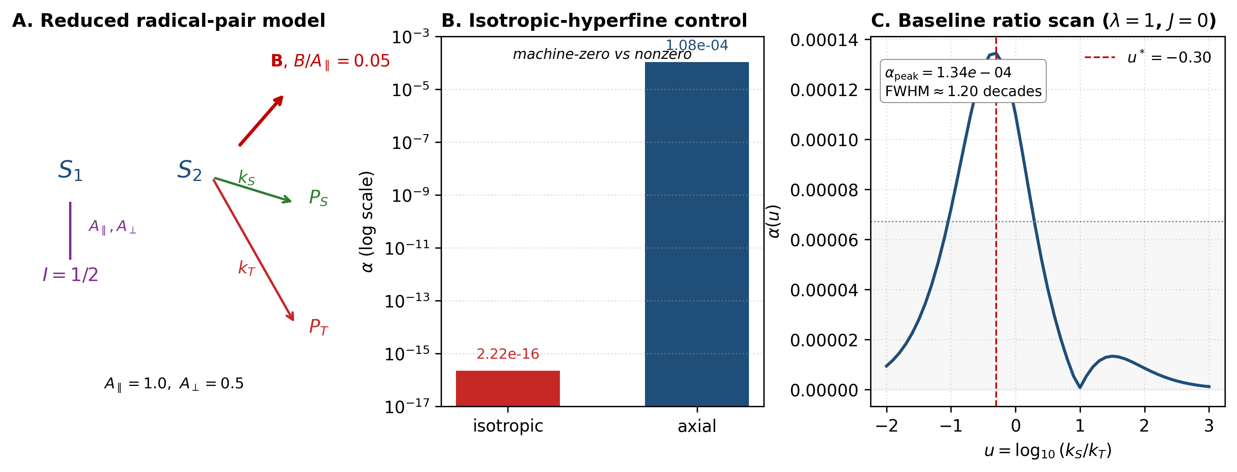
Figure 1. Reduced radical-pair model and baseline ratio response. (A) Schematic showing two electron spins, one nuclear spin coupled to electron 1 via the axial hyperfine tensor (A∥/A⊥ = 2:1), external field B at orientation θ, and singlet/triplet recombination channels. The geomagnetic regime corresponds to B/A∥ ≈ 0.05. (B) Orientation anisotropy α under the isotropic-hyperfine control versus axial coupling. The isotropic-hyperfine control (A∥ = A⊥) gives α = 2.22 × 10⁻¹⁶ (numerical precision). The axial coupling gives α ≈ 1.08 × 10⁻⁴, more than ten orders of magnitude above the isotropic limit. Hyperfine anisotropy is structurally necessary for the orientation-dependent response in the tested implementation. (C) Baseline ratio scan α(u) at λ = 1, J = 0. The response exhibits a broad peak at u* ≈ −0.3 with FWHM ≈ 1.2 decades and peak amplitude α_peak ≈ 1.34 × 10⁻⁴.

3.2 Recombination-ratio response structure
Figure 1C shows the baseline ratio scan α(u) at λ = 1, J = 0. The response exhibits a broad peak in recombination-ratio space, with peak location u* ≈ −0.3 (corresponding to k_S/k_T ≈ 0.5), peak amplitude α_peak ≈ 1.34 × 10⁻⁴, and approximate FWHM of 1.2 decades. The response remains above half-maximum across approximately one decade of ratio space.
We describe this as a "broad response region" rather than a "universal plateau." The response is real and reproducible across multiple v3 runs (bit-for-bit identical), but the absolute amplitude is small in the geomagnetic regime, consistent with previous reduced-model studies that report yield anisotropies of order 10⁻⁴ to 10⁻² depending on the parameter regime. The isotropic-hyperfine control (Figure 1B) is the cleanest structural test: setting A∥ = A⊥ eliminates the response entirely, confirming that the orientation dependence requires the structural anisotropy of the hyperfine tensor.

3.3 Absolute kinetic scale and exchange dependence
Figure 2 shows the response under absolute-rate scaling λ ∈ {0.1, 1.0, 10.0}. Three observations are direct from the data.
First, the form of α(u) is preserved across λ: a peak with comparable FWHM appears at each λ. This supports the notion that the response is organized in ratio space.
Second, the amplitude changes by orders of magnitude. At λ = 0.1, peak α ≈ 2.92 × 10⁻²; at λ = 1, peak α ≈ 1.34 × 10⁻⁴; at λ = 10, peak α ≈ 2.70 × 10⁻⁸. The response is therefore not amplitude-invariant under absolute scaling.
Third, the peak location also shifts: u* ≈ +0.5 at λ = 0.1, u* ≈ −0.3 at λ = 1, u* ≈ −0.3 at λ = 10. The normalized RMS deviation between λ = 0.1 and λ = 1 normalized curves is approximately 0.43, exceeding any reasonable threshold for "collapse."
The conclusion is that the response is organized by recombination ratio but is meaningfully modulated by the absolute kinetic scale. We do not claim absolute-rate scaling invariance.
The exchange coupling J ∈ [0, 3] modulates the response amplitude across the scanned range without eliminating the peak. The full u-vs-J heatmap is shown in Figure 2C.
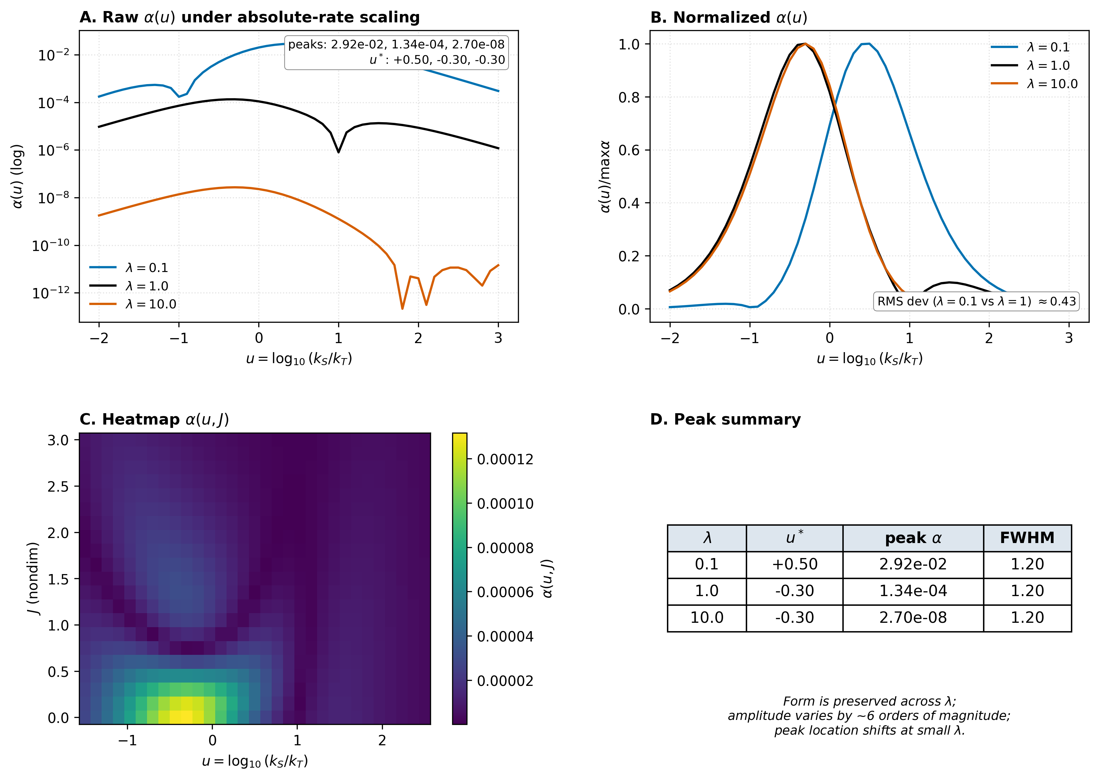
Figure 2. Absolute-rate scaling and exchange dependence. (A) Raw orientation anisotropy α(u) under absolute-rate scaling at λ ∈ {0.1, 1.0, 10.0}. The peak amplitude varies by approximately six orders of magnitude (2.92 × 10⁻², 1.34 × 10⁻⁴, 2.70 × 10⁻⁸), and the peak location shifts at small λ (u* = +0.5 at λ = 0.1; u* = −0.3 at λ ∈ {1, 10}). (B) Normalized α(u)/max(α). The form of the response is roughly preserved across λ but not identical: normalized RMS deviation between λ = 0.1 and λ = 1 is ≈ 0.43. The response is organized by recombination ratio but is meaningfully modulated by absolute kinetic scale. (C) Heatmap α(u, J) over the v3 exchange-coupling range J ∈ [0, 3]. The broad peak in u persists across J, with amplitude modulation but no qualitative structural change in the scanned range. (D) Numerical summary of peak parameters by λ.

3.4 Implementation-level recombination comparison
The Haberkorn implementation and the absorbing-product effective implementation produce yields that agree to numerical precision (max relative difference 0.0 at the level of double precision) across the (u, J) sweep. As noted in Methods §2.7, this agreement is structural to the present implementation: the absorbing-product effective dynamics for the radical-pair sector reduce to the Haberkorn equation. The comparison is therefore an implementation-level consistency check: it confirms that the two code paths produce the same yields, but it does not constitute a test of broad recombination-formalism independence in the sense of comparing structurally distinct dynamical formalisms (e.g., a fully separate Lindblad with non-projector jump operators).

3.5 Noise-channel dependence
Figure 3 shows the response to the two tested noise channels at u = 0 (near the baseline plateau center, but offset by ≈ 0.3 from the exact peak). The two channels behave qualitatively differently.
z-dephasing on both electron spins exhibits an enhancement window (Figure 3A). The response is approximately constant for weak dephasing (γ < 10⁻¹), passes through a local minimum near γ ≈ 0.2 (where α drops to roughly 0.1× the γ = 0 value), then rises to a peak at γ_opt ≈ 3 with α ≈ 2.28 × 10⁻⁴, approximately twice the γ = 0 baseline, before decreasing again at strong noise (γ ≫ 10). The Haberkorn and absorbing-product implementations agree across the full γ range.
Single-electron spin-flip relaxation behaves differently (Figure 3B). The maximum response is at Γ₁ = 0 with α ≈ 1.08 × 10⁻⁴; the response decreases as Γ₁ increases through Γ₁ ∼ 1, with a small partial recovery near Γ₁ ≈ 3 before tending to zero at strong relaxation. There is no enhancement window over the tested range; this channel suppresses the response under the tested implementation.
The conclusion is that noise effects are channel-dependent. Statements such as "moderate environmental noise enhances response" are supported only for the specific z-dephasing channel tested here, not as a general claim about open-system noise. Whether spin-flip relaxation acting symmetrically on both electrons would produce a different dependence remains untested in the present work.
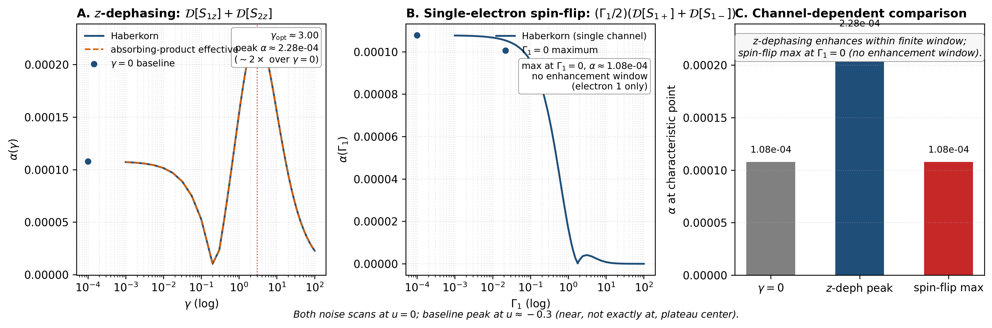
Figure 3. Channel-dependent noise response. (A) z-dephasing scan: response amplitude α(γ) for the channel 𝓟[S₁_z] + 𝓟[S₂_z]. The response exhibits a finite enhancement window with γ_opt ≈ 3 and peak α ≈ 2.28 × 10⁻⁴, approximately twice the γ = 0 baseline. A local minimum at γ ≈ 0.2 separates the weak-noise plateau from the enhancement window. The Haberkorn and absorbing-product effective implementations agree across the full γ range. The implemented channel is not fully isotropic (S_x and S_y components not included). (B) Single-electron spin-flip relaxation scan: response amplitude α(Γ₁) for the channel (Γ₁/2)(𝓟[S₁_+] + 𝓟[S₁_−]). Single-electron spin-flip relaxation has its maximum at zero relaxation (Γ₁ = 0, α ≈ 1.08 × 10⁻⁴) and suppresses the response over the tested range, with no enhancement window; a small partial recovery appears near Γ₁ ≈ 3 before the response tends to zero at strong relaxation. The channel acts only on electron 1; symmetric spin-flip relaxation on both electrons remains untested. (C) Comparison: noise effects are qualitatively channel-dependent. Both noise scans were performed at u = 0; the baseline peak is at u ≈ −0.3 (near, not exactly at, plateau center).

3.6 Liouvillian spectral correlate
Figure 4 shows the slowest-decay-rate spectral proxy Δ_H(u) overlaid with α(u) on a normalized scale (Panel B). The two curves track each other closely across the u range. The Pearson correlation coefficient is r = 0.9125. This represents a strong correlation but not a functional identity, and we report it as a spectral correlate of the anisotropy rather than as a mechanistic explanation.
The mode-reorganization diagnostic (tracking-loss score from Hungarian-assigned eigenvector overlaps between adjacent u points) is more variable across the u range, with a single localized peak near u = 0.1 and small values elsewhere. The permutation score oscillates at moderate values (0.4–0.7) without a clear pattern. We report the mode-reorganization diagnostic as descriptive but do not claim it as a robust independent signature of the response. The slowest-decay-rate proxy is the more reliable spectral correlate.
We do not interpret these spectral structures as evidence of a formal dissipative phase transition or mode-restructuring transition in the strict sense.
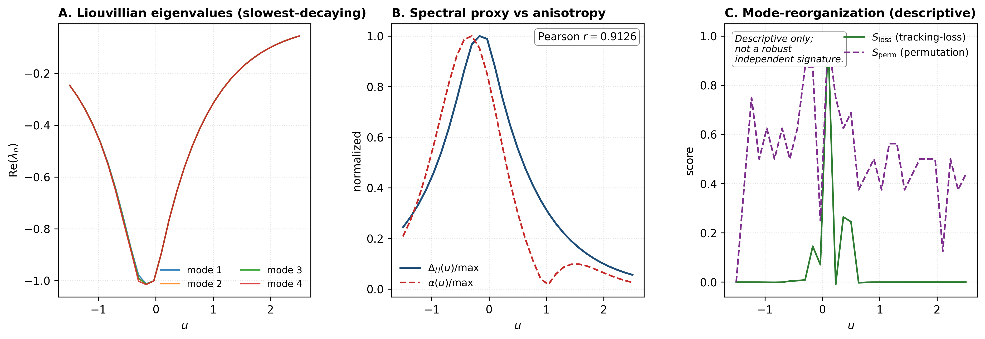
Figure 4. Liouvillian spectral correlate of the response. (A) Real parts of the slowest-decaying Liouvillian eigenvalues across the u scan. The Haberkorn radical-pair Liouvillian is trace-decreasing under recombination and has no zero eigenvalue. (B) Slowest-decay-rate spectral proxy Δ_H(u) (normalized to its own peak) overlaid with the orientation anisotropy α(u) (normalized to its own peak). The two curves track each other closely across the u range with Pearson correlation r = 0.9126. The proxy is reported as a descriptive correlate of the response, not as a mechanistic explanation or a phase-transition signature. (C) Mode-reorganization diagnostics. The tracking-loss score S_loss has a single localized spike near u = 0.10 with small values elsewhere; the permutation score S_perm oscillates at moderate values without a clear pattern. The slowest-decay-rate proxy in (B) is the more reliable spectral correlate.

4. Discussion
The reduced radical-pair model studied here exhibits a reproducible response structure in recombination-ratio space, organized around a broad peak of FWHM ≈ 1.2 decades. The structure depends on hyperfine anisotropy (eliminated by the isotropic-hyperfine control), is modulated meaningfully by absolute kinetic scale, is enhanced by z-dephasing within a finite window, is suppressed by single-electron spin-flip relaxation, and correlates strongly with the slowest-decay-rate Liouvillian spectral proxy.
These findings are consistent with — but more specific than — the qualitative picture in earlier reduced-model literature. A key methodological observation is that several claims that might be made on the basis of the qualitative picture (formalism independence across Haberkorn and Lindblad, scaling invariance across orders of magnitude, generic noise enhancement) are not directly supported when the implementation and the test are aligned. Each is bounded by specific implementation choices: the recombination comparison is between two code paths that share the same equation of motion in the radical-pair sector; the scaling test fails between λ = 0.1 and λ = 1 by both amplitude and peak location; the noise enhancement is specific to the z-dephasing channel and does not appear under single-electron spin-flip relaxation.
A natural physical reading of these results is that yields in spin-selective recombination are time-integrated, channel-weighted observables: the recombination operator extracts a singlet-projected component of the dynamics, integrated over the lifetime of the radical pair. This view, which is implicit in the standard yield formula but rarely emphasized as a structural feature, makes some of the present results expected: the absolute kinetic scale controls the integration window, so "ratio coordinate" and "absolute scale" both matter; different noise channels modify the integrated dynamics differently because they act on different parts of the spin algebra. This reading is descriptive rather than predictive; making it precise — for example, by defining a topological or geometric invariant of the integrated map — is left for future work.
We note that exploratory minimal-transducer simulations beyond the radical-pair system suggest that response morphology can be polymorphic across shelves, ridges, localized peaks, multi-peak structures, and orientation-address patterns; these models are not used as primary evidence here and will be treated separately.
The structural prerequisite that distinguishes the present model from a purely classical kinetic system is the hyperfine tensor anisotropy: removing it removes the response, regardless of the rate ratios or noise channels. This places hyperfine structure (more precisely, the axial component of it) as a necessary structural ingredient in the tested implementation.

5. Limitations
The following limitations are explicit and define the boundary of the claims above.
(a) The model is a reduced one-nucleus radical pair, not a full cryptochrome simulation. The full FAD/tryptophan multi-nuclear hyperfine spectrum is not included.
(b) The recombination formalism comparison is between two code paths that share the same equation of motion in the radical-pair sector by construction. It does not constitute a test of formalism-independence between structurally distinct recombination treatments.
(c) Absolute-rate scaling invariance is not supported. Amplitude varies by orders of magnitude across the tested λ range; peak location shifts.
(d) The z-dephasing channel acts only on electron-spin z-components, not isotropically (i.e., S_x and S_y dephasing are not included).
(e) The spin-flip relaxation channel acts only on electron 1 in the present implementation. Symmetric spin-flip relaxation on both electrons may behave differently and remains untested.
(f) Noise scans were performed at u = 0 rather than at the exact baseline peak u* ≈ −0.3. Results characterize the response near, but not exactly at, the plateau center.
(g) Spectral diagnostics are correlative. The slowest-decay-rate proxy correlates strongly with anisotropy (r ≈ 0.91), but this is not a mechanistic proof of mode structure or a phase-transition statement.
(h) Three-radical scavenging chemistry, anisotropic relaxation channels, and explicit cryptochrome-relevant geometric constraints are outside the scope of this work.
(i) Toy-model and 3D-geometry exploratory simulations are reported elsewhere as exploratory work and are not primary evidence for the claims made here.

6. Conclusion
A reduced radical-pair model with axial hyperfine coupling, geomagnetic-scale field, Fibonacci-sphere orientation sampling, and validated yield closure exhibits a reproducible broad response peak in recombination-ratio space at u* ≈ −0.3 with FWHM ≈ 1.2 decades. The response requires hyperfine anisotropy, depends on absolute kinetic scale, is enhanced by z-dephasing in a finite window, is suppressed by single-electron spin-flip relaxation, and correlates with the slowest-decay-rate Liouvillian spectral proxy at r ≈ 0.91. These findings are bounded to the tested implementation; the public reproducibility archive supports independent verification of every numerical claim. The work establishes a claim-aligned reduced-model baseline against which broader extensions (full cryptochrome systems, fully independent recombination formalisms, isotropic dephasing, symmetric spin-flip relaxation on both electrons, polymorphic response morphologies) can be tested.

Conflict of interest
The author declares that the research was conducted in the absence of any commercial or financial relationships that could be construed as a potential conflict of interest.

Author contributions
A-SU conceived the study, performed all simulations and analyses, and wrote the manuscript.

Funding
The author received no specific funding for this work.

Data availability statement
The complete v3 code, raw NPZ outputs, figure-generation scripts, claim-audit reports, and SHA256 manifests are archived in qbt_v3_complete_artifacts.tar.gz (SHA256: d966108a86a82b0098aecc14b6098c4ea00e2d7d33d653be8e7072642f9d03f3). A public Zenodo release will be created from the tagged GitHub repository before submission.

References
1. Hore PJ, Mouritsen H. The radical-pair mechanism of magnetoreception. Annu Rev Biophys (2016) 45:299–344. doi:10.1146/annurev-biophys-032116-094545
2. Schulten K, Swenberg CE, Weller A. A biomagnetic sensory mechanism based on magnetic field modulated coherent electron spin motion. Z Phys Chem (1978) 111(1):1–5. doi:10.1524/zpch.1978.111.1.001
3. Steiner UE, Ulrich T. Magnetic field effects in chemical kinetics and related phenomena. Chem Rev (1989) 89(1):51–147. doi:10.1021/cr00091a003
4. Haberkorn R. Density matrix description of spin-selective radical pair reactions. Mol Phys (1976) 32(5):1491–1493. doi:10.1080/00268977600102851
5. Jones JA, Hore PJ. Spin-selective reactions of radical pairs act as quantum measurements. Chem Phys Lett (2010) 488(4–6):90–93. doi:10.1016/j.cplett.2010.01.063
6. Maeda K, Henbest KB, Cintolesi F, Kuprov I, Rodgers CT, Liddell PA, et al. Chemical compass model of avian magnetoreception. Nature (2008) 453(7193):387–390. doi:10.1038/nature06834
7. Ritz T, Adem S, Schulten K. A model for photoreceptor-based magnetoreception in birds. Biophys J (2000) 78(2):707–718. doi:10.1016/S0006-3495(00)76629-X
8. Hiscock HG, Worster S, Kattnig DR, Steers C, Jin Y, Manolopoulos DE, et al. The quantum needle of the avian magnetic compass. Proc Natl Acad Sci USA (2016) 113(17):4634–4639. doi:10.1073/pnas.1600341113
9. Kattnig DR. Radical-pair-based magnetoreception amplified by radical scavenging: Resilience to spin relaxation. J Phys Chem B (2017) 121(44):10215–10227. doi:10.1021/acs.jpcb.7b07672
10. Cai J, Caruso F, Plenio MB. Quantum limits for the magnetic sensitivity of a chemical compass. Phys Rev A (2012) 85(4):040304(R). doi:10.1103/PhysRevA.85.040304
11. Gauger EM, Rieper E, Morton JJL, Benjamin SC, Vedral V. Sustained quantum coherence and entanglement in the avian compass. Phys Rev Lett (2011) 106(4):040503. doi:10.1103/PhysRevLett.106.040503
12. Kominis IK. Quantum Zeno effect explains magnetic-sensitive radical-ion-pair reactions. Phys Rev E (2009) 80(5):056115. doi:10.1103/PhysRevE.80.056115
13. Denton AJ, Tiersch M, Kattnig DR, Hiscock HG, Sowa JK, Worster S, et al. Magnetosensitivity of tightly bound radical pairs in cryptochrome is enabled by the quantum Zeno effect. Nat Commun (2024) 15:10823. doi:10.1038/s41467-024-55124-x
14. Kuprov I, Wagner-Rundell N, Hore PJ. Polynomially scaling spin dynamics simulation algorithm based on adaptive state-space restriction. J Magn Reson (2007) 189(2):241–250. doi:10.1016/j.jmr.2007.09.014
15. Worster S, Kattnig DR, Hore PJ. Spin relaxation of radical pairs in the slow-hopping limit. J Chem Phys (2016) 145(3):035104. doi:10.1063/1.4958624
16. Hogben HJ, Efimova O, Wagner-Rundell N, Timmel CR, Hore PJ. Possible involvement of superoxide and dioxygen with cryptochrome in avian magnetoreception: Origin of Zeeman resonances observed by in vivo EPR spectroscopy. Chem Phys Lett (2009) 480(1–3):118–122. doi:10.1016/j.cplett.2009.08.051
17. Plenio MB, Huelga SF. Dephasing-assisted transport: Quantum networks and biomolecules. New J Phys (2008) 10:113019. doi:10.1088/1367-2630/10/11/113019
18. Rebentrost P, Mohseni M, Kassal I, Lloyd S, Aspuru-Guzik A. Environment-assisted quantum transport. New J Phys (2009) 11:033003. doi:10.1088/1367-2630/11/3/033003
19. Kessler EM, Giedke G, Imamoğlu A, Yelin SF, Lukin MD, Cirac JI. Dissipative phase transition in a central spin system. Phys Rev A (2012) 86(1):012116. doi:10.1103/PhysRevA.86.012116
20. Minganti F, Biella A, Bartolo N, Ciuti C. Spectral theory of Liouvillians for dissipative phase transitions. Phys Rev A (2018) 98(4):042118. doi:10.1103/PhysRevA.98.042118
21. Lindblad G. On the generators of quantum dynamical semigroups. Commun Math Phys (1976) 48(2):119–130. doi:10.1007/BF01608499
22. Gorini V, Kossakowski A, Sudarshan ECG. Completely positive dynamical semigroups of N-level systems. J Math Phys (1976) 17(5):821–825. doi:10.1063/1.522979
23. Marais A, Adams B, Ringsmuth AK, Ferretti M, Gruber JM, Hendrikx R, et al. The future of quantum biology. J R Soc Interface (2018) 15(148):20180640. doi:10.1098/rsif.2018.0640
24. Kim Y, Bertagna F, D’Souza EM, Heyes DJ, Johannissen LO, Nery ET, et al. Quantum biology: An update and perspective. Quantum Reports (2021) 3(1):80–126. doi:10.3390/quantum3010006
25. Mouritsen H. Long-distance navigation and magnetoreception in migratory animals. Nature (2018) 558(7708):50–59. doi:10.1038/s41586-018-0176-1

