**Suggestions for further analysis/changes to the Cox proportional model**

* Standardisation of covariates
  + To allow for comparisons between variables as currently the hazard ratios are related to the change per specific unit increase of a covariate
* Analysis with South Asian vs. Non-Asian
  + Stepwise selection suggested that the best model included all the covariates except for ethnicity
  + However the South Asian category was significant in comparison to the reference category (White)
  + So it would be interesting to see whether having only two ethnicity categories (South Asian and non-Asian) would change the stepwise selection results
* Categorise variables
  + There were some slightly un-intuitive results with some variables
  + In particular the ones mentioned were BMI and eGFR
  + It was suggested that BMI becomes categories like normal, overweight, obese etc. to see whether this might shed some light on whether the observation that as BMI increases hazard decreases, is actually an accurate result
  + In addition eGFR was another slightly odd result
    - Andy mentioned that sometimes eGFR can increase initially when a person is experiencing kidney disease
    - This might have had an impact but it was also said that this initial increase is very short-lived
    - That being said, categorising eGFR might also help untangle the relationship
  + I think categorising variables could apply to other variables (ALT was mentioned) too, but these were the two main ones
* Log transform ALT
  + Pedro mentioned that ALT is a very skewed variable, so might be worth transforming it with a log before putting it in the analysis
  + Very quick plot I made, just for me to see the skew out of interest:
  + 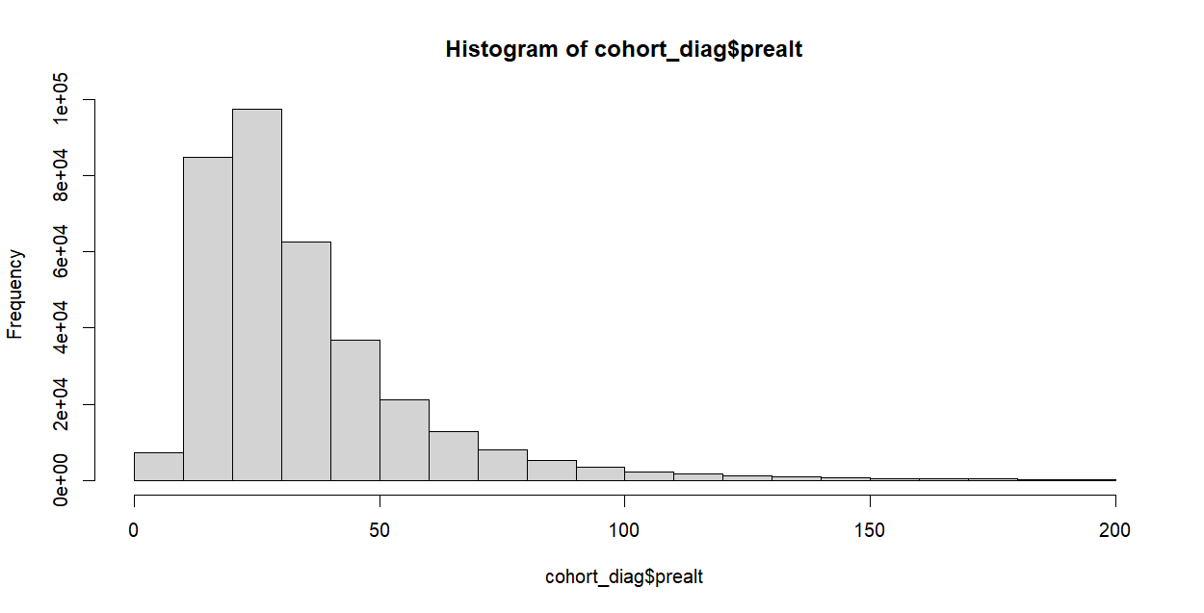
* Treatment covariate inclusions
  + Andy recommended including ACE inhibitors as a possibly relevant covariate
  + Research seems to show that they can help reduce the risk of retinopathy