**STAR GAZING WITH PYTHON TURTLE (Part 2) – Changes to a Star**

**Introduction:** This worksheet is written to create bite size chunks of the Club Leader Resources – Constellation program.

**Start:**

1. Setup and assemble the Raspberry Pi (RPi) environment:
   1. Connect RPi to a monitor, keyboard and mouse
   2. Power up the RPi module
   3. Observe the start-up script
2. Login and enter password
3. Start the GUI by typing ‘startx’
4. Open the Python 3 programming environment IDLE3
5. Click on **File** and **Open** **New Window**
6. Click on **File** and **Save As** andnaming itStar_Turtle_03.py

**Coding:**

*[Note the use of the comment # (hashtag) this will add further information about the code behaviour. Be careful to observe the use of capital and small letters.]*

1. Enter the following code into the new window: New code is shown in purple colour
2. Before you start to write your program import the Turtle and Random Libraries

import turtle #Import the Turtle Library

import random #Import the Random Library

1. Next create a window to display the turtle window. Assign this to a variable.

wn = turtle.Screen() #wn = variable; note Screen has a capital S

1. Give your turtle a name.

t = turtle.Turtle() #t is the name of the turtle (use your own name if

#preferred); note Turtle() has a capital T

1. Create a function

def drawStar(starSize): #create a function drawStar with starSize

t.fillcolor(“Red”) #change the colour of turtle to red

t.begin_fill() #entered to begin the fill process

for side in range (5):

t.left(144)

t.forward(starSize)#starSize replaces a numerical value

t.end_fill() #entered to end the fill process

drawStar(random.randint(50,400)) #Calls the function. Draws a star of a

#random size between 50 – 400 units

#int selects an integar (i.e. no decimal

#places)

wn.exitonclick()

1. Save and run the code several times will display different size stars

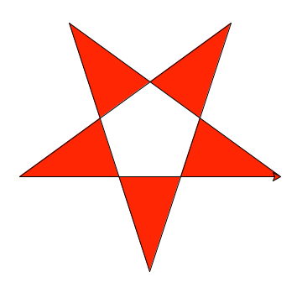

1. Change size and colour of the star and turtle
2. Add, delete or change the code in the previous exercise and **Save As** Star_Turtle_04.py

starColour = [“Red”,”Green”,”Blue”] #add starColour code

#square brackets indicate a list of variables

def drawStar(starSize, starColour): #amend function with changes

t.color(starColour) #add code will change turtle colour

drawStar(random.randint(50,400), random.choice(starColour))

#amend the code with changes

1. Save the code and run the code several times. The star will be displayed in a different colour in a random place on the screen.
2. Challenges: Change the values in the code and change colours

Complete Code for: Star_Turtle_04.py

#change size of star and star and turtle colour

import turtle

import random

wn = turtle.Screen()

t = turtle.Turtle()

starColour = ["Red","Green","Blue"] #create a variable with different star colours

def drawStar(starSize, starColour): #modify drawstar to include

#starColour

t.color(starColour) #change turtle colour

t.begin_fill()

for side in range (5):

t.left(144)

t.forward(starSize)

t.end_fill()

drawStar(random.randint(50,400), random.choice(starColour))

#change star colour

wn.exitonclick()