**STAR GAZING WITH PYTHON TURTLE (Part 3) – Create a Galaxy of Stars**

**Introduction:** This worksheet is written to create bite size chunks of the Club Leader Resources – Constellation program.

**Start:**

1. Setup and assemble the Raspberry Pi (RPi) environment:
   1. Connect RPi to a monitor, keyboard and mouse
   2. Power up the RPi module
   3. Observe the start-up script
2. Login and enter password
3. Start the GUI by typing ‘startx’
4. Open the Python 3 programming environment IDLE3
5. Click on **File** and **Open** **New Window**
6. Click on **File** and **Save As** andnaming itStar_Turtle_05.py

**Coding:**

*[Note the use of the comment # (hashtag) this will add further information about the code behaviour. Be careful to observe the use of capital and small letters.]*

1. Enter the following code into the new window:
2. Before you start to write your program import the Turtle and Random Libraries

import turtle #Import the Turtle Library

import random #Import the Random Library

1. Next create a window to display the turtle window. Assign this to a variable.

wn = turtle.Screen() #wn = variable; note Screen has a capital S

1. Give your turtle a name.

t = turtle.Turtle() #t is the name of the turtle (use your own name if preferred); #note Turtle() has a capital T

1. Create a list of star colours

starColour = [“Red”,”Green”,”Blue”] #square brackets indicate a list of colours

1. Create a function to move a random location

def moveToRandomLocation():

t.penup() #stops the turtle from writing on the screen

t.setpos( random.randint(-200,200) , random.randint(-200,200)

#setpos sends the turtle to an (x,y) position

t.pendown() #enable the turtle to write on the screen

1. Create a function to draw and size a star

def drawStar(starSize, starColour): #create a function drawStar with a

#starSize

t.color(starColour) #change colour of the turtle

t.pendown()

t.begin_fill() #entered to begin the fill process

for side in range (5):

t.left(144)

t.forward(starSize)

t.end_fill() #entered to end the fill process

t.penup()

1. Create a function to create a galaxy of stars

drawGalaxy(numberOfStars):

moveToRandomLocation()

for star in range(numberOfStars):

t.penup()

t.left( random.randint(-180,180))

t.forward( random.randint(-180,180))

t.pendown()

drawStar(random.randint(10,200), random.choice(star.Colour))

1. Complete code

t.speed(5) #changes the speed of the turtle

drawGalaxy(20) #changes the number of stars in the galaxy

wn.exitonclick()

1. Save and run the code

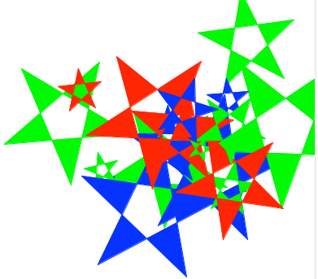

1. Challenges: Change the values in the code to create smaller stars. Change the range of colours to include Yellow and White stars. Change back ground colour Hint: wn.bgcolor(“MidnightBlue”)



Try other shapes by changing the star shape

