Document-No. Classification Location
EHS_TL_035
Internal Global
Owner Version Published
Miirkli Heinz 2.4
[ApprovalDateText]


PASSION. PRECISION. PURITY.

Conflict minerals Supplier enquiry
Pro ec environmen & ensure hea .h & safe y

4. Request for confirmation as a supplier of VAT

We hereby confirm for the year:

Comprehensive confirmation for all products
Including the completed Conflict Minerals Reporting Template (CMRT), Cobalt Reporting Template (CRT), bothe from the "Responsible Minerals lnitative", if applicable. | Conflict Minerals Reporting Template (CMRT) ◻  Extended Minerals Reporting )Orting I.::llpla EMRT) ◻  Not applicable ◻
Limited confirmation only for specific products, please specify
Name
Company

Approval by Head of Supply Chain or Quality Date, Sign Supplier

Please contact the author of this letter for further questions

Printout is not subject to revision service & will not be automatically updated Page 9 of 9














10.03.2023

 |  | 
 | 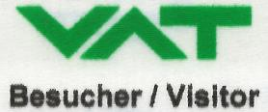
 | 
 | 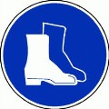
 |  | 
 |  | 
 |  | 
 | 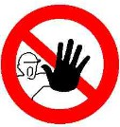 | 
 |  | 
 | 
 |  | 




Document-N . Classification Location
EHS_WI_010
Internal Global
Owner Version Published
Berger Stephan
6.0
10.03.2023


PASSION. PRECISION. PURITY.

Safety instruction for visitors
Pro ec. environmen & ensure hea h & safe y

Durch den Besucher auszufullen /Tobe filled in by the visitor

Hiermit bestatige ich die Sicherheitsvorschriften gelesen und verstanden zu haben, und dass ich diese wahrend meinem Besuch bei VAT/ COMVAT einhalten werde.

I hereby confirm that I have read and understood the safety regulations and that I will comply with them during my visit to VAT/
COMVAT.

Name name | Vorname first name | 1rma company | Unterschrift signature | Datum date | VAT Betreuer VAT advisor

Dieses Dokument wird im Besucherordner bei der Rezeption archiviert und nach einer Aufbewahrungsfrist van zwei Jahren vernichtet. This document is archived in the visitor folder at the reception and destroyed after a retention period of two years

Document-No. Classification Location
PFE_PO_008
Internal Glob,
Owner Version Published
Pototschnig Hansjiirg
4.0
03.08.2022


PASSION. PRECISION. PURITY.


Clothing
Provide facilities & equipment

r cleanliness controlled areas

Content
- Overview ,
- Definitions 2
Instructions for entering cleanrooms----------------------------- 2
- Cleaning cleanroom clothing 3
- Putting on cleanroom garments (e.g. cleanroom coat cleanroom class ISO 8) 4
Putting on reusable cleanroom garments (e.g. cleanroom class ≤ ISO 6) 5
- Putting on disposable cleanroom garments (e.g. cleanroom class ≤ ISO 6)----------- 6
- Accessing/staying in cleanrooms acc. to class ISO 8 and attached grey rooms 7
- Accessing/staying in cleanrooms acc. to class ISO 7 9
- Accessing/staying in cleanrooms acc. to class ≤ ISO 6---------------- 11
- Accessing/staying in cleanrooms acc. to class ≤ SO 6 (ACC controUed)------------ 13
- Accessing/staying in cleanrooms acc. to class ISO 7 and cleanroom class ≤ ISO 6 (Visitors) 15
- Staying at SD modules (example: mobile flow boxes ...)------------------ 17
- Accessing/staying in clean areas (example: cleanroom tents ...) 19
- Cleanroom staff accessing/staying in areas adjacent to cleanrooms 21
- Accessing/staying in controlled cleanliness rooms 23
- Accessing/staying in controlled cleanliness zones 24
- Cleanroom or cleanliness staff accessing/staying in not cleanliness controlled areas 25
- Accessing/staying in not controlled areas (production) 26
- Release of cleanroom clothing _
- Appendix 28

Overview
Process Sponsor Process Owner
This VAT instruction regulates the allowed clothing and garments in defined cleanliness controlled areas. The target is to ensure that the product environment and products are kept clean at all times.
Target & scope This instruction applies to the employees and visitors in cleanrooms and defined cleanliness controlled areas at all VAT production sites e.g.: VAT CH, Comvat, VAT MY, VAT RO, VAT TW and internal/external service centers

Key performance
Training requirements
KPI I r farget

Content Audience Frequency

Document-No. Classification Location
PFE_PO_008
Internal Glob,
Owner Version Published
Pototschnig Hansjiirg
4.0
03.08.2022


PASSION. PRECISION. PURITY.


Clothing
Provide facilities & equipment

r cleanliness controlled areas

Definitions

Term I Specification/ Regulation Brief description

Instructions for entering cleanrooms

  - Entering a cleanroom

    - Access to cleanrooms is restricted to persons that have previously familiarized themselves with the rules governing
�JV✓ tJ bt h< V l 'l ripere •t ( ( l' Jur JC l' he V vl r r l ted tJ obc V ru u
    - There is no access permitted to ISO 7 and s ISO 6 cleanrooms without previous consultation and approval of the person responsible for this particular cleanliness controlled area!
    - All relevant instructions and procedures must be strictly observed when visiting or performing operations in a cleanroom.

Changing areas / Sit-Over

    - All instructions displayed in the airlock area must be strictly observed!
    - The so-called sit-over bench separates the staff airlock into two areas: on the unclean side, there is storage space for street clothing and street shoes, and for disposable overshoes, beard cover and cap/hairnet.
On the clean side, the staff members will find their personal cleanroom garments and cleanroom shoes. The cleanroom garments must be put on only on the clean side.
    - Instead of a sit-over, there may also be a line drawn on the floor, separating the two sides. The area behind that
marking line is the clean side. The cleanroom garments must be put on only on the clean side.

Cleanroom garments

•
•

•

•

•

•

All instructions displayed in the airlock area must be strictly observed!
In some cleanrooms, it is mandatory to wear gloves, face mask (covering the mouth), beard cover and cap/hairnet. It must be ensured that no hair protrudes from below the cap/hairnet or beard cover
To prevent cross-contamination, cleanroom garments and personal clothes must never be put or hung up together, or next to each other!
bed sposed of i 1 the s.:iecial waste
containers provided. Using dirty or torn pieces of garment is not permitted!
Only clean long trousers and ankle-length skirts allowed underneath the cleanroom coat. Stockings are also permitted under the coat as legwear.
Instead off a cleanroom coat a corresponding coverall can be worn.

- No jewellery (rings, watches, bracelets, etc.) and cosmetics allowed when working in a cleanroom (see PFE_PO_018)!

Document-No. Classification Location
PFE_PO_008
Internal Glob,
Owner Version Published
Pototschnig Hansjiirg
4.0
03.08.2022


PASSION. PRECISION. PURITY.


Clothing
Provide facilities & equipment

r cleanliness controlled areas

Cleaning cleanroom clothing

The cleanroom clothing may only be cleaned by suitable cleaning companies. The cleaning companies must be qualified to clean the corresponding cleanroom clothing





























03.08.2022



 | 1. ➔ | 2. ➔ | 3. ➔ | 4.
 | 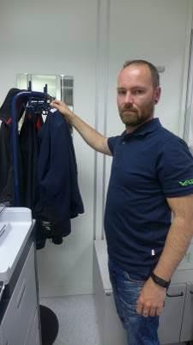  Hang jackets on the dedicated rack. Never hang street clothes next to cleanroom garments!  Attention! A man with a beard must wear a beard cover! |   Standing on the unclean side of the airlock (in front of the sit-over bench), put on the cap/hairnet and the beard cover  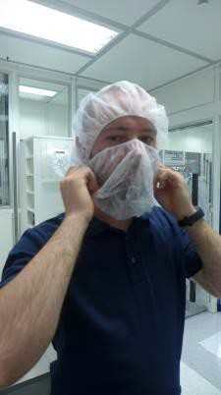 |   Visitors with cleanroom safety shoes: Take off street shoes. Swing your legs to the other side of the sit-over  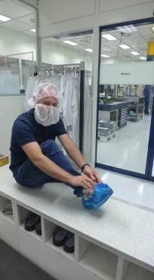  Visitors with street shoes: Slip overshoes over street shoes.  Swing your legs to the other side of the sit-over |   Put on cleanroom safety shoes and coat. Check the correct fit of the clothes    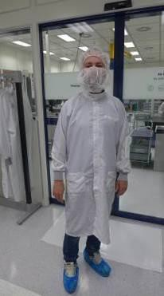  Put on a cleanroom coat. Check the correct fit of the clothes



































03.08.2022








1. ➔ | 2. ➔ | 3. ➔ | 4. ➔
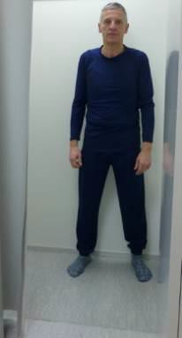 | 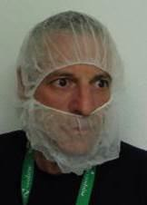 |  | 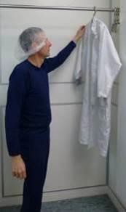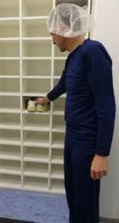
Already put on the cleanroom underwear in the  changing room | Put on disposable cleanroom cap/hairnet and  check the correct fit |  | Put off outer garment and shoes Take off jewelry and other personal  things
Visitors must wear clean street clothes | Attention! A man with a beard must wear a beard cover! | In the anteroom of the  ≤ ISO 6 personnel airlock | Cap/hairnet and beard cover can be changed in this area  Entry into the personnel airlock in socks
5. ➔ | 6. ➔ | 7. ➔ | 8. ➔
In the ≤ ISO 6 personnel airlock in front of the sit-over bench | 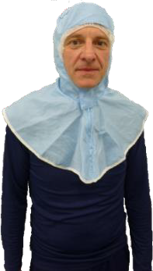  Put on a reusable cleanroom flat hood | 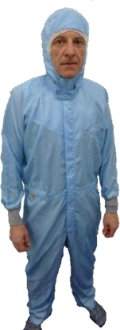  Put on a reusable cleanroom coverall check the correct fit of the clothes | 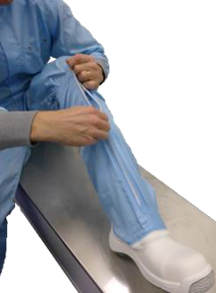  Put on cleanroom shoes and gaiters
9. ➔ | 10. ➔ | 11. ➔ | 12.
In the ≤ ISO 6 personnel airlock behind the sit-over bench with access to the L≤ ISO 6 cleanroom | 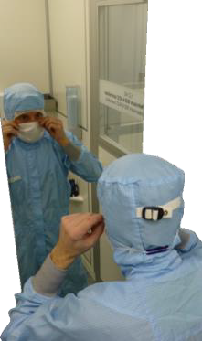  Put on the disposable cleanroom mouth mask | 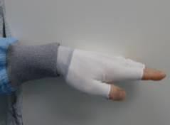  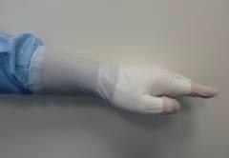  Put on disposable under gloves and disposable gloves | 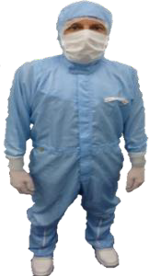  Before entering the cleanroom check the correct fit of the clothes
















03.08.2022







1. ➔ | 2. ➔ | 3. ➔ | 4. ➔
 | 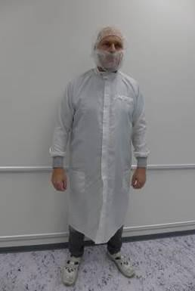 | 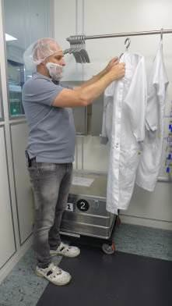 | 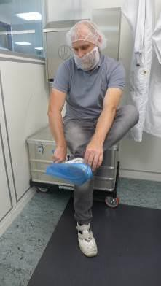
Put on disposable cleanroom cap/hairnet |  | Put off outer garment Take off jewelry and other personal things | Attention! Safety shoes are required for access to the cleanroom!
Attention! Only a man with a beard must wear a beard cover! | In the anteroom of the  ≤ ISO 6 personnel airlock | Cap/hairnet and beard cover can be changed in this area | Entry into the personnel airlock only with clean cleanroom shoes or with disposable overshoes
 |  |  | Option: For direct access from a production area put on disposable overshoes
5. ➔ | 6. ➔ | 7. ➔ | 8. ➔
In the ≤ ISO 6 personnel airlock in front of the sit-over bench | 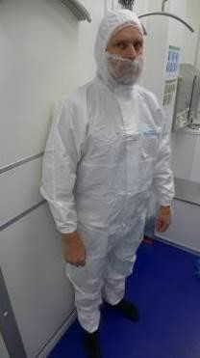  Put on the disposable cleanroom overall | 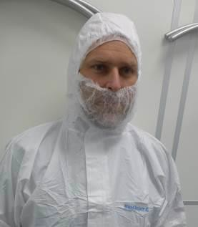  Check the correct fit of the clothes | 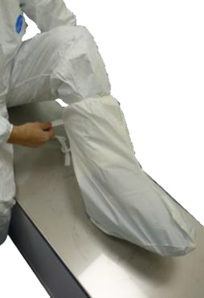  Put the disposable cleanroom gaiters over the safety shoes
9. ➔ | 10. ➔ | 11. ➔ | 12.
In the ≤ ISO 6 personnel airlock behind the sit-over bench with access to the ≤ ISO 6 cleanroom | 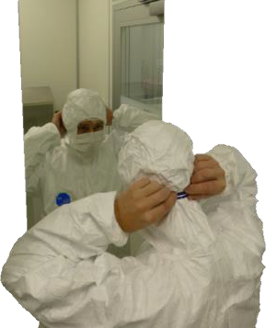  Put on the disposable cleanroom mouth mask | 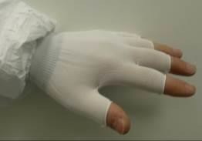  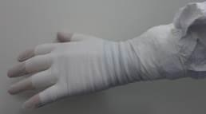  Put on disposable under gloves and disposable gloves | 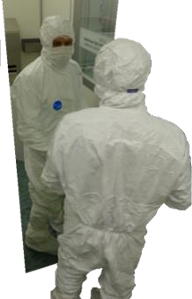  Before entering the cleanroom check the correct fit of the clothes


Document-No. Classification Location
PFE_PO_008
Internal
Owner Version Published
Pototschnig Hansjiirg 3.3
04.04.2022


PASSION. PRECISION. PURITY.

Clothing instructions for cleanliness controlled areas
Provide facilities & equipment

Accessing/staying in cleanrooms acc. to class ISO 8 and attached grey rooms

As a principle, clean long legwear must be worn under the coats. The coat must be completely buttoned up and closed at the collar.

Document-No. Classification Location
PFE_PO_008
Internal Glob,
Owner Version Published
Pototschnig Hansjiirg
3.3
04.04.2022


PASSION. PRECISION. PURITY.

Clothing instructions for cleanliness controlled areas
Provide facilities & equipment

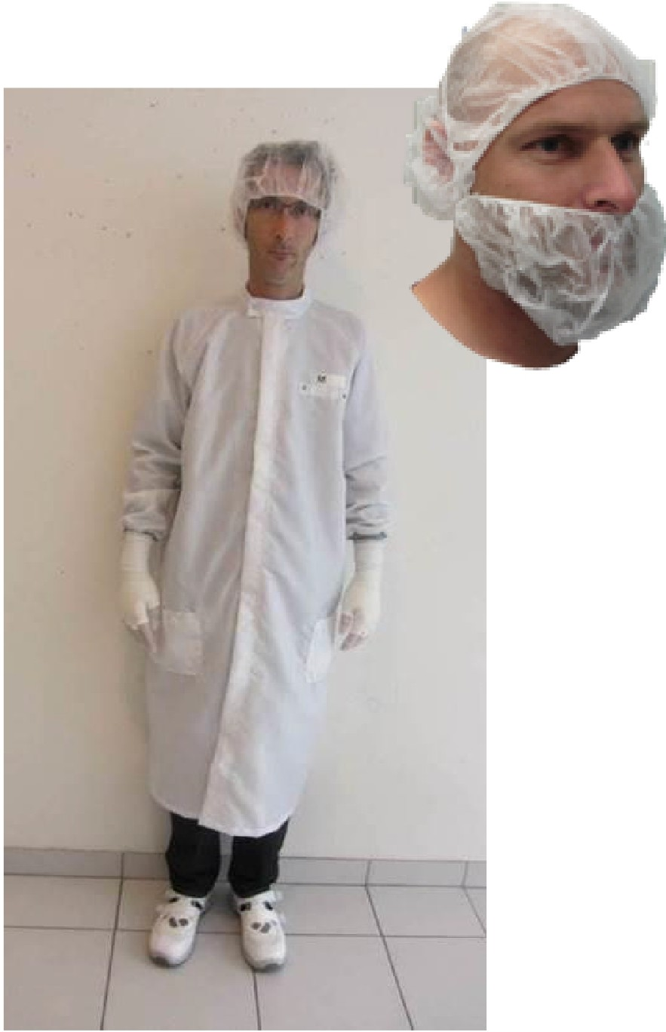
Cleanroom class ISO 8 / Grey room¹

VAT Cleanroom staff/ Visitors (VAT staff, suppliers ...)
  - Disposable cleanroom cap/hairnet
(Hair must be completely covered by the cap/hairnet)
  - Disposable cleanroom beard cover
(Required for men wearing a beard! Also applies to men that have not shaved for a day. See PFE_PO_009)
  - Reusable cleanroom coat white
(with cuffs and high-necked collar, "VISITOR" is printed in large letters on the back of visitor's coats provided for internal and external visitors in the designated airlock areas). Instead off a cleanroom coat a corresponding coverall can be worn.
  - If required: disposable cleanroom face mask (e.g., based on risk assessment ...)
  - Cleanroom safety shoes or disposable overshoes
  - If required: disposable cleanroom gloves (1-layer. See PFE_WI_051)
  - If required: cleanroom oversleeves (e.g., based on risk assessment)
  - Clean long legwear required
(e.g., no shorts permitted in grey areas! No dirty working trousers underneath the cleanroom coat permitted in cleanrooms!)

(Illustrative picture)
⁷Cleanroom class - ISO 14644-1 / Grey room clean area - ISO 14644-1

Document-No. Classification Location
PFE_PO_008
Internal Glob,
Owner Version Published
Pototschnig Hansjiirg 3.3
04.04.2022


PASSION. PRECISION. PURITY.

Clothing instructions for cleanliness controlled areas
Provide facilities & equipment

Accessing/staying in cleanrooms acc. to class ISO 7

Access is only via attached airlock areas or via air shower. Access limited to authorized and trained personnel

Document-No. Classification Location
PFE_P0_008
Internal Glob,
Owner Version Published
Pototschnig Hansjiirg
3.3
04.04.2022


PASSION. PRECISION. PURITY.

Clothing instructions for cleanliness controlled areas
Provide facilities & equipment

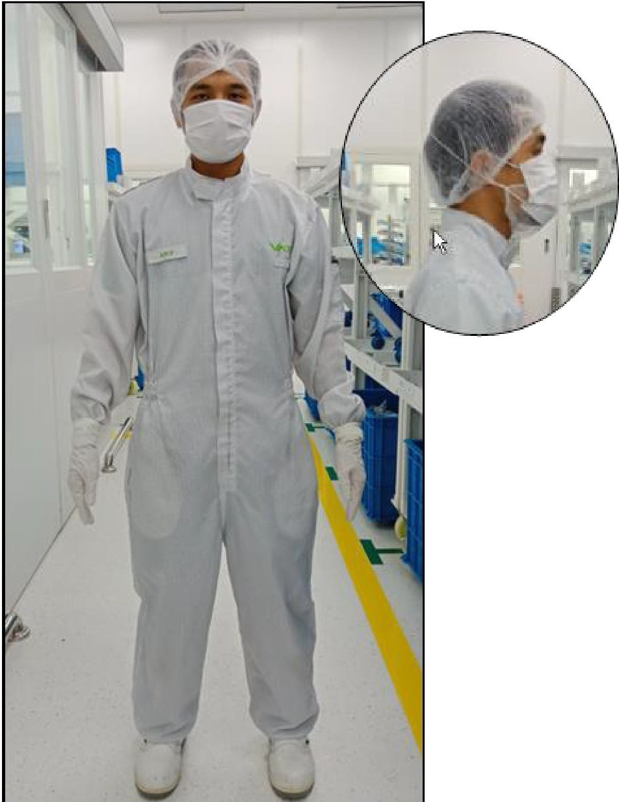
Cleanroom class ISO 7²

VAT Cleanroom Staff
  - Disposable cleanroom cap/hairnet
(Hair must be completely covered by the cap/hairnet)
  - Disposable cleanroom beard cover
(Required for men wearing a beard! Also applies to men that have not shaved for a day. See PFE_PO_009)
  - Reusable cleanroom coveralls (preferably white)
  - Disposable cleanroom face mask
(face mask can be fixed with a clip above the cap/hairnet)
  - Cleanroom safety shoes*
(*gaiters not required under class ISO 7)
  - Disposable cleanroom gloves (nitrile / 2-layers. See PFE_WI_051)

(Illustrative picture,) 2 Cleanroom class - ISO 14644-1

Document-No. Classification Location
PFE_PO_008
Internal Glob,
Owner Version Published
Pototschnig Hansjiirg 3.3
04.04.2022


PASSION. PRECISION. PURITY.

Clothing instructions for cleanliness controlled areas
Provide facilities & equipment

Accessing/staying in cleanrooms acc. to class s ISO 6

Access is only via attached airlock areas. Access limited to authorized and trained personnel!

Document-No. Classification Location
PFE_PO_008
Internal Glob,
Owner Version Published
Pototschnig Hansjiirg
3.3
04.04.2022


PASSION. PRECISION. PURITY.

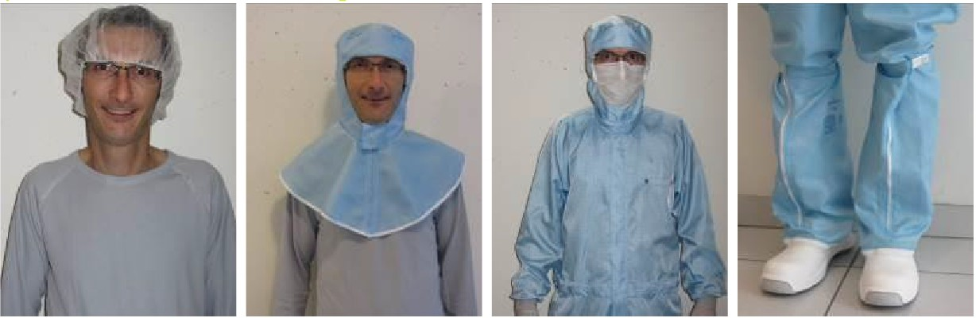

Clothing instructions for cleanliness controlled areas
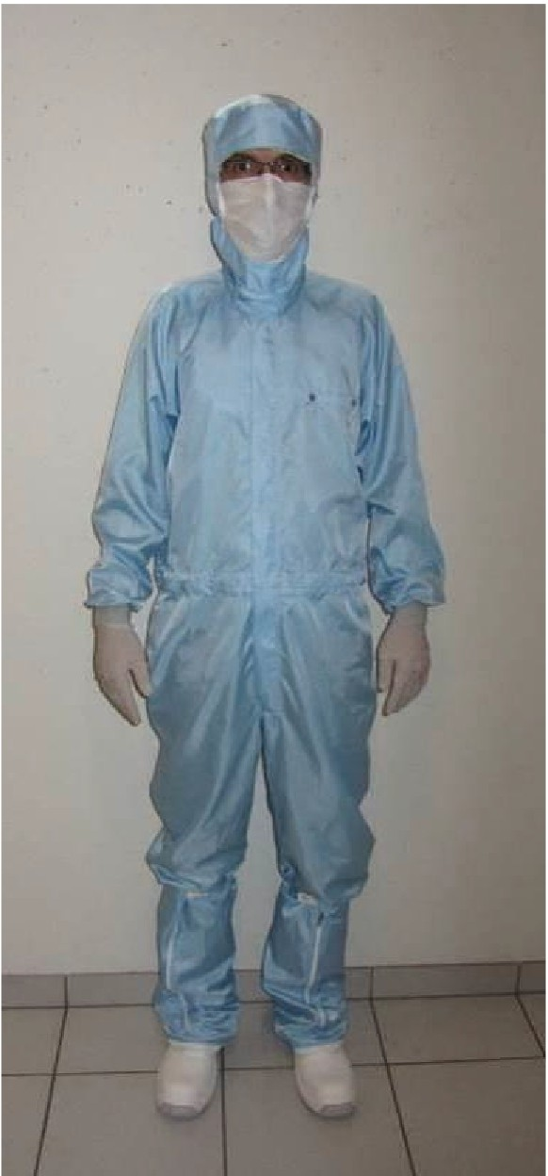
Provide facilities & equipment
Cleanroom class � SO 6³

VAT Cleanroom Staff
- Reusable cleanroom flat hood
(A disposable cap/hairnet must be worn underneath)
- Disposable cleanroom beard cover
(Required for men wearing a beard! Also applies to men that have not shaved for a day. See PFE_PO_009)
- Reusable cleanroom coveralls blue (VAT-HQ)
(provided func Iona undergarments to be worn underneath the cleanroom covera Is)
- Disposable cleanroom face mask
(face mask must be fixed with a clip above hood)
- Cleanroom safety shoes with gaiter* or similar. (*gaiters not required under class ISO 7)
(Illustrative picture)
6. Disposable cleanroom gloves (nitrile / 2-layers. See PFE_WI_051)
Cleanroom class - ISO 14644-1

Document-No. Classification Location
PFE_PO_008
Internal Glob,
Owner Version Published
Pototschnig Hansjiirg 3.3
04.04.2022


PASSION. PRECISION. PURITY.

Clothing instructions for cleanliness controlled areas
Provide facilities & equipment

Accessing/staying in cleanrooms acc. to class s ISO 6 (ACC controlled)

Access is only via attached airlock areas. Access limited to authorized and trained personnel!

Document-No. Classification Location
PFE_PO_008
Internal Glob,
Owner Version Published
Pototschnig Hansjiirg
3.3
04.04.2022


PASSION. PRECISION. PURITY.

Clothing instructions for cleanliness controlled areas
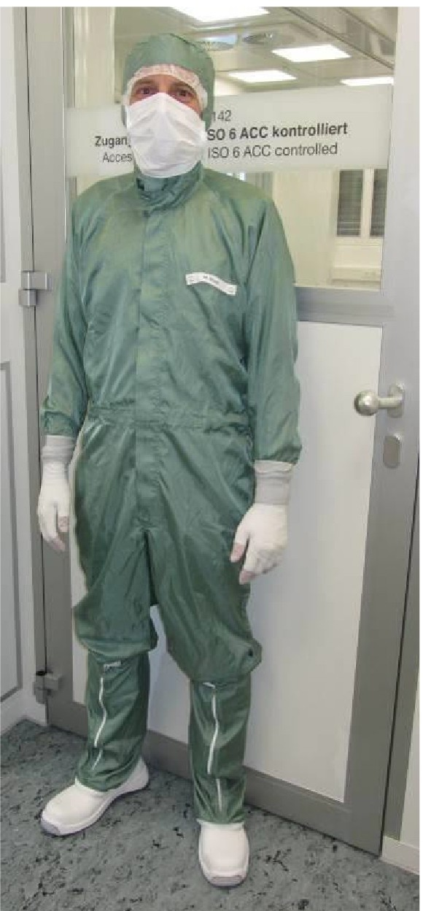
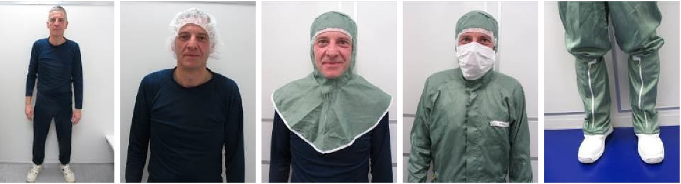
Provide facilities & equipment
Cleanroom class � SO 6 - ACC⁴

VAT Cleanroom Staff
- Reusable cleanroom flat hood
(A disposable cap/hairnet must be worn underneath)
- Disposable cleanroom beard cover
(Required for men wearing a beard! Also applies to men that have not shaved for a day. See PFE_PO_009)
- Reusable cleanroom coveralls green (VAT-HQ)
(provided functional undergarments to be worn underneath the cleanroom coveralls)

- Disposable cleanroom face mask
(face mask must be fixed with a clip above hood)
- Cleanroom safety shoes with gaiter* or similar. (*gaiters not required under class ISO 7)
- Disposable cleanroom gloves (nitrile / 2-layers. See PFE_WI_051)
(Illustrative picture,)

⁴Cleanroom class - ISO 14644-1/ ACC = air chemical cleanliness - ISO 14644-8

Document-No. Classification Location
PFE_PO_008
Internal Glob,
Owner Version Published
Pototschnig Hansjiirg
3.3
04.04.2022


PASSION. PRECISION. PURITY.

Clothing instructions for cleanliness controlled areas
Provide facilities & equipment

Accessing/staying in cleanrooms acc. to class ISO 7 and cleanroom class s ISO 6 (Visitors)

Access ·s on1y via attached airlock areas. Access limited to authorized and tra ned personnel'

Document-No. Classification Location
PFE_PO_008
Internal Glob,
Owner Version Published
Pototschnig Hansjiirg
3.3
04.04.2022


PASSION. PRECISION. PURITY.

Clothing instructions for cleanliness controlled areas
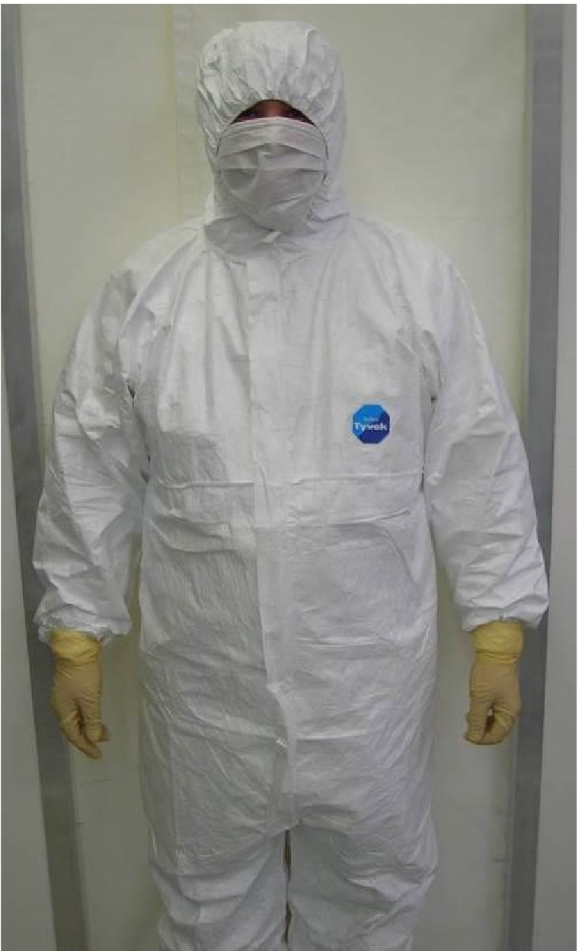
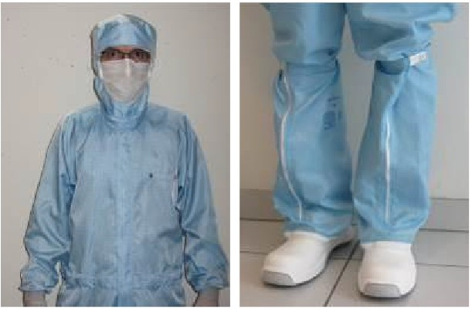
Provide facilities & equipment
Cleanroom class* ISO 7 (also ACC) / :5, ISO 6 (also ACC)5

VAT visitors (VAT staff, suppliers, customers ...)
- Cleanroom flat hood or similar type
(In the cleanroom ISO class 6, a disposable cap/hairnet must be worn underneath. In cleanroom ISO class 7, a disposable hood/ hair net is generally sufficient, no additional flat hood is required).
- Disposable cleanroom beard cover
(Required for men wearing a beard! Also applies to men that have not shaved for a day. See PFE_PO_009)
- Reusable cleanroom coveralls
(Street clothes to be worn underneath the cleanroom coveralls)

- Disposable cleanroom face mask
(face mask should be fixed with a clip above flat hood or disposable hairnet)
- Cleanroom safety shoes with gaiter* or similar. (*gaiters are not required in class ISO 7)
- Disposable cleanroom gloves (nitrile / 2-layers. See PFE_WI_051)
(Illustrative picture)

⁵Cleanroom class - ISO 14644-1 / ACC = air chemical cleanliness - ISO 14644-8

Document-No. Classification Location
PFE_PO_008
Internal Glob,
Owner Version Published
Pototschnig Hansjiirg 3.3
04.04.2022


PASSION. PRECISION. PURITY.

Clothing instructions for cleanliness controlled areas
Provide facilities & equipment

Staying at SD modules (example: mobile flow boxes ...)

As a principle, clean long legwear must be worn under the coats. The coat must be completely buttoned up. (Example: open laminar flow cleaning ...)

