1. I m one of the following persons authorized by law to direct disposition of the remains of the decedent.
□ □ □ □
D Patient Parent Spouse Sibling D Child (Over the age of 18) Other _
- 2. I hereby authorize the performance of a post-mortem examination _upon the above named patient.
- In the further hope that the above authorized examination may benefit others by protecting or preserving their lives and well-being, the undersigned also authorizes the examination physician-and surgeon to remove such specimens, tissues, and/or organs, and to retain, preserve, and/or contribute the same for such diagnostic, therapeutic, or other scientific purposes, as he/she shall deem proper.
- I understand that the examining physician and other physicians are not employees or agents of the hospital. They are independent medical practitioners.
  - Signature Time:, Date:
Witness Signature Time:. Date: _
Consent may be given by the following, in the order of priority listed. The attorney-in-fact under a valid Durable Power of Attorney for Health Gare, the decedent's spouse, an adult son or daughter of the desedent, either parent of decedent, an adult brother or sister of the decedent, a grandparent of the decedent, a guardian or conservator of the person at the time of death.
□ Unclaimed Dead Body: Contact Public Administrator Office

Ihereby grant permission to release the body ;: • C _
- ' 1-¥AlJTHOB·l S
t_ •
Patio 's Name
to:fJMU,/J.l'J}.bJ ,<fll/.. and acknowledge receipt of the personal effects as listed
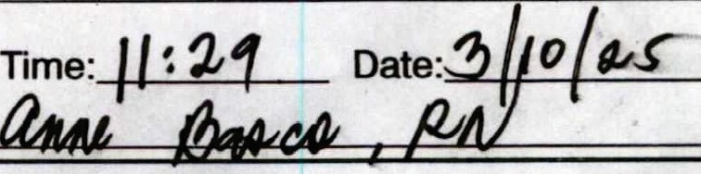
- Mortuary <......
Signa e:::-+" q,. ,:J!S. g;:2 -C. ";1- ­
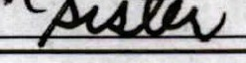
Witness (Nurse)
Relationship to Deceased
MORTUARrs RECEIPT
Mortuary Name: fu,"e\lC,\,Y\0\- )£\ l \]\J\\W'\ se # Phone-#} I o-'in y - S::3/

List articles and jewelry sent wi dy: -ft--­
f
Body Received by Signature: {J.f)tt·,t ctt;:!:ul_

Time: I 31f'Y'.\ Date: ·\0·2.$

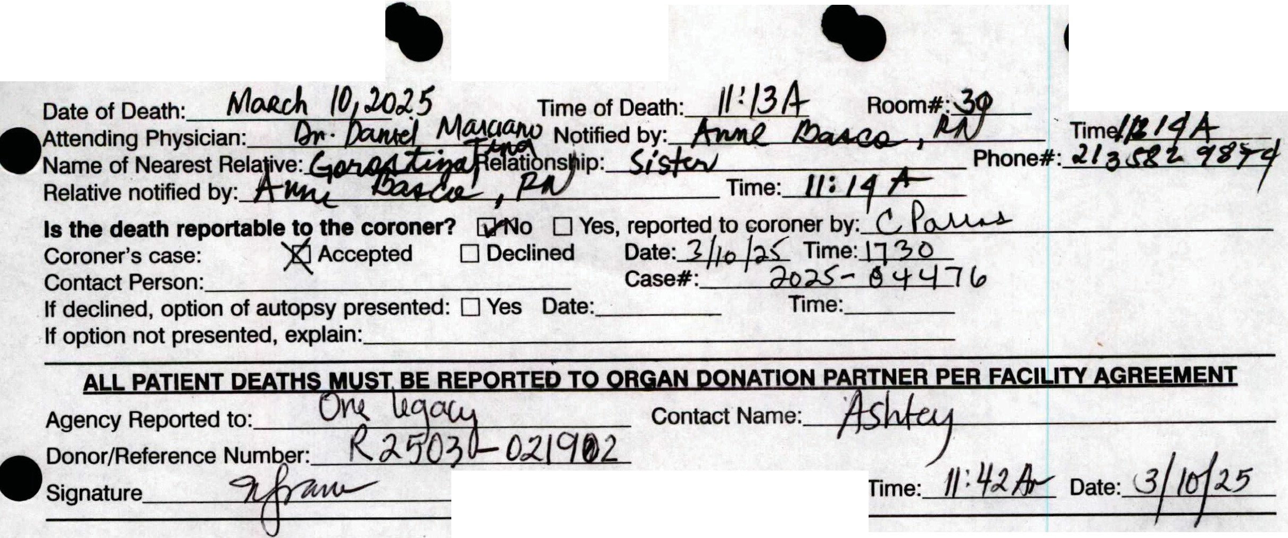
Body Received by Signature: Time:, Date:
•
•
•
AUTHORIZATION FOR AUTopsy
White - Chart.
Yellow - Procurement Agency
KindredfiHOsplta1
. RECORD OF DEATH/AUTHORIZATION
FOR RELEASE OF REMAINS
Pink - Nursing
PATIENVOC>J:netr_..&_TIOl>J_
GOROSTIZA, DANIEL
Kindred Hospital South Bay 12/1112024
Page 1 of 1 10/13
1H--1OC-10031--00100 11111111111
GS0002172260
ADMIN DR: MARCIANO. DANIEL A
111111111111111
MRN:GS00410643
M 06/1411976 48

'JE

IIME
GOROSTIZA, DANIEL
Kindred Hospital South Bay 12/11/2024
GS0002172260
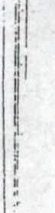
ADMIN DR: MARCIANO. DANIEL A

MRN:GS00410648

n..lir\it.t
1,d4;

111111111111111

M 06/14/1976 48

r - .. .

CLOTHING RETAII\IED BY PATIENT
PERSOl\lAL ITEMS RETAINED BY PATIENT

..
[j Bathrobe·
- Slippers
...
Dentures: .
. □-Glasses

□Coat
..
D Dress
D Lugg2ge D Pajamas D Purse
- Shirt
D Shoes
[j Sweater
- Pants
- Belt
□Tie
- Hat
OUndergar
- Upper ./
D Lower
□Partia
J::}e'c)ntact Lenses
D Hearing aids
D Money: Amount
D Jewelry
D Radio
- Raz.or
□Cane
- Quad Cane
D Walker·
D Wheelchair
D Miscellaneous (itemized)

D Shorts / V
□Skirt
□Slip

5

I

,O.CKNOWlEDGEMENT Of ITEMS KEPT BY PATIENT

! do h·ereby assu1:7e responsibility ior all srticles of clo_thi11g ai d p rs_o al bel g(eings wh· ' :.::::;-:::-'- ced
,n the :-1osp1tal Sci.Te; an gny m rs ,roughI 10 r:ie while a pauem 1n Ih1s hosp1Bl "1 \O • qJ
he
·-- - N t q\lJ\
Patiern/ .epresentaTive SignaLL:rs b \lt\ G\'\ (lVfiVA\ •
•
Witness t)OW,\\J\ liN ._r
l V I

Ct-lANGl:S DIJRiNG STAY

ITEMS SE!\lT HOME DATE/ INITIALS
I

I I
.. I

I I I I
I

ITEMS RETAINED IN HOSPITAL SAFE
ADD' ITC:MS BROUGHT 11\1
DATE/ INITIALS

I
, I

I I I I
I ' .

I
ENVELOPE VALUABLES NO.

I do hereby agree to items described on PatientVajuables Receipt that,_will be placed in the hospital safe. .
Patient/Represeritattv·e Signature X
·-·· - ···-. - .. . - RECEIPT FOR ITEMS RETURNED
I agree that I have received all my personal belongings and valuables and do hereby release Kindred Hospital of all resp_ ci_sipiUtY..!<2r._sai_d belongings upon my discharge.

;..:
•
Date

itness
..
.... ..
..
Patient/Representative Signature

PATIENT BELONGINGS LIST

p,o

KindredfHospital·
--
GOROSTIZA, DANIEL
Kindred Hospital South Bay 12/11/2024
GS0002172260
ADMIN DR: MARCIANO, DANIEL A

P:anP. 1 nf 1
1111111111Ill Ill I111111111111111llllllffi

11111m1111 1111

111111111111111

MRN:GS00410648
M 06/14/1976 48






CODE STATUS ORDER
- Patient Unable to Express Wishes
Preferences cannot be identified (choose all that apply):
- Responsible Party Not Available
- Advance Directive Not Available
- Advance Directive Not Completed by Patient
**Do Not complete remaining sections if any of the above options apply**
.-/.
Life Sustaining Treatment Therapie choose all that apply):
tubation / Mechanical Ventilation yardioversion
)tasopressors
Myanscutaneous Pacing
J2fAnti-arrhythmics
.,.e:J'Hemodialysis m,lood Products
c,0"Antibiotics
.Ef'Artificial Nutrition/Hydration
- All Measures
- Artificial Saliva and Tears
Comfort Measures (choose all that apply):
- Medications to Decrease Secretions
- Anti-nausea Medication
- Anti-anxiety Medication
- Pain Medication
- Palliative Care/Hospice Consult
- Pastoral Care Consult
- Ice Chips/Water
p11 Comfort Measures
• •
Advance Directive Reviewed:
D Yes (place copy in the medical record) I have reviewed and discussed its contents with the patient and/or the patient representative
o (c□hoose all that apply): □No copy□provided □Patient declined to execute
Responsible party unavailable
Patient unable to express if advance directive exists
CPR: D Yes (In the event of a cardiac or pulmonary arrest, resuscitate by manual (CPR), chemical, and/or electrical means including intubation)
ftNo, allow natural death
(In the event of a cardiac or pulmonary arrest, DO NOT resuscitate by manual (CPR), ch,emical, and/or electrical means (defibrillation), aRd DO mT i,,tabate ff WIW ff.t:>ad
□RN to Pronounce (if state allows - NV)
Printed Physician Name: --"'YR'lrf'cy..+-,r--+,£.L.LJIL..L..c......,_,, ---'--L-1--Vi--=-{_K-,--=-f--=-/fl'---'-/ lL M P ----r_ 1
Physician Signature. -+--+m'-1-------------- Time: '(Oq Date:->+-< --"""
Note: Any patient without designation will receive Full CPR / Full Code Status.

Patient Desires Regarding Life Sustaining Treatment/Comfort Measures
Choices should be shared with the physician - this document will become part of the medical record

o(lJJW ey sir TffJA ;.otorrrz/1"---L-
Completed By: SttA/ff 61rl1T7 (flt f/f Time: {,()4"t/:J.. Date: I/Ji [M--
Selected Life Sustaining Treatment/Comfort Measures require specific
- physician orders based on the wishes of :he patient/responsible party.
.tal coDE STATUS GOROSTIZA, DANIEL GS0002172260
KindredfiHospl
Kindred Hospital South Bay ADM IN 12/11/2024 DR: MARCIANO, DANIEL A

Page 1 of 1 03/13
111111111111111111I11111111 I 11111111ffl1111
H-OS-003--0000
111111111111111

MRN:GS00410648
M 06/14/1976 48

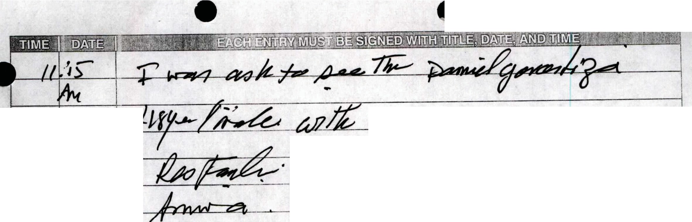
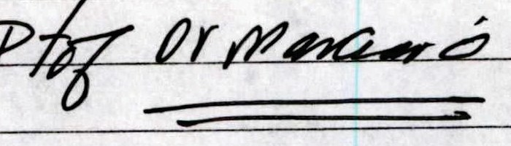
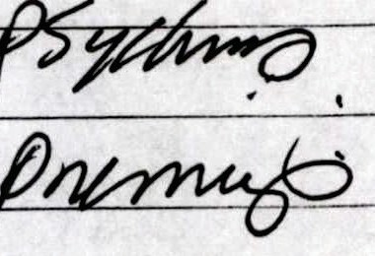
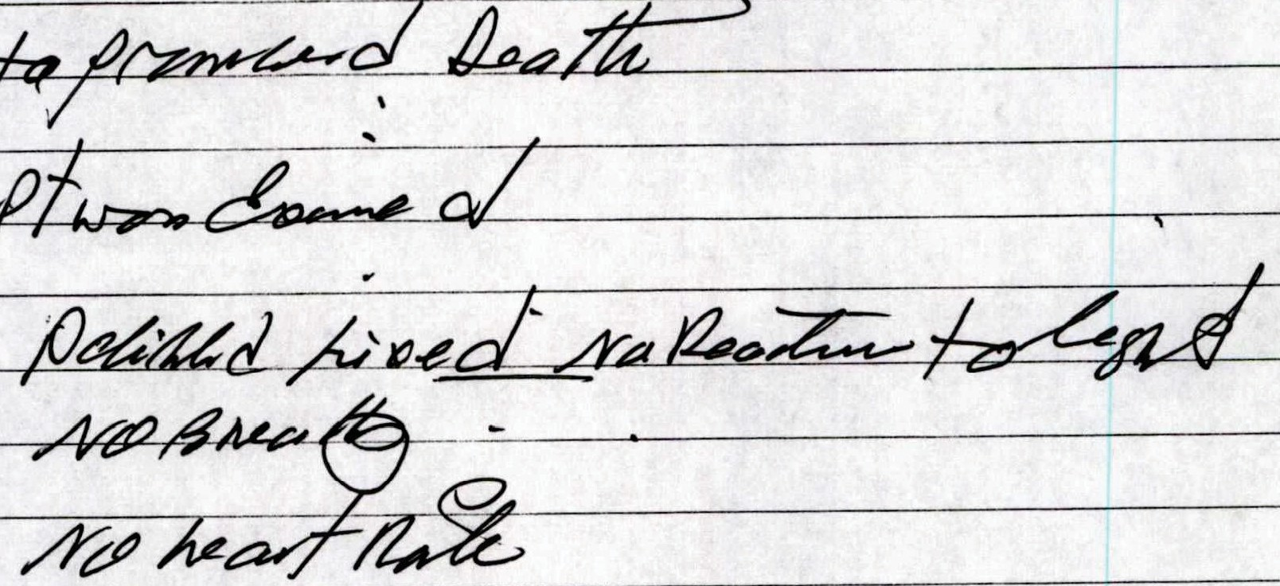
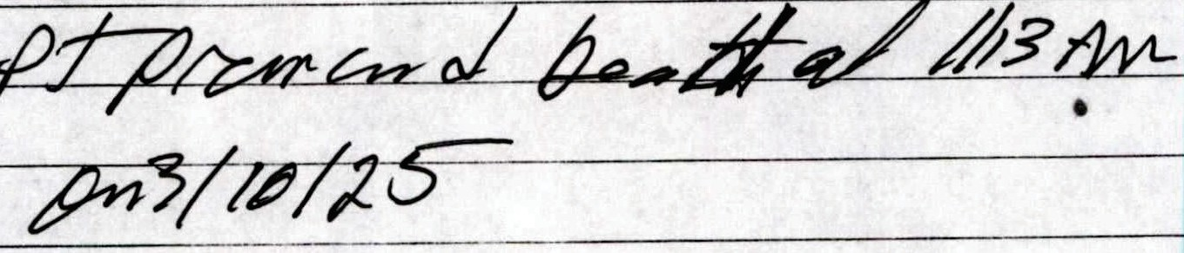
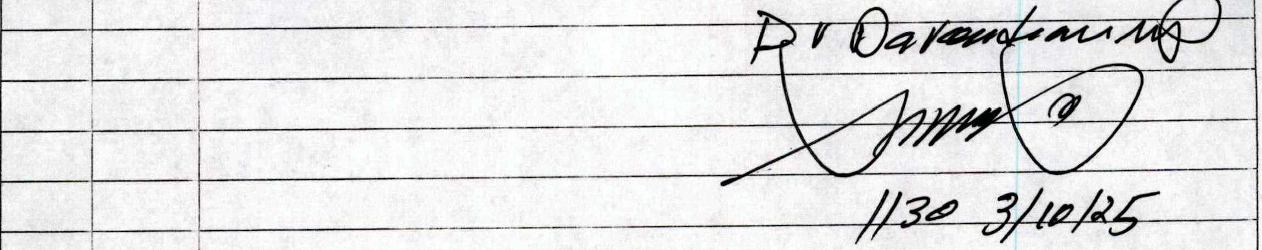
•

KindredrHJspital

Page 1 of 1
04/14
PHYSICIAN
. GRES O E
r n

!IIi11111!1111111iiI 11111 II 1111!1111 II 11!1
H-PN-OG:l-0000
PATIENT IDENTIFICATION _

,OROSTIZA, DANIEL GS0002172260

Kindred Hospital South Bay ADM IN 12/11/2024 DR: MARCIANO, DANIEL A

