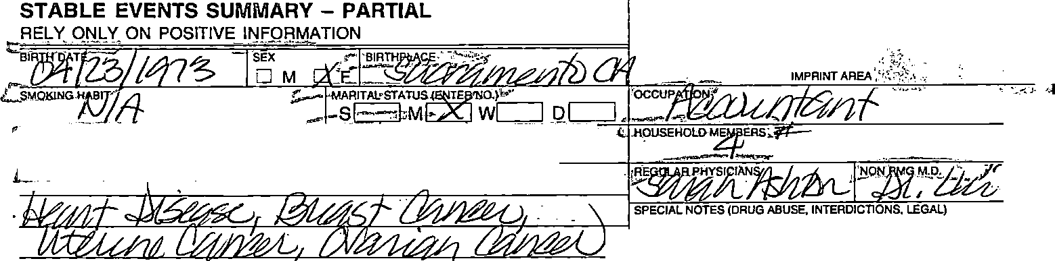
•
•1 f•••
NAME
J:JLIE R £YER
;;,: PERMANENTE
KAISER o
M.R.o
l00Y·Hll4
OJ, 7l
F
9 ')f:}'/lff
SIGN!.fJClfilLAMJ O B.'{Jr
!LQBEN

•
'
SIGNIFICANT SURGICAL PROCEDURES/DIAGNOSES (DATE EACH)  □ NONE |  |  |  |  | HOSPITALIZATIONS
 |  |  |  |  | DATE | REASON |  |  | FACILITY
 |  |  |  |  | SPECIAL NOTES
DRUG ALLERGIES (Date Each)
0 NONE
COMPLETION DATE OF  SUMMARY | I | I | I | I | I | I | I | I | I

•
•

•
06900-8 (1HM)

•

•
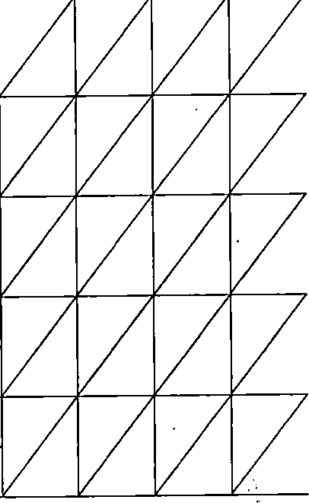
•
•
CURRENT ADDRESS |  |  | DATE ADDRESS  :> WAS LAST VERIFIED
 |  | .l?,H'O.•NE-is·": "!i:"• "'
 |  | BUSINESS!
 |  | HOME
 |  | BUSINESS,"
 |  | HOME
 |  | BUSINESS
 |  | HOME
 |  | BUSINESS
 |  | HOME
 |  | BUSINE S
 |  | HOME

TETANUS IMMUNIZATION RECORD TETANUS TOXOID SERIES TETANUS TOXOID BOOSTER

•
06900-8 (11-94) REVERSE

1'-l'·7S-eCo-nsrult
. \\\•'-"l'--v--, -
e., I o •.t5 0 (\r\, c" Page 15 of20

MRN: 10048714 |  | - Julia R Meyer
Patient Name: | Julia R Meyer
Mrn: | 10048714 | Requesting Provider: | For-Shing Lui, M.D.
Gender: | Female | Provider Id: | 000047798
Age: | 33y Bm | Fae/Adm Dept: | SAC/NEU
Language: | ENGLISH | Tie Line/Ext: | 8-426-6364
Contact Phone: | (916)825-7955 | Fax Tie Line:  PCP: | 8-426-6374  Sarah M Ashton, N.P. - (SAC)MED
 |  |  | Rebecca L King, M.D. -(SAC)GYN
Referral Detail
 |  | Access Time: 1 days

Status: (02) RESPONSE NEEDED

FAC/SPE: Redwood City/Neurological
Surgery
Assigned to For Triage: Triage Provider:
Problem Reason:
Regional Epilepsy
Date Initiated: 01/03/2007
Response Date:

Last Modified By: SACFSL 01/03/2007 12:01 PM
Entered By: For-Shing Lui, M.D. 01/03/2007 12:01 PM


Comments:
Referral
A: Dr. ustin, lease kindly see this patient with very frequent simple partial seizLlres presumed em oral lobe in origin. Her brain MR was norinal. Her EEG reported by George Palma in 20 had slow waves in left temporal lobe. She is stillexperiencing frequent stereotyped spells daily despite a good dose of Keppra. Thanks,

Response Notes:

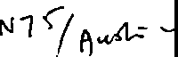



v-Jl

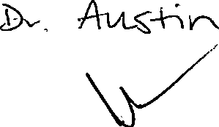

http://econsult.kp.org/econsult/controller
NEUROSURGERY - RWC RECEIVED
JAN O 4 2007
d
Appt .}t() Q

@ 1/4/2007

\f
PERMANENTE®
PATIENT PROGRESS RECORD |  |  |  |  |  | JULIE R fl EYER  Name: l00TITTl lf | 04 13 |  | F
PATIENT'S NAME (LAST, FIRST, MIDDLE)
ADDRESS
CITY
 |  |  |  | I |  |  |  | ,, ..
BIRTH DATE |  | PHONE |  | ICODE GROUP
 |  |  |  |  |  | IMPRINT AREA
DATE | TIME
NEUROSURGER:! - P,vvc..
nR E. AUS1IN
 |  |  |  | JAN 1 6 2007 |  | SMOKING
 |  |  | LD:1 |  |  | □Recent Qul st 12 mos. n-smoker □Smokinn """'-- "---
 |  |  | TIME
 |  |  | -:o. I a1 /c;;jLf |  | (?:::.- -=,--(_,, | T=-'l=l--, 'i5

•
•
•
•
•
•
90537 (REV. 6-06)

<
IS:: "a: PERMANENTE®
 |  |  |  |  | MR#:
PATIENT PROGRESS RECORD |  |  |  |  | Name:·
PATIENrs NAME (LAST, FIRST, MIDDLE)
ADDRESS
CITY
BIRTH DATE IPHONE |  |  | ICODE | IGROUP |  |  | IMPRINT AREA
DATE | TIME
 |  |  |  |  | ., | .. | - .

\
•
I

•
•
•
•
•
90537 (REV, 6·06) REVERSE



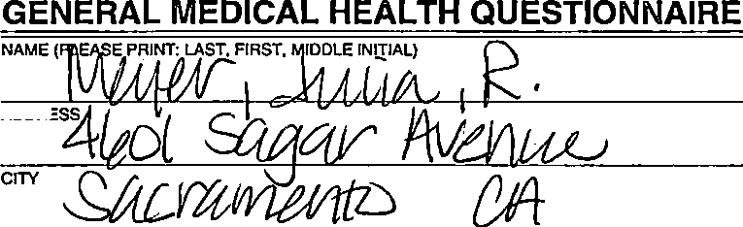

.......) F
JUL IE R MEYER
100Lf8ll 4
04 73
IMPRINT AREA
·:r
BIRTH DATE
ADDA
2JP coZfJJ9::Z/

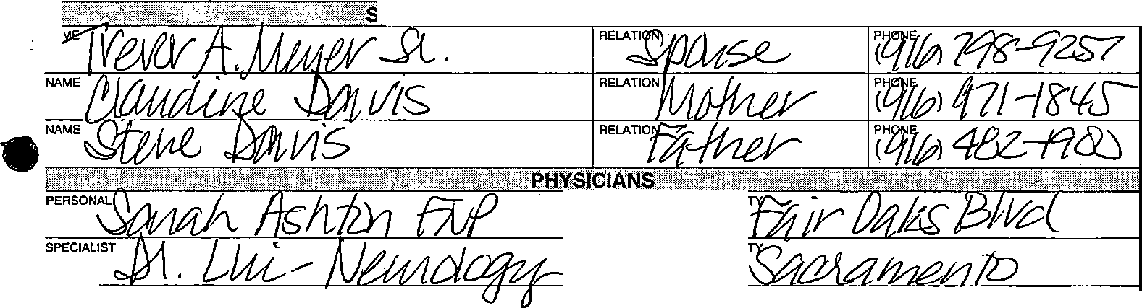
"tct 7°tt O -S { {}at 82E-74'§'
i>OUSS'08,0THE8f1>E8S
- NTA:Ct. i!si,c jfisr[ c'J(;JJ\J! l8f;[',.fft1?lit1r:;r1,
NA
FACILI

FAC1U
OTHER
FACILITY

Check if you have or have had any of the following:


Asthma Seizures
Emphysema/chronic lung disease D
aJeart murmur as adult
NO
□
□
DK'

I
i

Fractures (broken bones) Polyps in colon
Cancer type _

Kidney or bladder disease
";! NO
□
□
I
□
□

· earlattack or angina □
Congestive heart failure □
Gout □
Hepatitis □
Severe depression □
Duodenal ulcer □
Stroke □
l
Thyroid disease □
Gallstones or gallbladder disease □
Diabetes □
High blood pressure □
Glaucoma □
Bleeding disorder □
Spleen removed □
Positive TB skin test □
Radiation therapy to the head, stomach or neck □
High cholesterol □
Prolonged bleeding □
!
Jz(
i

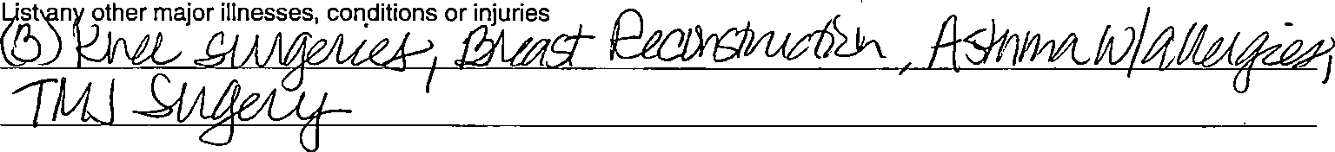

04499-4 (REV. 1-97)

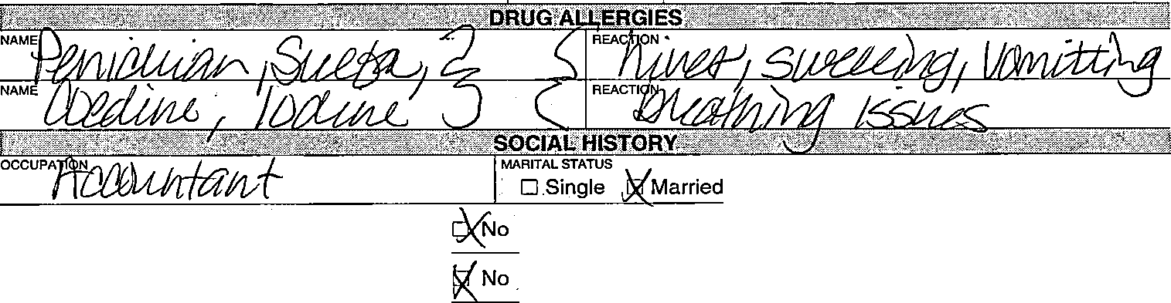
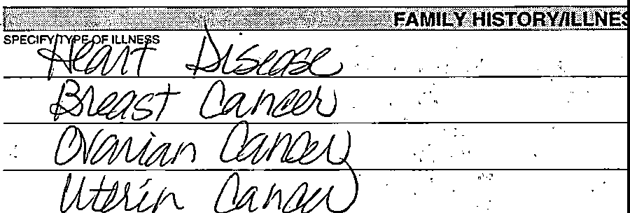

NAME
DOSAGE (TIME
A
NAME
STRENGTH
DOSAGE (TIMES PEA DAY)
NAME
STRENGTH
DOSAGE (TIMES PER DAY)
□ Separated □ Divorced □ Widow(er)
- Do you smoke cigarettes/cigars?

.Do you drink alcohol daily?
- Yes
- Yes
pack or number /day
quantity
Have you had any possible exposures to infectious diseases, parasites, or HIV?
- Yes
•
04499-4 (REV. 1•97) REVERSE l
: J! ltf¥dlt!;i •• • • •••• • • ••••• ' ' c>;::lH()SF!flfA:lllZAi!'.I ·•. ••••• ••• • 'J,,jjjj}i:tf 1,J¥'0,ill\l:.rtl,; ,J
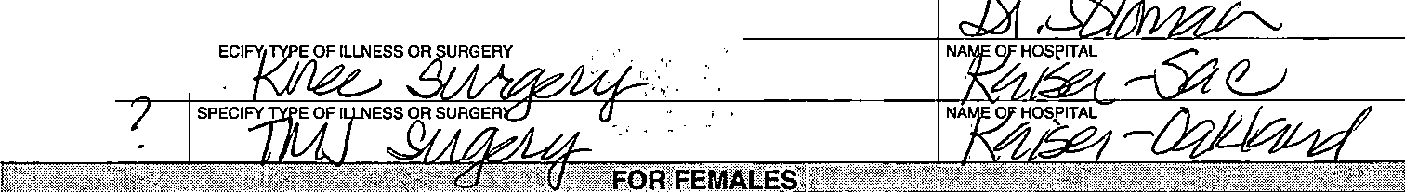
YEA"f))tD
YEA'!)_/)()/
SP
NUMBER OF PREGNANCIE
NUMBER OF OELIVEz_
List over the counter and prescription medications (including hormones, birth control, aspfrin, mmotrin)

NAME
NAME
NAME | 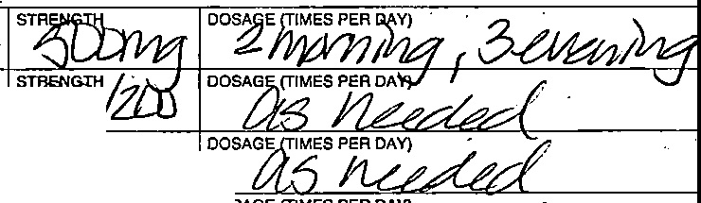  STRENGTH
  NAME | DO  .·;·

