LIVED EXPERIENCES OF HOME ECONOMICS SENIOR HIGH SCHOOL STUDENTS IN USING ARTIFICIAL INTELLIGENCE TOOLS

A Research Study
Presented to the
Thesis Committee
Senior High School Department
Isabel National Comprehensive School
Isabel, Leyte

In Partial Fulfilment
of the Requirement for the Applied Subject
Practical Research 1 (Qualitative Research)
with field of specialization in Information and Communication Technology

AGUILAR, ADRIAN CAZ
CALIXTRO, AILYN
CALVEZ, IVAN
DAJALOS, NICOLE BOYLES
ISOTTO, KYLE KRISTOFF G.
LOPEZ, ZARA JAMILIA
MAURILLO, CYFROS
RUFIN, JOHN LHISTER

May 2026
TABLE OF CONTENTS

Approval Sheet ………………………………….………………i
Panel of Oral Examiner ………………………………….………………ii
Acknowledgement ………………………………….………………iii
Abstract ………………………………….………………iv
Chapter I
Background of the Study ………………………………….………………1
Theoretical Framework ………………………………….………………2
Conceptual Framework ………………………………….………………4
Statement of the Problem ………………………………….………………5
Significance of the Study ………………………………….………………5
Scope and Limitation ………………………………….………………6
Definition of Terms ………………………………….………………7
Chapter II
Review of Related Literature ………………………………….………………9
Review of Related Studies ………………………………….………………11
Chapter III
Research Methodology (Design)
Research Design ………………………………….………………14
Research Participants ………………………………….………………14
Research Environment ………………………………….………………15
Research Instruments ………………………………….………………12
Gathering of Data ………………………………….………………15
Ethical Consideration ………………………………….………………17
Non-Statistical Treatment of Data …………………………….……………………18
Chapter IV
Presentation, Interpretation, Analysis ………………………………….………………19
Chapter V
Summary of Findings ………………………………….………………36
Conclusion ………………………………….………………37
Recommendation ………………………………….………………38

Recommendation ………………………………….………………38
References ………………………………….………………39
Appendix A
Transmittal Letter ………………………………….………………42
Appendix B
Questionnaire ………………………………….………………43
Appendix C
Pictures ………………………………….………………45
Appendix D
English Critic Certification ………………………………….………………46
Appendix E
Data Results ………………………………….………………47
Appendix F
Content Validity Tool ………………………………….………………53
Appendix G
Plagiarism Report ………………………………….………………55

APPROVAL SHEET

This research study entitled “Lived Experiences Of Home Economics Senior High School Students In Using Artificial Intelligence Tools ” prepared and submitted by ADRIAN CAZ AGUILAR, AILYN CALIXTRO, IVAN CALVEZ, NICOLE BOYLES DAJALOS, KYLE KRISTOFF G. ISOTTO, ZARA JAMILIA LOPEZ, CYFROS MAURILLO, JOHN LHISTER RUFIN, in the partial fulfillment of the requirements for the Applied Subject Practical Research 1 (Qualitative Research) with field of specialization in Information and Communication Technology has been examined and is recommended for acceptance and approval for Oral Examination.

NIEL V. DAYANDAYAN, MAEd
Adviser

THESIS COMMITTEE

NIKKO JHON C. EVANGELISTA, MAEd
Chairman

ANAFLOR C. CABALDA JEAN ANNE B. ROLDAN
Member Member

GEMO J. OCON, MAEd
Data Analyst

Accepted and approved for oral examination.

ALFRED P. ESPORLAS, EdD
Assistant School Principal II

PANEL OF ORAL EXAMINER

Approved by the Committee on Oral Examination Panel with the grade .

THESIS COMMITTEE

NIKKO JHON C. EVANGELISTA, MAEd
Chairman

ANAFLOR C. CABALDA JEAN ANNE B. ROLDAN
Member Member

GEMO J. OCON, MAEd
Data Analyst

ACCEPTED AND APPROVED in partial fulfillment of the requirements for the degree of Master of Arts in Education major in Physical Education.

ALFRED P. ESPORLAS, EdD
Assistant School Principal II

Comprehensive Examination :
Oral Examination :
Book Submission :

ACKNOWLEDGEMENT

We would like to express our sincere gratitude to all those who have contributed to the completion of our research study entitled " Lived Experiences of Home Economics Senior High School Students In Using Artificial Intelligence Tools ”.

First and foremost, we would like to thank our Almighty God, for providing us the knowledge, strength, and ability to accomplish this study.
To Dr. Alfred P. Esporlas, for giving us the opportunity to conduct our research study about Lived Experiences of Home Economics Senior High School Students In Using Artificial Intelligence Tools.
To Ms. Jean Anne B. Roldan, for giving us support and encouragement to on this study.
To Mr. Nikko Jhon V. Evangelista, for his never-ending support and assistance he can give to make this research study.
To Mr. Niel V. Dayandayan, for giving us motivation and guiding us throughout the journey in making this research study.

We would also like to thank the school administrators and students who willingly participated in the survey and interview sessions. Your valuable inputs have helped us gain a better understanding of the Lived Experiences of Home Economics Senior High School Students In Using Artificial Intelligence Tools, and your willingness to share your experiences and perspectives has been greatly appreciated.
Finally, we would like to extend our gratitude to our family and friends who have supported us throughout this research study, your encouragement and support have kept us motivated and inspired us to push ourselves further.

Abstract
This qualitative study explored the lived experiences of Grade 11 Home Economics students at Isabel National Comprehensive School in using Artificial Intelligence (AI) tools for academic tasks during the 2025-2026 school year. Grounded in the Technology Acceptance Model (TAM) and Self-Determination Theory (SDT), the research adopted an interpretive phenomenological design and purposive sampling to collect written narrative responses from 30 participants who used or selectively engaged with tools such as ChatGPT and Grammarly. Thematic analysis revealed mixed experiences: some students found AI convenient, efficient, and supportive for idea generation, explanations, translations, and task completion, while many deliberately limited or avoided its use due to the strand’s emphasis on hands-on performance skills rather than written assignments. Perceptions of AI’s influence on study habits and learning processes were dual—positive effects included enhanced understanding, quicker research (particularly for recipes and procedures), and improved knowledge acquisition, whereas over-reliance led to reduced independent learning and retention. AI’s impact on critical thinking, creativity, and problem-solving showed similar duality: it inspired ideas and suggestions for some, but diminished independent effort and fostered dependence for others. Key challenges included unreliable internet connectivity in the rural setting and inaccurate or misleading AI outputs, especially for Home Economics content, raising practical and ethical concerns. Students recommended balanced use through self-regulation (“try first, then AI”), clear guidelines, digital literacy and ethics education, and improved infrastructure. The findings suggest that while AI supports preparatory aspects of vocational learning, responsible integration with guidance and equitable access is essential to preserve independent competencies central to the Philippine K-12 Home Economics strand.

Keywords: Artificial Intelligence, Technology Acceptance Model, Self-Determination Theory, Home Economics Students, Academic Tasks, Student Motivation, Over-reliance, Phenomenology

CHAPTER I
INTRODUCTION

Background of the Study

The rapid advancement of Artificial Intelligence (AI) has significantly transformed educational practices across the globe. AI-powered tools such as ChatGPT, Grammarly, and Canva are increasingly used by students to generate ideas, improve writing, create presentations, and complete academic requirements. In secondary education, AI technologies are becoming integrated into students’ everyday learning routines, reshaping how knowledge is accessed, processed, and presented. Recent studies suggest that AI tools can enhance personalized learning, increase efficiency, and support creativity when used appropriately (Kasneci et al., 2023; Zawacki-Richter et al., 2019). However, concerns have also been raised regarding overreliance, reduced independent thinking, and ethical issues in academic work (Dwivedi et al., 2023).
Artificial intelligence tools present both opportunities and challenges. Home Economics requires applied knowledge, creativity, problem-solving, and performance-based outputs such as demonstrations, presentations, and project development. AI can serve as a support tool in generating recipes, planning budgets, designing outputs, and organizing presentations. Research indicates that AI-assisted learning environments may foster creativity and engagement when learners use them as cognitive support tools rather than replacements for thinking (Holmes et al., 2022). However, emerging evidence also suggests that students may become dependent on AI-generated responses, which can limit deep learning and critical thinking development if not properly guided (Kasneci et al., 2023).
Preliminary baseline data gathered by the researchers through a survey among Grade 11 Home Economics students at Isabel National Comprehensive School revealed that a majority of students frequently use AI tools in completing academic tasks and activities. The data further suggest a growing dependence on AI for idea generation, content writing, and task completion. While students report that AI makes tasks easier and faster, there are indications that some learners rely heavily on AI-generated outputs with minimal personal modification. This emerging pattern raises important questions about how AI usage influences study habits, academic performance, creativity, and higher-order thinking skills among senior high school learners.
Although existing international studies discuss the general impact of AI in education (Dwivedi et al., 2023; Zawacki-Richter et al., 2019), there is limited qualitative research focusing specifically on senior high school students in the Philippine context, particularly within skill-based subjects such as Home Economics. Moreover, most current studies emphasize higher education settings, leaving a gap in understanding how younger learners experience and interpret AI integration in their academic work. There is also a scarcity of research exploring student’s lived experiences regarding AI dependence and how it shapes their learning behaviors, critical thinking, creativity, and presentation skills in applied subjects.
Given this research gap, this study seeks to explore the lived experiences of Grade 11 Home Economics students in using AI tools for their academic tasks. By examining how students perceive and utilize AI, this research aims to contribute to a deeper understanding of AI-assisted learning in secondary education and provide insights that may guide teachers in promoting responsible and balanced AI integration in Home Economics instruction.

Theoretical Background

This study is anchored on Self-Determination Theory (SDT) proposed by Deci and Ryan (1985, 2000) and the Technology Acceptance Model (TAM) developed by Fred Davis (1986).
Self-Determination Theory posits that human motivation thrives when three basic psychological needs are satisfied: autonomy (the desire to feel volitional and self-directed in one’s actions), competence (the need to feel effective and capable in mastering tasks), and relatedness (the sense of connection with others). In educational settings, when these needs are supported, students exhibit greater intrinsic motivation, deeper engagement, persistence, and higher-quality learning outcomes. Conversely, when technologies or learning environments undermine autonomy or competence, motivation tends to shift toward controlled or diminished forms, often leading to reduced effort and poorer retention of skills (Deci & Ryan, 2000; Chiu, 2021).
In the context of senior high school Home Economics, where learning centers on hands-on performance, practical skill development, and real-world application rather than purely written tasks, SDT provides a powerful lens. Students are likely to engage more deeply when AI tools support their sense of competence (for example, by offering clear explanations of recipes or procedures) without threatening their autonomy through over-reliance that replaces personal effort and creative problem-solving.
Building upon this motivational foundation, the study further draws on the Technology Acceptance Model (TAM) (Davis, 1986) to explain the specific decision-making process behind students’ adoption or rejection of AI tools. TAM proposes that technology use is primarily driven by two key perceptions: perceived usefulness (PU) — the belief that the tool will improve performance — and perceived ease of use (PEOU) — the belief that the tool requires minimal effort. When students perceive AI tools as both useful and easy to use, they develop favorable attitudes toward them and are more likely to integrate the tools into their academic routines (Farhat et al., 2024).
The integration of SDT and TAM creates a coherent theoretical framework for this study. SDT explains the deeper motivational dynamics and psychological experiences of Grade 11 Home Economics students when interacting with AI, while TAM illuminates the cognitive factors that influence whether they actually choose to use these tools. For instance, even if AI is perceived as useful and easy (TAM), excessive dependence may still erode students’ autonomy and competence (SDT), leading many learners to deliberately limit or avoid its use in favor of preserving hands-on skill mastery. This combined lens is especially relevant in the Philippine K-12 vocational strand, where balancing technological support with the development of independent practical competencies remains essential.
Together, Self-Determination Theory and the Technology Acceptance Model provide a robust foundation for exploring the lived experiences of Grade 11 Home Economics students with AI tools — revealing not only why they adopt or reject them, but also how such use shapes their motivation, learning processes, critical thinking, creativity, and overall vocational development.
Conceptual Framework

OUTPUT
INPUT
PROCESS

1. Students describe their experiences in using AI tools.
2. Students perceive the influence of AI tools on their study habits and learning processes.
3. Ways AI tools affect their critical thinking, creativity, and problem-solving skills.
4. Challenges and ethical concerns do students encounter in using AI tools for their academic requirements.
1. Preparation of self-made
2. Asking permission from school administration and teachers
3. Distribution of questionnaires to the participants
4. Collection of answered questionnaires
5. Analysis of data using thematic technique.

Intervention/Solution Plan

Figure 1: Effects of AI on Education
The diagram presents a clear alignment between the research objective and the study’s methodological process. It shows that the research focuses on exploring the lived experiences of Grade 11 Home Economics students in using AI tools by examining their perceptions of its influence on study habits, learning processes, critical thinking, creativity, and problem-solving skills, as well as the challenges and ethical concerns they encounter. The diagram further illustrates the procedural flow of the study—from securing approval from school authorities and distributing questionnaires to collecting responses and analyzing data using a thematic technique. This structure reflects a qualitative approach, ensuring that the research questions guide both data collection and analysis, ultimately leading to the development of a proposed intervention that promotes responsible and balanced AI use in Home Economics learning.

THE PROBLEM

Statement of the Problem

This study aimed to explore the lived experiences of Grade 11 Home Economics students in using Artificial Intelligence (AI) tools at Isabel National Comprehensive School.
Specifically, it sought to answer:

- How do Grade 11 Home Economics students describe their experiences in using AI tools for their academic tasks and activities?
- How does using AI tools change the way Home Economics students study and learn their lessons?
- How do students describe the ways AI tools affect their critical thinking, creativity, and problem-solving skills?
- What difficulties do students run into, and do they feel using AI is a fair way to finish their activities?
- Based on the findings of the study, what intervention/solution may be proposed to promote responsible and balanced use of AI tools in Home Economics learning?

Significance of the Study

This study was significant as it provided insights into how Artificial Intelligence (AI) was used by Grade 11 Home Economics students and how it influenced their learning experiences. The findings of this research benefited the following groups:
Students. This study helped them better understand how AI tools supported their learning, improved efficiency, and addressed challenges they encountered when using technology in academic tasks.
Teachers. The results served as a basis for improving instructional strategies by identifying effective ways to integrate AI into teaching while addressing potential issues such as over-reliance and digital skill gaps.
School Administrators. This study provided useful information for decision-making related to technology integration, resource allocation, and the development of policies that promoted responsible and equitable use of AI in schools.
Future Researchers. This study served as a reference for further research on AI integration in secondary education, particularly in subject-specific contexts such as Home Economics.

Scope and Limitation of the Study

This research examines Grade 11 Home Economics students' use of AI tools—including specific applications (writing assistants, research platforms), usage frequency, and perceived helpfulness for research, writing, and concept mastery tasks.
The participants are exclusively Grade 11 Home Economics strand students at Isabel National Comprehensive School (INCS) in Leyte, Philippines—a rural public secondary institution. Their self-reported experiences captured during School Year 2025-2026.
The study prioritizes student perceptions gathered through written narratives, excluding grades testing, teacher methods, school policies, or AI technical analysis to focus on answering the five research questions via Technology Acceptance Model (TAM) framework analysis.
However, results face several limitations: self-reported data risks response bias; the single-site, single-strand, single-grade focus prevents generalization to other schools, levels, or strands; and coverage of only common AI apps excludes specialized tools.
This clearly defined scope ensures focused, manageable qualitative exploration while transparently acknowledging inherent limitations.

Definition of Terms

Conceptual Definition

Artificial Intelligence (AI) is a technology that enables machines to perform tasks requiring human-like intelligence, such as generating text, answering questions, and providing instant feedback. In this study, AI refers to commonly used tools like ChatGPT and Grammarly that Grade 11 Home Economics students apply to assist with research, writing, and project work.

Technology Acceptance Model (TAM) is a framework developed by Fred Davis in 1986 that explains why people accept and use new technology. It focuses on two main factors: perceived usefulness and perceived ease of use.

Perceived Challenges – Perceived challenges refer to the subjective difficulties, barriers, and concerns that Grade 11 Home Economics students personally experience or recognize when using Artificial Intelligence tools for their academic tasks. These primarily include technical limitations such as unreliable or absent internet connectivity that restricts access, and issues with the accuracy and reliability of AI outputs, particularly when information provided is incorrect, misleading, or unclear in relation to Home Economics topics

Operational Definition

Artificial Intelligence (AI) is a technology that enables machines to perform tasks requiring human-like intelligence, such as generating text, answering questions, and providing instant feedback. In this study, AI refers to commonly used tools like ChatGPT and Grammarly that Grade 11 Home Economics students apply to assist with research, writing, and project work.

Technology Acceptance Model (TAM) is a framework developed by Fred Davis in 1986 that explains why people accept and use new technology. It focuses on two main factors: perceived usefulness and perceived ease of use.

Perceived Challenges – In this study, perceived challenges are the self-reported obstacles encountered by Grade 11 Home Economics students at Isabel National Comprehensive School while using AI tools (e.g., ChatGPT, Grammarly) for Home Economics-related activities. These challenges encompass: (1) unstable, slow, or missing internet connection that hinders consistent use for research, explanations, or task support; and (2) instances of inaccurate, false, or unreliable AI-generated content that may lead to errors in academic work and raise concerns about depending on unverified information.

CHAPTER II

This chapter synthesizes key literature on Artificial Intelligence (AI) integration in secondary education, focusing on its applications, benefits, and challenges for Grade 11 Home Economics students at Isabel National Comprehensive School. Drawing from global and local studies, it provides a foundation for examining AI's impact on vocational competencies within the Philippine K-12 framework.

Review of Related Literature

The integration of Artificial Intelligence (AI) into the educational landscape has shifted from a futuristic concept to a foundational reality in secondary education. This review synthesizes current literature regarding AI applications, benefits, and challenges for learners, particularly within vocational and secondary education contexts. By drawing from global and local research, it establishes a theoretical and empirical base for understanding AI's impact on Grade 11 Home Economics (H.E.) students at Isabel National Comprehensive School.
Furthermore, Artificial Intelligence in Education (AIEd) primarily serves to augment learning rather than replace traditional instruction. For instance, Hwang et al. (2020) emphasize that AI-driven intelligent tutoring systems (ITS) provide tailored guidance and immediate feedback, effectively mimicking one-on-one human tutoring. For Senior High School students, these tools typically include writing assistants, research platforms, and adaptive learning systems that adjust content difficulty based on performance. In the Philippine setting, this adoption responds to the heavy K-12 curriculum demands, where students seek digital support for technical-vocational requirements amid limited resources.
Moreover, the adoption of AI among students is frequently analyzed through the Technology Acceptance Model (TAM), recently updated for the generative AI era. According to Farhat et al. (2024), the model posits that “Perceived Usefulness” and “Perceived Ease of Use” remain foundational drivers, though now influenced by “AI Anxiety” and “Trust.” Consequently, students generally view AI tools as intuitive and accessible, directly correlating to high behavioral intention for academic use. For Home Economics students, this ease enables AI to generate project ideas or organize livelihood research, quickly integrating into study routines.
Additionally, in the context of vocational strands like Home Economics, AI acts as a bridge between theory and practice. For example, Chiu (2021) explores how digital tools support engagement in blended learning, noting that AI provides virtual simulations of real-world tasks. This proves particularly relevant for H.E. students handling household management and livelihood skills, as AI platforms enable budgeting, meal planning, and inventory simulations in a “safe-to-fail” environment before physical lab applications.
One significant advantage of AI is its capacity to facilitate personalized learning and adaptivity. By analyzing individual data to tailor content, it ensures appropriate challenge levels for SHS students with varying technical knowledge in nutrition or consumer chemistry (Zawacki-Richter et al., 2019).
Similarly, the technology offers immediate feedback and continuous support. It provides real-time corrections that foster fluid learning during independent study—especially useful for H.E. students’ home-based projects (Molenaar, 2022).
Beyond these, AI greatly enhances efficiency and task automation by handling repetitive tasks like data gathering. This allows students to focus on higher-order cognition and hands-on vocational skills (Kuhail et al., 2023).
In addition, it promotes increased accessibility and inclusivity through features such as speech-to-text and translation. These capabilities help equalize access across diverse learner profiles in Philippine public schools (Zhang & Aslan, 2021).
Equally important, AI fosters innovative pedagogy and engagement through interactive simulations that make abstract concepts tangible. Consequently, this increases H.E. students’ motivation for household management strategies (Chen et al., 2020).
However, despite these benefits, a major concern remains cognitive over-reliance and dependency. When students overtrust automated responses, Seo et al. (2021) warn of declining independent study habits. For instance, H.E. students relying on AI for budgeting may struggle during practical assessments.
This dependency further leads to the erosion of critical thinking skills. As Dwivedi et al. (2023) suggest, instant answers encourage “epistemic laziness,” negatively impacting synthesis and reasoning—critical risks for SHS professional preparation.
Furthermore, ethical risks and academic integrity issues emerge with the rise of generative AI. Chan (2023) emphasizes plagiarism challenges, necessitating AI literacy and new assessments to verify strand competencies.
Another pressing issue is algorithmic bias and misinformation. Since AI accuracy depends on training data, the OECD (2023) notes that students’ limited fact-checking ability can lead to incorrect H.E. knowledge such as nutrition data.
Lastly, social isolation and the digital divide persist. While digital interfaces may reduce human interaction, infrastructure gaps (Vesna et al., 2025; Manila Times, 2025) widen rural-urban disparities, particularly relevant in Isabel, Leyte.
In summary, although AI transforms Grade 11 H.E. learning, its success requires balanced implementation as a “scaffolding” tool—supporting, not replacing, essential cognitive and manual competencies.

Review of Related Studies

This section synthesizes empirical studies on AI adoption in secondary and vocational education, particularly highlighting findings relevant to Home Economics (H.E.) students.
Internationally, Sok (2025) surveyed 450 high school students in urban settings, revealing that 78% used AI tools like ChatGPT for homework. Perceived ease of use strongly predicted adoption (β = 0.62, p < 0.01), yet 45% reported reduced critical thinking due to over-reliance. This aligns with TAM and underscores the dependency risks faced by Grade 11 learners managing complex H.E. tasks.
In the Philippine context, Instructure’s (2024) survey of 115 vocational schools found that 32% had integrated AI for research and planning. While 75% provided training, 38% still banned its use for assessments. Importantly, rural institutions lagged significantly due to access gaps — a reality that closely mirrors conditions at Isabel National Comprehensive School in Leyte.
Furthermore, RSIS International (2025) surveyed 464 senior high students across strands in Iriga City. The study reported high AI utilization (M = 4.2/5) primarily driven by accessibility. Nevertheless, 62% encountered misinformation challenges, prompting strong recommendations for teacher training and digital literacy in applied learning contexts such as Home Economics.
Similarly, Dela Cruz et al. (2025) examined 200 Grade 11 students at Taft National High School. Results showed that 66% used AI daily for writing tasks, correlating with 89% proficiency (r = 0.543). Although H.E. projects benefited greatly from AI-generated ideas for nutrition planning and budgeting, the study also identified clear links to procrastination.
In addition, Chua and Cruz (2025) analyzed 120 TVL-track students in Quezon Province. They discovered a moderate positive correlation between AI utilization and practical skills performance (r = 0.38), particularly in entrepreneurship projects where AI supported market analysis and financial planning.
Moreover, Milloria et al. (2024) conducted a quasi-experimental pretest-posttest study with Grade 11 students at Fervent Academy in Cebu. The findings demonstrated that integrating AI (ChatGPT 3.5) significantly improved academic performance (p < 0.05), engagement, and independence, while effectively addressing ethical issues like data privacy. These results are highly applicable to the practical project requirements in Home Economics.
Additionally, a qualitative study of 16 STEM senior high students (IJFMR, 2025) revealed that generative AI tools functioned effectively as virtual tutors and research aids. These tools boosted efficiency for simulations, yet they simultaneously raised serious concerns regarding overreliance — issue H.E. students are also likely to face in household management and livelihood tasks.
On a more specialized front, Erjavšek (2026) employed the Delphi method with 25 Home Economics educators across Europe, achieving 92% consensus on the value of AI for vocational simulations such as budgeting and inventory management.
Most significantly for the local context, a 2025 Manila Times report on DepEd Leyte pilots documented 15% improvements in H.E. project scores. However, the report emphasized persistent equity gaps caused by unreliable internet connectivity.
Collectively, these diverse empirical findings — drawn from surveys, quasi-experiments, qualitative inquiries, and expert consensus — strongly validate this study’s TAM-based investigation into the dual impacts of AI on Grade 11 Home Economics students. They also provide solid justification for targeted interventions aimed at achieving balanced and responsible vocational integration.
CHAPTER III

Research Design

This study utilized an interpretive phenomenological research design. This design was deemed appropriate because the study sought to investigate and comprehend the lived experiences, perceptions, and insights of Grade 11 Home Economics students regarding their use of Artificial Intelligence (AI) tools in learning. Using a phenomenological approach, the researchers investigated how participants interpreted their experiences and how AI tools affected their study habits, academic achievement, and learning processes.
This design prioritized the participants’ individual perspectives, opinions, and interpretations of AI tools and their uses. Grade 11 Home Economics students at Isabel National Comprehensive School (INCS) were the study’s primary focus. It explained how students utilized AI tools, their perceptions of their value, and the difficulties they faced when incorporating AI into their academic studies.

Research Participants

This study employed purposive sampling to select 30 Grade 11 Home Economics (H.E.) students from the total population of 45 at Isabel National Comprehensive School who provided rich insights into their lived experiences with AI tool usage guided by the Technology Acceptance Model (TAM). The sample size of 30 participants was informed by established qualitative research guidelines, such as Guest et al. (2006), who found data saturation typically occurred between 12-30 participants in focused phenomenological interviews. Similarly, Creswell and Poth (2018) recommended 20-30 participants as optimal for in-depth exploratory studies in educational contexts, balancing depth and manageability.
Through purposive sampling, these 30 participants were chosen based on their active use of AI tools (e.g., ChatGPT, Grammarly) for H.E. tasks like research, project planning, and presentations, with selection criteria aligned to TAM factors: perceived usefulness (PU) and perceived ease of use (PEOU).
This approach ensured participants possessed the relevant experiences needed for meaningful data on AI’s impacts. Overall, this selection yielded valuable, detailed perspectives on TAM-guided AI integration in vocational learning, supporting the study’s aim to explore both benefits and challenges in this specific context.

Research Environment

The study will be conducted at Isabel National Comprehensive School (INCS), an educational institution in Marvel, Isabel, Leyte, formerly recognized as the Isabel National Agricultural and Vocational School (INAVS). This school currently accommodates a total of 2,775 learners, consisting of 675 Senior High School (SHS) students. Led by researchers who are themselves part of the INCS community, this inquiry focuses on the unique perspectives, hurdles, and personal narratives of those involved. By employing written narratives as a qualitative tool, the researchers seek to figure out how AI tools are used by the Grade 11 Home Economics.

Data Gathering Procedures

Step 1: The researchers prepared a formal letter addressed to the principal of Isabel National Comprehensive School, Dr. Alfred P. Esporlas, requesting permission to conduct the study in the Senior High School Department. The study specifically involved Grade 11 H.E. students, who served as participants.
Step 2: Upon receiving approval from the principal, the researchers submitted the research questionnaire to designated research experts for validation and review to ensure its clarity, relevance, and appropriateness.
Step 3: After the validation process, the researchers sought consent from the Grade 11 H.E. class advisers to administer the survey to their respective advisory classes.
Step 4: Informed consent was obtained from each selected student participant prior to the administration of the survey, ensuring that students understood their voluntary participation and rights.
Step 5: The validated questionnaire was distributed to the participants. The researchers explained the purpose of the study and provided clear instructions to guarantee that all students fully comprehended the questions.
Step 6: To minimize disruption of regular classes, the survey was conducted at a scheduled time approved by the school administration. After the data collection, participants were informed that their responses remained confidential and were used solely for research purposes.
Step 7: Once all data were collected, the responses were organized, encoded, analyzed, and interpreted systematically to address the research questions of the study.

Research Instrument

The research instrument used in this study was a structured written narrative guide composed of open-ended questions. It was specifically developed to elicit detailed descriptions of Grade 11 Home Economics students’ lived experiences in using Artificial Intelligence (AI) tools for academic purposes. The instrument was aligned with the study’s five research problems and grounded in the Technology Acceptance Model (TAM), particularly focusing on perceived usefulness and perceived ease of use. The open-ended format allowed participants to freely express their thoughts, experiences, and reflections, enabling the researchers to gather rich, in-depth qualitative data necessary for thematic analysis.
Before data collection, participants were recruited through class coordination with teachers. Informed consent was obtained from each of the 30 participants as a prerequisite, ensuring they understood the study’s voluntary nature and their right to withdraw at any time without penalty. Open-ended questions aligned with the five research problems (e.g., “How has AI affected your study habits?” “Describe AI as a creative partner in H.E. projects.”) were clearly explained, both verbally and in writing, to promote comprehensive responses.
Data from the written narratives were analyzed using thematic analysis. Responses were transcribed, thoroughly reviewed multiple times, and coded to identify recurring patterns, such as benefits (e.g., efficiency gains) and challenges (e.g., over-reliance). Themes were categorized by TAM constructs and research questions to draw meaningful conclusions about AI’s dual impacts on vocational learning. Participant privacy and confidentiality were strictly maintained. Pseudonyms replaced real names in all reporting, and all data were stored securely on password-protected devices, accessible only to the research team.

Ethical Considerations

In conducting this study on the applications of AI among Grade 11 Home Economics (H.E.) students at Isabel National Comprehensive School, the researchers strictly adhered to ethical standards to protect the rights and welfare of the participants.
Before they decided to participate in the study, all potential Grade 11 H.E. participants were fully informed about the nature and goals of the research, particularly its focus on their lived experiences with Artificial Intelligence. They were informed that their participation was entirely voluntary and that they had the right to withdraw from the study at any time without any negative consequences to their grades or standing in the Home Economics strand. The researchers also informed the participants that they could ask questions regarding the study or the written narrative process at any time.
All participants were assured of the strict confidentiality of their responses. To protect their identity, pseudonyms were used, and their real names or other identifying information were not revealed in the final research paper or any published results. Furthermore, all collected narratives and data were stored securely on password-protected devices accessible only to the research team.
In addition, participants were advised that the researchers had a duty to notify the appropriate school authorities or advisers if any information they submitted indicated they were in danger or at risk of harm. These preventive measures guaranteed the safety and welfare of the Grade 11 students while also upholding the highest ethical standards in qualitative research.

Non-Statistical Treatment of Data

The experiences of Grade 11 Home Economics students in using Artificial Intelligence (AI) in their learning were determined in this study using thematic analysis. Thematic analysis was a non-statistical method used to identify, analyze, and interpret patterns and themes from qualitative data, such as written responses and narratives. Through this method, the researchers examined students’ answers from the questionnaires to determine their views, experiences, and opinions regarding the use of AI in their academic tasks.

- How do Grade 11 Home Economics students describe their experiences in using AI tools for their academic tasks and activities? | Thematic Analysis
- How do students perceive the influence of AI tools on their study habits and learning processes in Home Economics? | Thematic Analysis
- How do students describe the ways AI tools affect their critical thinking, creativity, and problem-solving skills? | Thematic Analysis
- What challenges and ethical concerns do students encounter in using AI tools for their academic requirements? | Thematic Analysis
- Based on the findings of the study, what intervention/solution may be proposed to promote responsible and balanced use of AI tools in Home Economics learning? | Thematic Analysis

CHAPTER IV

PRESENTATION, INTERPRETATION, AND ANALYSIS

This chapter presents the organized data, the corresponding analysis, and interpretation acquired from the result based on the answered written narrative questionnaires of the 30 Grade 11 Home Economics students at Isabel National Comprehensive School.
The gathered data were subjected to close thematic analysis and interpretation. The presentation of the findings follows the sequence of the stated problems. It is presented with identified themes for each research question, supported by verbatim student responses, followed by analysis, implications, and supporting literature from Chapter II of the study.
1. Grade 11 Home Economics Students Describe Their Experiences in Using AI Tools for Their Academic Tasks and Activities as Convenient, Efficient, and Skill-Focused.
The thematic analysis revealed two distinct patterns in how students experience AI tools in their Home Economics tasks. These patterns highlight a clear divide between those who actively use AI for support and those who intentionally limit or avoid it due to the strand's emphasis on practical skills.
Theme 1: Convenience, Efficiency, and Positive Assistance
The use of AI tools provides students with experiences of convenience and efficiency in completing academic tasks in Home Economics. AI serves as a quick assistant that helps with answering assignments, translating words, giving suggestions, and reducing the time and effort needed for difficult parts of the work.

Verbatim Accounts

“It will make me more efficient in answering assignments when using AI tools.”
(Participant 1)
“When I use AI, it is very convenient for me and gives me more time to do household chores.”
(Participant 8)
“I feel great when using AI as it feels like having a living assistant that gives live feedback and suggestions on how to do better.”
(Participant 15)
“AI makes my tasks easier to accomplish. When I cannot understand some words, I use AI to translate them.”
(Participant 17)
“It helps me accomplish my tasks faster.”
(Participant 18)
“It feels great because it is easy to get correct answers.”
(Participant 19)

The responses indicated that students recognized AI tools as a helpful aid that made academic work faster and less stressful. They described AI as something that felt like a personal assistant giving immediate answers, explanations, and feedback, especially when tasks were hard or time-consuming. This perception matched the TAM idea of perceived usefulness and perceived ease of use, where students accepted tools they saw as helpful and simple to use. As synthesized in the review of related literature, students generally viewed AI tools as intuitive and accessible, which directly correlated to high behavioral intention for academic use (Farhat et al., 2024). Furthermore, AI-driven intelligent tutoring systems and writing assistants provided tailored guidance and immediate feedback, effectively supporting efficiency in task completion (Hwang et al., 2020).
This finding shows that AI can support students in handling written or research parts of Home Economics tasks more quickly, which may allow them to spend more time on the practical skill performance that the strand emphasizes. In the Philippine K-12 context, where students seek digital support for technical-vocational requirements amid limited resources, AI acts as a bridge between theory and practice by enabling quick access to explanations, procedures, and ideas for project preparation (Chiu, 2021). However, not all students share this experience, as many reported little or no use of AI due to the strand’s focus on hands-on skills rather than written assignments.
This finding is consistent with Kasneci et al. (2023), who stated that large language models like ChatGPT can provide instant feedback and make tasks more efficient when used appropriately in education. It also aligns with the updated TAM framework for generative AI, where perceived usefulness and ease of use remain foundational drivers of adoption among students (Farhat et al., 2024). Additionally, research highlights that AI-assisted learning environments may foster efficiency and engagement when learners use them as cognitive support tools rather than replacements for thinking (Holmes et al., 2022).
Theme 2: Limited or No Usage Due to Focus on Practical Skills
A considerable number of students described their experience as having limited or no usage of AI tools because the Home Economics strand prioritizes hands-on performance tasks and skill development over written assignments and research-heavy activities.
Verbatim Accounts

“For me/us, we don’t use AI or Artificial intelligence for our homework because we focus more on skills we aren’t mostly focused on assignments, were more on focus on performance.”
(Participant 2)
“Home Economics students will not use AI because we will only use our skills.”
(Participant 3)
“We don’t use AI because we focus more on skills.”
(Participant 4)
“For me, we will not use AI since our strand focuses on skills rather than AI.”
(Participant 29)
“In our opinion, we will not use AI very often because we will focus more on developing our skills.”
(Participant 30)

These responses reflected a deliberate and conscious decision among many students to limit or completely avoid using AI tools. They perceived Home Economics as a performance-oriented and skill-based subject (such as cooking, baking, equipment handling, and demonstrations) where the core learning happened through direct practice rather than through digital assistance for writing or research. This view aligned with the Technology Acceptance Model (TAM), particularly when perceived usefulness was low for a specific context — students did not see AI as helpful or relevant for the dominant activities in their strand. As discussed in the review of related literature, adoption patterns depended heavily on perceived usefulness, and factors such as prior experience and task relevance influenced whether students integrated new technologies (Farhat et al., 2024).
The strong emphasis on practical skills in Home Economics appears to naturally protect students from over-reliance on AI, helping preserve the development of applied competencies and hands-on problem-solving that are central to the technical-vocational strand. At the same time, this limited usage suggests that AI’s potential as a supplementary tool — for example in generating initial project ideas, organizing procedures, or clarifying equipment usage — may be underutilized in this subject area. In the Philippine K-12 context, where vocational strands like Home Economics require bridging theory and real-world application amid resource constraints, this pattern indicates a need to carefully position AI only as an optional support rather than a core component.
This finding is supported by Holmes et al. (2022), who emphasized that AI-assisted learning environments are most effective when used as cognitive support tools rather than replacements for active thinking and skill practice. It also resonates with the review of related literature noting that in vocational strands such as Home Economics, AI can act as a bridge between theory and practice (e.g., virtual simulations for budgeting or meal planning), but only when learners perceive it as relevant to their specific tasks (Chiu, 2021). The reluctance to adopt AI here mirrors cases where perceived usefulness remains low due to the dominance of performance-based requirements (Farhat et al., 2024).

2. Students Perceive the Influence of AI Tools on Their Academic Performance in Home Economics.
The thematic analysis revealed two contrasting perceptions regarding the influence of AI on students' study habits and learning processes in Home Economics. These perceptions reflect both the benefits of AI as a learning aid and the risks associated with potential over-dependence.
Theme 1: Positive Influence on Understanding, Efficiency, and Knowledge Acquisition
Students who use AI tools perceive it as positively influencing their study habits and learning processes by providing clear explanations, quick research support, deeper topic understanding, and overall improvement in how they study and learn Home Economics concepts.
Verbatim Accounts

“AI tools have become helpful it aids me in my Home Economic studies Ex; when researching recipes.”
(Participant 1)
“It can explain topics deeply and easily understandable for recipes.”
(Participant 11)
“AI tools help improve my study habits because it gives quick explanations and examples that help me understand the lesson.”
(Participant 23)
“AI makes me more knowledgeable because it helps me with my studies.”
(Participant 30)
“AI has helped me improve my study habits.”
(Participant 18)

These responses showed that for students who engaged with AI, it acted as an effective aid that enhanced comprehension and efficiency in studying Home Economics. They highlighted AI’s ability to deliver quick, clear explanations, examples, and research assistance (particularly for recipes and procedures), which helped them grasp lessons more readily and build knowledge faster. This perception aligned with the Technology Acceptance Model (TAM), where perceived usefulness drove adoption when tools demonstrably improved task performance and learning outcomes. As discussed in the review of related literature, AI tools enabled more efficient study routines and deeper understanding when students viewed them as accessible and relevant to their needs (Farhat et al., 2024).
The positive influence suggests that AI has potential to strengthen conceptual foundations and support self-directed learning in Home Economics, particularly for theoretical or preparatory aspects like understanding procedures or researching ingredients. In the Philippine K-12 vocational context, where curriculum demands are heavy and resources limited, AI can serve as a supplementary bridge to help students clarify concepts before or after hands-on practice. However, this benefit is conditional on selective use, as over-dependence could undermine the independent learning habits the strand aims to develop.
This finding is consistent with Zawacki-Richter et al. (2019), who documented that AI applications in education support personalized learning processes and improved efficiency. It also aligns with research indicating that AI-driven tools provide tailored guidance and immediate feedback, mimicking aspects of one-on-one tutoring to enhance understanding (Hwang et al., 2020). When used appropriately, such tools can foster engagement and knowledge acquisition in applied subjects (Holmes et al., 2022).
Theme 2: Negative Influence Through Over-Reliance and Reduced Independent Learning
Several students perceive that relying too much on AI tools negatively influences their study habits and learning processes by reducing their ability to understand lessons independently and weakening their overall performance when AI is not available.

Verbatim Accounts

“Some students rely on AI too much.”
(Participant 2)
“My performance declines because I cannot fully understand the lesson unless the teacher discusses it beforehand.”
(Participant 7)
“I sometimes over-rely on it because it is the main tool I use.”
(Participant 20)
“I sometimes rely on using it.”
(Participant 14)

These responses highlighted a clear concern among some students that frequent or heavy dependence on AI diminished their capacity for independent thinking and deep processing of Home Economics concepts. They described situations where reliance on AI led to poorer retention, reduced understanding without external help, and a sense that personal effort was being replaced. This perception related to the Technology Acceptance Model in reverse — when overused, AI could lower perceived need for personal effort, potentially reducing long-term behavioral intention to engage deeply with material. As noted in the review of related literature, emerging evidence showed that students became dependent on AI-generated responses, which limited deep learning and critical thinking development if not properly guided (Kasneci et al., 2023).
This negative perception underscores the risk that unchecked AI use could hinder the development of self-directed learning and independent problem-solving skills, which are essential in a performance-based strand like Home Economics. In the Philippine senior high school context, where vocational subjects aim to build practical autonomy and real-world competence, over-reliance might create gaps in skill mastery when students face tasks without digital support (e.g., during demonstrations or practical exams). The finding calls for intentional guidance to ensure AI remains a tool that supports — rather than supplants — active student effort and teacher-led instruction.
This finding aligns with Kasneci et al. (2023), who raised concerns that overreliance on generative AI tools may limit deep learning and the development of critical thinking if students are not properly guided. It is also consistent with Dwivedi et al. (2023), who discussed multidisciplinary perspectives on the challenges of generative conversational AI, including risks of reduced independent thinking and ethical implications in academic contexts. The literature further notes that while AI can enhance efficiency, improper use can lead to dependency that undermines learner agency (Seo et al., 2021).
3. AI Tools Affect Students’ Critical Thinking, Creativity, and Problem-Solving Skills When Doing Home Economics Tasks.
The thematic analysis revealed two opposing ways students perceive the effect of AI tools on their critical thinking, creativity, and problem-solving skills in Home Economics tasks. These perceptions show both potential benefits from AI as a source of ideas and significant risks from dependence that reduces independent effort.

Theme 1: Positive Effects – Enhanced Ideas, Creativity, and Skill Support
Some students describe AI tools as positively affecting their critical thinking, creativity, and problem-solving skills by providing new ideas, suggestions, tips, different solutions, and clearer understanding of tasks and procedures.

Verbatim Accounts

“It usually affects my thinking skills and creativity as it gives me a lot of ideas and suggestions.”
(Participant 15)
“AI can help improve my thinking it can also inspire creativity.”
(Participant 26)
“It has helped improve my thinking because AI provides new information.”
(Participant 19)
“AI tools can help improve my thinking ny giving different ideas and solutions for tasks.” (Participant 23)

These responses indicated that for some students, AI functioned as a creative and cognitive partner that expanded their thinking by offering alternative perspectives, fresh ideas, and helpful tips. This allowed them to approach Home Economics tasks (such as project planning or procedure understanding) with more options and inspiration. This positive effect aligned with the Technology Acceptance Model (TAM), particularly when students perceived AI as useful for enhancing rather than replacing their own thought processes. As synthesized in the review of related literature, AI could act as a support tool that fostered creativity and engagement when positioned as cognitive assistance in applied learning environments (Holmes et al., 2022).
This perception suggests that AI has the potential to enrich higher-order thinking skills in Home Economics when used intentionally as a brainstorming or clarification aid, helping students generate more diverse solutions for practical tasks like recipe adaptation or project design. In the context of vocational education, where creativity and problem-solving are key competencies, selective use of AI could complement hands-on practice and support innovation without diminishing personal input. However, this benefit depends heavily on students actively engaging with and modifying AI suggestions rather than accepting them passively.
This finding is consistent with Holmes et al. (2022), who argued that AI-assisted learning environments may foster creativity and engagement when learners use them as cognitive support tools rather than replacements for thinking. It also resonates with the review of related literature noting that AI platforms can provide virtual simulations and idea generation that bridge theory and practice in vocational strands like Home Economics (Chiu, 2021). When perceived as relevant and supplementary, such tools can enhance problem-solving and creative output (Hwang et al., 2020).
Theme 2: Negative Effects – Reduced Independent Thinking and Increased Dependence
A larger number of students describe AI tools as negatively affecting their critical thinking, creativity, and problem-solving skills by causing over-dependence, reducing independent brain use, limiting personal potential, and changing how they think due to always relying on AI.
Verbatim Accounts

“In terms on relying on it, it does affect us a lot to the point you stop using your brain and rely mostly on AI.”
(Participant 5)
“I am struggling to catch up with the lessons because I tend to rely too much on AI instead of using my own thinking.”
(Participant 7)
“It limits my potential because I depend on it too much.”
(Participant 8)
“It changed how I think as I rely on it always.” (Participant 14)

These responses revealed a significant concern that frequent reliance on AI diminished students' confidence in their own reasoning and reduced active effort in thinking, creating, and solving problems. Students reported that depending on AI led to stopping personal brainwork, struggling without it, feeling limited, and shifting thought patterns toward external help. This aligned with TAM in reverse: when perceived usefulness became over-dominant without balance, it hindered intrinsic motivation and skill development. As noted in the review of related literature, emerging evidence showed that students became dependent on AI-generated responses, which limited deep learning, critical thinking, and independent agency if not properly guided (Kasneci et al., 2023).
This negative effect highlights a serious risk in a skill-based strand like Home Economics: over-dependence on AI could erode the very independent problem-solving, creative adaptation, and critical judgment needed for real-world performance tasks (e.g., adjusting recipes on the spot or troubleshooting during demonstrations). In the Philippine senior high context, where vocational competencies emphasize practical autonomy, this pattern suggests that without deliberate limits and guidance, AI integration might undermine rather than support higher-order skill development.
This finding aligns with Kasneci et al. (2023), who expressed concern that overreliance on large language models may limit deep learning and critical thinking development without proper guidance. It is also consistent with Dwivedi et al. (2023), who highlighted multidisciplinary challenges of generative AI, including reduced independent thinking and implications for learner agency. The literature further notes that excessive dependence on AI can impact learner agency and self-paced problem-solving negatively (Seo et al., 2021).
4. Students Encounter Challenges and Ethical Concerns While Using AI Tools for Their Academic Requirements in Home Economics.
The thematic analysis revealed two main challenges and ethical concerns students encounter when using AI tools for Home Economics academic requirements. These include dominant technical barriers related to access and persistent issues with the quality and reliability of AI outputs.
Theme 1: Technical and Connectivity Challenges
The most frequently reported challenge among students who use AI tools is unreliable, slow, or absent internet connectivity, which severely limits their ability to access and utilize AI effectively for Home Economics academic tasks.

Verbatim Accounts

“Wi-Fi signal, slow Wi-Fi signal can affect my research.”
(Participant 1)
“Low internet connection is a challenge.”
(Participant 10)
“Slow and Unstable Internet.”
(Participant 12)
“No Internet Connection.”
(Participant 14)
“Sometimes our Wi Fi internet connection is unstable.”
(Participant 19)
“Problems include having no internet access or an unstable connection.”
(Participant 20)

These responses consistently pointed to poor or unstable internet as the primary barrier that prevented consistent use of AI tools. In a rural school setting like Isabel National Comprehensive School, this technical limitation disrupted workflow, delayed research (e.g., recipes or procedures), and made AI unreliable for time-sensitive academic requirements. This aligned with the Technology Acceptance Model (TAM) barriers: even when perceived usefulness and ease of use were present, external factors such as infrastructure reduced actual adoption and behavioral intention. As discussed in the review of related literature, the digital divide — particularly unreliable connectivity — remained a major obstacle to equitable AI integration in education, especially in resource-constrained Philippine contexts (Vesna et al., 2025).
This dominant challenge creates a significant equity gap: students with better access benefit from AI while others are excluded, potentially widening performance differences in Home Economics tasks that involve preparatory research or clarification. In the Philippine senior high vocational strand, where consistent access to digital tools could support theory-practice bridging, persistent connectivity issues undermine the potential of AI to aid learning. Addressing this infrastructure barrier becomes a prerequisite before promoting wider, responsible AI use in the subject.
This finding is consistent with Vesna et al. (2025), who identified unreliable internet connectivity and the digital divide as persistent challenges to equitable AI-powered education, particularly in rural or under-resourced areas. The review of related literature also notes that in the Philippine setting, heavy curriculum demands and limited resources make digital support appealing, yet connectivity gaps hinder its effective implementation.
Theme 2: Accuracy, Reliability, and Information Quality Concerns
Students also encounter challenges related to AI providing incorrect, inaccurate, unclear, or misleading information, raising practical and ethical concerns about trusting outputs for Home Economics tasks.
Verbatim Accounts
“Sometimes AI gives false information in terms of other things connected in H.E which leads to me getting things wrong because of it.”
(Participant 5)
“Some AI tools lack accuracy, especially for topics in Home Economics.”
(Participant 8)
“Sometimes the information it provides is inaccurate.” (Participant 16)
“Sometimes AI gives incorrect information and answers.”
(Participant 17)

These accounts highlighted a recurring issue where AI outputs were not always reliable or precise, especially for domain-specific Home Economics content (e.g., recipes, procedures, equipment use). Students recognized that accepting unverified AI information could lead to errors in their work, creating both practical mistakes and ethical questions about academic honesty and correctness. This concern tied to TAM indirectly: low perceived reliability reduced trust and long-term usefulness. As synthesized in the review of related literature, AI tools suffered from accuracy limitations and algorithmic issues, necessitating verification to prevent misinformation in educational applications (OECD, 2023).
This challenge emphasizes the need for critical evaluation training in Home Economics: students must learn to cross-check AI suggestions against teacher guidance, textbooks, or real practice to avoid propagating errors in skill-based tasks. Ethically, it raises awareness of responsible use — accepting inaccurate AI content without modification could compromise learning integrity. In the Philippine context, where vocational subjects prioritize correct application of knowledge, this underscores the importance of teaching AI as a tool to be questioned rather than blindly trusted.
This finding aligns with OECD (2023), which discussed algorithmic bias, accuracy limitations, and the need for verification practices in educational AI applications. It is also consistent with Kasneci et al. (2023), who noted that while large language models offer benefits, they can produce incorrect or misleading information, requiring careful guidance to mitigate risks in learning environments.
5. Based on their experience, students suggest solutions to promote responsible and balanced use of AI tools in Home Economics learning.
The thematic analysis revealed two main categories of suggestions from students based on their experiences with AI tools in Home Economics. These suggestions focus on preventing over-reliance while promoting guided, ethical, and equitable integration of AI as a supportive tool rather than a replacement for personal effort and skills.
Theme 1: Limit Over-Reliance and Prioritize Independent Effort
The most frequently suggested solution is to avoid excessive dependence on AI by using it only when truly needed, attempting tasks independently first, and treating AI strictly as a supplementary aid to preserve thinking and skill development.

Verbatim Accounts

“Do not rely on AI too much.”
(Participant 2)
“By only using AI if it really is hard to understand.”
(Participant 5)
“Students should not overuse AI so that they can still think independently.”
(Participant 17)
“Students should try to do their tasks first before asking AI for help.”
(Participant 20)
“Do not overuse AI because it can affect your thinking.”
(Participant 27)

These suggestions reflected students' awareness that while AI offered convenience, over-dependence could weaken independent thinking and skill mastery — core elements of Home Economics. They advocated for self-regulation: attempt work personally first, then consult AI selectively for clarification or ideas. This aligned with the Technology Acceptance Model (TAM) principle that balanced use depended on maintaining perceived personal control and effort alongside tool usefulness. As noted in the review of related literature, concerns about overreliance limiting deep learning and critical thinking were widespread, and students themselves recognized the need to protect cognitive independence (Kasneci et al., 2023).
Implementing this student-generated principle could foster responsible habits that align directly with the strand’s emphasis on practical autonomy and performance competence. In Home Economics, where real-world application requires independent judgment (e.g., during demonstrations or troubleshooting), encouraging “try first, then AI” prevents erosion of higher-order skills. This approach also supports teacher efforts to guide AI as a tool rather than a crutch, promoting long-term learning outcomes in the Philippine K-12 vocational framework.
This finding is consistent with Kasneci et al. (2023), who emphasized the need for proper guidance to prevent overreliance on generative AI from limiting deep learning and critical thinking. It also aligns with Seo et al. (2021), who noted the impact of AI on learner agency and dependency, recommending strategies that prioritize independent effort. The review of related literature further supports positioning AI as cognitive support rather than replacement, ensuring it augments rather than supplants student initiative (Holmes et al., 2022).
Theme 2: Provide Guidelines, Ethics Education, and Improved Infrastructure
Students also recommend establishing clear school guidelines, integrating digital literacy and ethical instruction, practicing responsible usage, and improving internet access to enable fair and balanced AI integration.
Verbatim Accounts

“Integrate digital literacy and ethics when teaching AI use.”
(Participant 8)
“Practice responsible AI usage.”
(Participant 9)
“They should provide strong internet inside the school.”
(Participant 12)
“It cleans the guidelines on how to use AI tools as a support tool.”
(Participant 26)
“Make sure to use AI in a responsible way.” (Participant 28)

These suggestions showed recognition that responsible AI use required structured support: clear rules on when and how to use it, education on ethics (e.g., verification, citation, avoiding blind copying), and addressing access barriers like connectivity. This reflected an understanding that individual discipline alone was insufficient without school-level policies and infrastructure. As synthesized in the review of related literature, comprehensive AI policy frameworks in education should include ethics education, responsible usage guidelines, and efforts to close the digital divide for equitable integration (Chan, 2023; Vesna et al., 2025).
These practical recommendations provide a foundation for school interventions: teachers can incorporate AI literacy sessions, administrators can prioritize internet improvements, and policies can define AI as a support tool only. In the rural Philippine context of Isabel National Comprehensive School, combining guidelines with better connectivity would enable more students to benefit from AI without compromising the skill-focused objectives of Home Economics. This balanced approach could turn identified risks into opportunities for guided, ethical technology use in vocational learning.
This finding aligns with Chan (2023), who proposed comprehensive AI policy education frameworks emphasizing ethics, responsible usage, and institutional guidelines for teaching and learning. It also resonates with Vesna et al. (2025), who highlighted solutions for equitable AI-powered education through addressing connectivity challenges and digital literacy. The review of related literature supports targeted interventions to achieve balanced vocational integration of AI while maintaining learner agency (Holmes et al., 2022).

Chapter V
SUMMARY OF FINDINGS, CONCLUSION AND RECOMMENDATION

Summary of Findings
First, Grade 11 Home Economics students describe their experiences in using AI tools for their academic tasks and activities in two distinct ways. On one hand, some students experience AI as convenient, efficient, and helpful, viewing it as a quick assistant that provides instant answers, explanations, translations, suggestions, and feedback to make tasks faster and less stressful. On the other hand, a considerable number of students report limited or no usage of AI tools, deliberately avoiding or rarely using them because the Home Economics strand prioritizes hands-on performance tasks and skill development over written assignments and research-heavy activities.
Moreover, students perceive the influence of AI tools on their study habits and learning processes in Home Economics as both positive and negative. Specifically, for those who use AI, it positively improves understanding, efficiency, and knowledge acquisition by offering clear explanations, quick research support (especially for recipes and procedures), deeper topic comprehension, and better overall study habits. However, several students perceive a negative influence through over-reliance, which reduces independent understanding, weakens retention, and leads to performance declines when AI is unavailable or when lessons are not personally processed.
Furthermore, AI tools affect students’ critical thinking, creativity, and problem-solving skills in Home Economics tasks in mixed ways. For instance, some students describe positive effects, noting that AI enhances these skills by supplying new ideas, diverse suggestions, tips, alternative solutions, and clearer procedural understanding, inspiring creativity and expanding thinking options. In contrast, a larger number of students report negative effects, stating that over-dependence reduces independent thinking, stops personal brain use, limits potential, and changes thought patterns by shifting effort toward relying on AI instead of self-generated reasoning and creativity.
In addition, students encounter challenges and ethical concerns while using AI tools for their academic requirements in Home Economics, primarily technical and accuracy-related. Primarily, the dominant challenge is unreliable, slow, or absent internet connectivity, which severely restricts access and disrupts use in a rural school environment. Additionally, students report concerns about AI providing inaccurate, incorrect, unclear, or misleading information, especially for Home Economics-specific topics, raising practical risks of errors and ethical issues related to trusting unverified outputs.
Finally, based on their experience, students suggest solutions to promote responsible and balanced use of AI tools in Home Economics learning, focusing on two main areas. Most commonly, the recommendation is to limit over-reliance by prioritizing independent effort — attempting tasks first personally before using AI, using it only when genuinely needed, and avoiding overuse to preserve thinking and skill development. Furthermore, students recommend providing clear school guidelines, integrating digital literacy and ethics education, practicing responsible usage, and improving internet infrastructure to support fair, guided, and equitable AI integration.

Conclusion
In summary, the lived experiences of Grade 11 Home Economics students at Isabel National Comprehensive School reveal a divided engagement with AI tools. While some benefit from its convenience and support in conceptual understanding and task efficiency, many intentionally limit or avoid it due to the strand's strong focus on practical skills and performance. Overall, the study highlights both opportunities for AI to assist preparatory and research aspects of vocational learning and significant risks of over-dependence that could undermine independent thinking, creativity, and problem-solving — core competencies in Home Economics. Therefore, technical barriers (especially connectivity) and accuracy concerns further limit equitable access. Ultimately, responsible integration of AI requires deliberate guidance, clear policies, and infrastructure support to ensure it augments rather than replaces student effort, aligning with the goals of the Philippine K-12 technical-vocational strand.

Recommendations:
Based on the findings of the study, the following are the suggested recommendations.
- Teachers in the Home Economics strand should implement a "try first, then AI" classroom rule, so that students attempt tasks independently before consulting AI tools for clarification or ideas, thereby preserving independent thinking and skill development.
- School administrators should prioritize improving internet connectivity within the campus (e.g., stronger Wi-Fi in classrooms and laboratories), in order to reduce the dominant technical barrier and enable more equitable access to AI tools for all students.
- The Senior High School Department should develop and enforce clear guidelines on AI use in Home Economics, such that AI is defined only as a supplementary support tool, requiring students to cite AI assistance, verify outputs, and avoid direct copying of generated content.
- Teachers should integrate short digital literacy and AI ethics sessions into Home Economics lessons, so as to teach students how to critically evaluate AI outputs, cross-check information with reliable sources, and use AI responsibly to support, not replace their own reasoning and creativity.
- The school should conduct orientation or training for both students and teachers on balanced AI integration in vocational subjects, emphasizing its role as cognitive support in preparatory tasks while reinforcing the primacy of hands-on skill mastery in performance-based assessments.

References

A., Chan C.K.Y. “A Comprehensive AI Policy Education Framework for
University Teaching and Learning | International Journal of Educational
Technology in Higher Education | Full Text.” Int J Educ Technol High
Educ, 7 July 2023,
educationaltechnologyjournal.springeropen.com/articles/10.1186/s41239-023-00408-3/tables/3.
Chiu, T. K. (2021). Digital support for student engagement in blended learning
based on self-determination theory. Computers in Human Behavior, 124, Article 106909. https://doi.org/10.1016/j.chb.2021.106909
Creswell, J. W., & Poth, C. N. (2018). Qualitative inquiry and research design:
Choosing among five approaches (4th ed.). SAGE Publications. https://us.sagepub.com/en-us/nam/qualitative-inquiry-and-research-design/book261729
Dela Cruz, R., et al. (2025). AI application tools usage in senior high. EPRA
International Journal of Multidisciplinary Research. https://eprajournals.com/IJMR/article/18033
Dwivedi, Y. K., Kshetri, N., Hughes, L., Slade, E. L., Jeyaraj, A., Kar, A. K.,
Baabdullah, A. M., Koohang, A., Raghavan, V., Ahuja, M., Albanna,
H., Albashrawi, M. A., Al-Busaidi, A. S., Balakrishnan, J., Barlette, Y.,
Basu, S., Bose, I., Brooks, L., Buhalis, D., … Wright, R. (2023).
Opinion paper: “So what if ChatGPT wrote it?” Multidisciplinary
perspectives on opportunities, challenges and implications of
generative conversational AI for research, practice and policy.
International Journal of Information Management, 71, 102642.
https://doi.org/10.1016/j.ijinfomgt.2023.102642
Erjavšek, G. (2026). Defining key areas of home economics education based
on stakeholders' perceived needs: Results of a Delphi study. European Journal of Educational Research. https://www.eu-jer.com/defining-key-areas-of-home-economics-education-based-on-stakeholders-perceived-needs-results-of-a-delphi-
Farhat, J., et al. (2024). Investigating the drivers of students' intention to use
generative AI: An extended TAM. Computers and Education: Artificial Intelligence, 6, Article 100222. https://doi.org/10.1016/j.caeai.2024.100222
Guest, G., Bunce, A., & Johnson, L. (2006). How many interviews are
enough? An experiment with data saturation and variability. Field Methods, 18(1), 59–82. https://doi.org/10.1177/1525822X05279903
Holmes, W., Bialik, M., & Fadel, C. (2022). Artificial intelligence in education:
Promises and implications for teaching and learning. Center for
Curriculum Redesign.
Kasneci, E., Sessler, K., Küchemann, S., Bannert, M., Dementieva, D.,
Fischer, F., Gasser, U., Groh, G., Günnemann, S., Hüllermeier, E.,
Krusche, S., Kutyniok, G., Michaeli, T., Nerdinger, F., Pfeffer, J.,
Poquet, O., Sailer, M., Schmidt, A., Seidel, T., … Kasneci, G. (2023).
ChatGPT for good? On opportunities and challenges of large language
models for education. Learning and Individual Differences, 103,
102274. https://doi.org/10.1016/j.lindif.2023.102274
Hwang, G. J., Xie, H., Wah, B. W., & Gašević, D. (2020). Vision, challenges,
roles and research issues of AI in education. Computers and Education: Artificial Intelligence, 1, Article 100001. https://doi.org/10.1016/j.caeai.2020.100001
Kuhail, M. A., et al. (2023). Role of AI chatbots in education: Systematic
literature review. International Journal of Educational Technology in Higher Education, 20, Article 56. https://doi.org/10.1186/s41239-023-00426-1
Milloria, M., Marzon, J., & Derasin, R. (2024). Investigating AI-integrated
instruction in improving academic performance of Grade 11 students. Harbin Engineering Journal. https://harbinengineeringjournal.com/index.php/journal/article/view/3090
Molenaar, I. (2022). Towards hybrid human-AI learning technologies.
European Journal of Education, 57(4), 632–645. https://doi.org/10.1111/ejed.12527
OECD. (2023). Algorithmic bias: The state of the situation and policy
recommendations. In OECD digital education outlook 2023. https://www.oecd.org/en/publications/oecd-digital-education-outlook-2023_c74f03de-en/full-report/algorithmic-bias-the-state-of-the-situation-and-policy-recommendations_a0b7cec1.html
Seo, K., et al. (2021). The impact of AI on learner agency and dependency in
self-paced learning. Frontiers in Education, 6, Article 623029. https://doi.org/10.3389/feduc.2021.623029
Sok, M. (2025). Investigating high school students' attitudes toward the use of
AI. SAGE Open. https://journals.sagepub.com/doi/10.1177/21582440251353575
Vesna, L., et al. (2025). Digital divide in AI-powered education: Challenges
and solutions for equitable learning. Journal of Information Systems Engineering and Management, 10(21s). https://jisem-journal.com/index.php/journal/article/view/3327
Zawacki-Richter, O., Marín, V. I., Bond, M., & Gouverneur, F. (2019).
Systematic review of research on artificial intelligence applications in
higher education. International Journal of Educational Technology in
Higher Education, 16(1), 39. https://doi.org/10.1186/s41239-019-0171-0

March 05, 2026

MRS. LOIDA Y. LAURITO
SHS Academic Head
Isabel National Comprehensive School
Marvel, Isabel, Leyte

Dear Ma’am:

We, the Grade 11 students of Information and Communication Technology (ICT), currently enrolled in Practical Research 1 (Qualitative Research) at Isabel National Comprehensive School for the academic year 2025 – 2026, are conducting a study entitled “Lived Experiences Of Senior High School Home Economics Students In Using Artificial Intelligence Tools.” Our aim is to explore the lived experiences of Grade 11 Home Economics students in using Artificial Intelligence (AI) tools at Isabel National Comprehensive School.

In light of this, we respectfully seek your permission to conduct our study involving the H.E students under your school administration. This provides valuable insights into the clarity of questions, flow of interviews, and comfort level of interactions, ensuring that the main study captures meaningful results.

Your favorable response to this request would be instrumental in ensuring the successful completion of our research.

Thank you for your attention and consideration.

Sincerely,

Aguilar, Adrian Caz Calixtro, Ailyn Calvez, Ivan


Dajalos, Nicole Boyles Isotto, Kyle Kristoff Lopez, Zara Jamilia

Maurillo, Cyfros Rufin, John Lhister

Endorsed by:

Niel V. Dayandayan, MAEd Nikko Jhon C. Evangelista, MAEd
Subject Teacher, Practical Research 1 Research Coordinator

Approved:

Mrs. Loida Y. Laurito
SHS Academic Head

Republic of the Philippines
Department of Education
Region VIII- Eastern Visayas
Division of Leyte
ISABEL NATIONAL COMPREHENSIVE SCHOOL
Marvel, Isabel, Leyte
Lived Experiences Of Senior High School Home Economics Students In Using Artificial Intelligence Tools

Purpose: To explore the lived experiences of Grade 11 Home Economics students in using Artificial Intelligence (AI) tools at Isabel National Comprehensive School.

Note: All pieces of information reflected on this paper will be kept confidential.

Directions: Please answer the following comprehensively.

Name (optional):___________________
Questions:

1. How do you feel when you use AI tools for your Home Economics assignments and activities? Please describe your experience.

2. What are your thoughts on how AI tools influence your study habits and learning process in Home Economics?

3. How do AI tools affect your critical thinking, creativity, and problem-solving skills when doing Home Economics tasks? Please explain.

4. What challenges or difficulties have you faced while using AI tools for your Home Economics assignments? Are there any ethical concerns you think about?

4. Based on your experience, what suggestions or solutions can help promote responsible and balanced use of AI tools in Home Economics learning?

APPENDIX C

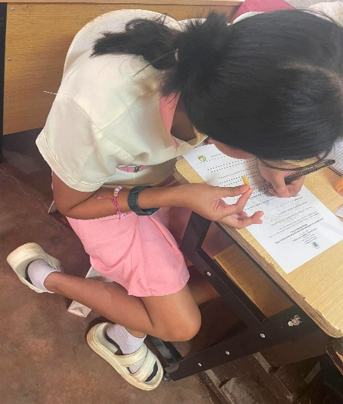 |  | 
 | 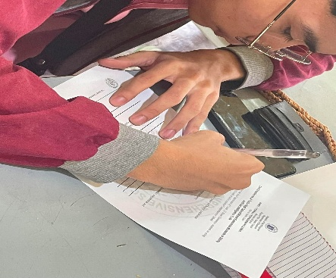 | 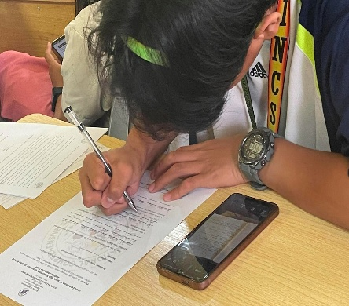
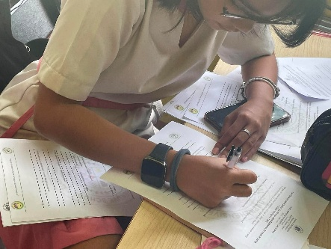 | 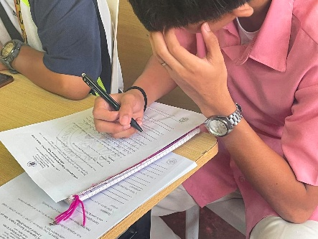 | 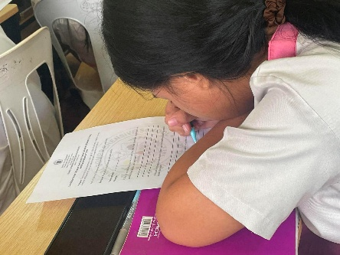
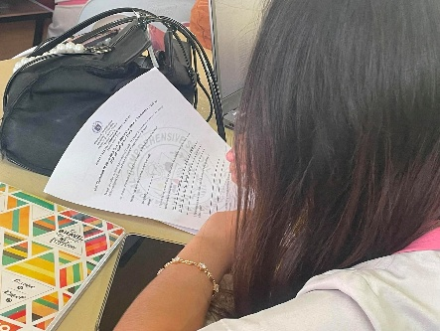 | 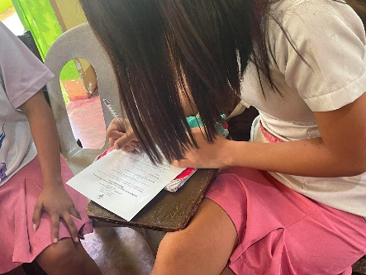 | 



Republic of the Philippines
Department of Education
Region VIII- Eastern Visayas
Division of Leyte
ISABEL NATIONAL COMPREHENSIVE SCHOOL
Marvel, Isabel, Leyte
S.Y. 2025 – 2026

ENGLISH CRITIC CERTIFICATION


This is to certify that the research study entitled “Lived Experiences Of Home Economics Senior High School Students In Using Artificial Intelligence Tools” has thoroughly checked, reviewed, and edited by the undersigned. This Research Paper on Qualitative Research is one of the final requirements for the completion of the subject Practical Research 1 for the second semester.

Furthermore, this certifies that the scope of editing is primarily on sentence structures and grammar only.

This certification is issued to the group of researchers who come to my office for editing.

This is issued on the ____ day of ____________ 2026.

____________________________________________________
(Signature over Printed Name)

APPENDIX E
No. | Question 1: How do you feel when you use AI tools for your Home Economics assignments and activities? Please describe your experience. | Question 2: What are your thoughts on how AI tools influence your study habits and learning process in Home Economics? | Question 3: How do AI tools affect your critical thinking, creativity, and problem solving skills when doing Home Economics tasks? Please explain. | Question 4: What challenges or difficulties have you faced while using AI tools for your Home Economics assignments? Are there any ethical concerns you think about? | Question 5: Based on your experience, what suggestions or solutions can help promote responsible and balanced use of AI tools in Home Economics learning?
1 | It will make me more efficient in answering assignments when using AI tools. | AI tools have become helpful it aids me in my Home Economic studies Ex; when researching recipes. | AI can provide quick solutions or summaries. | Wi-Fi signal, slow Wi-Fi signal can affect my research. | No pay to win subscription.
2 | For me/us, we don’t use AI or Artificial intelligence for our homework because we focus more on skills we aren’t mostly focused on assignments, were more on focus on performance. | Some students rely on AI too much. | We actually don’t use ai because our strand focuses on skills. And maybe for some students, It can affect their grades. | Some answer where correct, but we really don’t use AI for our strand. | Do not rely on AI too much.
3 | Home Economics students will not use AI because we will only use our skills. | Home Economics Students won’t need AI because we only focus on our skills. | For us H.E students we don’t need to use AI for our performance task because we are more on skills. | Declined to answer. | Declined to answer.
4 | We don’t use AI because we focus more on skills. | We don’t use AI because we aren’t allowed to use it. | No AI because we are H.E students we don’t use AI. | We don’t feel difficulties about it because we don’t use AI for our skills. | AI can’t provoke our skills.
5 | Relieve especially if the assignment is too Hard for me to understand. | I only use AI in things I don’t understand but if used properly I would think it is bad but overall it is verry helpful. | In terms on relying on it, it does affect us alot to the point you stop using your brain and rely mostly on AI. | Sometimes AI gives false information in terms of other things connected in H.E which leads to me getting things wrong because of it. | By only using AI if it really is hard to understand.
6 | We don’t usually use AI tools because we are focused more in skills. | I don’t know, because we focus more on our skills about backing, we don’t use AI. | For me as an H.E student we need skills not AI. | For me the challenges is all about baking we need skills, sometimes we need AI but sometimes not. | For me AI is not a way to promote our mental skills Ai in our life, but in H.E we don’t use AI, Skills only!
7 | Sometimes it feels overwhelming, but overall it is still understandable. | My performance declines because I cannot fully understand the lesson unless the teacher discusses it beforehand. | I am struggling to catch up with the lessons because I tend to rely too much on AI instead of using my own thinking. | I would be even more academically challenged without AI because it helps me accomplish tasks. | For me, the main issue is poor internet connection.
8 | When I use AI, it is very convenient for me and gives me more time to do household chores. | AI tools make me more efficient when researching. | It limits my potential because I depend on it too much. | Some AI tools lack accuracy, especially for topics in Home Economics. | Integrate digital literacy and ethics when teaching AI use.
9 | Based on my experience using AI tools, they make our strand easier and more accurate. | . It influences me in many helpful ways. | It makes it easier to manage tasks and develop more skills. | The only challenge I found is that some questions are too difficult to find answers for. | Practice responsible AI usage.
10 | AI tools greatly helped me complete my activities. | It helped me study, and I highly recommend using it. | It improved my baking skills because AI shows me how to do it. | Low internet connection is a challenge. | Make AI access easy and free.
11 | It Helps me do assignments efficiently and understand more. | It can explain topics deeply and easily understandable for recipes. | It helped me improve my cooking skills as an HE student. | The AI sometimes add extra things that aren't part of the recipe. | Only Use AI sometimes as it can give false information.
12 | It Helps me answer my assignments. | Mostly Useless as the Strand is more on cooking and the recipes are provided. | Mostly Useless as the Strand is more on cooking and the recipes are provided. | Slow and Unstable Internet. | They should provide strong internet inside the school.
13 | I feel that using AI tools makes my work easier and faster. | AI tools helps me study and learn more. | It gives me tips. | Sometimes AI tools give me unclear answers. | I use AI tools to help me understand tasks.
14 | It Helps for me. | I sometimes rely on using it. | It changed how I think as I rely on it always. | No Internet Connection. | I can do works myself but if I think I can't do it, that's where I use it.
15 | I feel great when using AI as it feels like having a living assistant that gives live feedback and suggestions on how to do better. | AI tools has influenced my study habits positively because it helps me when doing something. | It usually affects my thinking skills and creativity as it gives me a lot of ideas and suggestions. | The challenge is the cooking. | The solution is don't trust it mostly but on yourself but only use it to help boost your performance
16 | It feels great using AI because it makes tasks easier. | AI has influenced me positively because it helps me answer questions that I do not understand. | . AI has positively affected my skills because it helps me understand tasks more easily. | Sometimes the information it provides is inaccurate. | AI is helpful for completing tasks, but students should not overuse it.
17 | AI makes my tasks easier to accomplish. When I cannot understand some words, I use AI to translate them. | AI has helped me improve my study habits, but not all the time. | AI can affect students’ attitudes when they rely on it too much. | Sometimes AI gives incorrect information and answers. | Students should not overuse AI so that they can still think independently.
18 | It helps me accomplish my tasks faster. | AI has helped me improve my study habits. | It can affect students’ attitudes, including mine, but I always make sure that I do not depend on it too much. | Sometimes it does not give accurate answers. | It helps finish tasks faster, especially online tasks, and reduces extra work.
19 | It feels great because it is easy to get correct answers. | AI has helped me a lot because when I have a task I do not understand, I can ask AI for help. | It has helped improve my thinking because AI provides new information. | Sometimes our Wi Fi internet connection is unstable. | It can be used for assignments or searching for information needed for school. In short, it should mainly be used for educational purposes.
20 | AI is helpful because it assists me when I have many assignments. | I sometimes over-rely on it because it is the main tool I use. | It has affected me because I became too dependent on AI. | Problems include having no internet access or an unstable connection. | Students should try to do their tasks first before asking AI for help.
21 | I feel like while using AI, I can do it easily. | nice but sometimes the AI can be wrong too. | Actually, we don't use AI because we use skills. | We don't use AI because we forced on skills. | We focused on skills not academic.
22 | AI can answer my question. AI also has a question or recommendation for me. | I can answer questions easily. | The more I learn, the more I can learn. | sometimes AI can't give reliable answers. | Sometimes we don't use AI because we use our skills.
23 | I feel that using AI tools helps me understand my Home Economics assignment more easily. | AI tools help improve my study habits because it give quick explanations and examples that help me understand the lesson. | AI tools can help improve my thinking ny giving different ideas and solutions for tasks. | One challenge I save when using AI tools. | Students should use AI tools and help them understand the lesson, not to copy others.
24 | He can help with using the equipment to understand how to use it. For me, it will help with using the equipment. | It can help you use the equipment to understand how to use it. | Using AI tools greatly affects. | I don’t know much but I learn when I use it. | My experience in Home Economics AI tools can provide solutions and answer easily.
25 | When I use AI I feel comfortable, no pressure because it directly give an answer. | I can rely on if there is an assignment or other academic activities | Affect me positive because I rely on AI. | Challenges because sometimes it give wrong grammar. | Based on my experience, the current education system does not teach regulated AI usage.
26 | It helps me understand and give an idea. | AI tools help improve my study habits. It help me understand the lesson. | AI can help improve my thinking it can also inspire creativity. | Challenges difficulty understanding how to input the right prompts to get useful results. | It clean the guidelines on how to 0use AI tools as a support tools.
27 | When I use AI tools, the activities feel much easier. | 1. AI influences my learning process in Home Economics by showing me how to do the steps and providing the procedures. | AI affects my critical thinking and creativity because it helps me with my assignments, and sometimes I rely on AI. | The difficulty I faced when using AI is that sometimes it does not give me exactly what I ask for. | Do not overuse AI because it can affect your thinking.
28 | To make the my work simpler and easier. | To encourage students to use AI | It is easy to understand, and I don’t have any more questions. | It is too difficult to find a specific answer. | Make sure to use AI in a responsible way.
29 | For me, we will not use AI since our strand focuses on skills rather than AI. | For me, it is neutral because we still use our minds, but sometimes we may use AI, just not all the time. | It cannot affect us, as we can handle it using our skills and expertise. | The biggest challenge in baking is understanding how the process will be carried out. | Based on my experience, I suggest that in our generation, AI should not be used as a way to promote our skills.
30 | In our opinion, we will not use AI very often because we will focus more on developing our skills. | AI makes me more knowledgeable because it helps me with my studies. | For me, I don’t use AI for my academic work because I don’t need it for my major subject. | Sometimes I face internet issues and a lack of free time. | I’m not sure because I don’t use AI for my major subject, but I use AI in other subjects.

APPENDIX F
Qualitative Content Validation Questionnaire Tool

Research Study Title: Lived Experiences Of Home Economics Senior High School Students In Using Artificial Intelligence Tools
Purpose of the Study: To explore the lived experiences of Grade 11 Home Economics students in using Artificial Intelligence (AI) tools at Isabel National Comprehensive School..

Dear Experts,

Thank you for agreeing to serve as an expert reviewer for this research study. Your expertise is invaluable in ensuring the quality and relevance of the questionnaire. Please carefully review each question and provide your feedback based on the following criteria. Your honest and constructive feedback will help strengthen the research and enhance the validity of the findings.
For each interview question, please indicate your level of agreement with the following statements using the scale provided. Also, please provide written comments to elaborate on your ratings and suggest improvements.

Degree of Clarity and Comprehension
Rating Scale | Description
1 | The item is not clear and understandable
2 | The item is somewhat clear and understandable
3 | The item is clear and understandable
4 | The item is very clear and understandable

Reviewer Information:
- Name: ___________________________________________________________
- Credentials/Expertise: __________________________________________
- Date: ____________________________________________________________
- Signature: _______________________________________________________

Section 1: Interview Question Assessment
- How do Grade 11 Home Economics students describe their experiences in using AI tools for their academic tasks and activities?
- How does using AI tools change the way Home Economics students study and learn their lessons?
- How do students describe the ways AI tools affect their critical thinking, creativity, and problem-solving skills?
- What difficulties do students run into, and do they feel using AI is a fair way to finish their activities?
- Based on the findings of the study, what intervention/solution may be proposed to promote responsible and balanced use of AI tools in Home Economics learning?

Section 2: Overall Feedback
- Overall Comments: Please provide any overall comments or suggestions regarding the questions as a whole. Are there any gaps or areas that are not adequately covered?
___________________________________________________________________________
___________________________________________________________________________

- Suggestions for Improvement: What specific changes would you recommend to improve the clarity, relevance, or effectiveness of the interview questions?
___________________________________________________________________________
___________________________________________________________________________

- Additional Questions: Are there any additional questions you would suggest adding to the interview protocol?
___________________________________________________________________________
___________________________________________________________________________

APPENDIX G
BACKGROUND OF THE STUDY
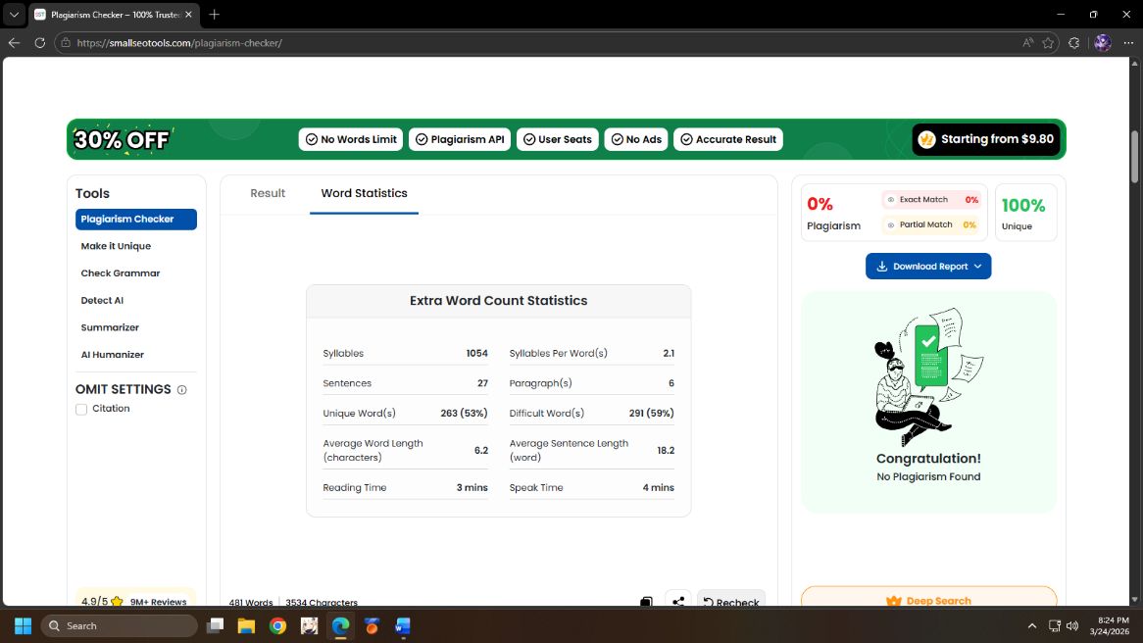

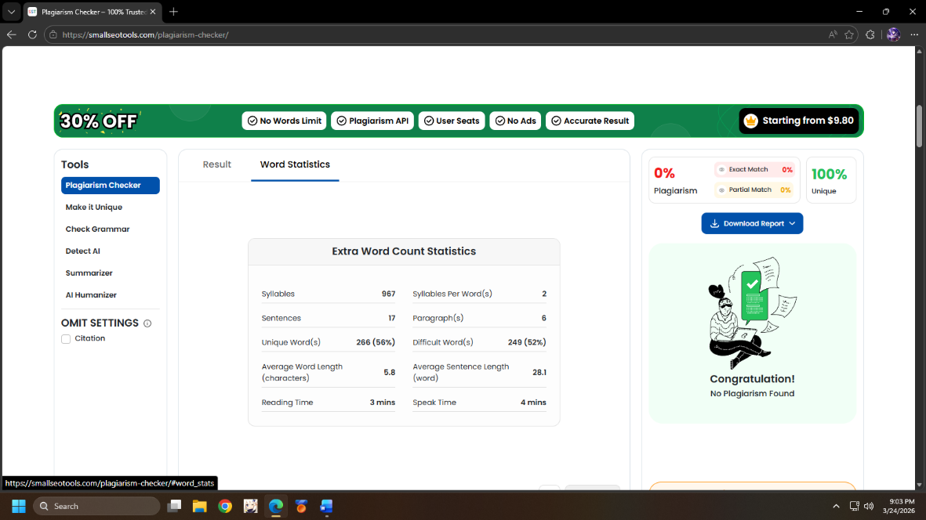
THEORITICAL BACKGROUND
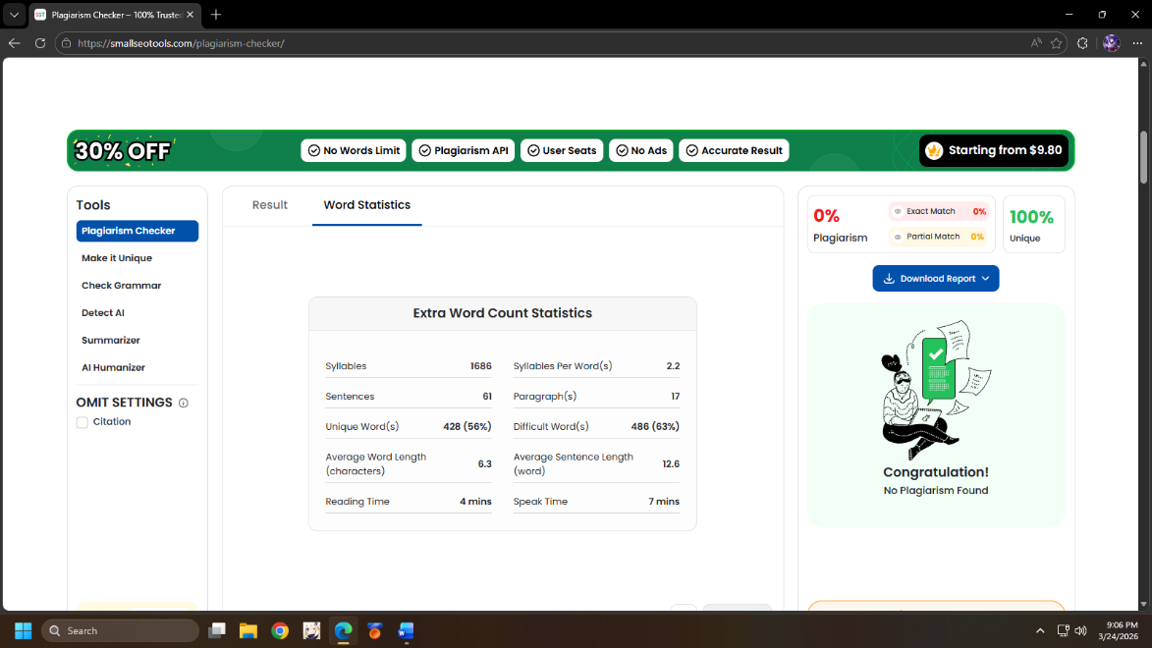
REVIEW OF THE RELATED LITERATURE

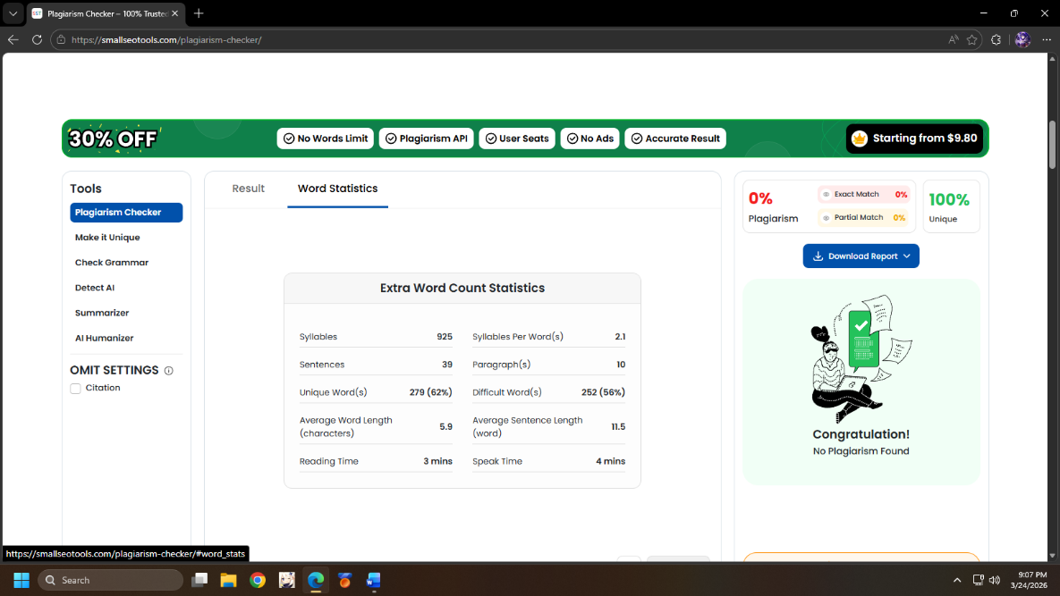
REVIEW OF THE RELATED STUDIES

