

**SCHOOL OF INFOCOMM TECHNOLOGY**

Diploma in Information Technology

**MODERN ARTIFICIAL INTELLIGENCE**

**Year 2024/25 - Semester 3**

**ASSIGNMENT – Proposal (10%)**

Deadline for Submission:

17 May 2024 (Friday) 5pm

|  |  |  |  |  |
| --- | --- | --- | --- | --- |
| **Tutorial Group** | **:** | P01 | | |
| **Group Number** | **:** | 1 | | |
| **Tutor** | **:** | Lee Ching Yun | | |
| **Members** | **:** | **No.** | **Student No.** | **Student Name** |
|  |  | 1 | S10258726H | Lee Jung Sek |
|  |  | 2 | S10255731J | Brydon Ti |
|  |  | 3 | S10260423C | Cheong Zhi Xun |

*Name your group proposal as "* *mai_p0x_gp0x_Proposal" (p0x refers to your class and gp0x refers to your assignment group)*

Contents

1. Title of the chatbot 3

2. Description of the chatbot and its domain 3

3. Chatbot Dialog flows 4

a. Welcome and Greeting 4

b. Service Inquiry 4

c. Price Calculation 4

d. Find Nearest Outlet 6

e. Appointment Booking 6

f. Promotions and Discounts 7

g. Contact Information 8

h. Operating hours 8

4. Entities and Intent identified for each conversation flow 9

a. Service Inquiry 9

b. Price Calculation 9

c. Find Nearest Outlet 10

d. Request Appointment Booking 10

e. Request Contact Information 10

f. Request Operating Hours 11

g. Request Appointment Policy 11

5. Contributions of each team member 12

1. Title of the chatbot
2. Description of the chatbot and its domain

The chatbot is for a nail salon business. It helps to answer questions about the business’ information, such as locations, contact information, etc. It also has tools like “Price Calculation” and “Find Nearest Outlet” to assist the user.

Domain: nail care service, business

1. Chatbot Dialog flows

The full flowchart can be accessed from this link:

https://www.canva.com/design/DAGFQ6OfX5o/AMU5iO77eIQ7c1QciRw90A/edit

1. Welcome and Greeting

Intent: Welcome

Entities: Username (optional)

Dialog: Greet the user and offer assistance.

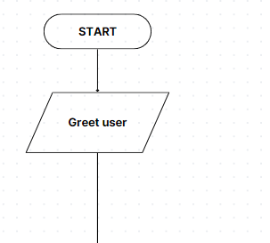

1. Service Inquiry

Intent: Service_Info

Entities: Service type (manicure, pedicure, nail art)

Dialog: Provide details about the requested service.

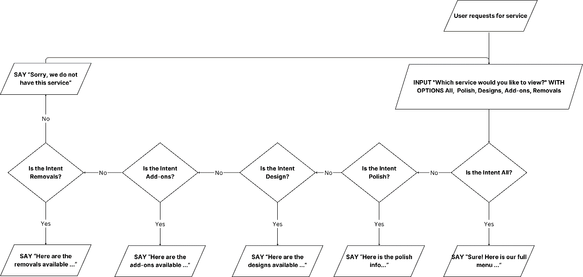

1. Price Calculation

Intent: Price_Calculation

Entities: Service type, Add-ons

Dialog: Display available services, then calculate and provide the total cost for the selected services.

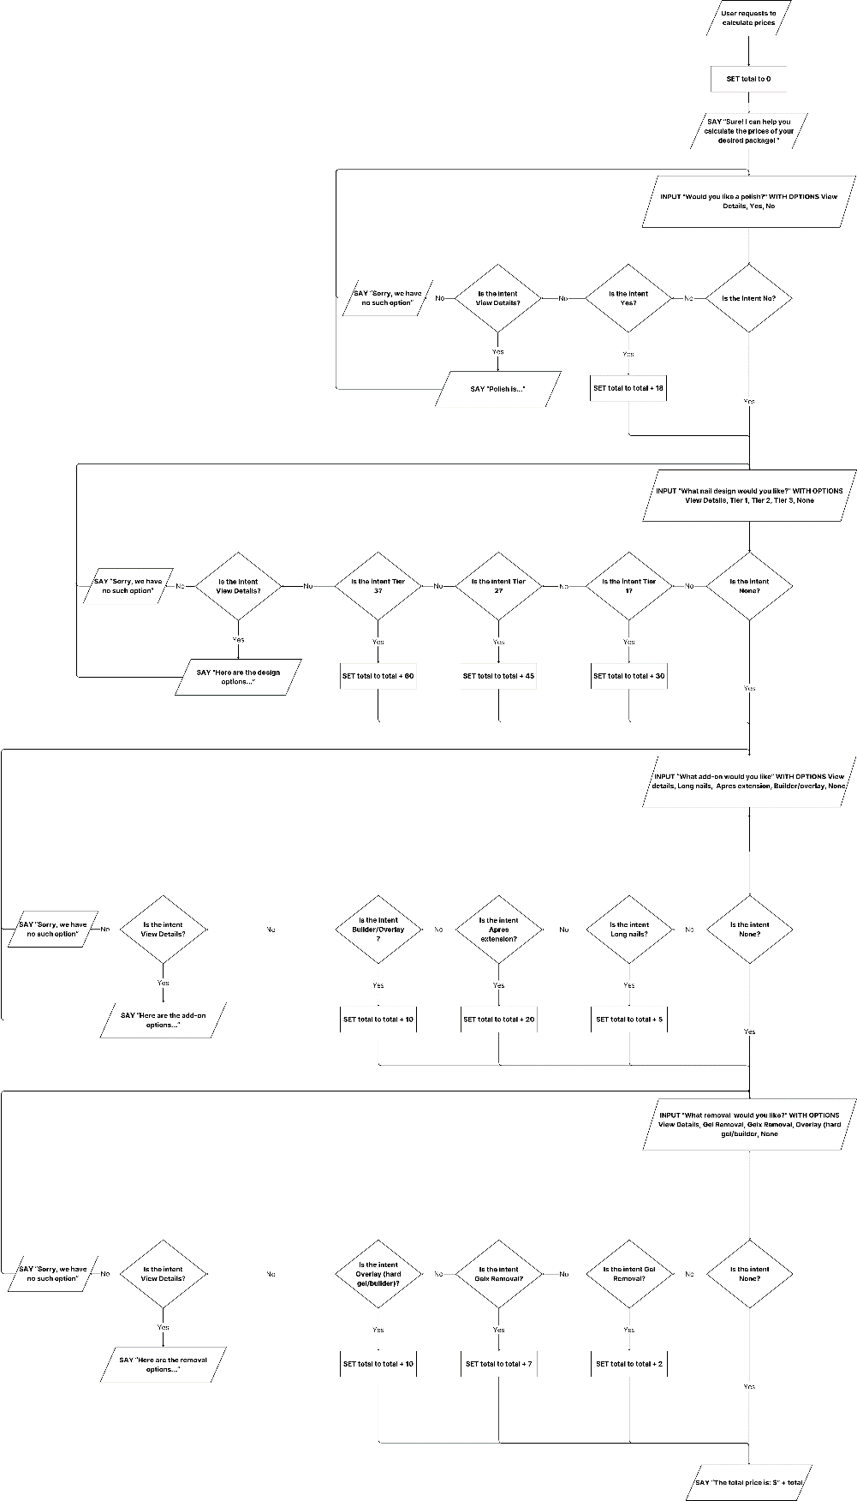

1. Find Nearest Outlet

Intent: Find_Outlets

Entities: User's location (address or zip code or enable location)

Dialog: Identify the nearest salon location and provide directions.

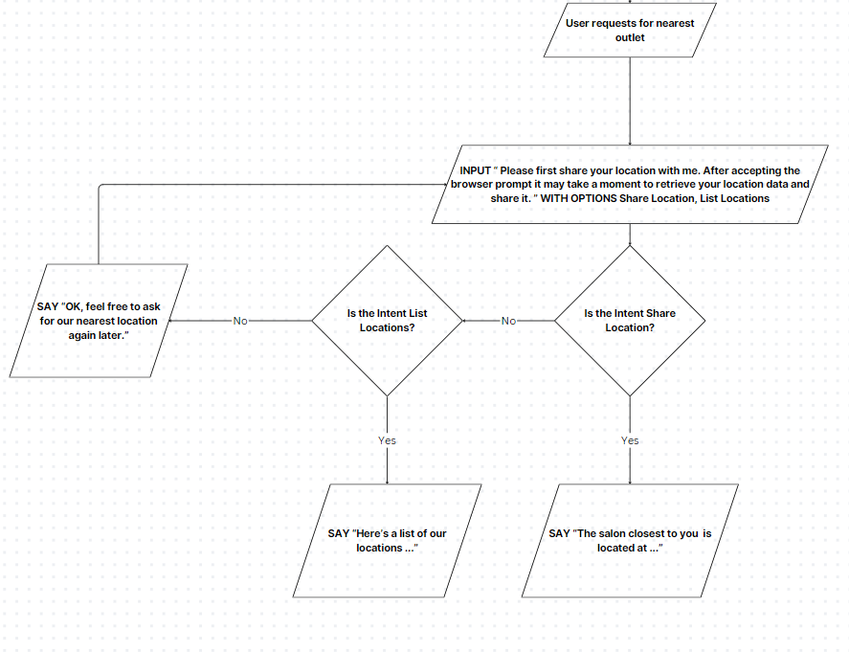

1. Appointment Booking

Intent: Book_Appointment

Entities: Date, Time, Service type

Dialog: Schedule an appointment and send confirmation.

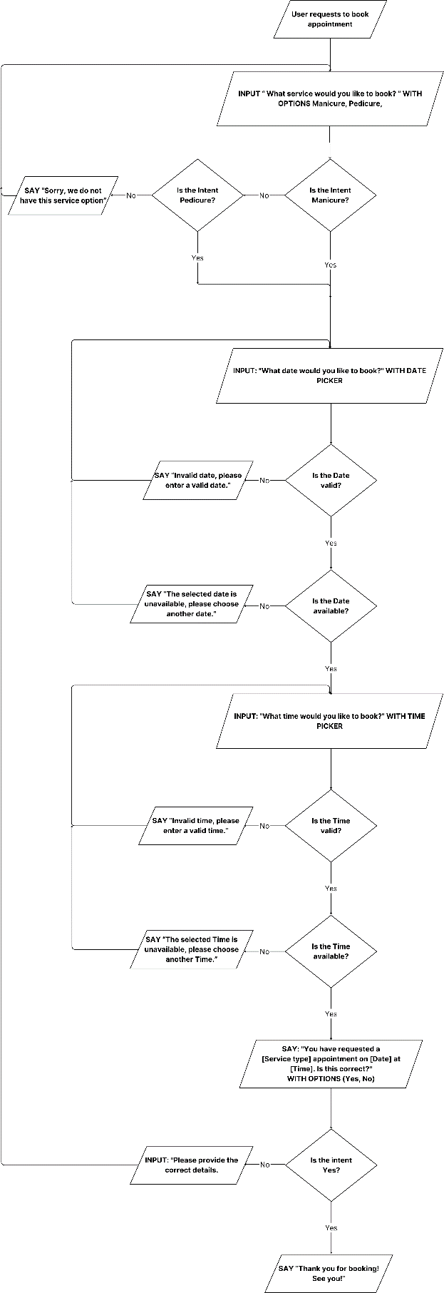

1. Promotions and Discounts

Intent: Promotions_Info

Entities: None

Dialog: Provide information about current promotions and discounts.

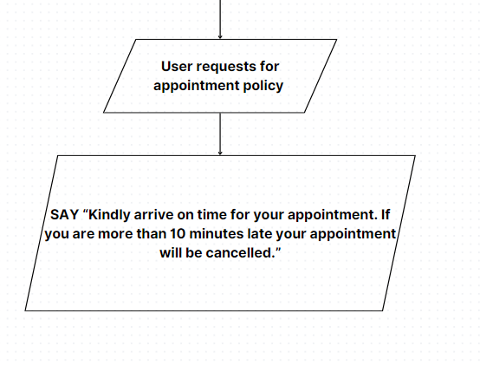

1. Contact Information

Intent: Contact_Info

Entities: Contact information, Whatsapp number, phone number, email address

Dialog: Provide information about ways to contact the nail salon.

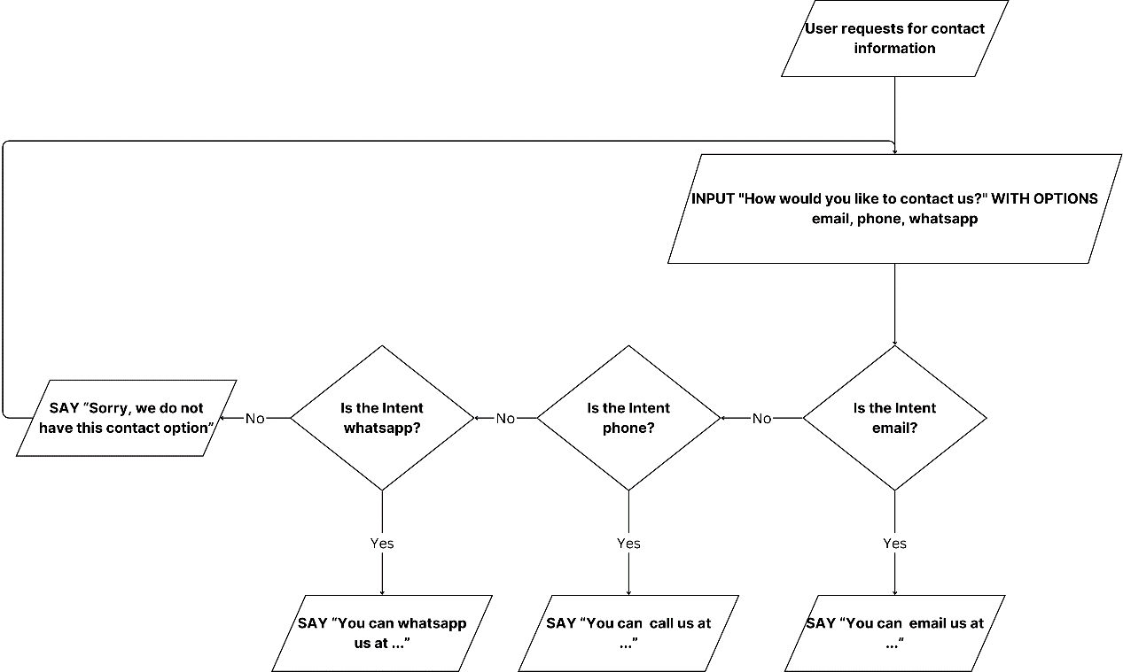

1. Operating hours

Intent: Operating_Hours

Entities: None

Dialog: Provide information about business operating hours.

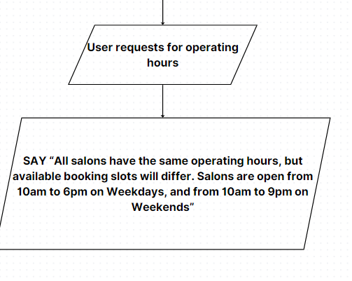

1. Entities and Intent identified for each conversation flow
2. Service Inquiry

|  |  |  |
| --- | --- | --- |
| **Intent** | **Possible user inputs** | **Entities** |
| Menu | What are the designs? | Design |
| How much do designs cost? | Design |
| What designs are available? | Design |
| What polishes are available? | Polish |
| How much is a polish? | Polish |
| What add-ons can I get? | Add-ons |
| How much do add-ons cost? | Add-ons |
| Whats the price of extensions? | Extensions |
| Whats the menu? | Menu |
| Can I have the menu? | Menu |
| What options are there? | Menu |
| Is gel removal available? | Gel removal |
| What removals are there? | Removal |
| How much do removals cost | Removal |
| Can I get a gelx removal? | Gelx removal |
| Is there polishing? | Polish |
| How much does a gel removal cost? | Gel removal |
| How much does a gelx removal cost? | Gelx removal |
| How much does an overlay cost? | Overlay |
| What is an overlay? | Overlay |
| Are overlays available? | Overlay |
| Are gels available? | Design |
| What gels are there? | Design |
| How much do gels cost? | Design |

1. Price Calculation

|  |  |  |
| --- | --- | --- |
| **Intent** | **Possible user inputs** | **Entities** |
| Calculate price | Help me calculate the price of a package | Price, Services |
| Help me calculate the cost of a combination of options | Price, Services |
| How do I calculate the price of options? | Price, Services |
| Is there a price calculator? | Price |

1. Find Nearest Outlet

|  |  |  |
| --- | --- | --- |
| **Intent** | **Possible user inputs** | **Entities** |
| Outlet | Where’s the nearest outlet? | Location |
| What locations are the salons at? | Location |
| How to go to salon? | Location |
| Is there a salon located in the nearest shopping mall? | Location |

1. Request Appointment Booking

|  |  |  |
| --- | --- | --- |
| **Intent** | **Possible user inputs** | **Entities** |
| Book Appointment | I want to book an appointment | Date, Time, Location |
| Can I schedule an appointment for [Date]? | Date, Time, Location |
| Book me for an appointment on [Date] at [Time], at [Location] | Date, Time, Location |
| Schedule an appointment for me | Date, Time, Location |
| How can I reach customer service? | Contact Information |

1. Request Contact Information

|  |  |  |
| --- | --- | --- |
| **Intent** | **Possible user inputs** | **Entities** |
| Contact | What is your contact information? | Email Address, Whatsapp number, Phone number |
| How do I contact you? | Email Address, Whatsapp number, Phone number |
| What's your number? | Phone Number |
| How do I email you? | Email address |
| What's your email address? | Email address |
| What's your WhatsApp contact? | WhatsApp number |
| How do I speak to support? | Email Address, Whatsapp number, Phone number |
| How can I reach customer service? | Email Address, Whatsapp number, Phone number |

1. Request Operating Hours

|  |  |  |
| --- | --- | --- |
| **Intent** | **Possible user inputs** | **Entities** |
| Operating Hours | What time is the salon open? | Hours |
| Is the salon open on weekends? | Hours |
| Help me calculate the cost of a combination of options | Package |
| Whats the cost of shaping? | Shaping |

1. Request Appointment Policy

|  |  |  |
| --- | --- | --- |
| **Intent** | **Possible user inputs** | **Entities** |
| Appointment Policy | Help me calculate the price of a package | Package |
| How much does a polish cost? | Polish |
| Help me calculate the cost of a combination of options | Package |

Contributions of each team member

Jung Sek - Request appointment booking, Promotions and discounts,

Brydon – Request Contact information, Service Inquiry, Calculate prices

Zhi Xun - Welcome and greeting, Find nearest outlet, Request Operating Hours, Request appointment policy