Stephen Hanna 109097796

AMS 394: Statistical Laboratory

HW 2

2.1:

> x = as.vector(t(rmultinom(30,300,c(.2,.3,.5))))

> plot(x)

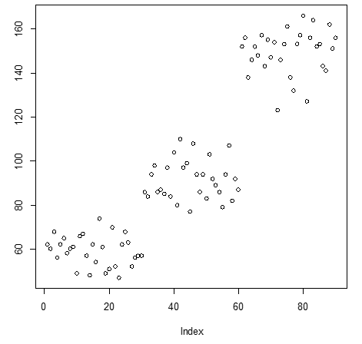

2.2:

> 1 - pnorm(43, 36, 6)

[1] 0.1216725

> 1 - pchisq(6.7,3)

[1] 0.08210006

> dbinom(10,10,.8)

[1] 0.1073742

2.3:

> Age <- array(c(30,15,17,4,123,98,139,60),dim=c(4,2),dimnames=list(c("18-20","21-23","24-25",">25"),c("Accidents","No")))

> Age <- as.table(Age)

> names(attributes(Age)$dimnames) <- c(" Age","")

> Age

Age Accidents No

18-20 30 123

21-23 15 98

24-25 17 139

>25 4 60

2.4:

> plot(ecdf(rexp(100,2)))

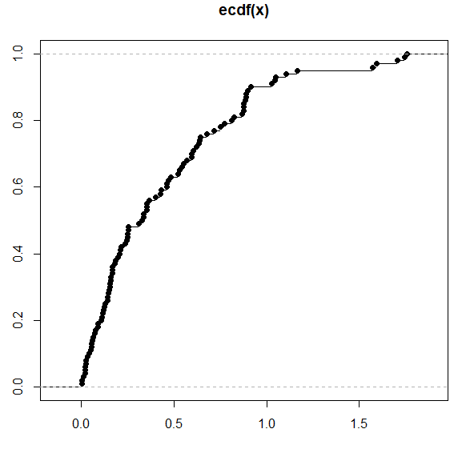

2.5:

> data(react)

> hist(react)

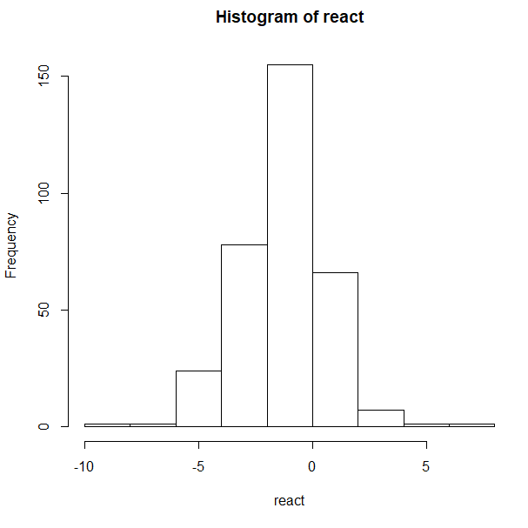

>truehist(react)

