Stephen Hanna 109097796

HW4 AMS 394

**Problem (1)**:

> company = matrix( c(2.4,1.6,2.0,2.6,1.4,1.6,2.0,2.2,225,184,220,240,180,184,186,215),nrow = 8,ncol = 2)

> colnames(company) <- c("Expenses","Sales")

> company

Expenses Sales

[1,] 2.4 225

[2,] 1.6 184

[3,] 2.0 220

[4,] 2.6 240

[5,] 1.4 180

[6,] 1.6 184

[7,] 2.0 186

[8,] 2.2 215

**(a)**

> cor(company[,1],company[,2])

[1] 0.9129053

**(b)**

> fit <- lm(company[,2] ~ company[,1])

> fit

Call:

lm(formula = company[, 2] ~ company[, 1])

Coefficients:

(Intercept) company[, 1]

104.06 50.73

Response: Sales = 50.73*Expenses + 104.06

**(c)**

> summary(fit)$r.squared

[1] 0.8333961

**(d)**

> diff = company[,2] - company[,1]

> shapiro.test(diff)

Shapiro-Wilk normality test

data: diff

W = 0.85466, p-value = 0.1062

Response: Data is normally distributed because the p-value is greater than .1, meaning we cannot reject the null hypothesis that the data is normally distributed, so use parametric test.

> cor.test(company[,1],company[,2],method="pearson")

Pearson's product-moment correlation

data: company[, 1] and company[, 2]

t = 5.4785, df = 6, p-value = 0.001546

alternative hypothesis: true correlation is not equal to 0

95 percent confidence interval:

0.5837739 0.9843477

sample estimates:

cor

0.9129053

Response: The p value is below .01, so we can reject the null hypothesis that there is no significant linear relationship between the two variables with a confidence level over 99%. Hence, there is a significant linear relationship between these two variables.

**(e)** > 1000*(50.73*1.8+104.06)

[1] 195374

Response: The company should expect to make $195,374

**Problem 2:**

**(a)**

> stocks <-read.table("http://www.ams.sunysb.edu/~xing/statfinbook/_BookData/Chap03/d_logret_6stocks.txt", header=T)

> fit <- lm(stocks[,2] ~ stocks[,6])

> summary(fit)

Call:

lm(formula = stocks[, 2] ~ stocks[, 6])

Residuals:

Min 1Q Median 3Q Max

-0.049930 -0.013003 -0.000505 0.017353 0.049231

Coefficients:

Estimate Std. Error t value Pr(>|t|)

(Intercept) -0.005325 0.002756 -1.932 0.05794 .

stocks[, 6] 0.354649 0.119729 2.962 0.00433 **

---

Signif. codes: 0 ‘***’ 0.001 ‘**’ 0.01 ‘*’ 0.05 ‘.’ 0.1 ‘ ’ 1

Residual standard error: 0.02178 on 62 degrees of freedom

Multiple R-squared: 0.124, Adjusted R-squared: 0.1098

F-statistic: 8.774 on 1 and 62 DF, p-value: 0.004328

Response: The coefficient of correlation is .354649 and the coefficient of the intercept is -.005325.

**(b)**

> fit <- lm(stocks[,2] ~ stocks[,6]-1)

> summary(fit)

Call:

lm(formula = stocks[, 2] ~ stocks[, 6] - 1)

Residuals:

Min 1Q Median 3Q Max

-0.054231 -0.019506 -0.005463 0.012151 0.043688

Coefficients:

Estimate Std. Error t value Pr(>|t|)

stocks[, 6] 0.3183 0.1208 2.635 0.0106 *

---

Signif. codes: 0 ‘***’ 0.001 ‘**’ 0.01 ‘*’ 0.05 ‘.’ 0.1 ‘ ’ 1

Residual standard error: 0.02224 on 63 degrees of freedom

Multiple R-squared: 0.09929, Adjusted R-squared: 0.08499

F-statistic: 6.945 on 1 and 63 DF, p-value: 0.01057

Response: The coefficient of correlation is .3183

**(c)**

> cor(stocks[,2],stocks[,6])

[1] 0.3520965

> diff = stocks[,2] - stocks[,6]

> shapiro.test(diff)

Shapiro-Wilk normality test

data: diff

W = 0.9836, p-value = 0.5544

Response: Since the p value is greater than .1, the data is assumed to be normally distributed. Parametric test will be used.

> cor.test(stocks[,2],stocks[,6], cor = 0)

Pearson's product-moment correlation

data: stocks[, 2] and stocks[, 6]

t = 2.9621, df = 62, p-value = 0.004328

alternative hypothesis: true correlation is not equal to 0

95 percent confidence interval:

0.1163578 0.5502798

sample estimates:

cor

0.3520965

Response: Since p is less than .01, we can say with 99% confidence that the correlation is not zero and can reject the null hypothesis that the correlation is 0.

**Problem 3:**

> data(rmr)

> plot(rmr[,1],rmr[,2],xlab = "Body Weight", ylab = "Metabolic Rate",main = "Body Weight plotted against Metabolic Rate")

> lm(rmr[,2]~rmr[,1])

Call:

lm(formula = rmr[, 2] ~ rmr[, 1])

Coefficients:

(Intercept) rmr[, 1]

811.23 7.06

> abline(811.23,7.06)

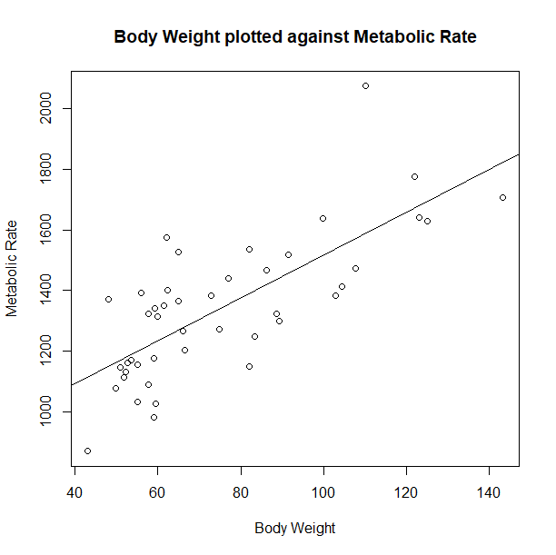

> 7.06*80+811.23

[1] 1376.03