Stephen Hanna 109097796

HW6

**Problem 1:**

**DATA** toads;

INPUT ToadName $ Weight Jump1 Jump2 Jump3;

DATALINES;

Lucky 2.3 1.9 . 3.0

Spot 4.6 2.5 3.1 .5

Tubs 7.1 . . 3.8

Hop 4.5 3.2 1.9 2.6

Noisy 3.8 1.3 1.8

1.5

Winner 5.7 . . .

;**PROC** **PRINT** DATA = toads;

TITLE 'SAS Data Set Toads';

**RUN**;

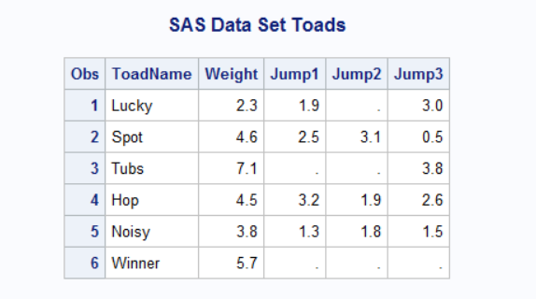

**data** _null_;

set toads;

file 'C:\Users\Stephen Hanna\Documents\Classes\AMS 394\SASdata\ToadJump.dat' ;

put ToadName $ Weight Jump1 Jump2 Jump3;

**run**;

**DATA** toads;

INFILE ''C:\Users\Stephen Hanna\Documents\Classes\AMS 394\SASdata\ToadJump.dat';

INPUT ToadName $ Weight Jump1 Jump2 Jump3;

**PROC** **PRINT** DATA = toads;

TITLE 'SAS Data Set Toads';

**RUN**;

**Problem 2:**

**(1)**

**data** sales;

input VisitingTeam $ **1**-**20**

ConcessionSales **21**-**24**

BleacherSales **25**-**28**

OurHits **29**-**31**

TheirHits **32**-**34**

OurRuns **35**-**37**

TheirRuns **38**-**40**;

datalines;

Columbia Peaches 35 67 1 10 2 1

Plains Peanuts 210 2 5 0 2

Gilroy Garlics 151035 12 11 7 6

Sacramento Tomatoes 124 85 15 4 9 1

;

**PROC** **PRINT** DATA = sales;

TITLE 'SAS Data Set

Sales'; **RUN**;

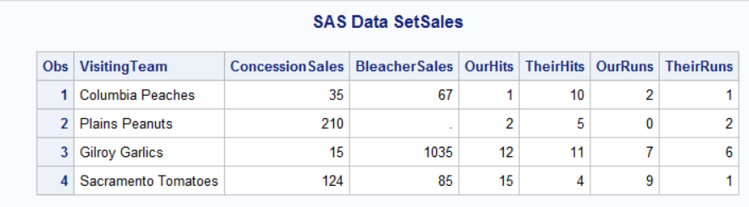

**data** _null_;

set sales;

file 'C:\Users\Stephen Hanna\Documents\Classes\AMS 394\SASdata\Onions.dat' ;

put VisitingTeam $ **1**-**20**

ConcessionSales **21**-**24**

BleacherSales **25**-**28**

OurHits **29**-**31**

TheirHits **32**-**34**

OurRuns **35**-**37**

TheirRuns **38**-**40**;

**run**;

**DATA** sales;

INFILE 'C:\Users\Stephen Hanna\Documents\Classes\AMS 394\SASdata\Onions.dat';

INPUT VisitingTeam $ **1**-**20** ConcessionSales **21**-**24** BleacherSales **25**-**28**

OurHits **29**-**31** TheirHits **32**-**34** OurRuns **35**-**37** TheirRuns **38**-**40**;

**PROC** **PRINT** DATA = sales; TITLE 'SAS Data Set Sales'; **RUN**;



**(2)**

**data** sales;

input VisitingTeam $ **1**-20

ConcessionSales **20**-**24**

BleacherSales **25**-**28**

OurHits **29**-**31**

TheirHits **32**-**34**

OurRuns **35**-**37**

TheirRuns **38**-**40**;

datalines;

Columbia Peaches 35 67 1 10 2 1

Plains Peanuts 210 2 5 0 2

Gilroy Garlics 151035 12 11 7 6

Sacramento Tomatoes 124 85 15 4 9 1

;

**PROC** **PRINT** DATA = sales;

TITLE 'SAS Data Set Sales';

**RUN**;

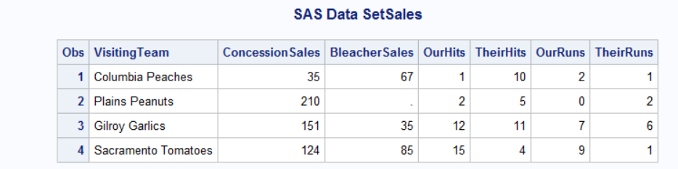

**Problem 3:**

**DATA** contest;

INPUT Name $16. Age **3.** +**1** Type $1. +**1** Date MMDDYY10.

(Score1 Score2 Score3 Score4 Score5) (**4.1**);

DATALINES;

Alicia Grossman 13 c 10-28-2003 7.8 6.5 7.2 8.0 7.9

Matthew Lee 9 D 10-30-2003 6.5 5.9 6.8 6.0 8.1

Elizabeth Garcia 10 C 10-29-2003 8.9 7.9 8.5 9.0 8.8

Lori Newcombe 6 D 10-30-2003 6.7 5.6 4.9 5.2 6.1

Jose Martinez 7 d 10-31-2003 8.9 9.510.0 9.7 9.0

Brian Williams 11 C 10-29-2003 7.8 8.4 8.5 7.9 8.0

;

**PROC** **PRINT** DATA = contest;

TITLE ’Pumpkin Carving Contest’;

**RUN**;

**DATA** contest;

INPUT Name $16. Age **3.** +**1** Type $1. +**1** Date MMDDYY10.

(Score1 Score2 Score3 Score4 Score5) (**4.1**);

FORMAT Date MMDDYY10.;

DATALINES;

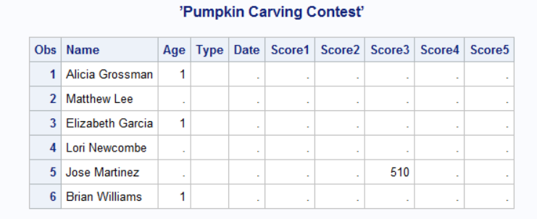

**Problem 4:**

**(1)**

**i)**

**DATA** nationalparks;

INPUT ParkName $ **1**-**22** State $ Year @**40** Acreage COMMA9.;

DATALINES;

Yellowstone ID/MT/WY 1872 4,065,493

Everglades FL 1934 1,398,800

Yosemite CA 1864 760,917

Great Smoky Mountains NC/TN 1926 520,269

Wolf Trap Farm VA 1966 130

;

**PROC** **PRINT** DATA = nationalparks;

TITLE ’Selected National Parks’;

**RUN**;

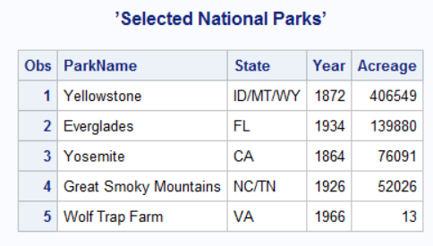

**ii)**

**DATA** nationalparks;

INPUT ParkName $ **1**-**22** State $ Year @**39** +**1** @**40** Acreage COMMA9.;

DATALINES;

Yellowstone ID/MT/WY 1872 4,065,493

Everglades FL 1934 1,398,800

Yosemite CA 1864 760,917

Great Smoky Mountains NC/TN 1926 520,269

Wolf Trap Farm VA 1966 130

;

**PROC** **PRINT** DATA = nationalparks;

TITLE ’Selected National Parks’;

**RUN**;

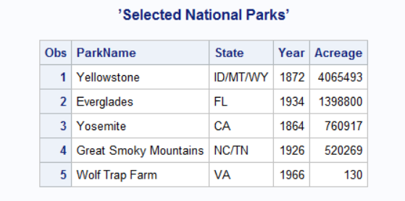

**DATA** nationalparks;

INPUT ParkName $ **1**-**22** State $ Year @**40** Acreage COMMA9.;

DATALINES;

Yellowstone ID/MT/WY 1872 4,065,493

Everglades FL 1934 1,398,800

Yosemite CA 1864 760,917

Great Smoky Mountains NC/TN 1926 520,269

Wolf Trap Farm VA 1966 130

;

**PROC** **PRINT** DATA = nationalparks;

TITLE ’Selected National Parks’;

**RUN**;

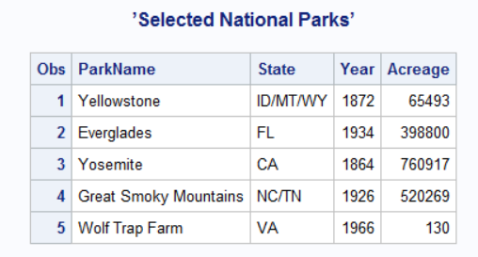

**(2)**

**DATA** nationalparks;

*INPUT ParkName $ 1-22 State $ Year @40 Acreage COMMA9.;

INPUT ParkName $ **1**-**22** State $ Year Acreage COMMA9.;

DATALINES;

Yellowstone ID/MT/WY 1872 4,065,493

Everglades FL 1934 1,398,800

Yosemite CA 1864 760,917

Great Smoky Mountains NC/TN 1926 520,269

Wolf Trap Farm VA 1966 130

;

**PROC** **PRINT** DATA = nationalparks;

TITLE ’Selected National Parks’;

**RUN**;

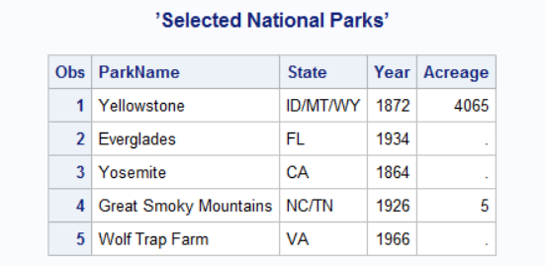

The acreage will only read 9 characters to the right of the end of year in each row

**Problem 5:**

**DATA** books;

Input Name $ v1 v2 v3 v4 v5;

DATALINES;

Grace 3 1 5 2 6

Martin 1 2 4 1 3

Scott 9 10 4 8 6

;

**PROC** **PRINT** DATA = books;

TITLE ’Books’;

**RUN**;

**data** _null_;

set books;

file 'C:\Users\Stephen Hanna\Documents\Classes\AMS 394\SASdata\Books.text' ;

put Name $ v1 v2 v3 v4 v5;

**run**;

