Stephen Hanna 109097796

HW7

**Problem 1:**

**DATA** homegarden;

INPUT Name $ **1**-**7** Tomato Zucchini Peas Grapes;

Zone = **14**;

Type = 'home';

Zucchini = Zucchini * **10**;

Total = Tomato + Zucchini + Peas + Grapes;

PerTom = (Tomato / Total) * **100**;

DATALINES;

Gregor 10 2 40 0

Molly 15 5 10 1000

Luther 50 10 15 50

Susan 20 0 . 20

;

**PROC** **PRINT** data=homegarden;

TITLE 'Home Gardening Survey';

**RUN**;

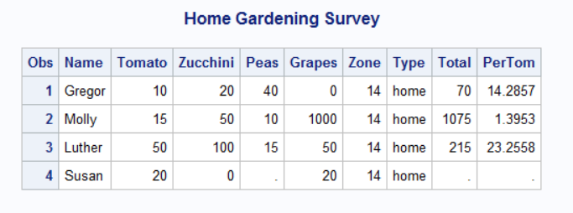

**data** _null_;

set homegarden;

file 'C:\Users\Stephen Hanna\Documents\Classes\AMS 394\SASdata\homegarden.dat' ;

put Name $ **1**-**7** Tomato Zucchini Peas Grapes;

**run**;

**DATA** homegarden;

INFILE ' D:\Users\mshu\Desktop\Garden.txt';

INPUT Name $ **1**-**7** Tomato Zucchini Peas Grapes;

Zone = **14**;

Type = 'home';

Zucchini = Zucchini * **10**;

Total = Tomato + Zucchini + Peas + Grapes;

PerTom = (Tomato / Total) * **100**;

**PROC** **PRINT** DATA = homegarden;

TITLE 'Home Gardening Survey';

**RUN**;

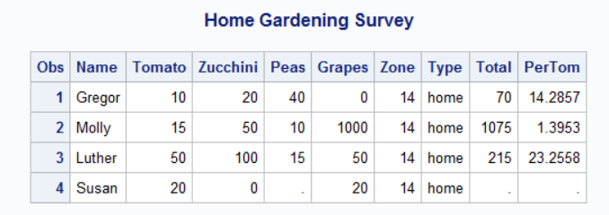

**Problem 2:**

**DATA** contest;

INPUT Name $16. Age **3.** +**1** Type $1. +**1** Date MMDDYY10.

(Scr1 Scr2 Scr3 Scr4 Scr5) (**4.1**);

AvgScore = MEAN(Scr1, Scr2, Scr3, Scr4, Scr5);

DayEntered = DAY(Date);

TotalScore=SUM(Scr1, Scr2,

Scr3, Scr4, Scr5);

Type = UPCASE(Type);

DATALINES;

Alicia Grossman 13 c 10-28-2003 7.8 6.5 7.2 8.0 7.9

Matthew Lee 9 D 10-30-2003 6.5 5.9 6.8 6.0 8.1

Elizabeth Garcia 10 C 10-29-2003 8.9 7.9 8.5 9.0 8.8

Lori Newcombe 6 D 10-30-2003 6.7 5.6 4.9 5.2 6.1

Jose Martinez 7 d 10-31-2003 8.9 9.510.0 9.7 9.0

Brian Williams 11 C 10-29-2003 7.8 8.4 8.5 7.9 8.0

;

**PROC** **PRINT** DATA = contest;

TITLE 'Pumpkin Carving Contest';

**RUN**;

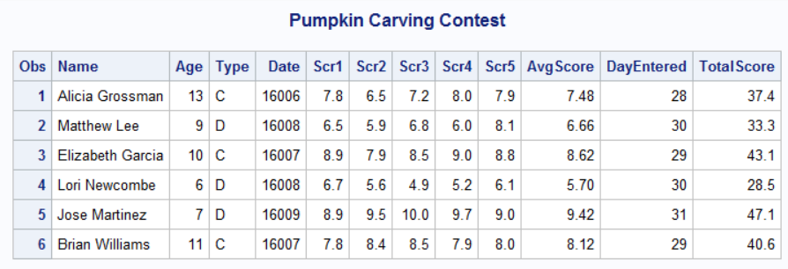

**Problem 3:**

**DATA** sportscars;

INPUT Model $ Year Make $ Seats Color $;

IF Year < **1975** THEN Status = 'classic';

IF Model = 'Corvette' OR Model = 'Camaro' THEN Make = 'Chevy';

IF Model = 'Miata' THEN DO;

Make = 'Mazda';

Seats = **2**;

END;

DATALINES;

Corvette 1955 . 2 black

XJ6 1995 Jaguar 2 teal

Mustang 1966 Ford 4 red

Miata 2002 . . silver

CRX 2001 Honda 2 black

Camaro 2000 . 4 red

;

**PROC** **PRINT** DATA = sportscars;

TITLE “Eddy’s Excellent Emporium of Used Sports Cars”;

**RUN**;

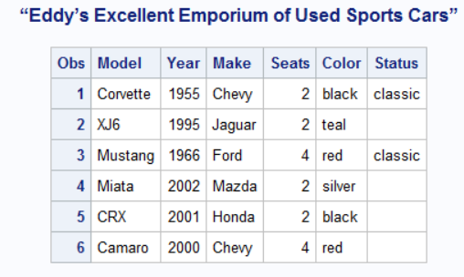

**data** _null_;

set sportscars;

file 'C:\Users\Stephen Hanna\Documents\Classes\AMS 394\SASdata\cars.dat' ;

put Model $ Year Make $ Seats Color $;

**run**;

**DATA** sportscars;

INFILE ' (path) '; INPUT Model $ Year Make $

Seats Color $;

IF Year < **1975** THEN Status = 'classic';

IF Model = 'Corvette' OR Model = 'Camaro' THEN Make = 'Chevy';

IF Model = 'Miata' THEN DO;

Make = 'Mazda';

Seats = **2**;

END;

**PROC** **PRINT** DATA = sportscars;

TITLE “Eddy’s Excellent Emporium of Used Sports Cars”;

**RUN**;

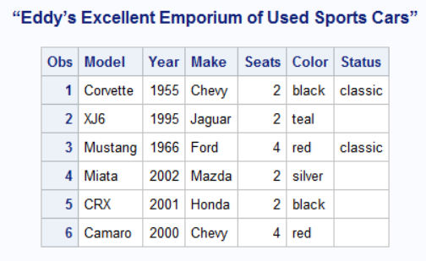

**Problem 4:**

**DATA** homeimprovements;

INPUT Owner $ **1**-**7** Description $ **9**-**33** Cost;

IF Cost = **.** THEN CostGroup = 'missing';

ELSE IF Cost < **3000** THEN CostGroup = 'low';

ELSE IF Cost < **9000** THEN CostGroup = 'medium';

ELSE CostGroup = 'high';

DATALINES;

Bob kitchen cabinet face-lift 1253.00

Shirley bathroom addition 11350.70

Silvia paint exterior .

Al backyard gazebo 3098.63

Norm paint interior 647.77

Kathy second floor addition 75362.93

;

**PROC** **PRINT** DATA = homeimprovements;

TITLE 'Home Improvement Cost Groups';

**RUN**;

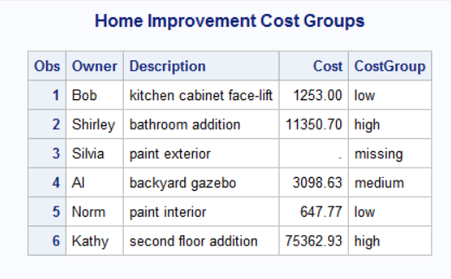

**Problem 5:**

(1)

**DATA** comedy;

INPUT Title $ **1**-**26** Year Type $;

IF Type = 'tragedy' OR Type = 'romance' OR Type = 'history' THEN DELETE;

DATALINES;

A Midsummer Night’s Dream 1595 comedy

Comedy of Errors 1590 comedy

Hamlet 1600 tragedy

Macbeth 1606 tragedy

Richard III 1594 history

Romeo and Juliet 1596 tragedy

Taming of the Shrew 1593 comedy

Tempest 1611 romance

;

**PROC** **PRINT** DATA = comedy;

TITLE 'Shakespearean Comedies';

**RUN**;

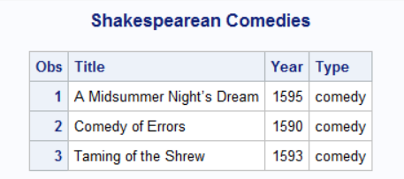

(2)

**DATA** comedy;

INPUT Title $ **1**-**26** Year Type $;

IF Type = 'tragedy' OR Type = 'romance' THEN DELETE;

DATALINES;

A Midsummer Night’s Dream 1595 comedy

Comedy of Errors 1590 comedy

Hamlet 1600 tragedy

Macbeth 1606 tragedy

Richard III 1594 history

Romeo and Juliet 1596 tragedy

Taming of the Shrew 1593 comedy

Tempest 1611 romance

;

**PROC** **PRINT** DATA = comedy;

TITLE 'Shakespearean Comedies';

**RUN**;

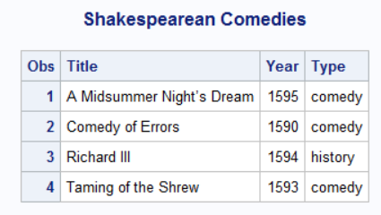

(3)

**DATA** comedy;

INPUT Title $ **1**-**26** Year Type $;

IF Type = 'tragedy';

DATALINES;

A Midsummer Night’s Dream 1595 comedy

Comedy of Errors 1590 comedy

Hamlet 1600 tragedy

Macbeth 1606 tragedy

Richard III 1594 history

Romeo and Juliet 1596 tragedy

Taming of the Shrew 1593 comedy

Tempest 1611 romance

;

**PROC** **PRINT** DATA = comedy;

TITLE 'Shakespearean Comedies';

**RUN**;

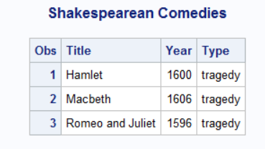

**Problem 6:**

**DATA** studentscores;

INPUT Name $ **1**-**4** Score1 Score2 Score3;

AverageScore = Mean(Score1,Score2,Score3);

DATALINES;

Joe 75 86 90

Mary 88 88 97

Jim 65 05 100

Jane 100 99 78

Mike 90 90 90

Sue 10 60 80

;

**PROC** **SORT** DATA = studentscores OUT=sorted;

by descending AverageScore;

**run**;

**proc** **print** data=sorted;

TITLE 'Student Exam Scores';

**RUN**;

