Stephen Hanna 109097796

HW9

**Problem 1:**

1.1:

(a)

**data** coordinates;

input x y z;

datalines;

1 3 15

7 13 7

8 12 5

3 4 14

4 7 10

;

**proc** **corr** data=coordinates;

title 'Coordinate Correlation';

var x y z;

**run**;

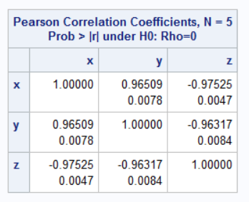

The probability of x against y, y against z, and x against z are all below .05, therefore we can reject the null hypothesis that the variables are related by chance.

(b)

**data** coordinates;

input x y z;

datalines;

1 3 15

7 13 7

8 12 5

3 4 14

4 7 10

;

**proc** **corr** data=coordinates;

title 'Coordinate Correlation';

var x y;

partial z;

**run**;

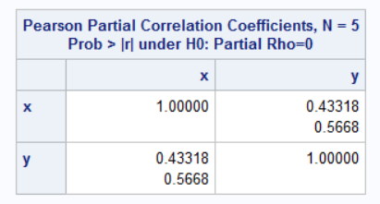

The probability of x against y, when the effect of z has been removed, is above .05, so we cannot reject the null hypothesis that the variables are related by chance.

1.2:

(a)

**data** coordinates;

input x y z;

datalines;

1 3 15

7 13 7

8 12 5

3 4 14

4 7 10

;

**proc** **reg** data=coordinates;

title 'Coordinate regression';

model y=x;

**run**;

(b)

Slope = 1.52410

Intercept = .78916

(c)

For the intercept, p = .5753 > .05, so we cannot reject the null hypothesis that the intercept is approximately 0.

For the slope, p = .0078 < .05, so we can reject the null hypothesis and state, with 95% confidence, that the slope is significantly different than 0.

(d)

**data** coordinates;

input x y z;

datalines;

1 3 15

7 13 7

8 12 5

3 4 14

4 7 10

;

**proc** **gplot** data=coordinates;

title 'Coordinate';

plot y*x;

**run**;

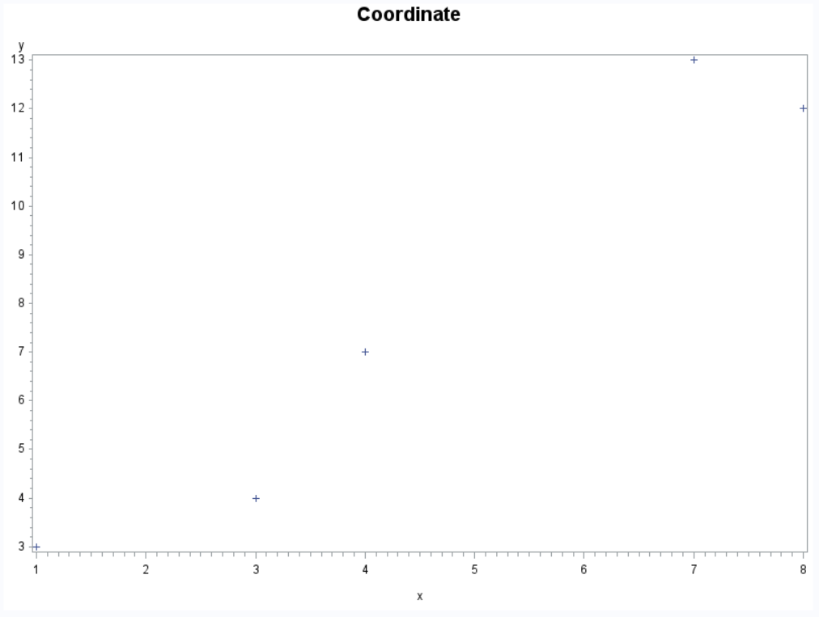

(e)

**data** coordinates;

input x y z;

datalines;

1 3 15

7 13 7

8 12 5

3 4 14

4 7 10

;

**proc** **reg** data=coordinates;

title 'Coordinate regression';

model y=x;

plot y*x;

**run**;

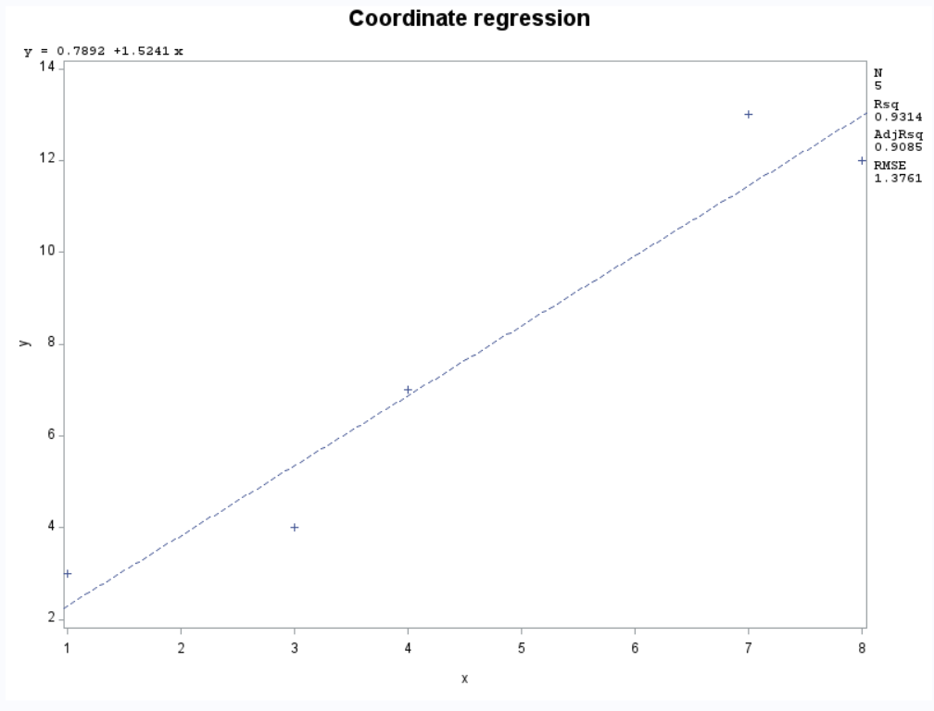

1.3:

**data** coordinates;

input x y z;

logx = LOG(x);

logy = LOG(y);

logz = LOG(z);

datalines;

1 3 15

7 13 7

8 12 5

3 4 14

4 7 10

;

**proc** **corr** data=coordinates;

title 'Coordinate Correlation';

var logx logy logz;

**run**;

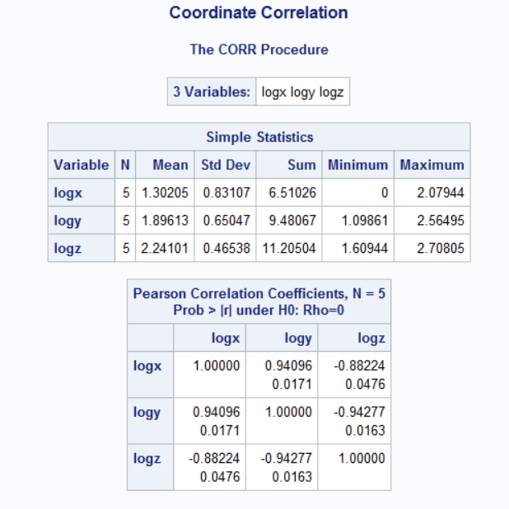

2.

(1)

**data** stocks;

input Date $ Pfizer Intel Citigroup AmerExp Exxon GenMotor;

datalines;

1-Aug-00 -0.001438612 0.049981263 0.044275101 0.017410003 0.010224894 0.093294017

1-Sep-00 0.017489274 -0.255619266 -0.033536503 0.012656982 0.03798902 -0.032209239

2-Oct-00 -0.017046116 0.034546736 -0.011645582 -0.004897625 0.000330555 -0.019602167

1-Nov-00 0.012012934 -0.072550667 -0.022674793 -0.03827587 -0.00365002 -0.0948916

1-Dec-00 0.016278701 -0.102497868 0.010708311 0 -0.005252049 0.012461253

2-Jan-01 -0.008063083 0.090223122 0.03990062 -0.066129678 -0.014169243 0.022971579

1-Feb-01 -0.00042298 -0.11219423 -0.055096146 -0.030733152 -0.014046895 0.000824088

1-Mar-01 -0.040906294 -0.035702138 -0.038726816 -0.026380545 -0.000240008 -0.012105099

2-Apr-01 0.024190228 0.069994483 0.038511978 0.011868735 0.038897488 0.024082196

1-May-01 -0.002978787 -0.05826061 0.019333184 -0.002446047 0.002844256 0.020148775

1-Jun-01 -0.029781389 0.03463487 0.013258067 -0.03564197 -0.006813464 0.053440295

2-Jul-01 0.012504432 0.008168789 -0.022187219 0.017739418 -0.019481402 -0.005100405

1-Aug-01 -0.0306632 -0.027529477 -0.038475736 -0.044368019 -0.01460743 -0.061635162

4-Sep-01 0.01981548 -0.135934121 -0.053479798 -0.098043942 -0.008224146 -0.105946472

1-Oct-01 0.019063731 0.077211653 0.050835509 0.006689711 0.00061005 -0.016274333

1-Nov-01 0.015543895 0.126580684 0.02356606 0.048543672 -0.020726234 0.08521096

3-Dec-01 -0.036145791 -0.016421934 0.022871285 0.035242521 0.021578866 -0.009657415

2-Jan-02 0.019356687 0.046876533 -0.025940517 0.002871379 -0.002807817 0.022139216

1-Feb-02 -0.006050198 -0.088680731 -0.020151007 0.007237226 0.026948074 0.01967222

1-Mar-02 -0.013187975 0.027384065 0.039197815 0.050683167 0.025807264 0.057331233

1-Apr-02 -0.038640426 -0.026448085 -0.058277811 0.00137534 -0.037828005 0.025768635

1-May-02 -0.020012226 -0.014900615 0.000481346 0.015691714 -0.000118352 -0.010495544

3-Jun-02 0.00498962 -0.179572434 -0.046948457 -0.068454444 0.010640133 -0.065487824

1-Jul-02 -0.034159152 0.01226155 -0.062746165 -0.01186007 -0.0465282 -0.060041503

1-Aug-02 0.011452067 -0.051537916 0.022330581 0.009740522 -0.013050696 0.016998701

3-Sep-02 -0.056822917 -0.079127863 -0.043102044 -0.063162423 -0.045786933 -0.090010126

1-Oct-02 0.039382501 0.09536996 0.097624046 0.067951966 0.023357105 -0.068058029

1-Nov-02 -0.001620779 0.082000518 0.022127194 0.029514688 0.017231827 0.083238291

2-Dec-02 -0.013493147 -0.127500953 -0.043258124 -0.040869439 0.001739589 -0.032155007

2-Jan-03 -0.000914625 0.002562217 -0.008110182 0.002151752 -0.009860009 -0.006417575

3-Feb-03 -0.007697729 0.042681011 -0.012956568 -0.024428147 0.001227785 -0.025617995

3-Mar-03 0.01899439 -0.025156666 0.014203546 -0.004565156 0.011692992 -0.001942487

1-Apr-03 -0.005686915 0.053056729 0.056727624 0.057647618 0.003171011 0.030362391

1-May-03 0.005686915 0.054144721 0.021322255 0.041490099 0.01767084 -0.00280191

2-Jun-03 0.041784483 -0.000213046 0.018444872 0.001579917 -0.005981586 0.008214181

1-Jul-03 -0.010109859 0.077829522 0.023189447 0.024870758 -0.003990877 0.016906014

1-Aug-03 -0.045266311 0.06043443 -0.01419843 0.008620388 0.028166116 0.046380496

2-Sep-03 0.006546894 -0.016587184 0.021075597 0.000112293 -0.01291723 -0.001791893

1-Oct-03 0.017184425 0.078321576 0.020888904 0.018572284 -0.00024981 0.018169063

3-Nov-03 0.028255616 0.007861351 -0.003462108 -0.01144524 -0.001501884 0.006155458

1-Dec-03 0.022153888 -0.019719492 0.013782077 0.024270976 0.054151115 0.096343714

2-Jan-04 0.015748075 -0.021237664 0.011862818 0.03132587 -0.00221919 -0.031390331

2-Feb-04 0.002115176 -0.018679024 0.006780909 0.01301928 0.01712318 -0.009458693

1-Mar-04 -0.01928823 -0.030753805 0.012267738 -0.012145545 -0.006030469 -0.007941261

1-Apr-04 0.008607804 -0.024068646 -0.027843588 -0.024949111 0.009863444 0.001620126

3-May-04 -0.003063819 0.045791862 -0.015263851 0.015239967 0.00995531 -0.014176433

1-Jun-04 -0.013135825 -0.01478726 0.000692103 0.006594513 0.011450989 0.011337234

1-Jul-04 -0.030491723 -0.053760665 -0.019188415 -0.009580051 0.018083807 -0.03339934

2-Aug-04 0.011876253 -0.058250748 0.023904782 -0.002001822 0.000773627 -0.013614662

1-Sep-04 -0.02833205 -0.02581149 -0.023595125 0.012265109 0.020475586 0.012073829

1-Oct-04 -0.024200939 0.045251691 0.006452318 0.01438828 0.007945468 -0.042109935

1-Nov-04 -0.015356644 0.003157084 0.003644451 0.021085951 0.019898881 0.006031965

1-Dec-04 -0.01408469 0.019040089 0.032148678 0.005093112 8.64354E-05 0.016341604

3-Jan-05 -0.046516472 -0.017862074 0.00770161 -0.022982941 0.002842759 -0.036824626

1-Feb-05 0.039975516 0.030472706 -0.008076244 0.006507102 0.090927282 -0.00798521

1-Mar-05 -0.000338104 -0.013929818 -0.02606549 -0.02185412 -0.026194026 -0.083992068

1-Apr-05 0.014633051 0.00525287 0.023245386 0.011111802 -0.019130346 -0.042013994

2-May-05 0.014630589 0.060803225 0.001318328 0.009356124 -0.004194614 0.079608491

1-Jun-05 -0.005088825 -0.015344193 -0.008162243 -0.004091884 0.009725145 0.03275369

1-Jul-05 -0.017295755 0.018252426 -0.022110024 0.014246467 0.009586797 0.034619924

1-Aug-05 -0.014040733 -0.02213234 0.002713407 0.001894712 0.010547196 -0.02599387

1-Sep-05 -0.008682706 -0.01834345 0.016994806 0.016950229 0.025608232 -0.047977476

3-Oct-05 -0.060303366 -0.020818266 0.002497608 -0.003389887 -0.053831314 -0.048092196

1-Nov-05 0.002411637 0.058709923 0.03829912 0.024183203 0.031923551 -0.070676054

;

**proc** **reg** data=stocks;

title 'stock regression';

model Pfizer=Exxon;

**run**;

Intercept: -.0053

Slope: .35465

(2)

**proc** **corr** data=stocks;

title 'stocks Correlation';

var Pfizer Exxon;

**run**;

Correlation: .35210

The probability of this correlation being due to chance is .0043, so we can reject the null hypothesis and conclude the correlation is significantly different than 0 with over 95% confidence.

3.

(a)

**data** Prob3;

input AGE SBP;

datalines;

15 116

20 120

25 130

30 132

40 150

50 148

;

**proc** **corr** data=prob3;

title 'Correlation';

var AGE SBP;

**run**;

Correlation is .95258

(b)

**data** Prob3;

input AGE SBP;

datalines;

15 116

20 120

25 130

30 132

40 150

50 148

;

**proc** **reg** data=Prob3;

title 'Regression';

model sbp=age;

plot sbp*age;

**run**;

