IU2541230786 – CPP73 – PROJECT REPORT
Freelance Project Management
Enrollment No.: IU2541230786
Student Name: Divyansh Jogai
Subject: C++ Guided Project (7-Day, Console-Based OOP)
Date: 14-10-2026

1. Introduction
Freelance Project Management is a console-based C++17 application that lets an administrator keep records of clients and freelancers, create projects, assign a freelancer, record client payments, and close or cancel projects. All records are saved to text files so they are still available after the program is restarted.

2. Problem Statement
Small freelance work is often tracked in chats and notes. This causes double-assigned freelancers, payments larger than the agreed budget, projects closed while money is still due, and lost records. A simple, validated, persistent system is needed to enforce these rules.

3. Objectives
- Design the system with classes, encapsulation, inheritance and runtime polymorphism.
- Provide add, display, search, update and delete for clients, freelancers and projects.
- Implement the project transaction: create, assign, pay, close and cancel, with business rules.
- Use dynamic arrays (new[] / delete[]) that grow automatically and are released in destructors.
- Persist data with file handling and validate every input with exception handling.

4. Functional Requirements
- FR1: Add, display, search, update and delete clients and freelancers.
- FR2: Create a project only for an existing client with a valid title and budget; it starts as Open.
- FR3: Assign a freelancer only to an Open project, and only if the freelancer is not already working on an Assigned project.
- FR4: Record a payment only for an Assigned project; the total paid can never exceed the budget.
- FR5: Close a project only when it is Assigned and fully paid; cancel only if no payment has been made.
- FR6: Block deletion of clients, freelancers and projects that other records depend on.
- FR7: Show a report: counts, projects by status, budget, paid, outstanding and earnings per freelancer.
- FR8: Load records at start-up and save on exit or on request.

5. System / Project Flow
USER → MAIN MENU (main.cpp / FreelanceSystem::run) → FreelanceSystem → Client / Freelancer / Project / Payment objects → FileManager → Data/*.dat files
main.cpp only creates the system object and calls run(); all logic lives in FreelanceSystem.

6. Class Design and Responsibilities
Class | Key data members | Key functions | Responsibility
Person (abstract) | id, name | display(), toRecord(), role() (pure virtual); setName() | Common base for people; forces subclasses to implement the interface.
Client : Person | phone | Client(), setPhone(), display(), toRecord() | Holds client details; validates phone.
Freelancer : Person | skill, rate | Freelancer(), setRate(), calculateFee(hours), display() | Holds freelancer details; computes rate × hours.
Project | projectId, clientId, freelancerId, title, budget, status | Project(), assign(), updateStatus(), setTitle(), setBudget() | Owns the project life cycle Open → Assigned → Closed/Cancelled and rejects illegal changes.
Payment | paymentId, projectId, amount, date | Payment(), makePayment(), display() | Validates and stores one payment.
FreelanceSystem | Client*, Freelancer*, Project*, Payment* + counts/capacities, FileManager | createProject(), assignFreelancer(), makePayment(), closeProject(), cancelProject(), report(), run() | Controller: owns the dynamic arrays and enforces every business rule.
FileManager | dir | save(), load() | Writes and reads the four .dat files; skips corrupt lines.
Utils (namespace) | – | readLine/Int/Double, isValidName/Phone/Text/Date, toLower, grow<T>() | Input reading, validation and array growth.

7. C++ Concepts Demonstrated (and where)
Concept | Where in the code | How it was verified
Classes & objects / Encapsulation | Private data in every class; validated setters | Harness: bad phone/rate/name rejected, object unchanged; compiler rejects c.phone, f.rate
Default + parameterized constructors | All entity classes | Harness: default objects empty; parameterized values stored
Destructors | ~Person() virtual; ~FreelanceSystem() releases 4 arrays with delete[] | AddressSanitizer: no leaks
Inheritance | Client and Freelancer derive from Person | static_assert is_base_of in the harness
Runtime polymorphism | displayEveryone(): Person* array calls the right display()/role() | Harness: typeid + output check; test T22
Abstract class | Person has pure virtual functions | static_assert is_abstract; compiler rejects 'Person p;'
Dynamic memory | new[] arrays (start capacity 4), Utils::grow() doubles, delete[] in destructor | Harness: 2 → 4 growth keeps elements; ASan clean
File handling | FileManager::save/load, '|' separated lines | Tests T25 (restart) and harness (corrupt line skipped)
Validation + exceptions | invalid_argument / logic_error thrown by classes, caught in run() | Tests T02, T04, T06, T07, T16–T18, T20; 400-run fuzz

8. Business Rules (as implemented)
- Project status path: Open → Assigned → Closed; Open or Assigned → Cancelled. Anything else throws logic_error.
- A freelancer can work on only one Assigned project at a time.
- Payment ≤ remaining balance; payments only while Assigned.
- Close requires balance = 0. Cancel requires no payments.
- Cannot delete a client or freelancer linked to a project; cannot delete an Assigned/Closed project or one with payments.
- IDs are max(existing)+1, so deleted IDs are never reused.

9. File Design
File | Record format
Data/clients.dat | id|name|phone
Data/freelancers.dat | id|name|skill|rate
Data/projects.dat | id|clientId|freelancerId|title|budget|status (0 Open, 1 Assigned, 2 Closed, 3 Cancelled)
Data/payments.dat | id|projectId|amount|date

At start-up the program loads all four files (missing files are fine on first run); on Exit it saves them. Lines that fail validation are skipped and counted in a warning.

10. Build and Run
g++ -std=c++17 -Wall -Wextra -Wpedantic -Wold-style-cast -Werror -o household src/*.cpp then ./household (Windows: BUILD_WINDOWS.bat). The strict build produces 0 warnings.

11. Test Cases (real results)
ID | Operation | Input | Expected | Actual (captured output) | Result
T01 | Add Client | Name=Neha Joshi, Phone=9876543210 | Client added with ID 1 | Client added with ID 1 | PASS
T02 | Add Client (invalid phone) | Phone=12345 | Error: Phone must be exactly 10 digits | Error: Phone must be exactly 10 digits | PASS
T03 | Add Freelancer | Karan Mehta, Web Design, Rs. 800/hr | Freelancer added with ID 1 | Freelancer added with ID 1 | PASS
T04 | Add Freelancer (negative rate) | Rate=-50 | Error: Rate must be between 1 and 100000 | Error: Rate must be between 1 and 100000 | PASS
T05 | Create Project | Client 1, 'Company Website', Rs. 20000 | Project created with ID 1 (status Open) | Project created with ID 1 (status Open) | PASS
T06 | Create Project (unknown client) | Client ID 9 | Error: Client not found | Error: Client not found | PASS
T07 | Create Project (zero budget) | Budget=0 | Error: Budget must be between 1 and 10000000 | Error: Budget must be between 1 and 10000000 | PASS
T08 | Display Clients | Display > Clients | 2 Rohit Verma 9123456780 | 2 Rohit Verma 9123456780 | PASS
T09 | Search Freelancer by skill | Skill contains 'web' (case-insensitive) | 1 Karan Mehta Web Design Rs. 800.00/hr | 1 Karan Mehta Web Design Rs. 800.00/hr | PASS
T10 | Update Freelancer rate | Freelancer 1 -> Rs. 950/hr | Freelancer updated. | Freelancer updated. | PASS
T11 | Delete Client without projects | Delete client 2 | Client deleted. | Client deleted. | PASS
T12 | Delete blocked: client has a project | Delete client 1 | Cannot delete: client has a project. | Error: Cannot delete: client has a project. | PASS
T13 | Assign Freelancer | Project 1 -> Freelancer 1 | Freelancer assigned. Project 1 is now Assigned. | Freelancer assigned. Project 1 is now Assigned. | PASS
T14 | Assign blocked: freelancer busy | Freelancer 1 on a 2nd project | Freelancer is already working on project 1 | Error: Freelancer is already working on project 1 | PASS
T15 | Record Payment | Project 1, Rs. 5000, 20-10-2026 | Payment recorded. Payment ID 1. Paid Rs. 5000.00 of Rs. 20000.00 | Payment recorded. Payment ID 1. Paid Rs. 5000.00 of Rs. 20000.00 | PASS
T16 | Payment exceeds budget | Rs. 25000 on a Rs. 20000 project | Error: Payment exceeds the budget (balance Rs. 20000.00) | Error: Payment exceeds the budget (balance Rs. 20000.00) | PASS
T17 | Payment (invalid date) | Date=31-02-2026 | Error: Date must be a valid DD-MM-YYYY | Error: Date must be a valid DD-MM-YYYY | PASS
T18 | Close blocked: unpaid balance | Close with Rs. 5000 of 20000 paid | Error: Cannot close: Rs. 15000.00 still unpaid | Error: Cannot close: Rs. 15000.00 still unpaid | PASS
T19 | Pay in full, then Close | Pay remaining 15000, close project 1 | Project closed. Total paid Rs. 20000.00 | Project closed. Total paid Rs. 20000.00 | PASS
T20 | Cancel blocked: project has payments | Cancel project 1 after a payment | Error: Cannot cancel: project already has payments | Error: Cannot cancel: project already has payments | PASS
T21 | Cancel Open Project | Cancel project 1 | Project cancelled. | Project cancelled. | PASS
T22 | Polymorphic display (Person*) | Display > Everyone | Freelancer: 1 Karan Mehta | Freelancer: 1 Karan Mehta Web Design Rs. 800.00/hr | PASS
T23 | Estimate fee (calculateFee) | Freelancer 1, 5 hours | Estimated fee for Karan Mehta: Rs. 4000.00 | Estimated fee for Karan Mehta: Rs. 4000.00 | PASS
T24 | Report with earnings per freelancer | Project paid Rs. 5000, then Report | Karan Mehta Rs. 5000.00 | Karan Mehta Rs. 5000.00 | PASS
T25 | Persistence: save on exit, reload on restart | Run 1: add data, create, assign, pay, Exit. Run 2: restart, Report | Data loaded: 2 clients, 2 freelancers, 1 projects, 1 payments. + Assigned 1, paid Rs. 5000.00 | Data loaded: 2 clients, 2 freelancers, 1 projects, 1 payments. + Projects : 1 (Open 0, Assigned 1, Closed 0, Cancelled 0) + Total paid: Rs. 5000.00 | PASS

Result: 25 of 25 tests passed. The 'Actual' column is the real line captured from the running program.

12. OOP Verification and Evidence (real runs)
Every screenshot below was produced by running the compiled program (Tests/run_tests.py, Tests/make_evidence.py). Typed input is cyan; the checked output line is highlighted.
OOP harness (Tests/oop_checks.cpp): 30 checks under AddressSanitizer and UBSan, 30 passed, 0 failed, no leaks. Tests/compile_fail_checks.sh shows the compiler rejects instantiating Person and reading private members. A 400-run randomized fuzz (garbage input, long strings, corrupt data files, end-of-input) produced no crash or sanitizer error.
Build with -Wall -Wextra -Wpedantic -Werror
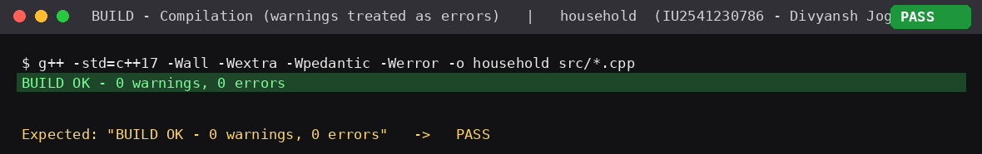
OOP verification harness
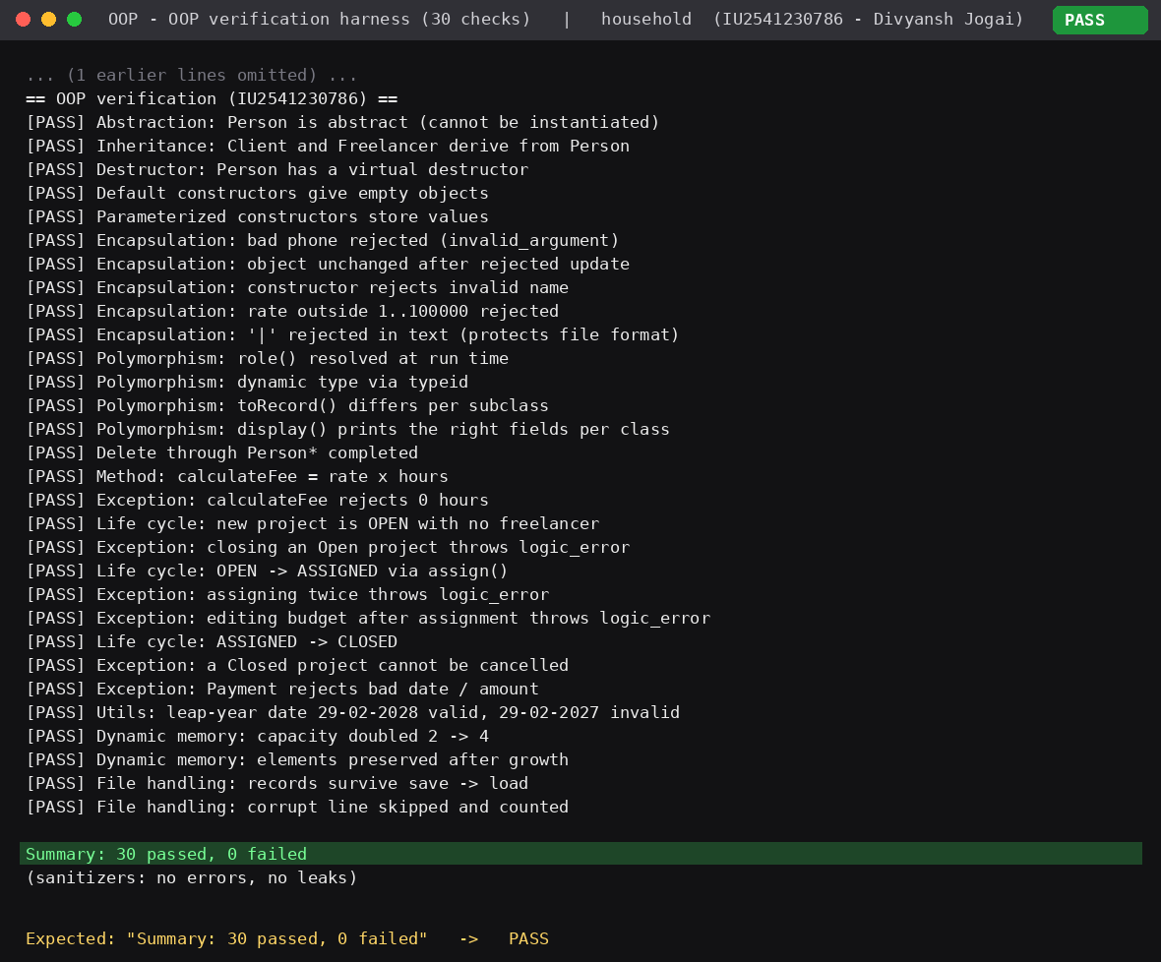
Compiler enforces abstraction and encapsulation
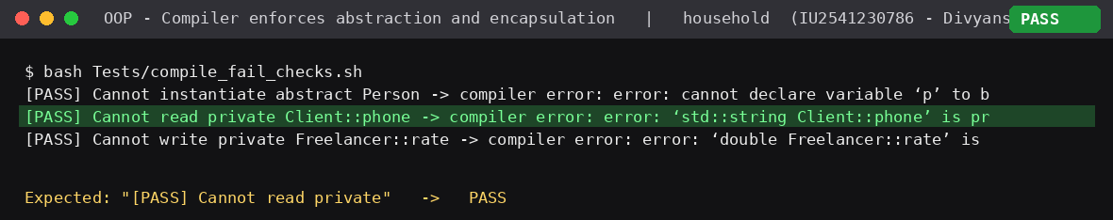
T05 Create project
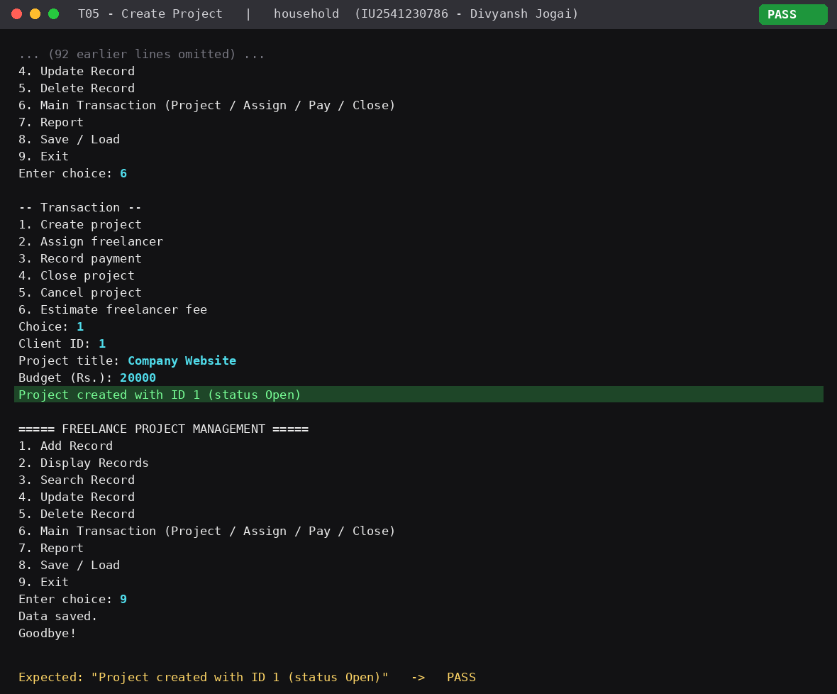
T13 Assign freelancer
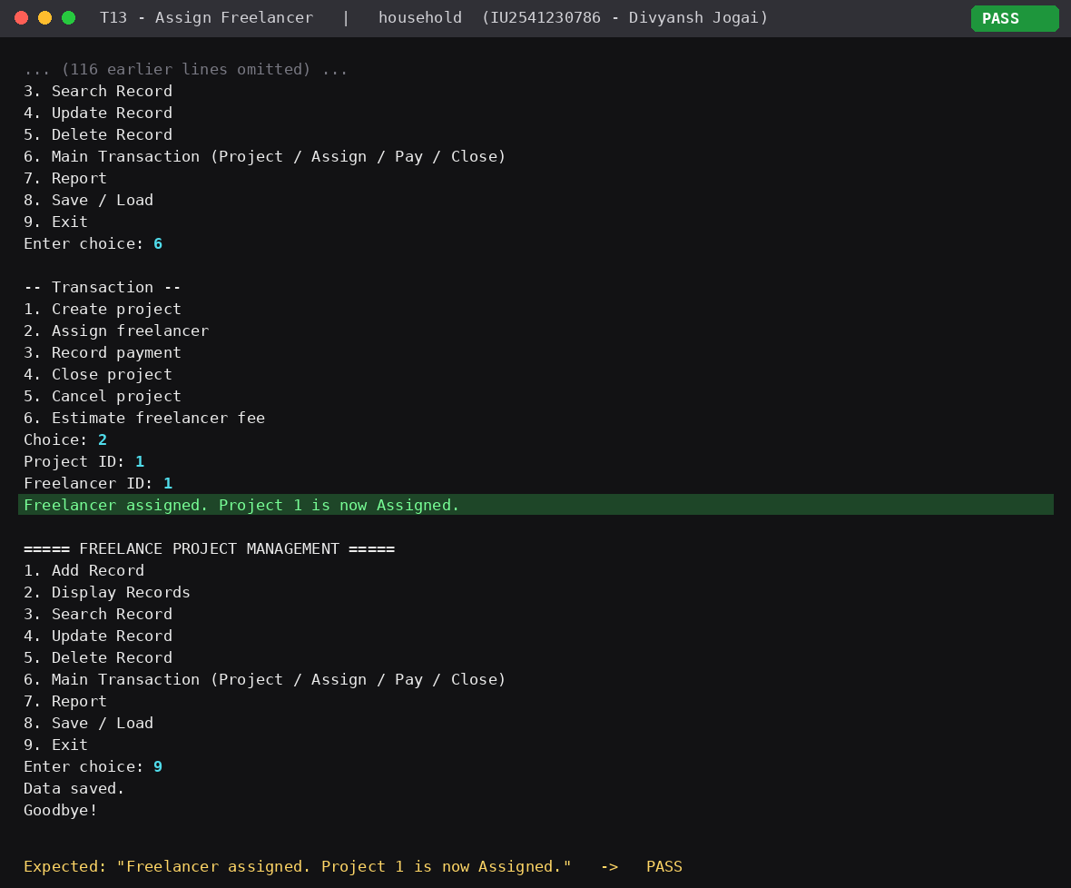
T14 Busy freelancer blocked
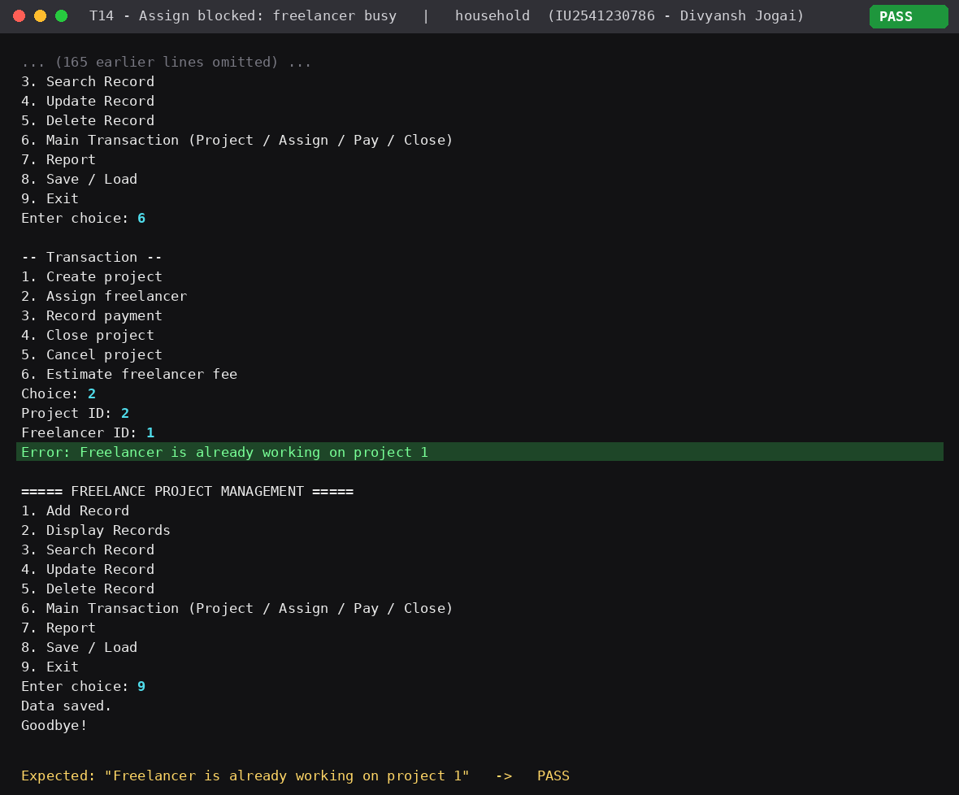
T15 Record payment
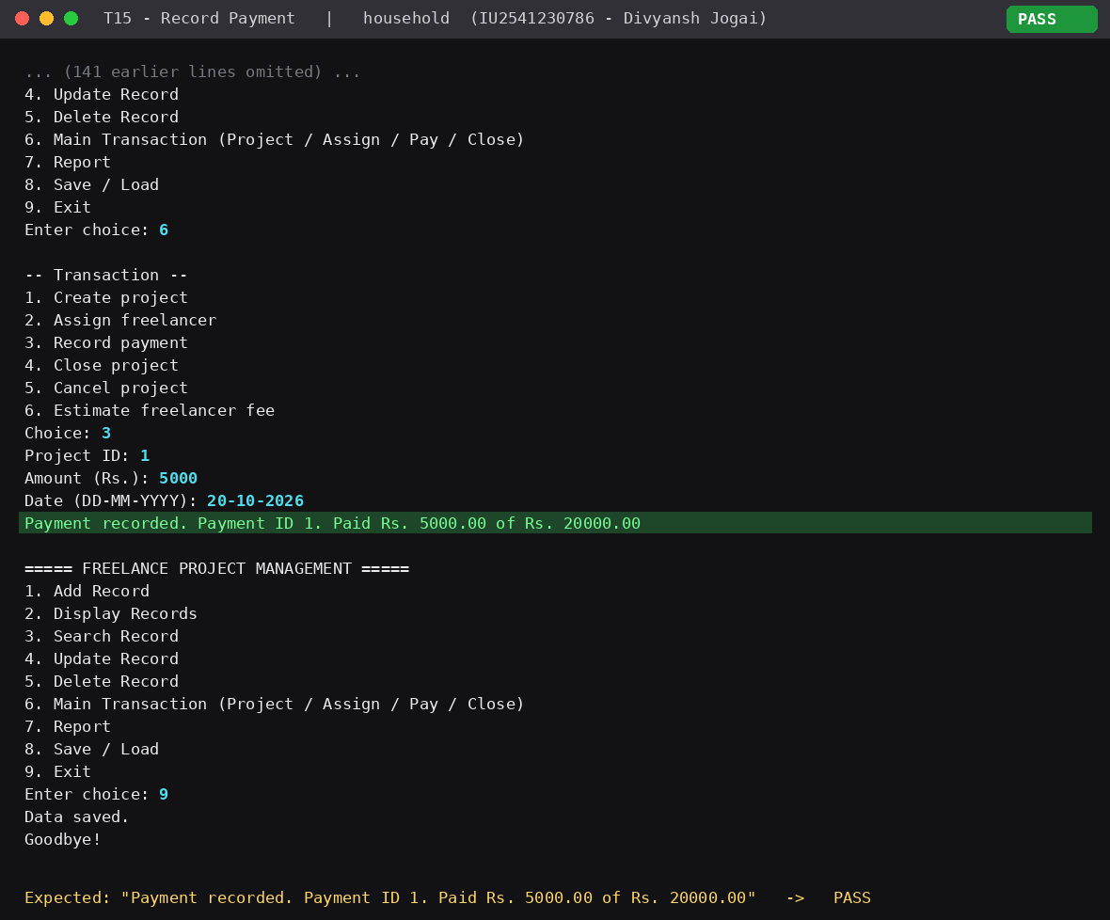
T16 Overpayment blocked
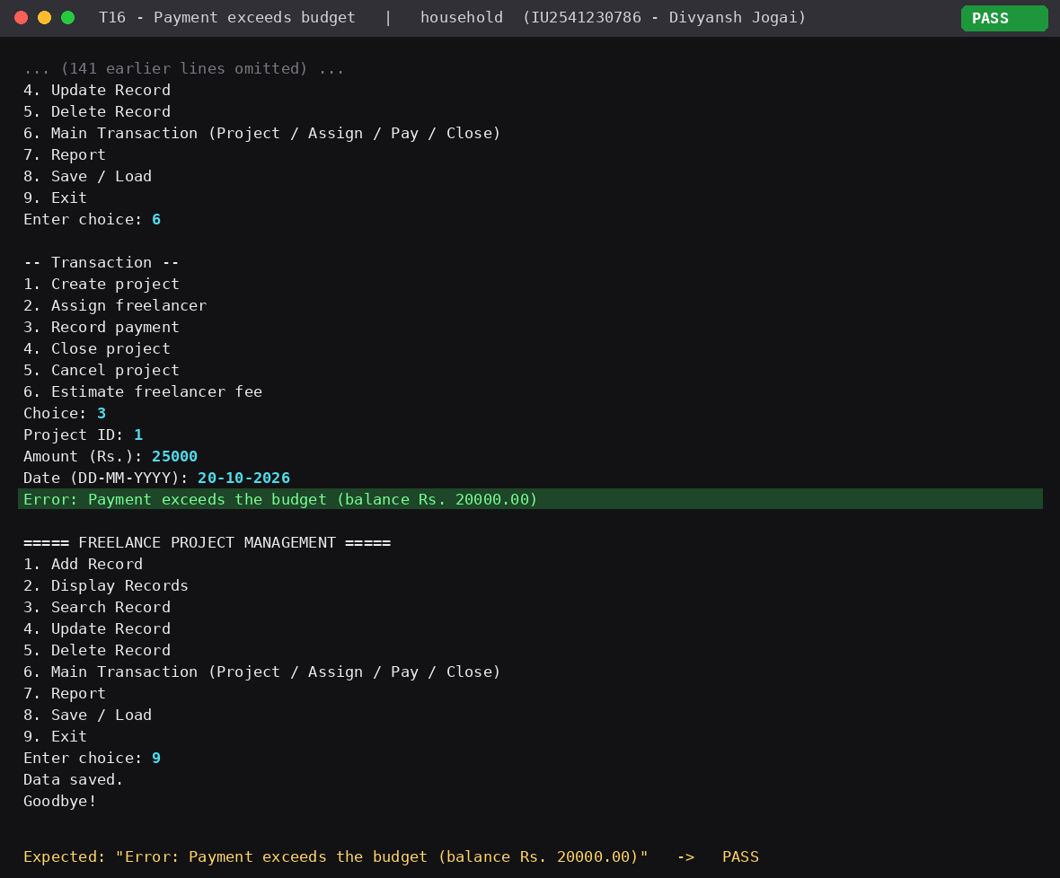
T18 Close blocked while unpaid
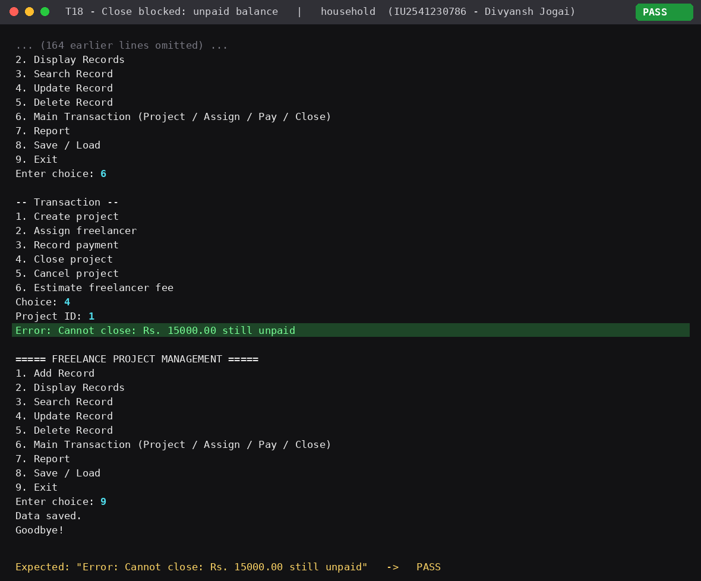
T19 Pay in full and close
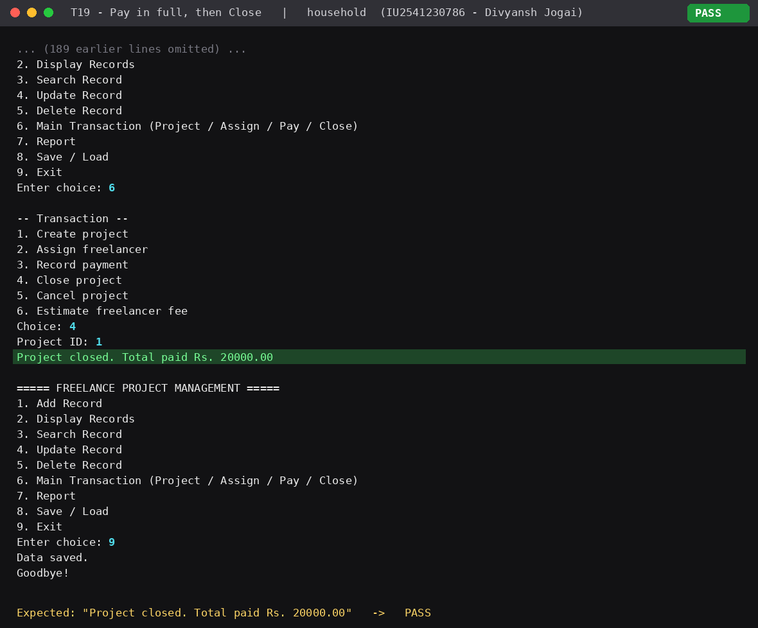
T22 Runtime polymorphism (Person*)
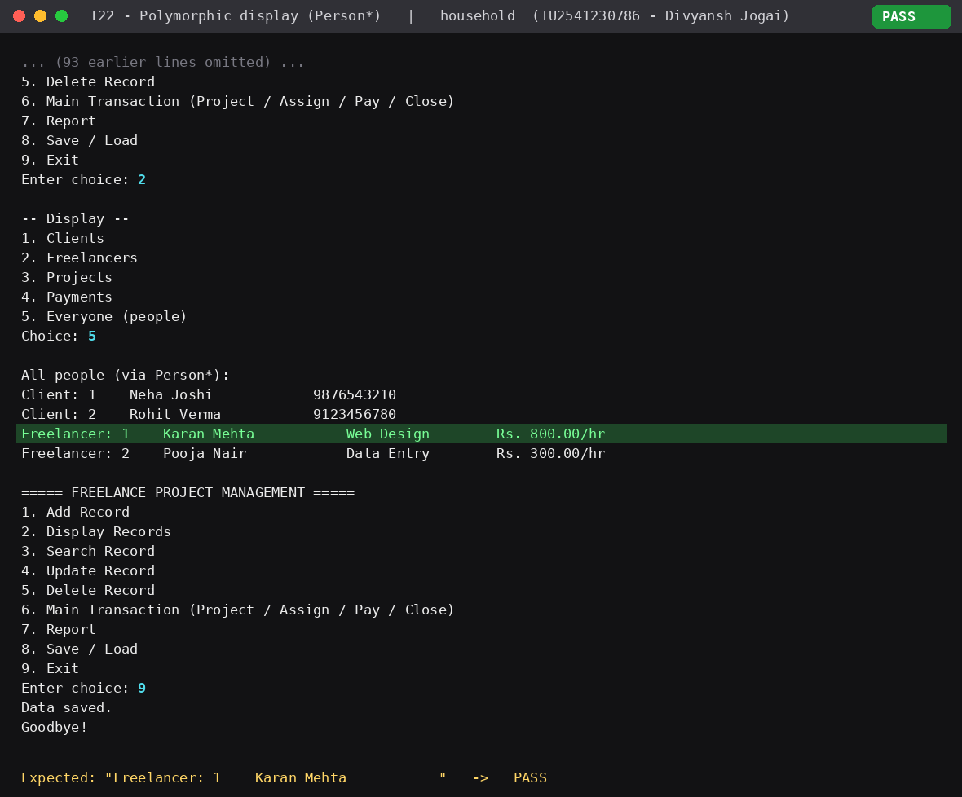
T25 Persistence after restart
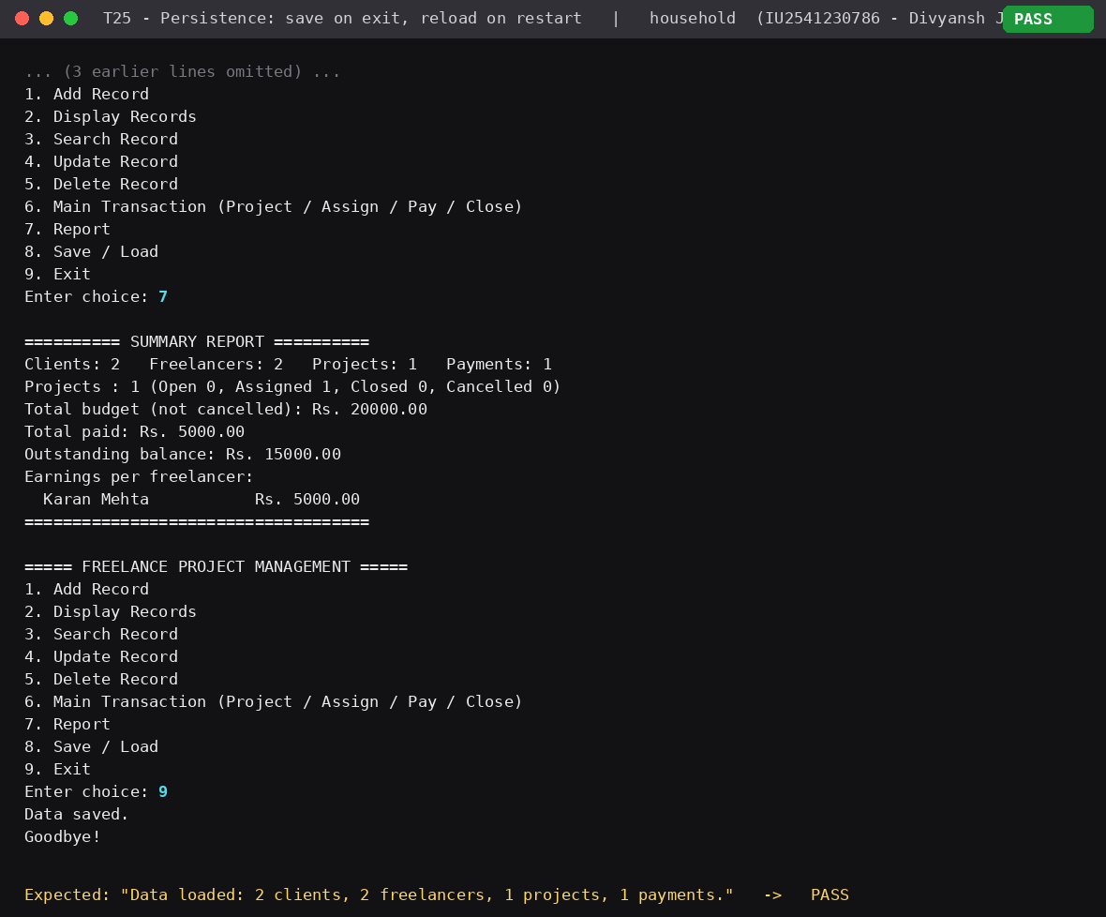

13. UML Diagrams
Use Case Diagram (3 actors, 10 use cases)
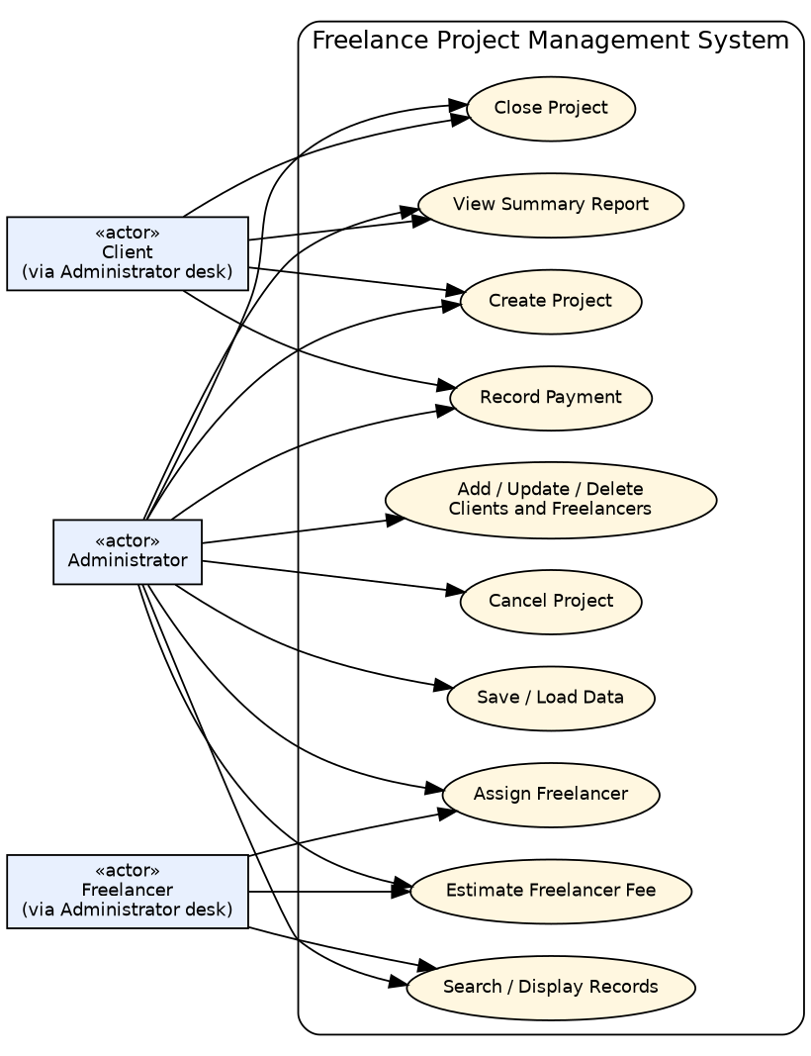
Class Diagram
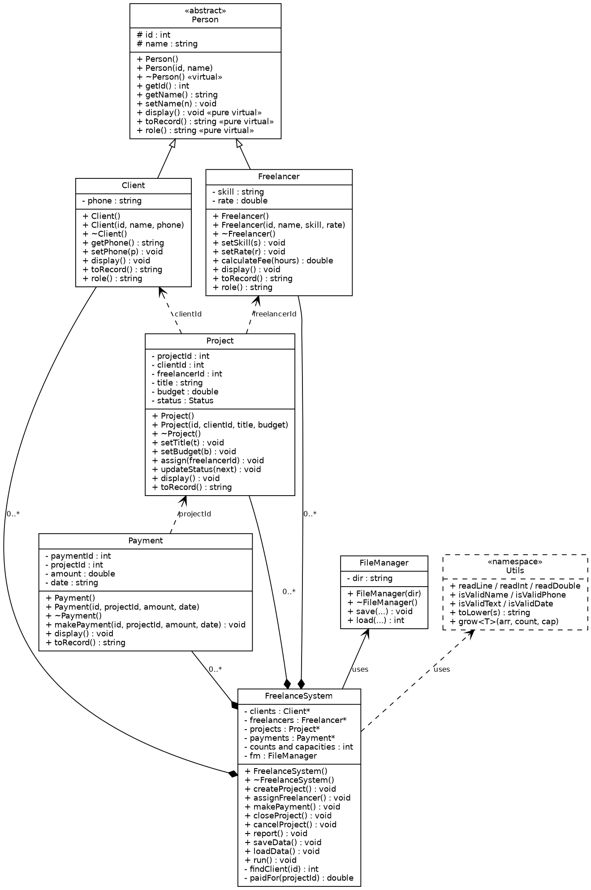
Sequence Diagram 1 – Record a payment and close a project (main transaction)
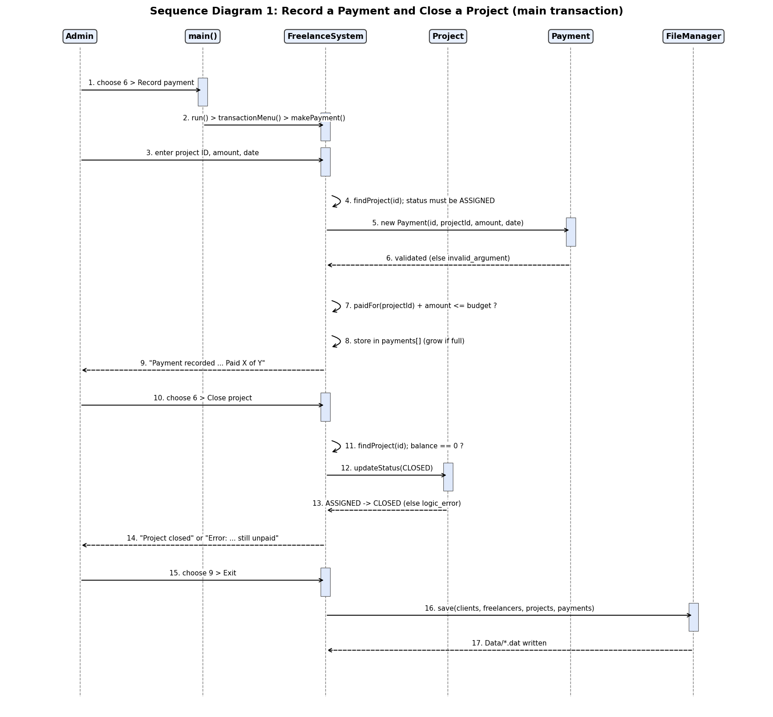
Sequence Diagram 2 – Assign a freelancer
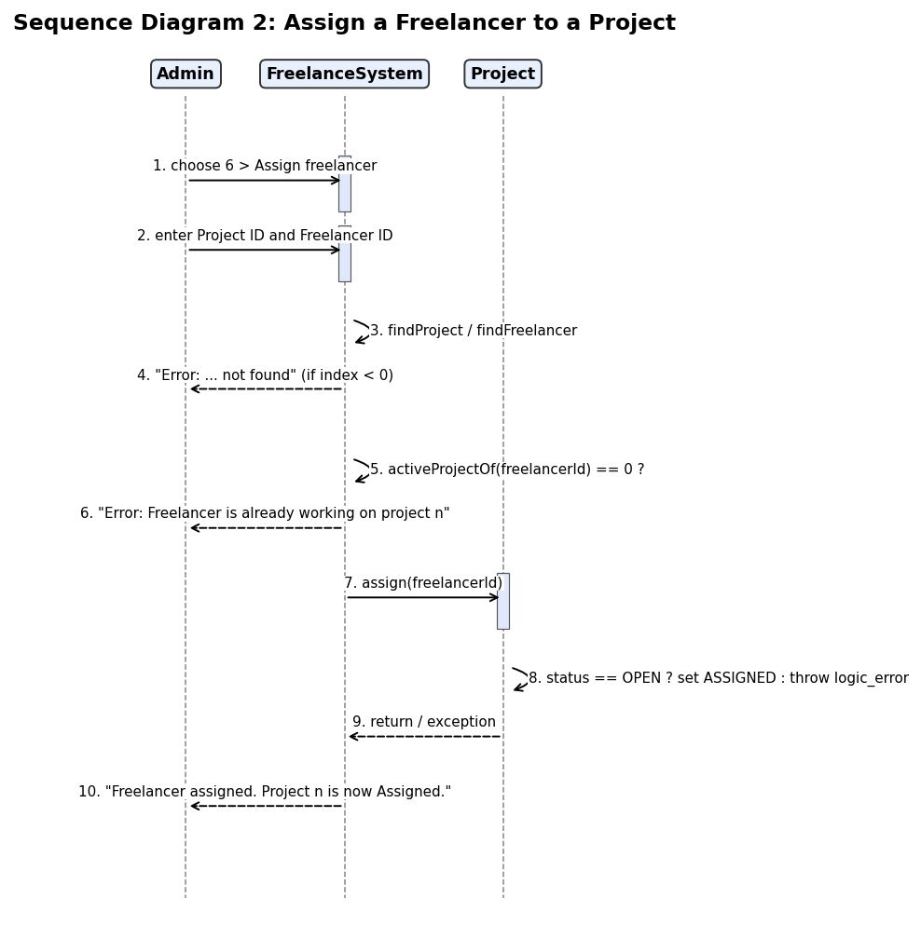
Relationships: Client and Freelancer inherit from Person (generalization). FreelanceSystem owns arrays of Client, Freelancer, Project and Payment (composition, 0..*). Project refers to Client and Freelancer, and Payment refers to Project, by ID (association). FreelanceSystem uses FileManager and Utils (dependency).

14. Viva Preparation (short answers)
Question | Answer
Responsibility of each class | See section 6: entities hold and validate their own data; FreelanceSystem applies the rules; FileManager does persistence.
One relationship in the class diagram | FreelanceSystem owns Project objects (composition): the Project array is created in its constructor and deleted in its destructor.
Inheritance and polymorphism | Client/Freelancer derive from Person; displayEveryone() stores both in Person* and the correct display() runs (test T22).
Dynamic memory | new Client[4] etc. in the FreelanceSystem constructor; Utils::grow() allocates double and delete[]s the old; ~FreelanceSystem() calls delete[].
Close and reopen | run() calls loadData() first (FileManager::load reads Data/*.dat); Exit calls saveData(). Test T25 proves it with two separate processes.

15. Final Checklist
Item | Done | Evidence
Minimum 5 classes | Yes | Person, Client, Freelancer, Project, Payment, FreelanceSystem, FileManager (+Utils)
Constructors + destructors | Yes | All classes; harness checks
Inheritance + polymorphism | Yes | T22, harness
Dynamic memory | Yes | grow + delete[]; ASan clean
File persistence | Yes | T25
Add/Search/Update/Delete | Yes | T01–T12
Main transaction | Yes | T13–T21
Use Case Diagram | Yes | UML/Use_Case_Diagram.png
Class Diagram | Yes | UML/Class_Diagram.png
2 Sequence Diagrams | Yes | UML/Sequence_Diagram_1/2.png
15 test cases | Yes | 25 tests, all pass
Executable + README | Partly | Linux executable and README included; Windows .exe must be built with BUILD_WINDOWS.bat or the GitHub Action

16. Limitations and Future Work
- Console interface only; one freelancer per project and one active project per freelancer.
- Linear search is used (fine for small data); a database or map would scale better.
- No login or user roles; a GUI could be added later.

17. Conclusion
The project meets every item in the blueprint: seven classes plus a helper namespace, inheritance with runtime polymorphism, dynamic memory, file persistence, validated CRUD, a rule-driven project transaction, four UML diagrams, and 25 real tests with screenshots.

