Discovery Vitality:

Active Rewards Account Management System

**CMPG323: Project 1**

**Mr. DE Roux**

Project submitted for the degree *Bachelors* in Information Technology at the North-West University

Supervisor(s): Dr. JT Janse van Rensburg

Mr. Z Boonzaaier

Student number: 30196299

Preface

As project 1 of the CMPG 323 module of the North-West University, I was instructed to create a rather simple system for the backend of the Discovery Vitality Account system.

The project’s aim was to teach me the entry-level technology stacks, or the like, that will most probably be used in my early years in the field of software engineering. The technologies involved was mostly java-related, but the experience is assured to overflow into any other stack.

The project itself was of great concern for most of my semester, as it offered great challenges and difficulties I am still not used to dealing with. Nonetheless, it was a wonderful learning experience, and sparked interest into learning more.

Abstract

The system’s purpose is the management of a user account of the Discovery Vitality Rewards Program. The following is applicable:

* The user can see their available balances of their accounts.
* They can subtract their balances by using their currencies for rewards, coupons, gifts, and many more.
* The user can add currencies to their rewards balances by claiming rewards, lucky draws, and weekly rewards.

The system that was developed included many components. These components were built using a technology stack that was provided:

* Maven – as a build tool.
* Spring-boot.
* Swagger – for testing and documentation.
* Hibernate and JPA – for database connections, repositories and entities.
* MySql Database, and connector – for database server, creation and connections.
* MySQL Workbench – for database creation, visualization and connections.

Table of contents

Preface i

Abstract ii

Chapter 1 Design 1

1.1 ERD diagram 1

1.1.1 members 1

1.1.2 account_types 1

1.1.3 account_transactions 1

1.2 Use case diagram 2

1.3 Flow diagrams 3

1.3.1 Show balance 3

1.3.2 Update (add/subract) currency 4

List of Figures

Figure 1:Figure showing the database ERD diagram 1

Figure 2: Figure showing the system's basic use case diagram 2

Figure 3:Figure showing the flow diagram of the balance showing service 3

Figure 4:Figure showing the update account / transaction service 4

Chapter 1 Design

# Heading 1 won’t print. Don’t delete – doing so will lead to incorrect numbering.

## ERD diagram

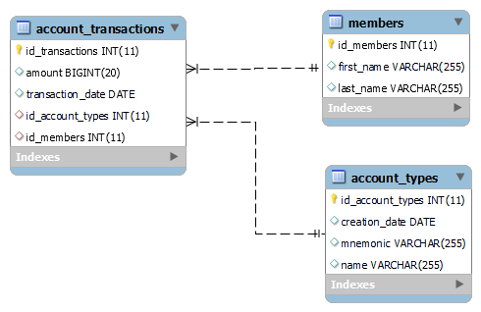

Figure 1:Figure showing the database ERD diagram

### members

The members table represents the common users of the system, storing their first and last names, and auto generating a unique id for each row. This table will be the base of the database, as the other tables cannot exist without an existing entry in members.

### account_types

The account_types table represents the different accounts that one member can have, storing a mnemonic value for different currencies, or even different rewards points and programs, as long as the basic structure is constant.

### account_transactions

The account_transactions table represents a log of transactions made by users with their respective accounts. It acts as a balance calculation table in code as well.

## Use case diagram

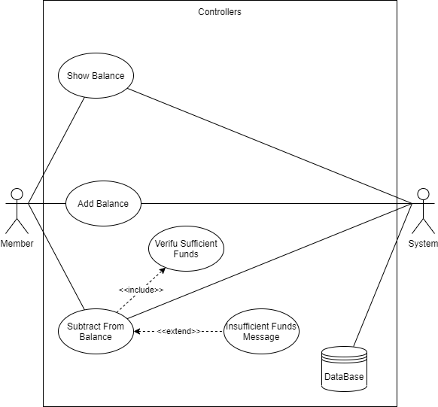

Figure 2: Figure showing the system's basic use case diagram

The system is used for very basic functionality, where a member can see their current balances, add points and subtract accordingly. Because of the application layering used in the code, this is a very basic representation of the product, but will be further fleshed out in the flow diagrams.

## Flow diagrams

### Show balance

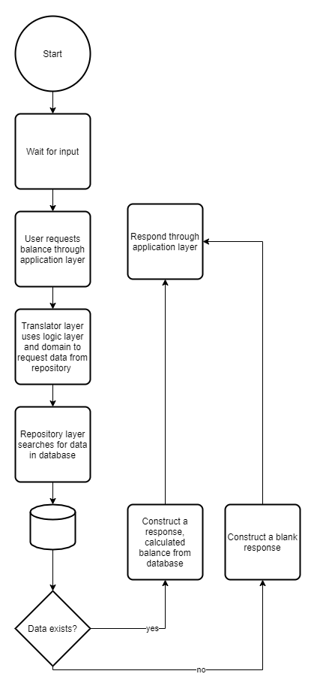

Figure 3:Figure showing the flow diagram of the balance showing service

### Update (add/subract) currency

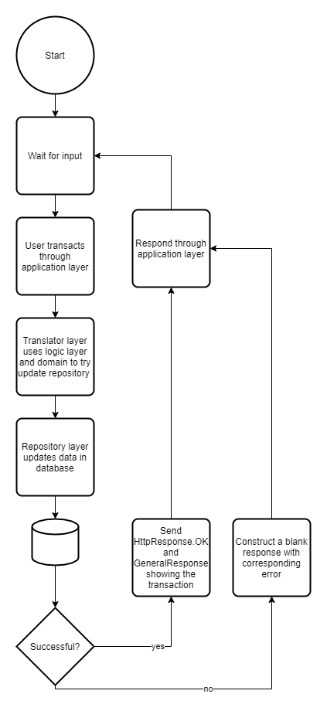

Figure 4:Figure showing the update account / transaction service