|  |  |  |
| --- | --- | --- |
|  |  |  |
|  |  |  |
|  |  |  |
| **Audio and video support** | | |
|  | | |

This document explains audio and video support in EXMARaLDA 1.5.1. and gives recommendations about media file formats.

**Contents**

A. Audio and video support in EXMARaLDA 2

B. Player types 3

C. Recommended media formats and codecs 5

D. Summary: Which player type? 5

E. Some more recommendations 5

[System version 1.5.1.]

# A. Audio and video support in EXMARaLDA

EXMARaLDA supports the playback of digital audio or video files and their synchronisation with the transcriptions through the audio-/video panel, the Praat panel and the timeline viewer in the Partitur-Editor, and through corresponding components in EXAKT. In order for the waveform panel to show you a real waveform, you need to have an audio file in WAV format associated with your transcription. If you’re working with a video file, extract a WAV file from it and associate both video and WAV file with your transcription, putting the video file on top of the list.

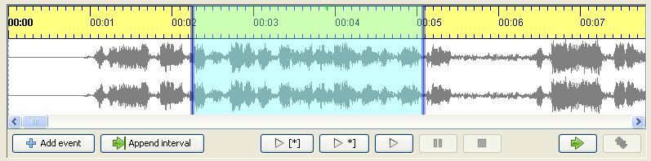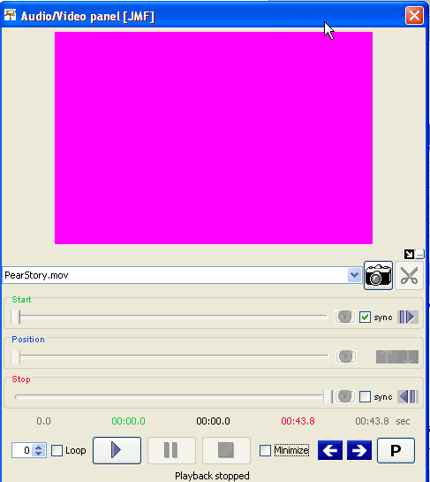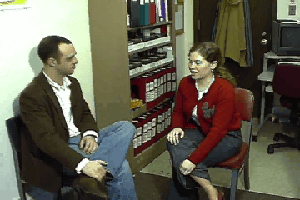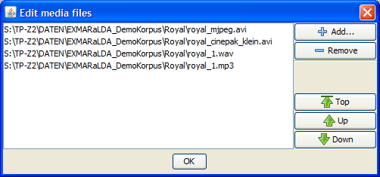

Whether and how audio or video support works for a given media file can be tricky to find out because it depends on many parameters:

* Your sound and video card
* Your operating system (e.g. MAC OS, Windows, Linux)
* Certain pieces of software that is installed or missing on your system (e.g. media frameworks like Quicktime or certain codecs, i.e. software to decode a media format like divx)
* The file format of your media (e.g. wav, mov or avi etc.)
* The codec used for data compression (e.g. mpeg-2, divx, soerensen etc.)
* Other encoding parameters of your media file (e.g. bitrate, framerate etc.)

Because there are many ways of combining these parameters, it is very difficult to compile a full list of possible combinations and to say whether or not EXMARaLDA supports them. If you intend to use EXMARaLDA with a certain media file, you should read this document and then try to determine yourself whether or not it is supported by EXMARaLDA. If you are planning to construct a bigger corpus, we strongly recommend to spend ample time on these experiments – time lost in this process will be paid back to you later if your format is supported smoothly.

Since advice on (free) tools that are useful for conversion between different audio and video formats becomes outdated faster than we can update our documentation, we advice you to review the relevant sites and make an informed choice.

# B. Player types

EXMARaLDA allows you to choose between different player types. You can make this choice by going to Edit > Preferences in the Partitur-Editor selecting the Media tab. In order for the changes to take effect, you need to restart the software.

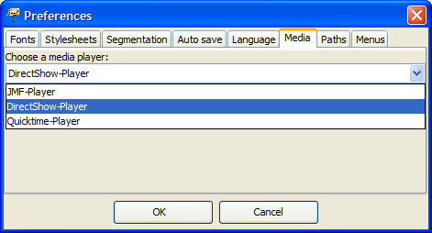

The player types to choose from are:

* **JMF-Player** – JMF stands for Java Media Framework. This used to be the default player for all systems. It is known to work OK on Windows, Linux and Macintosh computers with an Intel processor. It does not work very well on Macintosh computers with a PowerPC processor. The biggest problem with the JMF player used to be that it did not support newer video codecs like MPEG-4, DivX or xvid. With version 1.3.4. of the EXMARaLDA Partitur-Editor, we were able to remedy this by using a FOBS implementation of the JMF (see below).
* **Quicktime-Player** – This is a player which, in principle, supports all the file types that are also supported by the JMF-Player. If you’re working on Macintosh, you can simply choose this player type if you have problems with the others. On Macintosh computers with a PowerPC processor, this is likely to be the best available option. On a Windows computer, you need to install Quicktime (from <http://www.apple.com/de/quicktime/>) before you can choose this player.[1]
* **DirectShow-Player** – this is a player developed by the MPI in Nijmegen, which plugs into the native media playback framework DirectShow on Windows. It is therefore only available on Windows computers. The DirectShow-Player supports a wide range of file types, and is often more accurate and plays more smoothly than the JMF-Player. Since version 1.4.4., it is the default player on Windows.
* **ELAN-Quicktime-Player**– this is a player developed by the MPI in Nijmegen, which plugs into the native media playback framework Quicktime on Macintosh. It is therefore only available on Macintosh computers. The Macintosh player supports a big range of file types, and it is often more accurate and plays more smoothly than the JMF-Player. Since version 1.4.5., it is the default player on Macintosh.

**Sun’s and FOBS implementation of the JMF**

There are two implementations of the Java Media Framework: One by Sun and one open­source implementation by FOBS. Sun’s implementation is known to run well on Windows computers, but it lacks support for some newer video codecs like MPEG-4, DivX or xvid. The FOBS implementation is known to run well on Windows computers and on Macintosh computers with Intel processors. It will not run on Macintosh computers with PowerPC processors.

Therefore on Windows, you have the choice between using Sun’s JMF or the FOBS JMF. If you start the Partitur-Editor or EXAKT from the start menu or from the desktop, the SUN JMF Player will be used. If you want to use the FOBS JMF player instead, go to the program directory (typically c:\program files\EXMARaLDA), choose the subdirectory FobsJMF and double click on PartiturEditorWithFOBS.exe or ExaktWithFOBS.exe (of course, you can also set up appropriate shortcuts on your desktop or in your start menu).

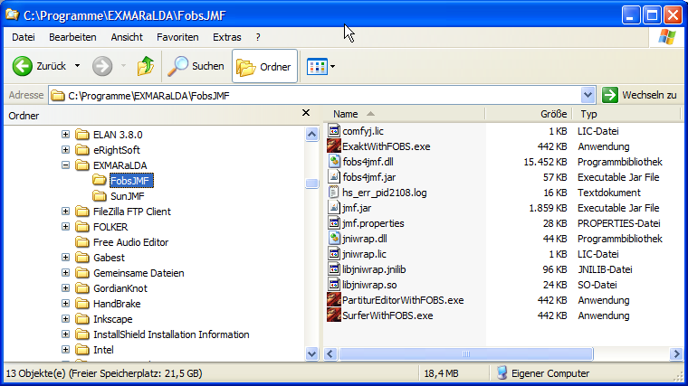

Since the DirectShow Player is usually the preferred option anyway, you will need the FOBS JMF option only in special circumstances. On Macintosh, the choice is already made for you: the Macintosh PowerPC version of EXMARaLDA comes with Sun’s JMF, the Macintosh Intel version comes with the FOBS JMF. The Linux version also comes with FOBS JMF.

# C. Recommended media formats and codecs

The preferred format for audio is **PCM/WAV** – a format used by very many audio applications and recording devices. All EXMARaLDA players work well with this format and you are free to use it with different encoding parameters (e.g. mono or stereo, different sample rates). It is crucial, however, that the audio bit depth is 16 bit – and not 24 bit – and that the WAV file is **uncompressed**. Some recording devices store audio files in a compressed format which also carries the filename suffix WAV. These compressed audio files will cause problems for the waveform display and the players in EXMARaLDA. You can transform compressed WAV into uncompressed WAV with an appropriate piece of software, e.g. Audacity. **MP3** is also fine for many purposes, but you have to make sure that you use a **constant bitrate** for encoding the MP3 file.

It is harder to give a clear recommendation for video. For playing video in EXMARaLDA, you need to make sure that the appropriate codec is installed on your system. You can check this by trying to open the video file with your system’s media player (Windows Media Player on Windows, Quicktime on Macintosh). Even if EXMARaLDA is able to play a given format and codec, the performance and accuracy of the player may be unsatisfactory. This mostly happens with newer video codecs which use very advanced compression mechanisms. We found that **Cinepak** and **MJPEG** (=Motion JPEG) are codecs which work well when put inside a **MOV** or an **AVI** container.

# D. Summary: Which player type?

To sum up, the following combinations are recommended:

**Windows PC**: Use the **DirectShow** player. With JMF, if the default version of the Partitur-Editor ("Partitur-Editor (with SUN JMF)" does not support your media file, try to start the Partitur-Editor with "Partitur-Editor (with FOBS JMF)" instead.

**Macintosh Intel PC**: Use the **ELAN-Quicktime-Player**.

**Macintosh Power PC**: Use the **Quicktime**-**Player**.

**Linux**: Use the **JMF** **Player**.

# E. Some more recommendations

* If you’re looking for a maximum portability of sound across different computers, use WAV audio files. If you need to save space, MP3 is the better option.
* Be aware that some recording devices produce audio files with the suffix WAV which actually contain compressed data. When loading such files in the Partitur-Editor you will not get a correct display of the waveform, and playback of the file will also not work correctly. The problem can be solved by opening the file with Audacity and saving it as uncompressed WAV.
* If you plan to create a bigger corpus, make extensive experiments with your media files on different types of computer before you start transcribing.
* It is usually much less work to convert your media file to a good format than to work with a format that is not well supported.
* On Windows, installing the Combined Community Codec Pack (CCCP, <http://www.cccp-project.net>) can resolve many coded related problems.
* If you cannot play a given media file, first try to choose a different player type. If that does not help and you’re on a Windows computer, try using FOBS JMF implementation rather than Sun’s (see above).
* If you have trouble displaying a video file, make sure that the video panel is visible (View) before you load it.

1. We’ve had reports that the Quicktime Player suffers from “Drift” while playing MP3 files and maybe also WAV files on the Macintosh. “Drift” means that the player loses accuracy towards the end of longer audio files resulting in timestamps that may be several seconds off the mark. If your system is up-to-date, it is therefore recommended to use the ELAN-Quicktime Player instead.