|  |  |  |
| --- | --- | --- |
|  |  |  |
|  |  |  |
|  |  |  |
| **How to use and configure the annotation panel** | | |
|  | | |

This document explains how to use and configure the annotation panel of the EXMARaLDA Partitur-Editor. Before you start reading this document, you should read

* Understanding the basics of EXMARaLDA

The annotation panel is meant to support you in a consistent application of a *tagset*, i.e. a closed list of categories. In order to use the annotation panel, you need a file with an *annotation specification*. An annotation specification looks as follows:

|  |
| --- |
| <annotation-specification> <annotation-set exmaralda-tier-category="ADVpos"> <category name ="Adverb"> <tag name="ADV"/> <description>An adverb, e.g. "much", "quickly" etc.</description> </category> <category name="Partikel"> <tag name="PTK" keyboard-shortcut="alt 1"/> <description>A particle, e.g. "well"</description> </category> </annotation-set> <annotation-set exmaralda-tier-category="ADVsynt" depends-on="ADVpos"> <category name="Adverb" depends-on="ADV"> <category name="Adverb Typ 1"> <tag name="ADVVP"/> </category> <category name="Adverb Typ 2"> <tag name="ADVS" keyboard-shortcut="alt 2"/> </category> </annotation-set> </annotation-specification> |

It consists of one or more *annotation sets*. Each annotation set is associated with a certain *tiercategory* of an EXMARaLDA transcription, i.e. the tags specified inside that annotation set are meant to be applied inside tiers with that tier category. Furthermore, each annotation set and its categories can be associated with another tier category (attribute *depends-on*). If it is, then the annotation panel will look up corresponding annotations in that tier, and on the basis of that lookup decide which tags to offer to the user. Using the example file, the subcategories of the *Adverb* categorie for the *ADVsynt* tier will only be suggested if the *ADVpos* tier contains and the annotation *ADV*.

Each annotation set consists of one or more *categories.* A category, in turn, can (but need not) be further specified by a *tag* and a *description*, and it can contain further subcategories. If the annotation set as a whole depends on another tier category, then each category inside it can depend on another tag inside that other tier. The tag is the thing that is actually inserted in the transcription. Categories without tags therefore solely serve to organise other categories. The description is a free text offered to the user explaining what the category stands for.

In order to use an annotation specification, you first need to display the annotation panel via View > Annotation Panel. You can then choose Open... to load the annotation specification file.

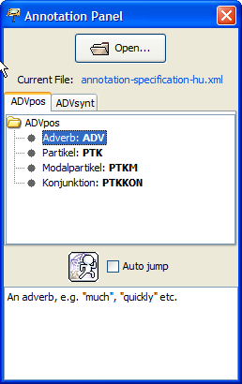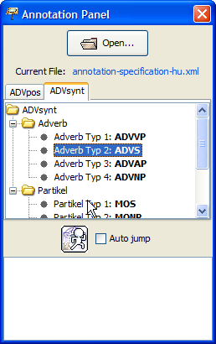

Each annotation set is represented in a separate tab. The annotation panel will react on the current selection in the partitur and bring to the front the annotation set that corresponds to the currently selected tier.

Inside each tab, categories are organised into a tree. Tags associated with a category are printed in bold. If you double click on a category with an associated tag, the tag will be inserted at the current cursor position in the partitur. If **Auto jump** is selected, the partitur will then jump to the next event in the currently selected tier.

Since version 1.5 of the Partitur-Editor, tags can be optionally associated with keyboard shortcuts. Keyboard shortcuts are specified in an attribute *keyboard-shortcut* of the *tag* element. The value of the attribute takes the form

**modifier(s) + key**

as described in the JAVA documentation at:

<http://download-llnw.oracle.com/javase/6/docs/api/javax/swing/KeyStroke.html#getKeyStroke(java.lang.String)>

Here are some examples:

A the key ‘A’

alt B the key ‘B’ with the ALT key pressed

alt shift X the key ‘X’ with the ALT key and the SHIFT key pressed

ctrl 4 the key ‘4’ with the CTRL key pressed

Note that these keyboard shortcuts will only work while the annotation panel has the focus (otherwise they would interfere with keyboard shortcuts of the Partitur-Editor). They therefore make most sense when the **Auto jump** option is activated because this will ensure that the annotation panel keeps the focus after insertion of a tag.