|  |  |  |
| --- | --- | --- |
|  |  |  |
|  |  |  |
|  |  |  |
| **How to get started with EXMARaLDA tools on the basis of the Demo Corpus** | | |
|  | | |

This document explains how to install the EXMARaLDA tools and how to use the EXMARaLDA demo corpus to get a first impression of the EXMARaLDA system. More documents and literature can be found in the section “Help & Documentation” on the EXMARaLDA homepage (<http://www.exmaralda.org/en_hilfe.html>).

Contents

A. Installation of the tools 2

1. Download 2

2. Java Runtime installation 2

3. Installation 2

B. Demo corpus 3

C. Partitur Editor 4

D. Corpus Manager 5

E. EXAKT 6

[System version 1.5.1.]

**A. Installation of the tools**

1. **Download**

You can download the EXMARaLDA tools from [www.exmaralda.org/en_downloads.html](http://www.exmaralda.org/en_downloads.html). The versions you find there are the most recent releases. Previews of upcoming versions can be found at [www.exmaralda.org/previews2.html](http://www.exmaralda.org/previews2.html).

Which and how many files you download depends on your operating system:

* Windows: one installation file which contains all EXMARaLDA tools
* Macintosh: three icons each of which contains one EXMARaLDA tool
* Linux: one gnuzipped tarball containing all EXMARaLDA tools

1. **Java Runtime installation**

In order for the tools to work, your computer needs a Java Runtime Environment (JRE). On Macintosh, a JRE is preinstalled. On Windows or Linux, you can find out whether a JRE is installed by typing "java -version" in a terminal window.

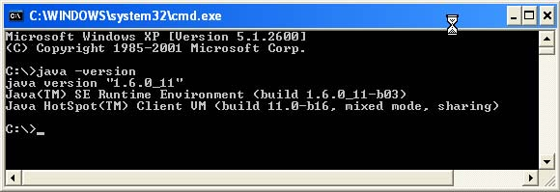

If no JRE is installed, you can freely download the newest JRE from **Sun/Oracle** at <http://java.com/en/download/manual.jsp>. Please note that some Linux distributions come with a preinstalled JRE which is *not* **Sun/Oracle**'s JRE. EXMARaLDA does not work well with these preinstalled JREs. Replace them with the most recent **Sun/Oracle** JRE.



1. **Installation**

Once you've downloaded the files appropriate for your system, installation should be straightforward:

* Windows: double click "setup.exe" and follow the instructions
* Macintosh: mount the disk images and drag the included application file to some appropriate place on your system
* Linux: unzip the tarball to some appropriate place on your system

# B. Demo corpus

A good way to get a first impression of the EXMARaLDA system is to have a look at the EXMARaLDA demo corpus at http://www.exmaralda.org/corpora/en_demokorpus.html.

2

1

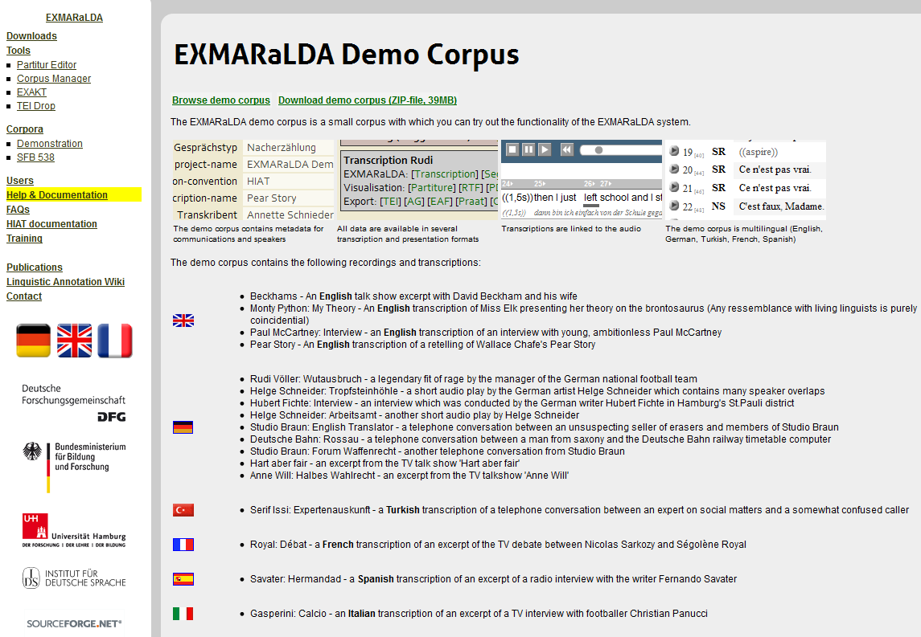

You can start by browsing the online version of the corpus (1) – there are transcription examples in several languages (see also "How to use an EXMARaLDA corpus"). You can then also download a ZIP archive of the demo corpus (2). In the following three sections, it will be assumed that you downloaded the demo corpus and unpacked it onto your system. The unpacked folder structure (3) should look something like this:

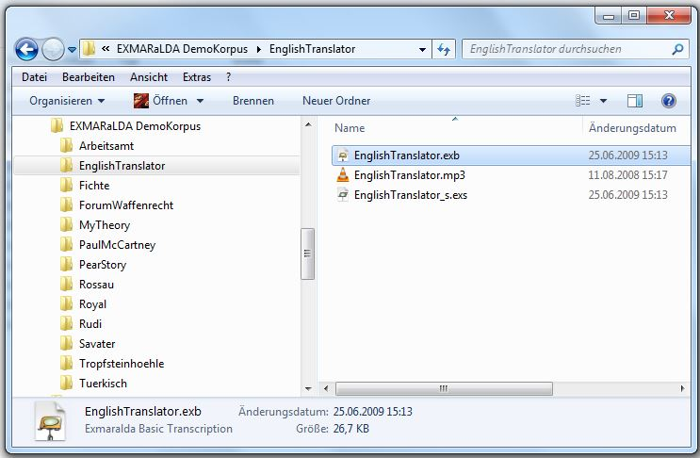

3

C. Partitur Editor

To get a first impression of the Partitur-Editor, start it

* on Windows by selecting the appropriate entry in the start menu or by double clicking the symbol on your desktop.
* on Macintosh by double clicking the application symbol
* on Linux by double clicking "partitureditor.sh" or by calling this shell script from a terminal window (you may have to make the file executable before the first start)

and open a basic transcription file from the demo corpus via File > Open (1). Basic transcriptions can be found in all directories on the first level (i.e. 'Arbeitsamt', EnglishTranslator' etc.). They have the ending ".exb". For example, you could open "Beckhams/Beckhams.exb" in the Partitur-Editor:

1

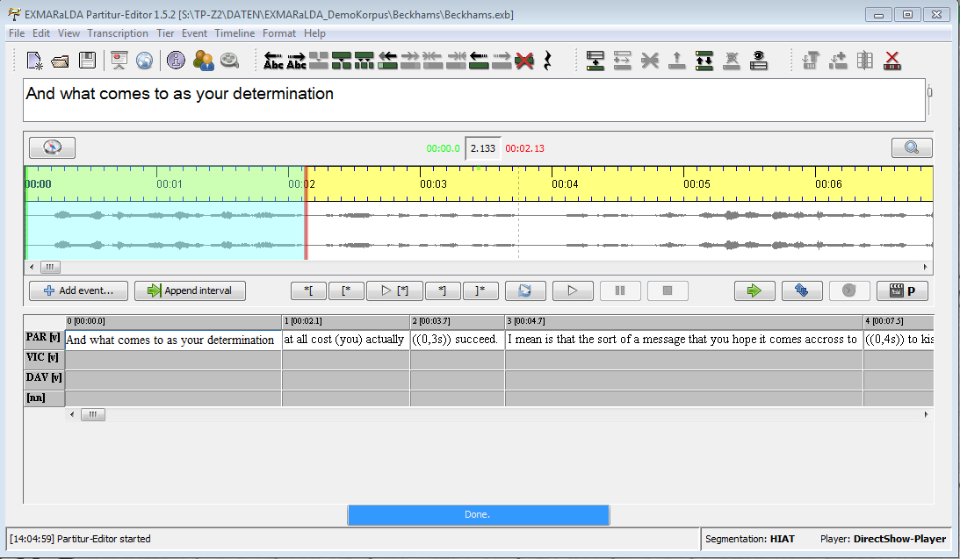

To continue from here, have a look at following documents and videos:

* Partitur-Editor video tutorial
* Quickstart documents for the Partitur-Editor
* Partitur-Editor Manual

**D. Corpus Manager**

To get a first impression of the Corpus Manager, start it (see above) and open the corpus file of the demo corpus via File > Open Document(1). The corpus file is in the top level directory and has the name "EXMARaLDA_DemoKorpus.coma”. After opening it, switch to the Data tab (2) and browse through the lists on the left and right to see meta-data about communications (3) and speakers (4).

4

3

1

2

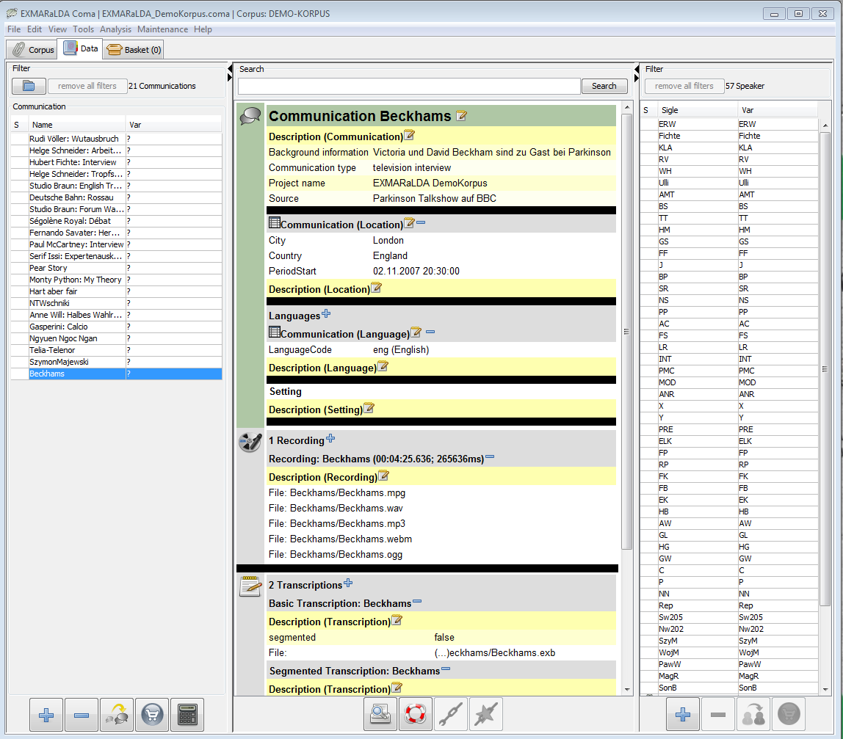

To continue from here, have a look at following documents:

* Corpus Manager Manual
* Quickstart documents for Corpus Manager

**E. EXAKT**

To get a first impression of the query tool EXAKT, run it and open the corpus file of the demo corpus via File > Open Corpus:

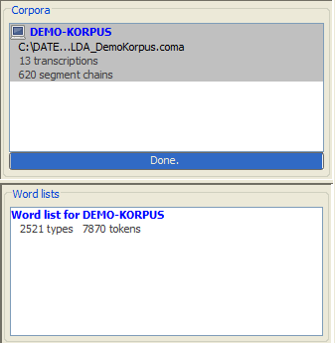

The corpus file is in the top level directory and has the name "EXMARaLDA_DemoKorpus.coma". Opening the corpus may take several seconds because EXAKT first creates an index, then a wordlist. The opened corpus (1) and the wordlist (2) will be displayed in the section titled "Corpora" (3).

3

1

2

A new concordance will be opened. Make a test query for the word 'the' by entering the regular expression[1]**\bthe\b** (1) in the text field beside the Search (2) button and hit enter to carry out the query:

2

1

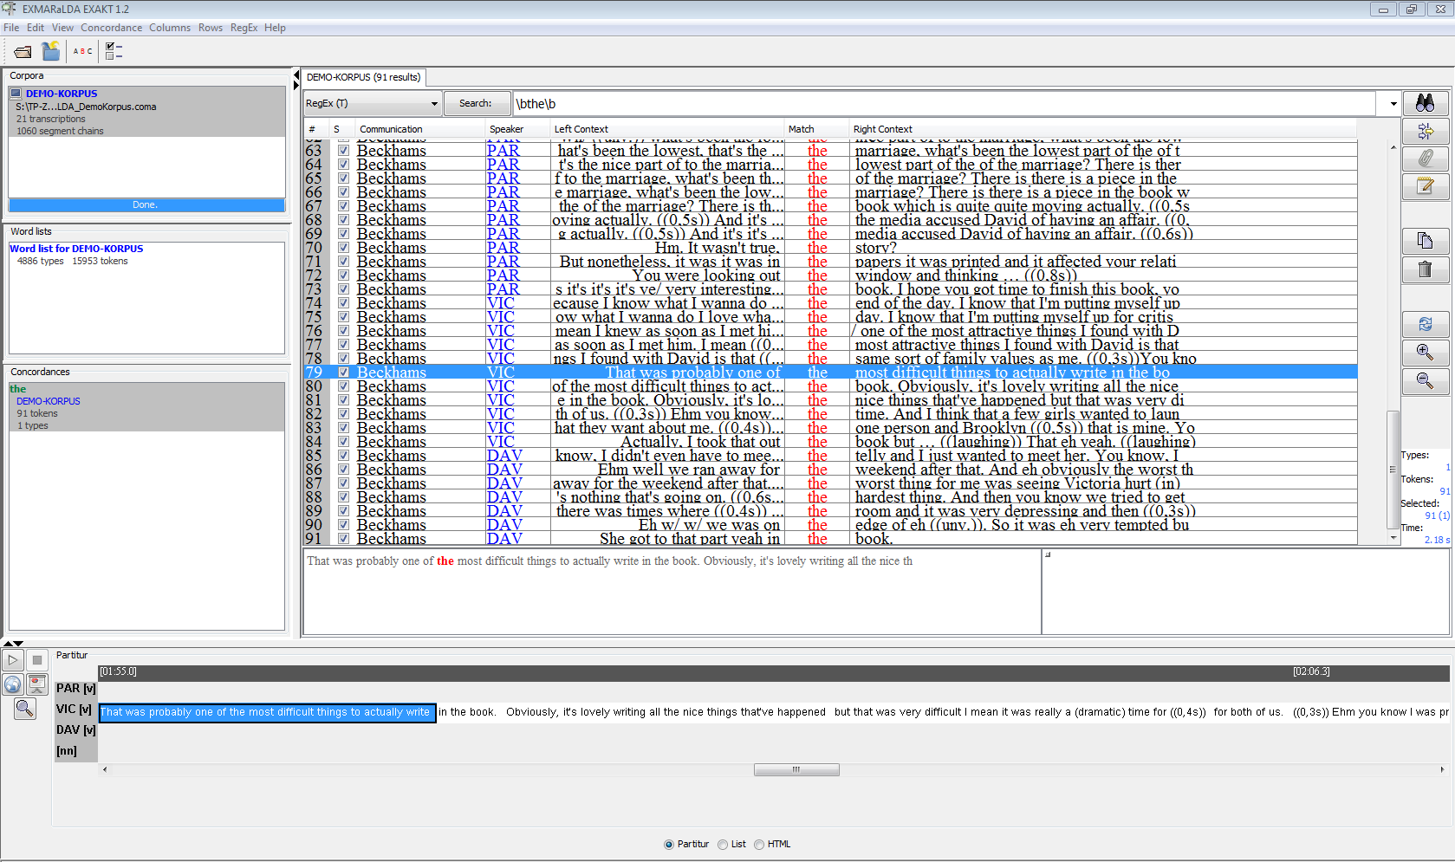

To continue from here, have a look at following documents:

* EXAKT manual
* Document “Quickstart Regular Expressions”

1. The characters “\b” indicate a word boundary. Searching using the word “the” would also yield results such as “them” or “bother”.