### Clarin > WebLicht…

In order to work with the WebLicht function, you need a WebLicht account. If you do not have an account – but you are a member of a University – you can create one [now](http://weblicht.sfs.uni-tuebingen.de/weblichtwiki/index.php/FAQ" \l "How_do_I_log_in_to_WebLicht.3F).

Step 1: start WebLicht and choose the Advanced Mode.

Step 2: upload a TCF file. This file format can, inter alia, be created in the Partitur Editor by saving your transcription via **File > Export** as *TCF file*.

Step 3: define your desired Processing Chain. This chain executes a set of tools which, at this point, include exclusively tools to annotate:

* 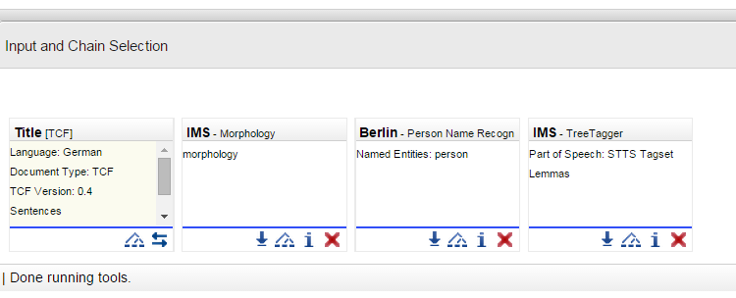Lemmas
* POS
* Named Entitites
* and Morphology

Step 4: download and save your Processing Chain. A more specific manual explaining Processing Chains can be found [here](http://weblicht.sfs.uni-tuebingen.de/weblichtwiki/index.php/Getting_Started" \l "Processing_Chains).

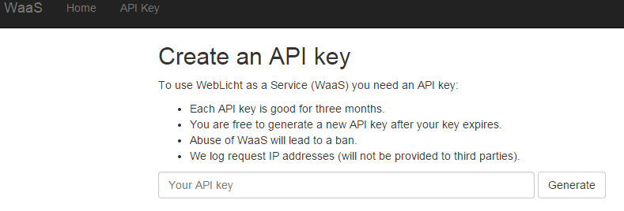Step 5: Go to the website WaaS (Weblicht as a Service) and generate an API Key. This key helps WebLicht to identify who you are and can be compared with a password. To receive this key, please open the tab “API Key” and click on the button “Generate”. Please copy and save this key.

Step 6: Open your transcription in the Partitur Editor (a HIAT segmentation must be possible) and launch **CLARIN > WebLicht…** .

Step 7: enter the following parameters into the pop –up window 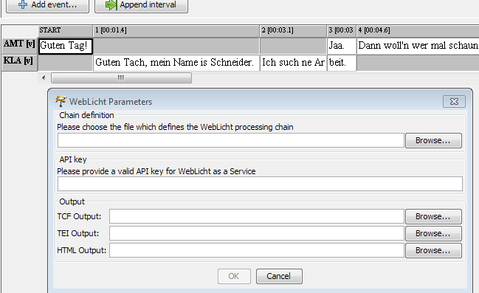

Chain definition: Click on Browse… to choose the Processing Chain you defined in Step 3

API key: Click on Browse … to enter the API Key you created in Step 5

Output: Choose the output format you want to save your file as (one of the three specified), and click Browse… to define its location.

Example: HTML Output

