## Quickstart – Maintenance Functions

Coma offers a variety of options not only for metadata maintenance, but also some options for transcriptions’ check-up:

A. Segment transcriptions

In general, any changes made to transcriptions should wexecuted on the basic transcription level (file extension .exb) in the Partitur-Edtor.

However, the segmented transcription format (.exs) is needed in order to integrate the transcriptions into a corpus in Coma (.coma file) and as base for EXAKT searches[1]. Whenever you correct errors and save changes to your .exb file(s), you should update your segmented transcription(s) in the Partitur-Editor (via Transcription > Export segmented transcription...). You could also correct errors in your .exb files first and then use the following Coma function:

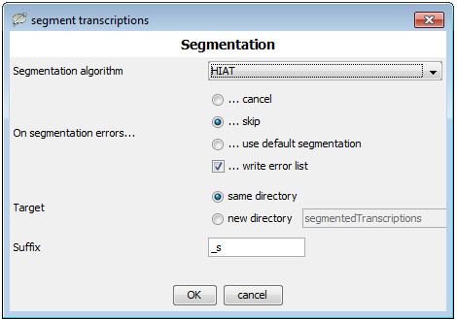1. Select segment transcriptions from the Maintenance menu in Coma and set your preferences (i.e. segmentation algorithm, target directory, suffix[2] etc.).

2. Click OK to confirm – .exs files for all basic transcriptions in your corpus will be created automatically.

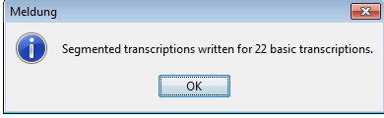3. Consequently, the following dialog will be displayed, click OK to confirm:

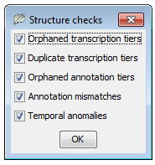B. Structure errors

1. Select Maintenance > Check for structure errors.... to screen the whole corpus. For more information structure errors and how to deal with them, consult “Quickstart “Correcting structure and segmentation errors” (Partitur-Editor).

2. Shall any errors be found, the following dialog will pop up:

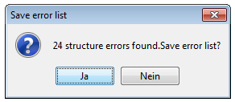

You can now save the error list as an .xml file which can be opened in any browser and text editor. Furthermore you could directly upload and correct the error list in the Partitur-Editor

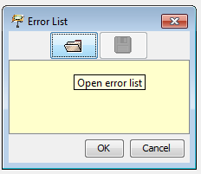

3. Now, you can switch to the Partitur-Editor and open the list you saved to your computer via File > Error list.... Click on the file symbol and OK, for the list to be loaded.

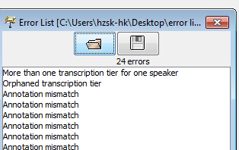

4. If you double-click any of the errors displayed, the transcription will be opened at the exact position of the error. Correct the error and save the changes.

5. Do not forget to update your segmented transcriptions (for reasons described in section A)

### C. Segmentation errors

1. Choose Maintenance > Check for segmentation errors...

The dialoguewill specify the segmentation algorithm, i.e. HIAT and click OK to display a list of segmentation errors.

2. You can now save the error list to a file:

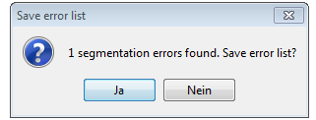

To correct the errors, simply repeat the procedure described in steps 2-5 of section B “Structure errors”.

### D. Speaker assignment

1. Choose Maintenance > Check speaker assignment... to look for “undefined speakers” (i.e. speakers with no tiers assigned to them). A new dialog listing the results will be opened.

2. You can now Save error list... to a file, which then can be opened in the Partitur Editor to correct the errors cf. Section B, steps 2-5).

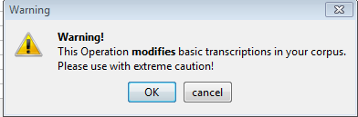E. Search and Replace

1. Choose Maintenance > Search and Replace in the Corpus... the following warning will be displayed:

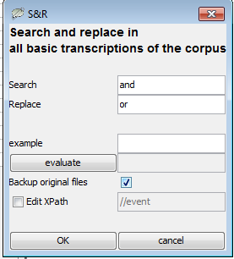2. Click OK to proceed.

3. The following dialog will pop up. Now you can search for & replace items in all basic transcriptions of the corpus. Note that you can also check the box “Backup original files” in case you want to save your original files. Confirm with OK.

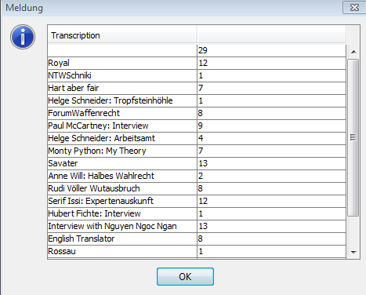

4. Finally, you will be shown a summary displaying all changes made. If needed, you can select and copy the results and paste them into your text editor or word processor.

F. Update segment counts

1. Choose Maintenance > Update segment counts.... and Coma will perform an automatic segment count based on all (segmented) transcriptions already linked to the corpus. The numbers of segments will be then included as secured metadata into the transcriptions’ descriptions.

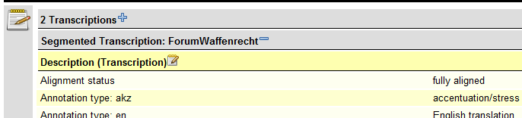2. Although the interface did not change, if you select the option read-only-metadata from the View menu, the numbers of segments will be displayed.

Compared to the default view on the right, the option set to “activate the view of segment counts” will look somewhat like this:

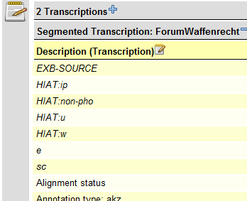

This option might be useful if transcriptions (and number of segments) have been changed.

G. Update recordings from transcriptions

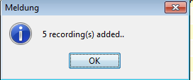1. Choose Maintenance > Update recordings from transcriptions in order to check the transcription headings in the corpus for linked media files and to add them as recordings to the .coma file (already existing recordings will not be not changed or removed).

In general, you might find this function particularly useful if you added new media files to already linked transcriptions (i.e. audio/video files in different formats).

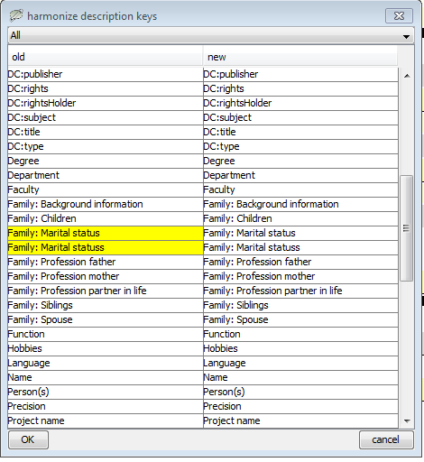H. Harmonize description keys

1. Choose Maintenance > Harmonize description keys... to check and/or standardize the description keys, as oversights happen quite often while typing. Example of the output:

2. Description keys that are highly similar (and thus an indication for a possible error) are marked in yellow. You can edit them in the right column

3. Click OK to confirm and the key will be replaced for the whole corpus.

1. For more information on this topic consult also “Quickstart segmentation”.
2. Note that it is useful to use file suffixes as for instance _s to differentiate between basic and segmented transcriptions at first glance. The ‘s’ stands for ‘segmented’ and it will it is used as default.