**Working with Coma**[1]



A. Coma metadata types

1. **Communication**: any information regarding the communicative situation (like place, time, circumstances, languages spoken etc.); communications typically feature *speakers* and there can be *recordings* and *transcriptions* of the conversation (in the coma data-model recordings, transcriptions and speakers are linked to communications)



1. **Speaker**: any important information about a speaker (like date and place of birth, language learning history etc.); since speakers can be linked to multiple communications, data that is only relevant for one communication should not be saved with the speaker, but with the communication



1. **Description**: data encoded through free key-value pairs (create a unified vocabulary of description-keys for corpus metadata within the project in advance); *descriptions* exist in all Coma-datatypes (e.g. for corpora, communications, recordings etc.)



1. **Location**: locations represent a location/ stage of life at a certain time



1. **Recording**: recordings are always connected to a communication and cannot exist on their own



1. **Transcription**: transcriptions establish the link to actual EXMARaLDA-transcription-files and must also be linked to a communication, as they cannot be managed without them
2. **Attached files** (like questionnaires etc.)



B. Saving and renaming Coma files

1. Saving a Coma file:

File > Save document as... -> type in the data name and click *save*

1. Open and rename existing corpus:

File > Open document -> select a coma file and click *open*; corpus name can be changed in the register *Corpus* via click on the button *change* on the right side (next to the corpus name)



C. Adding speaker and speaker information

1. The list of speakers is shown in the right column of the register *Data*. In order to add speakers click on any speaker in the list, then on the button (*Add new person*).



*Or*: Select a speaker from the speakers list and click on (*clone person*); you can make changes via the notepad symbol. (Advantage: if templates are given (s. F) only the values need to be adjusted)

1. Via the notepad button next to *Speaker* in the middle part, sigle, pseudo and sex can be changed or defined.

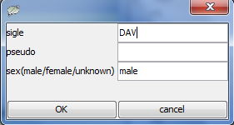

1. Add **speaker information** by clicking on the notepad button next to *Description (Speaker)*. Here you can add or change keys and values. To save your changes click *OK*.

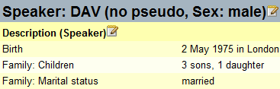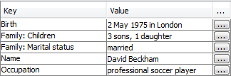

1. Adding and changing **languages**: Click on plus button and choose language from the list next to *name*. Choosing a certain language, generates the ISO 639-9 Code by default. For the *type* use *L1*, *L2* etc. Repeat to add further languages.
2. Adding **locations**: Click on plus button and choose a location template (see F.) or type it in manually, then add place and time. Save changes via click on *OK*. Repeat to add further locations.

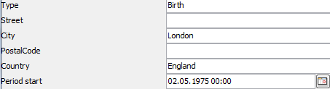

D. Adding communications

1. A list of communications is shown in the left column in the register *Data*. In order to add communications click on any communication in the list, then on the button

(*add communication*) or



(*clone communication*). For changes use the notepad button in the middle part next to *Description (Communication)*.



1. Add or change the name of a communication using the notepad button next to *Communication* in the middle part.



1. In order to add or change descriptions, locations, languages and settings of communications use the appropriate notepad and plus buttons (see C. steps 3 to 4).
2. Use plus button next to *Recordings* to add a recording to a communication.

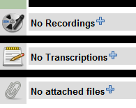

1. Use plus button next to *Transcriptions* to add transcriptions.
2. Use plus button next to the paperclip symbol to attach files to a communication.

E. Assigning speaker and communication

1. Select communication from the list on the left.
2. Select speaker from the list on the right.
3. Assign selected communication and speaker by clicking on the chain symbol. A paperclip will appear in front of the communication/ speaker. (Unassign selected communication/ speaker via click on torn chain symbol ).

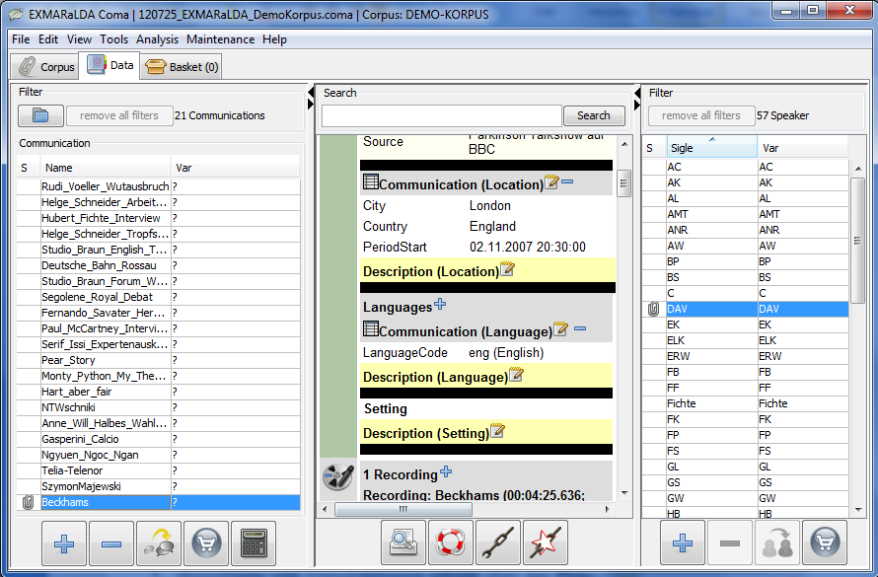

F. Creating templates

For frequently used datasets, templates can be created – for any data type with the standardised template bar at the top of the window.

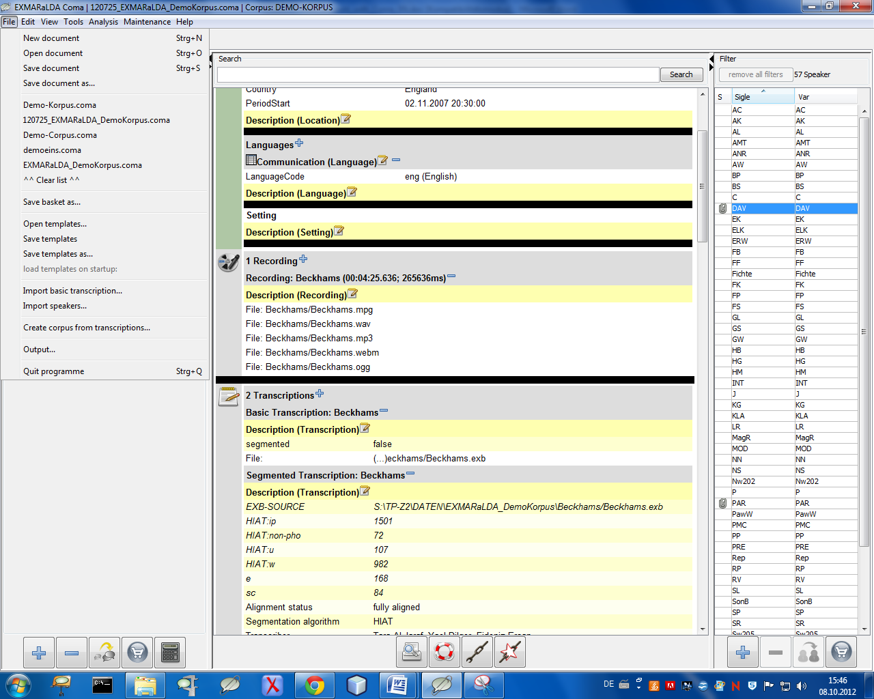

1. The templates created can be saved and (re-)opened via File > Here (or via Edit > preferences) you can also choose a template file to be loaded when starting the Corpus-Manager.
2. Use the plus button to transfer the entered data into a new template. You can name it in the window popping up next. Now, you have a dataset which can be used for the same data types, like e.g. for those in *communications* or *descriptions*. By choosing the template from the drop-down menu, the keys and values will be filled in automatically.



1. Use the minus button to delete a selected template from the drop-down menu.



1. See also *Coma Manual*.