**Working with EXAKT** [1]



A. Functionality of EXAKT

The *EXMARaLDA Analysis and Concordancing* *Tool* is a tool for searching and analysing corpora of spoken language transcriptions as created by the EXMARaLDA Partitur-Editor and the EXMARaLDA Corpus Manager. EXAKT enables you to:

* perform corpus searches on different levels (transcriptions, metadata, annotations...)
* display search results in context (KWIC concordances)
* generate word lists
* filter, categorize, [quantify](http://www.dict.cc/englisch-deutsch/quantify.html) search results (+ metadata) according to various criteria.

B. Opening a corpus and generating a word list

1. Open corpus[2] via File > Open corpus… and choose a *.coma* file.
2. If the corpus has been segmented for words, EXAKT offers you the possibility to generate and use a word list. If you choose Yes, the word list will be created and displayed in the Word lists section of EXAKT (left column).

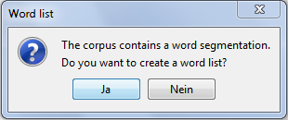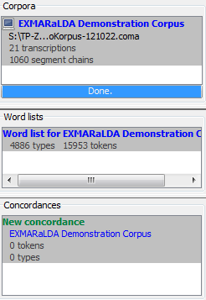

1. Double click on an entry of that list to display it with all the word types occurring in the corpus together with their frequency. The words can be sorted alphabetically or by their frequency.

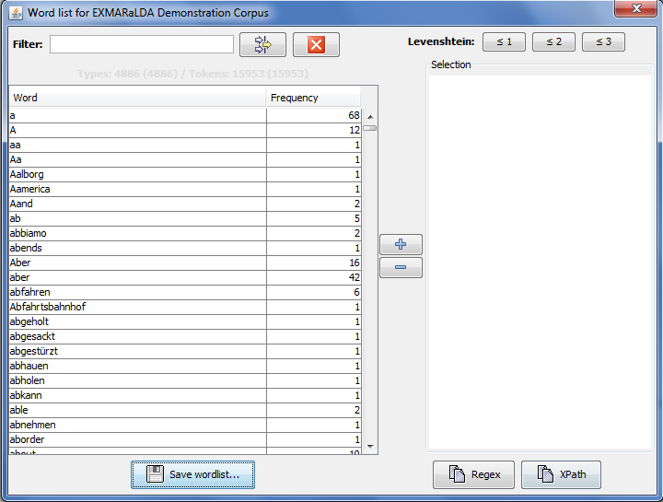

Via Save wordlist… a *.txt or *.html version of the wordlist can be generated. You can filter the list using a regular expres-sion. Double click on any entry in the word list or click on the button with the plus/minus sign to add/remove a word to the selection on the right side of the dialog.

C. KWIC Concordance

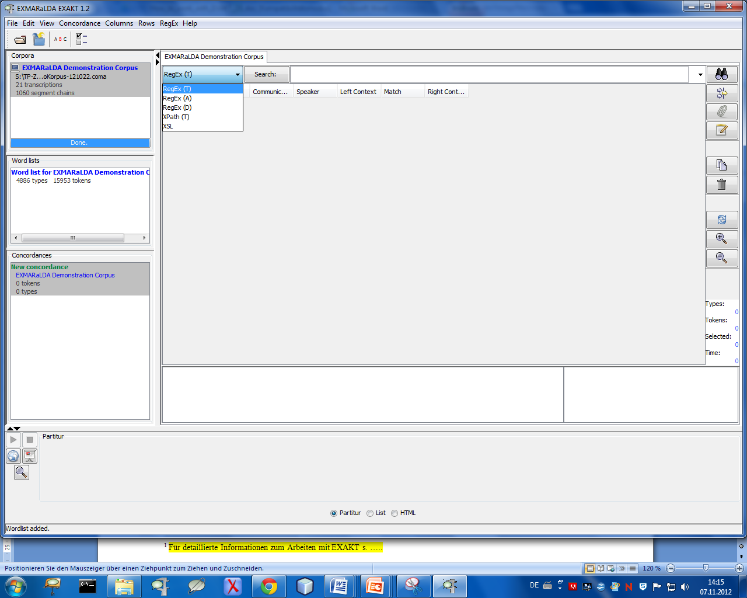

1. Choose a tier from the drop-down menu you want to search in, then enter a word in the field beside the Search button and hit the *Enter* key or click .



1. You will be given a KWIC concordance displaying all the places in the corpus which match your word (e.g. *know*) with left and right context. You can reduce or increase the amount of text in the left and right context columns by clicking on the buttons *show more* or *less context*  , respectively.

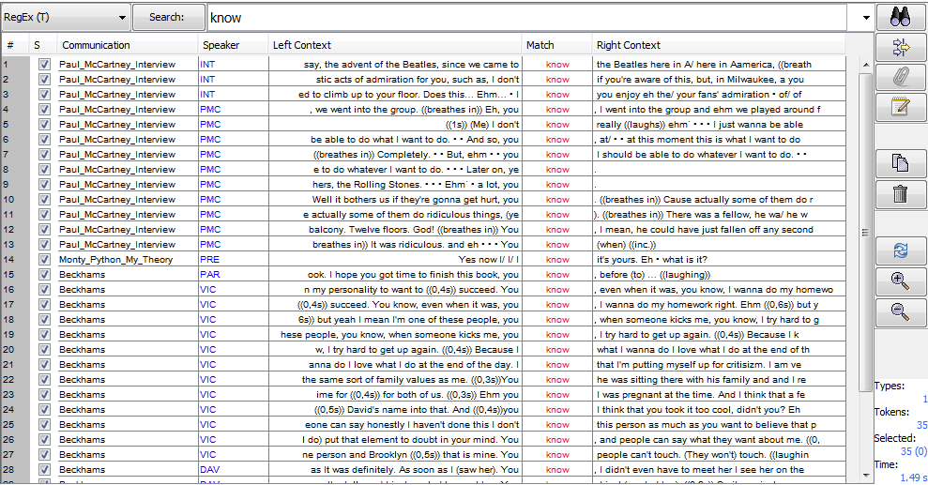

1. If you double click on a search result, the corresponding transcription will be opened in the lower part of the screen (displayed as a musical score, if Partitur option is chosen). You can freely navigate in this transcription and if your transcription is aligned with an audio or video file, you can use the play button to playback the corresponding part of the recording.

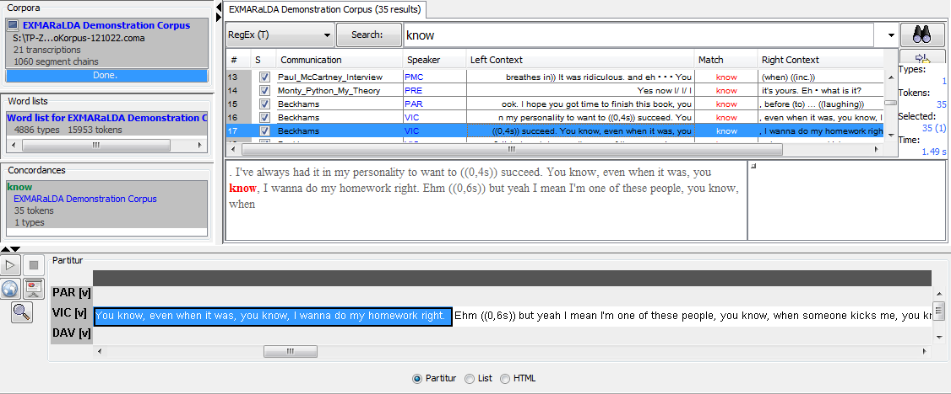

1. You can also search the corpus using *regular expressions*[3]. EXAKT provides help for working with regular expressions in several places:
2. The context menu in the search expression text field lists some commonly used meta-characters. Choose any entry in that context menu to paste the respective character into the search expression text field.
3. If you click on the Search button to the left of the search expression text field, a dialog will come up which helps you to formulate some commonly used types of regular expression
4. Under the menu item RegEx > Regex Library Dialog a dialog with different *regular expression libraries* can be found, one of them, the EXMARaLDA Regex Library, is built into EXAKT. It contains some commonly used search patterns for different languages and different transcription systems.

D. Filtering and categorizing search results

Once you have carried out a search, you can display metadata, i.e. data about speakers, communications or transcriptions in additional columns of your KWIC concordance. These can be searched, sorted and filtered.

1. Displaying metadata for concordances:



1. Click on
2. Choose metadata fields and click



1. Set/change order via



1. Confirm with



1. Filtering concordances:



1. Click on



1. Enter manually *or* click on
2. Click on register Types
3. Choose data and click on >
4. Confirm with



1. Checkbox (on the left) displays filter results
2. Delete unselected entries via click on



1. Adding analysis:
2. In order to classify or categorize your search results, you can add one or several analysis columns to the KWIC Concordance.



1. Click on > enter title and type > in the case of “closed category list” enter categories > click on



1. Analysis columns can be sorted and filtered just like the other columns of the KWIC concordance.

display as html

display as list

display as partitur

output as .html

open partitur in browser

play

show more/ less context

refresh view

remove unselected search results

copy

add analysis

metadata

filter

search

concordance list

word list

corpus list

KWIC concordance

right context

left context

search item

number of matches

checkbox

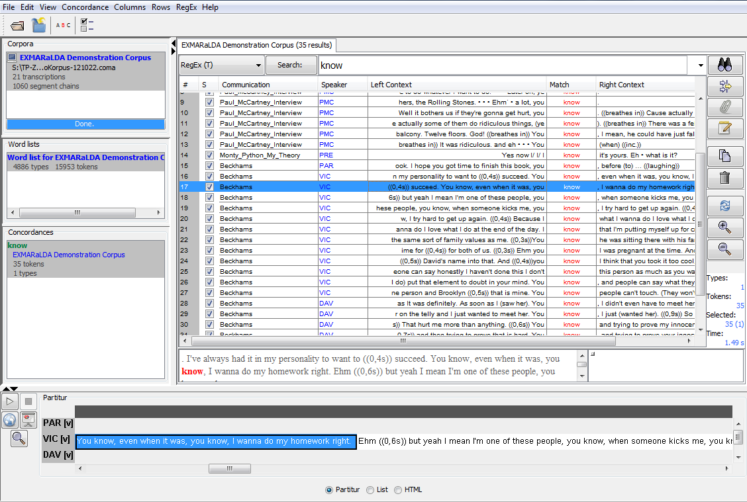

1. For detailed information on working with EXAKT see *EXAKT manual*
2. See also *How_to_create_ a_corpus_from_a_set_of_transcriptions_EN*
3. See also *Regular_Expressions_EN*