**Quickstart – Aligning transcription with recording**

A. Assigning recordings

Assign a WAVrecording (and further recordings if applicable) by adding it via Transcription > Recordings... and click OK. The recording should now be displayed in the waveform view and the first and last event in the timeline are assigned to time points (1, 2).

2

1

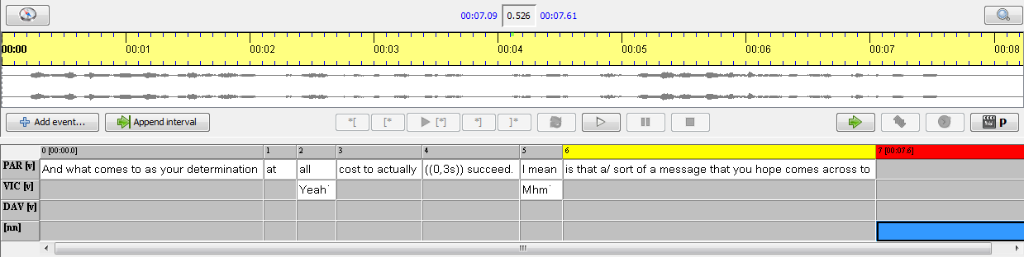

B. Aligning time points/intervals manually

1. Select an interval in the transcription which is not yet aligned with the recording (the blue fragment).

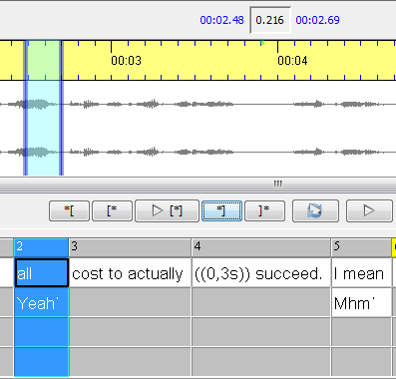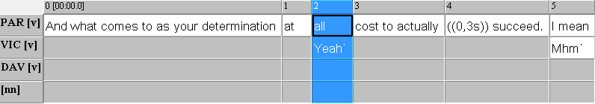

1. Find and select the corresponding part of the recording in the waveform view.
2. Now click on the button Assign times on the right side of the panel between waveform view and transcription to assign the selected part with the transcription.



1. The boundaries in the waveform view are now green and red (instead of blue as in Section 2) since they are attached to an interval.

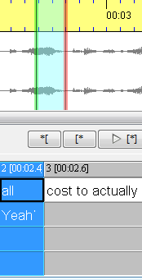

The selected interval from the transcription can now be playbacked and checked with the Play selection button.



1. Repeat steps 1. to 4. a couple of times (approx. every 30 seconds) throughout the whole recording.

C. Interpolating the timeline and correcting time points/intervals

After aligning some time points manually, the remaining time points can be estimated automatically. The timeline is then interpolated, i.e. interspersed with approximate time points:

1. Choose Timeline > Interpolate timeline… In the dialog that opens choose Character Count Interpolation and click **OK**. The interpolated time points are marked with an asterisk and are usually not 100% accurate. Thus, they need to be checked and adjusted where necessary:

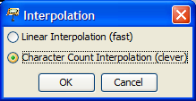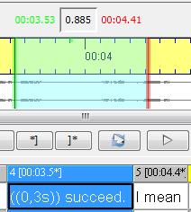

1. Select the next event with an interpolated time point of the transcription. The corresponding part of the waveform view will be automatically selected, too. The boundaries are green and red, since the recording is attached to the transcription.
2. Play selected interval by clicking the Play selection button.



1. Adjust left and right boundaries, if necessary, by dragging the green and red boundaries in the waveform view or moving them by scrolling the mouse wheel. The absolute times in the transcriptions will now also be changed. Note that this will make the asterisk(s) disappear, i.e. the absolute time is henceforth treated as non-interpolated.

**IMPORTANT:**

In order for this procedure to work efficiently, you should start out with an interval in the recording which at least partly corresponds to the selection in the transcription. In other words: the interpolation should be at least approximately correct. If this is not the case, do the following:

1. Remove all interpolated times through Timeline > Remove interpolated times.
2. Correct false time points, which are not interpolated anymore, manually or delete them. This can also be done by selecting the corresponding event and choosing Edit timeline itemvia right-click. Now change or delete the figure.
3. Do a new interpolation with Timeline > Interpolate timeline.