**Quickstart – Annotating**

A. Adding annotation tier(s)



**Tier** > Add tier…**:** Tier is added as last tier of the transcription



**Tier** > Insert tier…**:** Tier is added above the selected tier



**Tier** > **Move tier upwards:** Moves selected tier up



**Tier** > Change tier order…**:** Changes the order of the tieres

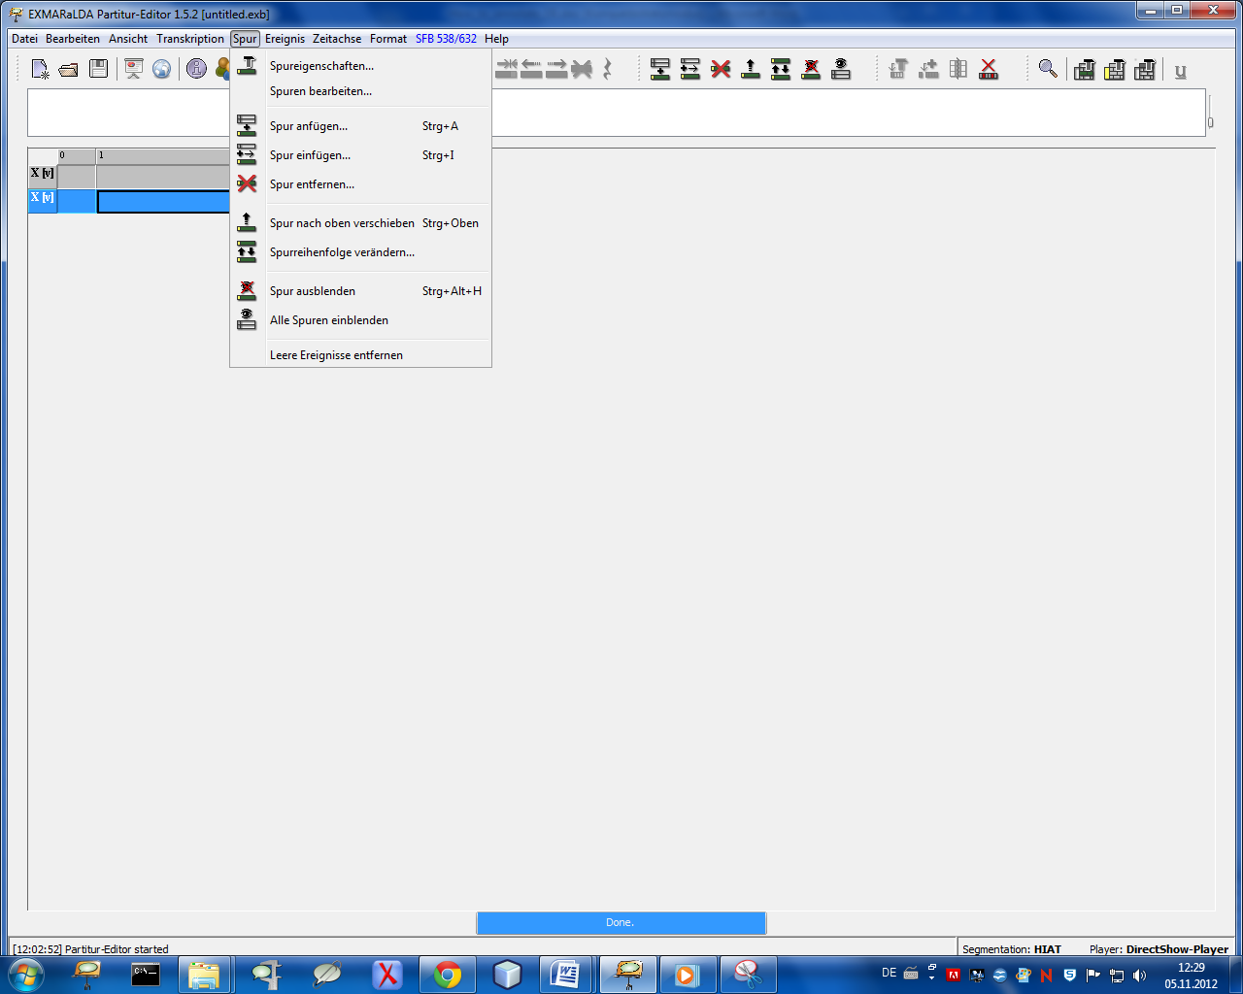

**Tier** > **Tier properties...:** Tier properties can be displayed and set in the dialog box

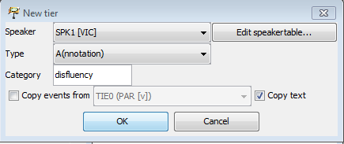

* 1. Speaker: Choose a speaker (from the speaker table), each speaker has his own annotation tier!

1. Type:Specify the type as *A(nnotation)*.
2. Category: Specify the category with a short and content-related description, in this case e.g. *disfluency*.

B. Annotate manually

1. Specify the event for the annotation tier by selecting the appropriate event(s) in the *transcription* tier using the features *Split*, *Double split* or *Merge events[1]*.

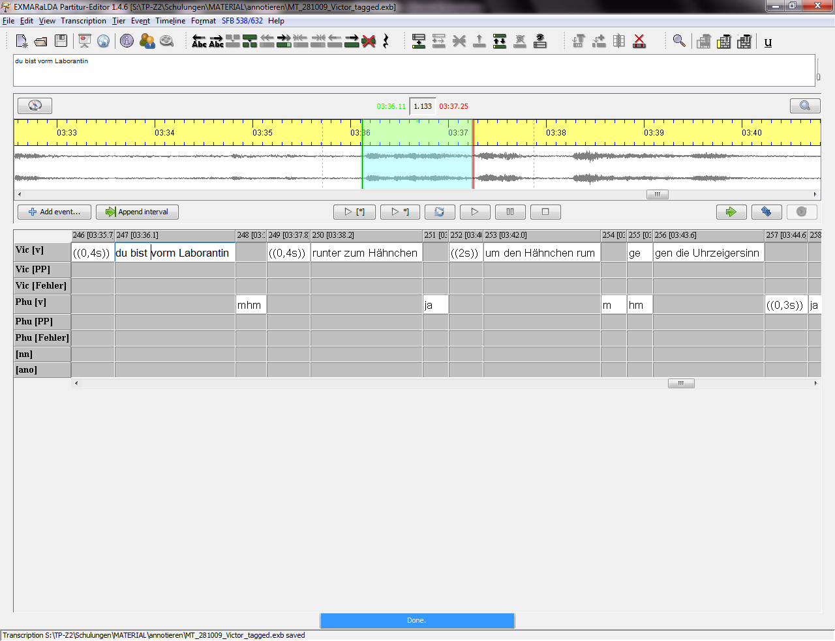

a. By simple splitting an event:

Place the cursor in the right place of the event – here „Ehm“ is to be annotated – and split the event. Event > Split(Strg+2)

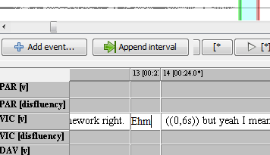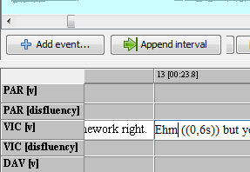

An interpolated (estimated) time point will be created for the new event. The left boundary needs to be adjusted: select the event and shift the green boundary in the oscillogram.

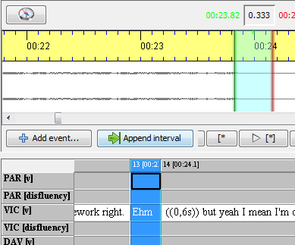

b. Double splitting an event:

Select the transcription text you want to annotate and create a new event via Event > Double split(Strg+3). This time both boundaries – left and right – need to be adjusted!

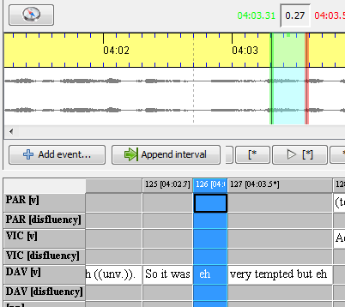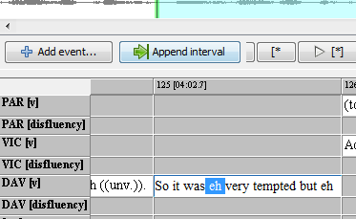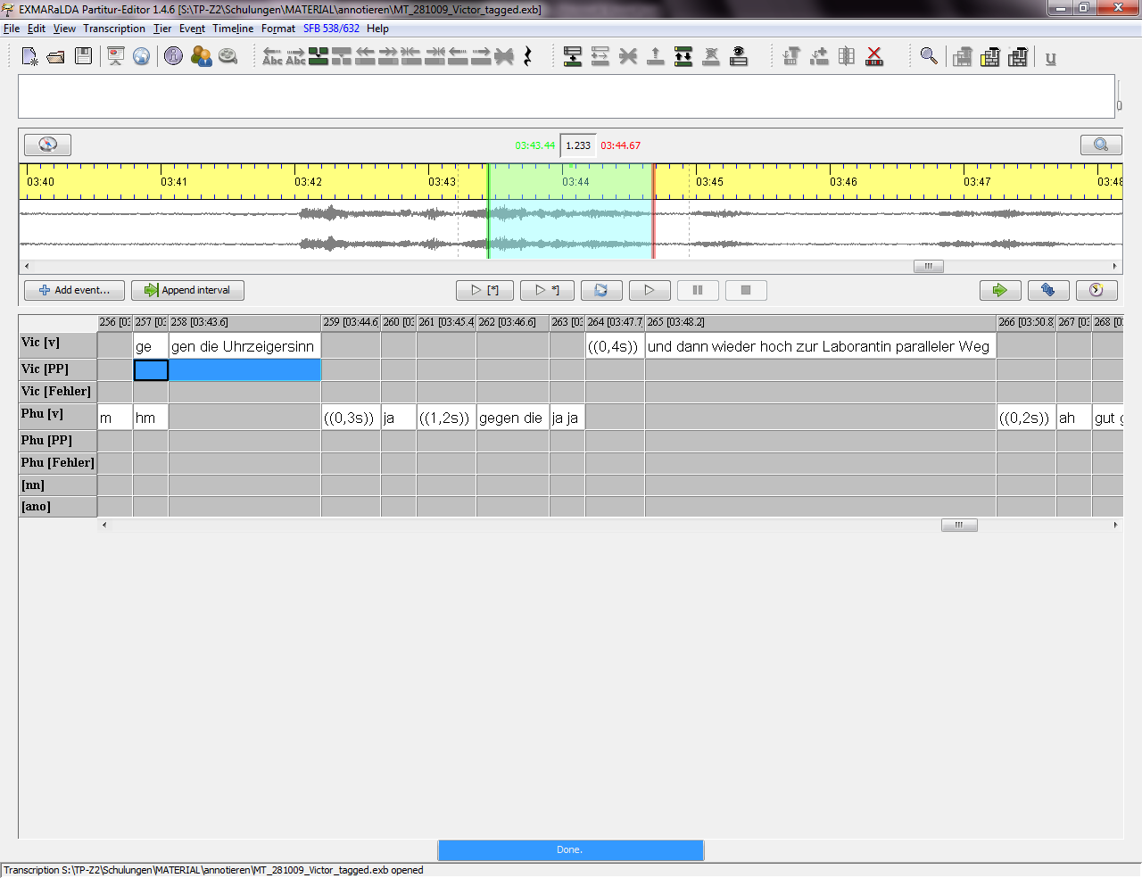

c. By merging events:   
  
Select the events in the annotation tier and merge them via Event > Merge(Strg+1) – but only in the annotation tier!

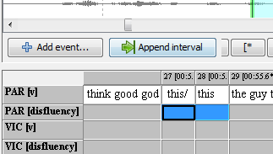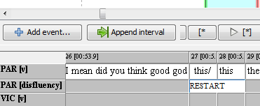

This time, there is no need to adjust the boundaries as we have used already existing time points.

1. Enter the annotation text into the annotation tier[2], here e.g. *RESTART*.

C. Annotating with the Annotation panel

1. A prerequisite for the use of annotation panel is the so-called “Annotation Specification” (*tag set*). It is a XML file which specifies annotation schemes:

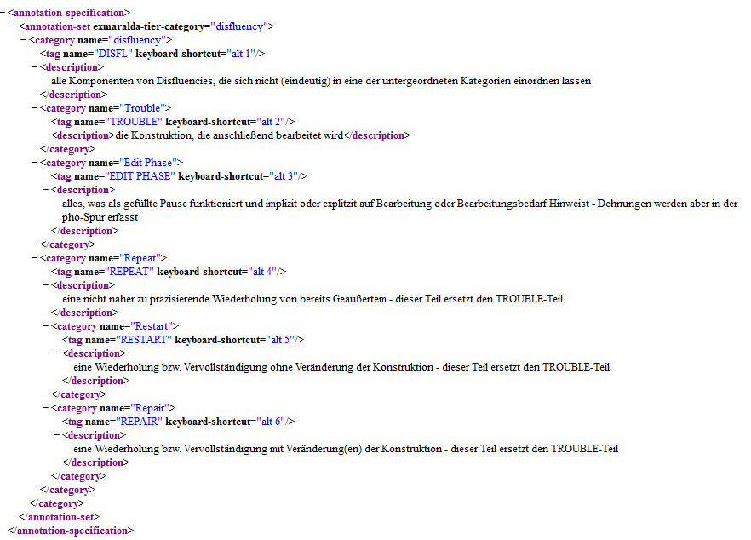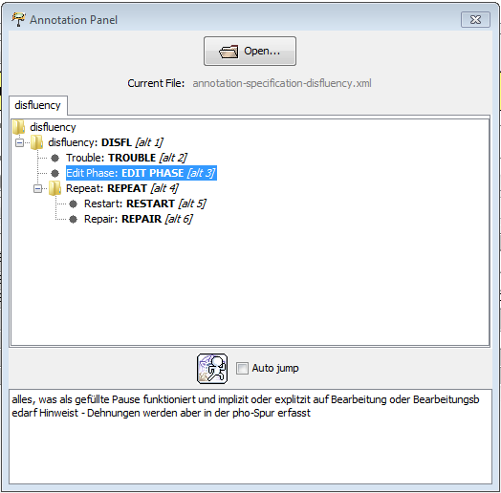

1. You can access the annotation panel in the Partitur Editor via View > Annotation panel and choose an annotation specification file (*tag set*) via Open….
2. As mentioned in section B, you need to create the events for annotations first. Then place the cursor in the right place and double click on a certain category or tag from the annotation panel to insert the corresponding annotation.

1. For detailed information on these features see “Quickstart splitting, double splitting and merging events”
2. Do *not* use SPACE after entering the annotation text (e.g. RESTART).