## Quickstart – Correcting structure and segmentation errors

You should check for formal errors after your transcription has been completed, and you should carry out the check in the order suggested here:

### A. Structure errors

Structure errors can be checked via the function Transcription > Structure errors.... They concern properties of and relations between tiers or events in tiers, and they are independent of the transcription convention used.

The dialog gives you a list of errors. Double clicking on any list entry will scroll the transcription to the place where the error occurs.

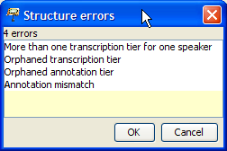

Types of structure errors:

1. *More than one transcription tier for one speaker*

You can have only one tier of type "T(ranscription)" for each speaker.

1. *Orphaned transcription tier*

Tiers of type "T(ranscription)" must be assigned to a speaker.

1. *Orphaned annotation tier*

Tiers of type "A(nnotation)" must be assigned to a speaker and there must be a corresponding tier of type "T(ranscription)" which is assigned to the same speaker.

None of these errors should occur if you use stylesheets to generate your transcriptions.

If any of the above errors occur, use the function Tier > Tier properties... to correct the speaker or type assignment of the respective tier.

1. *Annotation mismatch*

For every event in a tier of type "A(nnotation)", there must be an event or an uninterrupted sequence of events in a corresponding tier of type "T(ranscription)" which has the same start and end points on the timeline. For example, the following is an annotation mismatch because the event "*loud*" is in an annotation tier, but there is no corresponding (sequence of) event(s) in the transcription tier.

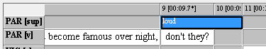

If an annotation mismatch error occurs, use the functions in the Event menu to shrink, move, extend the offending event appropriately.

If you're done with correcting the displayed structure errors, close the dialog and call Transcription > Structure errors... again. Repeat this until the list is empty.

### 

### B. Segmentation errors

Segmentation errors are errors related to a wrong use of transcription symbols. In order for the check to work correctly, you therefore have to make sure that you have the correct transcription system specified under Edit > Preferences... > Segmentation:

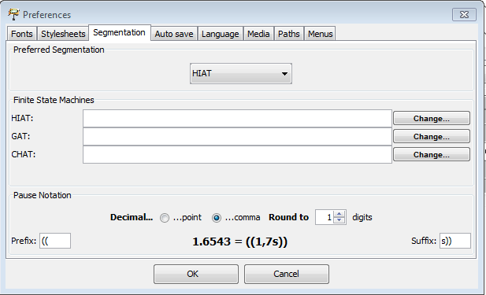

Use Transcription > Segmentation errors... to display a list of segmentation errors:

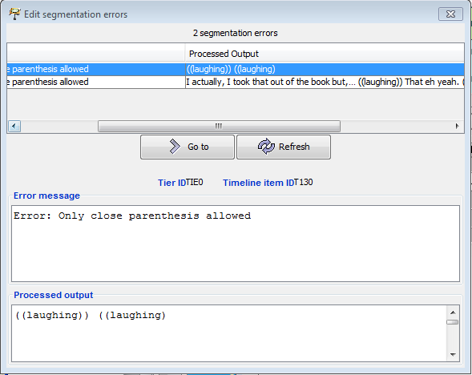

In the above example, the segmentation error is caused by a missing closing parenthesis – i.e. it should be ***((laughing))*** instead of ***((laughing)***. Double click on any entry in the error list to scroll the transcription to the position where the error occurs. Correct it and click "Refresh" in the dialog. Repeat this for all errors until the list is empty.

### 

### C. Word lists

If there are no segmentation errors, you can use Transcription > Word list... to display a list of all words in the transcription. You can sort this list alphabetically to check for the correct spelling and other typing errors. A rather common error is an omitted space at a word boundary at the end of an event resulting in two words being glued to one another.

If you find an error, double click on the word to get to the corresponding position in the transcription. Correct the error, then click "Refresh" in the word list.