**Quickstart – Importing text transcriptions into the Partitur-Editor**

A. Preparing the file for import

There are two ways to import transcriptions of spoken language created with a text editor or a word processor (e.g. Word, OpenOffice etc.) into the Partitur-Editor:

* You can use the plain text (.txt) as input format. The plain text format will be useful if you have not been using any formatting information (e.g. instances of **bold** or *italic* text).
* Respectively, you can also use the “Simple EXMARaLDA” format. It is a format for plain text files. It can also handle transcriptions with some basic annotations, non-verbal behavior and overlapping speech.

C:\Users\hzsk-hk\AppData\Local\Microsoft\Windows\Temporary Internet Files\Content.IE5\XVWGTUWM\MC900349997[1].wmfPlease note: Fully automatic conversion of your transcription format into the Simple EXMARaLDA format is only possible if you have used layout and/or mark-up in a **consistent** way, with all different kinds of information encoded differently and in a way that can be recognized without human interpretation. Revisit your transcription key to see if any ambiguous annotations or mark-up need to be adjusted manually.

The Simple EXMARaLDA format can only handle the transcription itself – if you need to remove some preamble with e.g. metadata about the communication and the speakers, remember to save a copy of the transcription with the respective metadata.

B. Importing the file into the Partitur-Editor

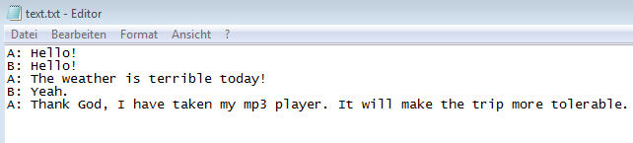Let’s consider the following .txt file:

1. Click on File > Import
2. In case you’ve decided to use the plain text format, choose the Plain text file (*.txt) from the dropdown menu (1). If necessary, change the options for character encoding (dropdown menu Char encoding) from System-Default to your preferred ones (2). However, if you don’t know the character encoding, first try the default. Confirm your selection (3)

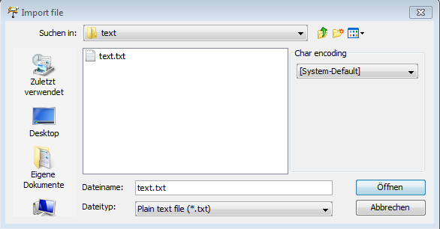

3

2

1

Then, you will be asked to select your preferred text splitter:

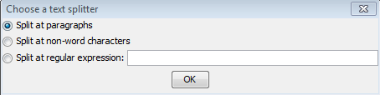

In more detail:

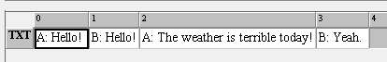Split at paragraphs All carriage returns will automatically generate event boundaries:

Split at non-word characters The text will be divided into word-alike chunks (non-alphabetic characters within words may be problematic), e.g.:

Split at regular expression Event boundaries will be inserted at the exact points, at which the regular expression(s) you’ve typed matches your query. An example for a query “[\.\?]“.

1. In case you will be using the Simple EXMARaLDA format, choose Simple EXMARaLDA text file (*.txt) from the dropdown menu (1). As already pointed out in section 1a. you should pay attention to Char encoding (2). Then click on Open (3):

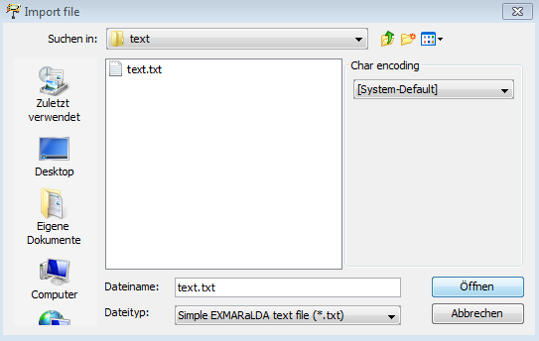

2

3

1

This time, the event boundaries will be inserted depending on the formatting conventions which were applied. In the example below using speaker abbreviations with a following colon (A:) is the simplest way of indicating a dialogue (note that it is still ambiguous whether there are overlaps or not):

A: Hello!

B: Hello!

A: The weather is terrible today!

B: Yeah!

A: Thank God, I have taken my mp3 player. It will make the trip more tolerable.

The same text, if imported to the Partitur-Editor as Simple EXMARaLDA format will look as follows:

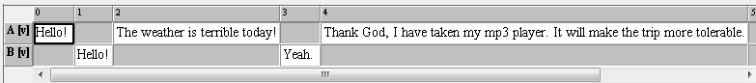

The dialogue structure was converted into EXMARaLDA score.

2. Now you can save your file as EXMARaLDA Basic Transcription (XML, EXB) (1) File > Save as... (2). If you do not wish to save the formats (i.e. if you have edited the transcription), simply deselect Save formats (3):

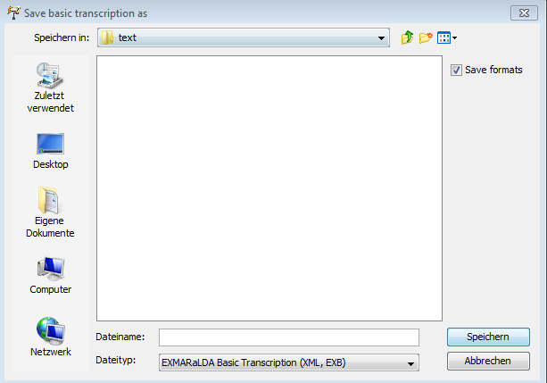

3

2

1