**Quickstart – Output an utterance list (HIAT)**

A. Sort events

So that the utterance list can be output correctly, all events need to be sorted. In this example, it is not possible to decide which of the “second” utterances begins first.

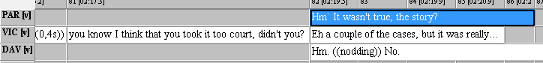

The events may be sorted chronologically by means of the event boundaries which relate to the common timeline:

1. You can view the list of the unsorted utterances via Transcription > Insert utterance numbers. If the following note will pop up – click OK:

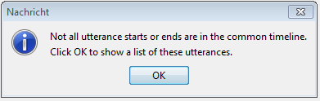

1. 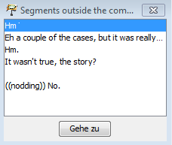By double clicking on the list entry, the cursor will jump to the position of the unsorted utterance. Alternatively you can use the Go to button.
2. Arrange the events in chronological order by adding new event boundaries (splitting events CTRL+2):

B. Output the utterance list (HIAT example)

1. Via Transcription > Transformation… you will reach the dropdown menu Transformation Scenarios. Select HTML Utterance list (HIAT). The default parameters do not need to be changed.

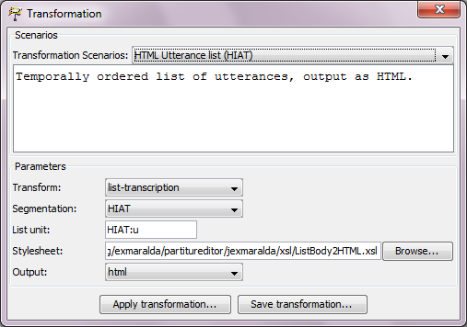

1. Confirm the output via Apply transformation… and save the output file. The HTML file can be opened in any browser, the layout may vary according to the browser you use, i.e.:

