**Quickstart – Splitting, double splitting and merging events**

A. Split event

1. 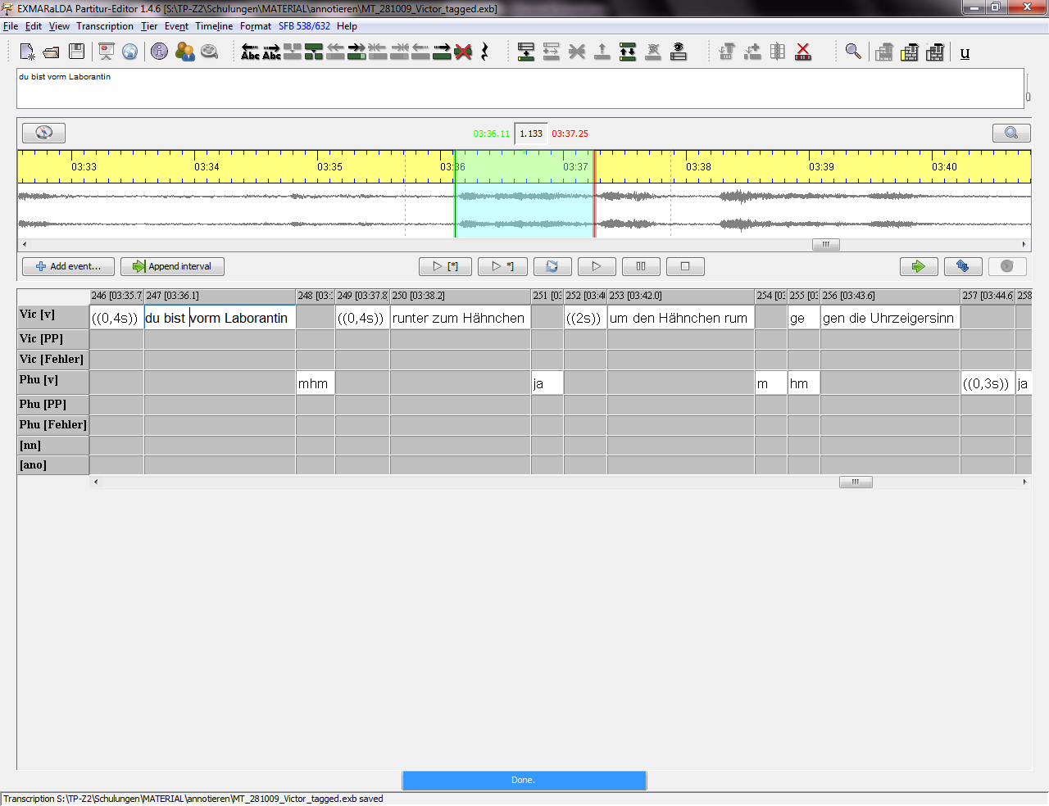Place the cursor at the position in the event where you want to split it.   
   Choose Event > Split (Ctrl+2) or click on the icon:

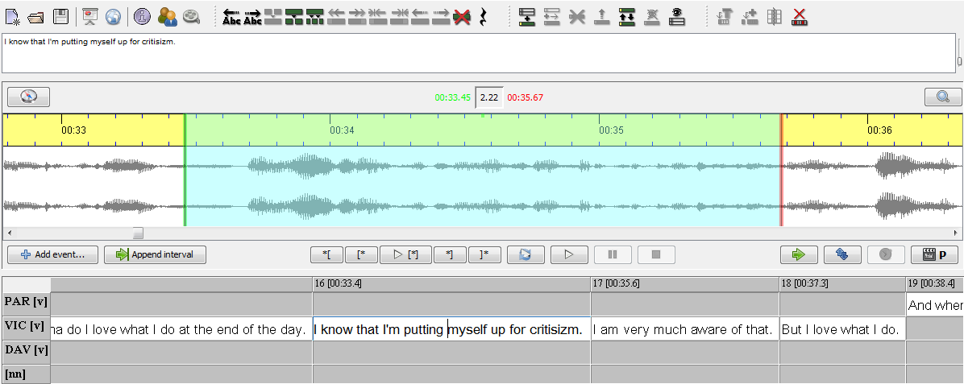



1.



1. A new event is created.
2. Interpolated time point (*) for the new event. (Partitur-Editor estimates the new time point and adds this information automatically)

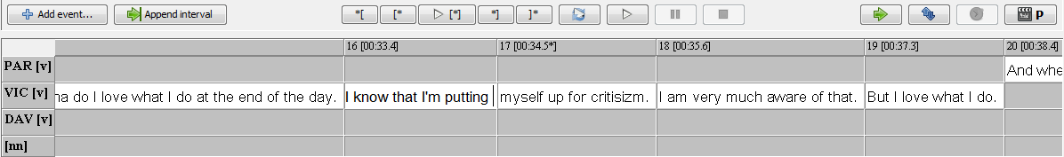

3.

2.

4.

1. 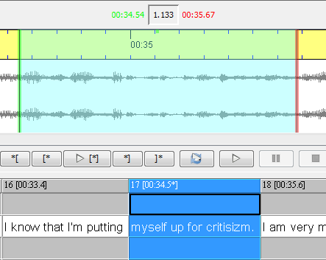The estimated value (boundary of new event) has to be adjusted afterwards.

B. Double split event

1. Mark the passage you want to double split. (Don’t forget to type a space after the last word!)

Choose Event > Double split (Ctrl+3) or click on the icon:

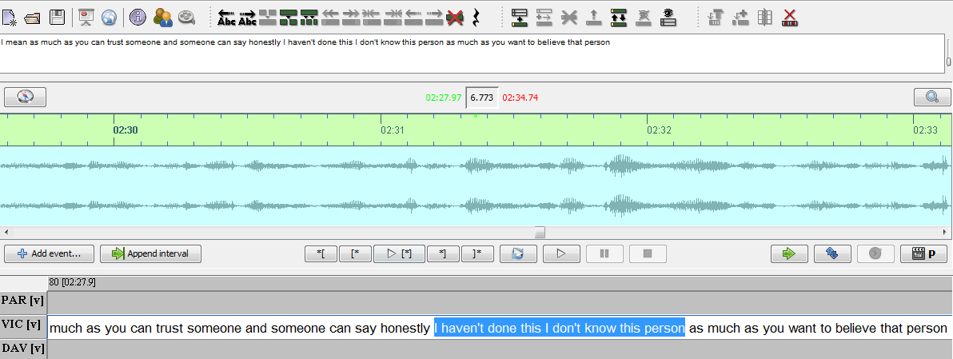

1.

1. A new event is created.

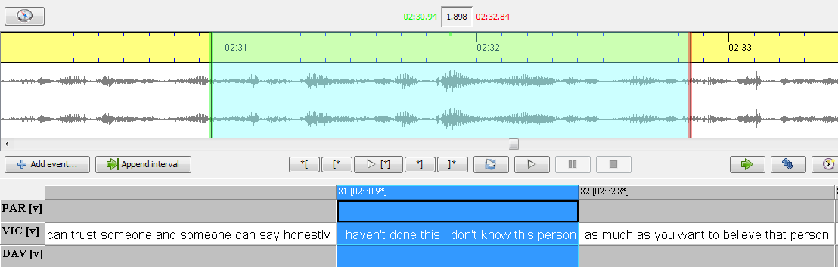

4.

3.

2.

1. Interpolated time point (*) for the new event.
2. Both boundaries have to be adjusted afterwards.

C. Merge event

1. Mark the events you want to merge.

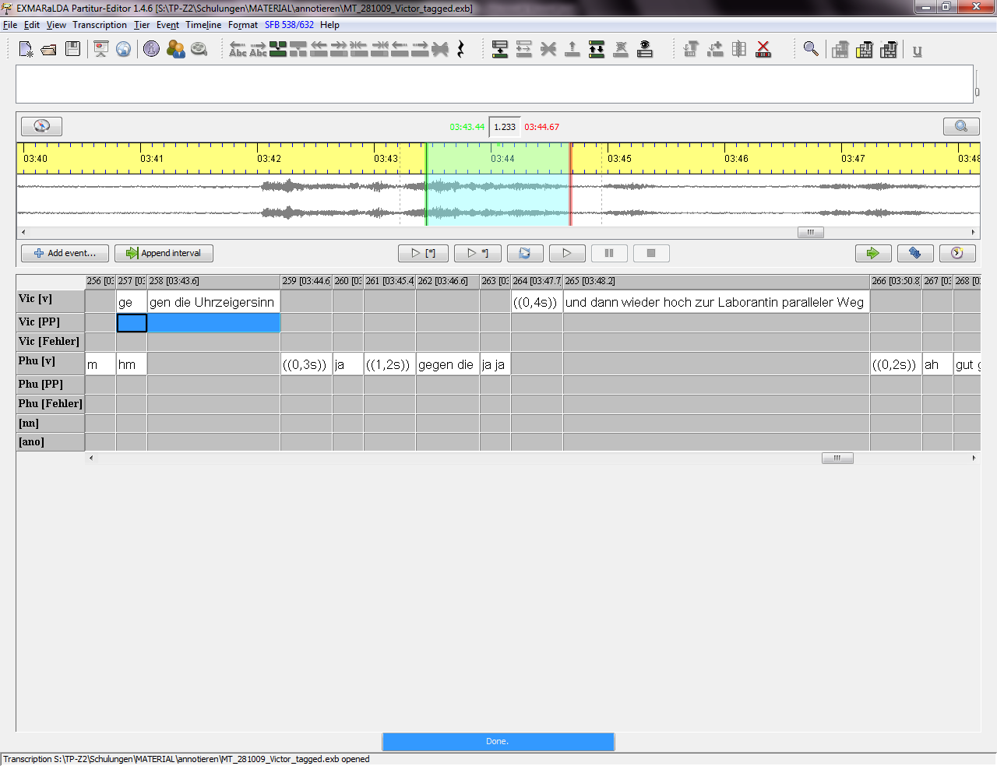Choose Event > Merge (Ctrl+1) or click on the icon:

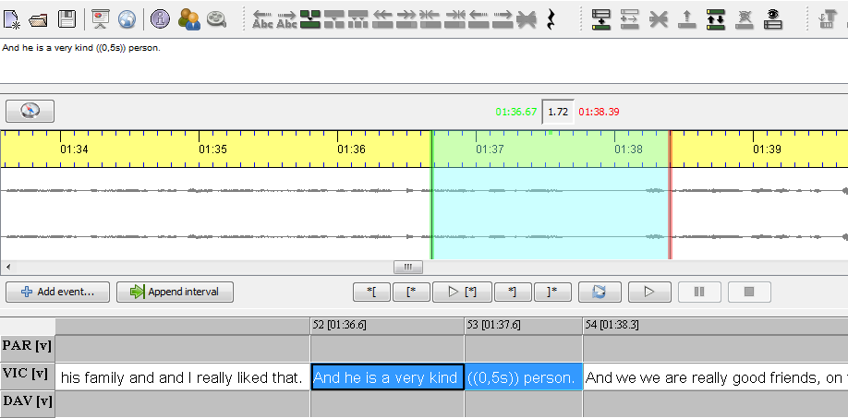

1.

1. A new merged event is created, however the events in the timeline and in the other tiers are still splitted. First, merge the events in each tier accordingly.

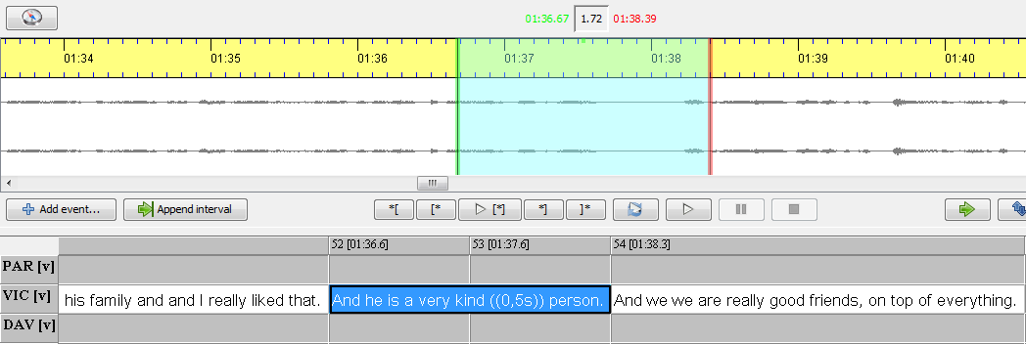

2.

1. Now clean the timeline by removing unused timeline items and gaps.

Choose Transcription > Clean up…

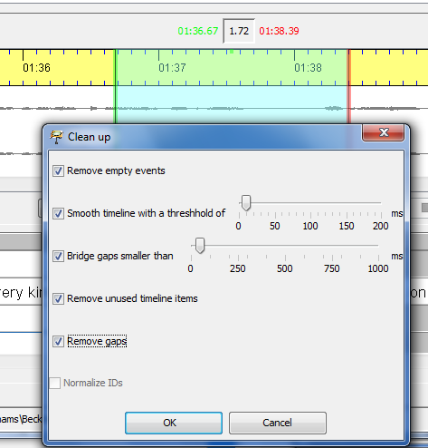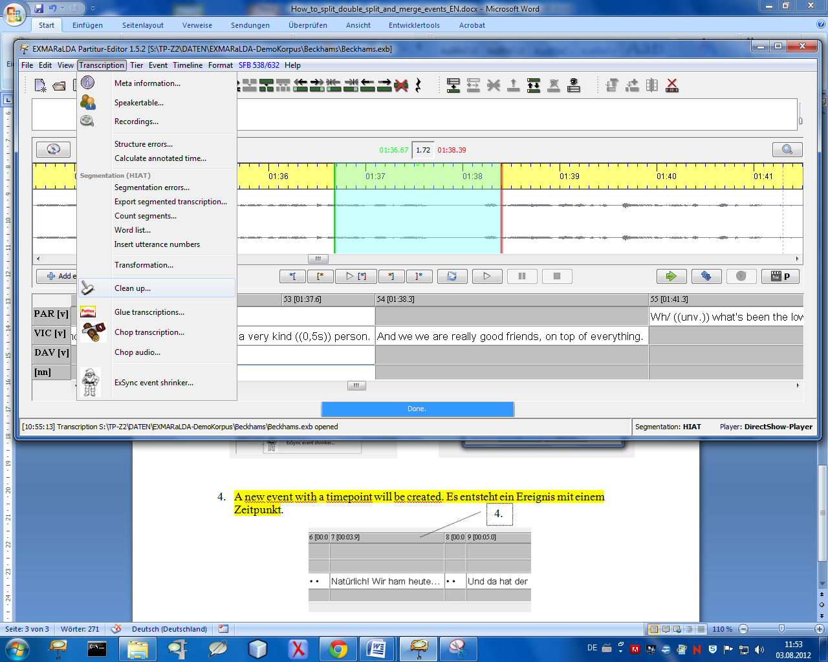

3.

1. A new event with only one time point is created.

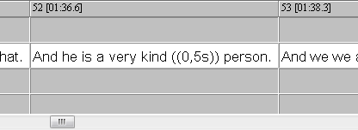

4.