**Quickstart – Transcribing**

A. Preparatory steps

*In single steps:*

1. Create new transcription  
   File > New...



1. Add meta data   
   Transcription > Meta information...



1. Assign media file(s)

Transcription > Recordings...  
Add audio/video file(s) by clicking on   
→ the audio file is displayed as a wave form and loaded into the player [1]



→ the video is displayed inside the audio/video panel, so you need to make sure that this panel is visible: View > Audio/Video panel[2]

1. Create speakertable



Transcription > Speakertable…  
Create new speakers by clicking on   
Change speaker abbreviation in the field Abbreviation



1. Add a tier for each speaker  
   **Tier** > **Add Tier...**



*Alternatively, use the wizard* *to create a new transcription:*

File > New from wizard...

*Don’t forget to* Save *your file*!

B. Transcribe

1. Select the passage to be transcribed in the waveform

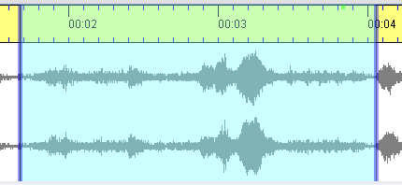

Blue boundaries: selection is not connected to time points in the transcription

1. Play selection and modify boundaries by click & drag or with the mouse wheel if necessary

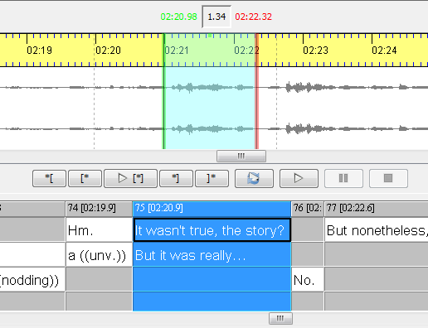

Loop selection

Play selection

Play second before selection

Play second after selection

Play first second of selection

Play last second of selection

(Green and red selection boundaries: selection is connected to time points in the transcription)

1. Enter transcription text  
     
   **There are two modes for entering transcription text:**  
   a)   
     
   … for **creating new events**, when no preceding event exists or for transcribing simultaneous passages.   
     
   After clicking the button, a new event will be inserted.   
   🡪 select the corresponding tier of the transcription   
   🡪 a new interval in the timeline will be created   
   🡪 a new empty event in the tier will be created



🡪 enter the transcription text in this event (do not transcribe within the red and yellow events!)  
🡪 for the word boundaries to be recognized as such, use a space after each word

b)   
  
… for **creating a new event at the end of the currently transcribed part**.   
  
After clicking the button, a new interval immediately following the currently transcribed part will be created. Initially, this interval is two seconds long.   
🡪 the corresponding part of the recording will be automatically selected in the waveform display  
🡪 modify the right selection boundary (cf. section 2)



🡪 right interval boundary in the partitur adjusts automatically

🡪 enter transcription text in the appropriate tier in the transcription

🡪 so that the word boundaries can be recognized as such, use a space after each word  
🡪 repeat this step to append another interval

1. Musical score („Partitur“)
2. Waveform
3. Cursor position in the waveform
4. Left selection boundary in the waveform (a) and in the musical score (b)
5. Right selection boundary in the waveform (a) and in the musical score (b)

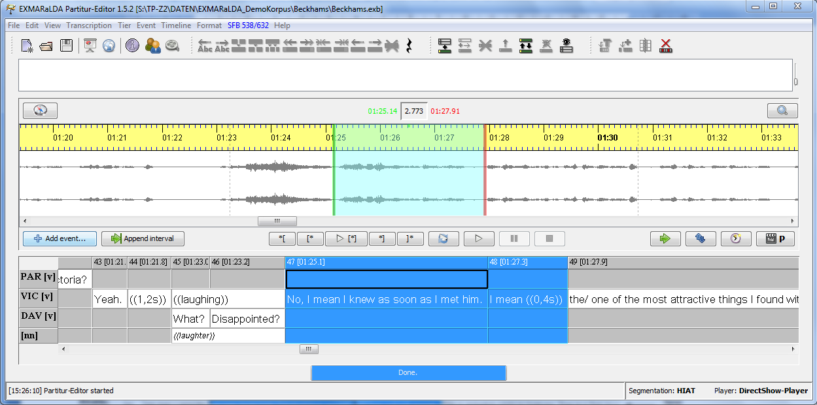

timeline item

event

tier label

tier

timeline

3

4a

5a

2

5b

4b

1

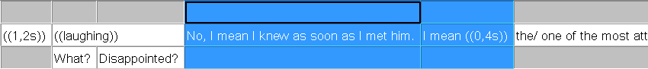

1. A waveform will only be displayed for audio files in wave format (file suffix *\*.wav*).
2. The audio/video panel selects the file on top of the list (in the window “Edit media files“).